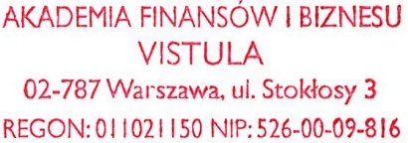

**Warsaw, 16.01.2017**

**Issued by :**

Vistula University

ul .Stokłosy 3

02-787

Warsaw, Poland

**Received by:**

SHLIAKHOV YELISEI, Ukraine

**Payment before 20.01.2017**

**Invoice Pro forma 2016/AY/PR/0163-a**

|  |  |  |  |  |  |
| --- | --- | --- | --- | --- | --- |
| Name of service | Price per month | | Number of months | Total | |
| Payment for the Accommodation in the dormitory “Porto” in 2-bedded room for 01.02.2017 -30.06.2017 for Academic year 2016/2017 | 200 | EUR | 5 | 1000 | EUR |
| Payment for the refundable deposit | 250 | EUR | 1 | 250 | EUR |
| Total | X | | X | 1250 | EUR |

In the Title of Payment please write Name and Surname of the student and INVOICE number.

|  |  |
| --- | --- |
| **Account Owner’s Address:**  AKADEMIA FINANSÓW I BIZNESU VISTULA  Ul. Stoklosy 3, 02- 787  Warsaw / Poland  **Account Owner’s Bank Address:**  ING BANK SLASKI  Malczewskiego 45, 02- 622  Warsaw Poland  **Currency:** EURO  **Swift Code :** ING BPLPW  **IBAN :** PL 77 1050 1025 1000 0024 0300 5990 | **The person authorized to issue:**  **Olga Petranevskaya** |