**Fred D. Martin Invitational XC Course**

finish

**1.5 Mile Course**

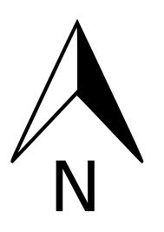

start

Dog

Park

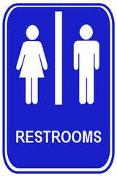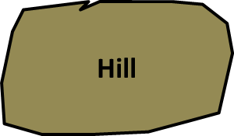

finish

**First Lap**

**Second Lap**