**Fred D. Martin Invitational XC Course**

finish

**2.0 Mile Course**

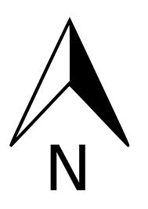

start

Dog

Park

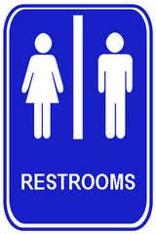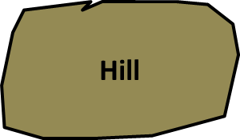

finish

**First Lap**

**Second Lap**