GLOW CO: INTEGRATED PLATFORM FOR SKINCARE PRODUCTS & BEAUTY SOLUTIONS
A course project report submitted in partial fulfilment of the requirement
of
AI ASSISSTANT CODING
by

B.Sathwika (2303A51135)

Under the guidance of
Dr. SALAUDDIN
Asst. Professor, Department of CS & AI


SR University, Warangal
APRIL-2026

ABSTRACT:
Glow Co is a full-stack web application developed to provide a centralized platform for skincare products and beauty solutions. The system enables users to browse various skincare items, understand their benefits, and place orders online through a secure and user-friendly interface. It simplifies the shopping experience by offering categorized products, detailed descriptions, and smooth navigation. The backend efficiently handles user authentication, product management, and order processing, ensuring reliable performance and data management.
The application is developed using modern web technologies, where the frontend is built using HTML, CSS, and JavaScript to ensure responsiveness and interactivity. The backend is implemented using Node.js, which handles business logic, user authentication, and communication with the database. MySQL is used as the database to store and manage user information, product details, and order records efficiently.
Glow Co also provides essential features such as user registration and login, product browsing, cart management, and order placement with multiple payment options including online payment and cash on delivery. The system ensures proper data handling and improves accessibility for users to purchase skincare products anytime and anywhere.
Overall, Glow Co simplifies the process of discovering and purchasing skincare products while providing a reliable platform for managing product data and user interactions. The project demonstrates the practical implementation of full-stack web development concepts and aims to enhance the digital shopping experience in the beauty and skincare domain.
OBJECTIVES:
The main objective of the Glow Co project is to design and develop a user-friendly web-based platform that enables users to easily explore and purchase skincare products online. The system aims to provide a smooth and efficient digital shopping experience by combining an interactive frontend with a reliable backend and database.
One of the key objectives is to create an intuitive and responsive user interface that allows users to navigate through different categories of skincare products without difficulty. The platform focuses on presenting clear product information, including descriptions, benefits, and usage details, so that users can make informed purchasing decisions.
Another important objective is to implement a secure user authentication system. This includes user registration and login functionality, ensuring that user data is handled safely and access to personal accounts is protected. The system also aims to maintain accurate records of user activities such as orders and preferences.
The project also aims to develop an efficient backend using Node.js to handle business logic, manage requests, and ensure smooth communication between the frontend and the database. The integration of a MySQL database is intended to store and manage product details, user information, and order data in a structured and organized manner.
Additionally, the platform is designed to support essential e-commerce features such as product browsing, cart management, and order placement. It provides flexibility in payment options, including online payment and cash on delivery, to enhance user convenience.
Overall, the objective of Glow Co is to build a reliable, scalable, and easy-to-use skincare platform that improves accessibility, enhances user experience, and demonstrates the practical implementation of full-stack web development technologies.
STAKEHOLDERS
👤 Customers / Users
🛒 Admin (Product management)
💻 Developers
🏢 Business Owners / Skincare Brands
📦 Delivery/Logistics Partners
💳 Payment Gateway Providers
Technologies
Frontend: HTML, CSS, JavaScript
Backend: Node.js (Express.js)
Database: MySQL
Tools: VS Code, GitHub
Browser: Chrome / Edge
Development Tools:
Visual Studio Code as primary IDE
Git for version control and collaboration
Postman for API testing
Chrome DevTools for debugging
Prompts
Create a Cart Page component in React for an e-commerce skincare website. It should display cart items, allow quantity updates, item removal, and show a summary with subtotal, shipping, and total price. Use React Router for navigation and a context API for cart state.
Create a secure Express.js server for a full-stack skincare e-commerce application. Include MongoDB connection using Mongoose, environment variable configuration using dotenv, and middleware such as helmet for security, cors for cross-origin requests, and express-rate-limit to prevent abuse. Structure the app with modular routes for users, products, orders, reviews, and admin.

Flowchart :
The workflow of the Glow Co system begins when the user opens the website, where the homepage is displayed with various skincare products and categories. The user can browse products, search for specific items, or proceed to login or registration if not already authenticated.
Once the user selects a product, the system processes the request and allows the user to add items to the cart. If the user is not logged in, the system redirects them to the login or registration page to ensure secure access. After successful authentication, the user can continue shopping and proceed to place an order.

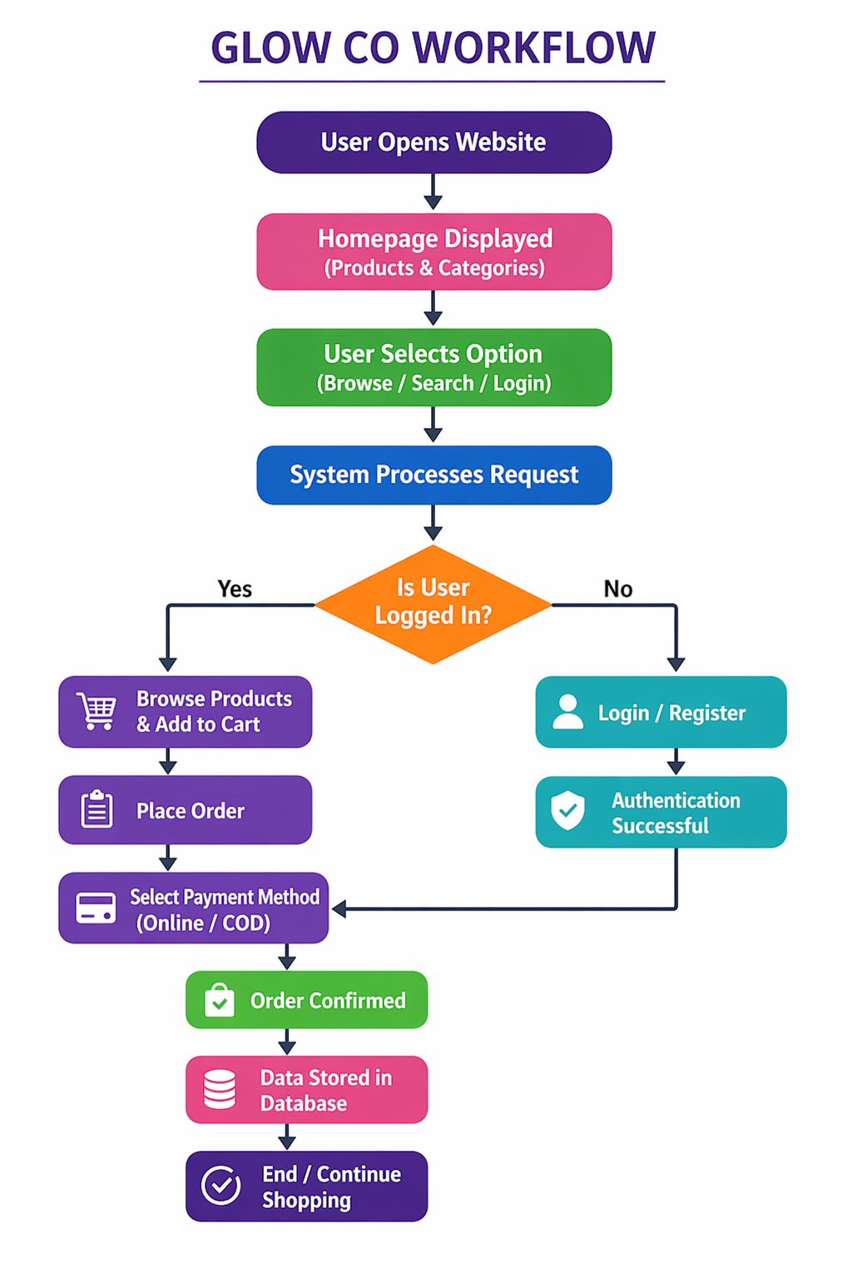

Frontend
The frontend of the Glow Co project is designed to provide an interactive and user-friendly interface for users to explore and purchase skincare products. It is developed using HTML, CSS, and JavaScript, which together ensure proper structure, styling, and functionality of the web application.
HTML (HyperText Markup Language) is used to create the basic structure of the web pages, including elements such as headings, input fields, buttons, product cards, and forms. It defines how content is displayed on the browser.

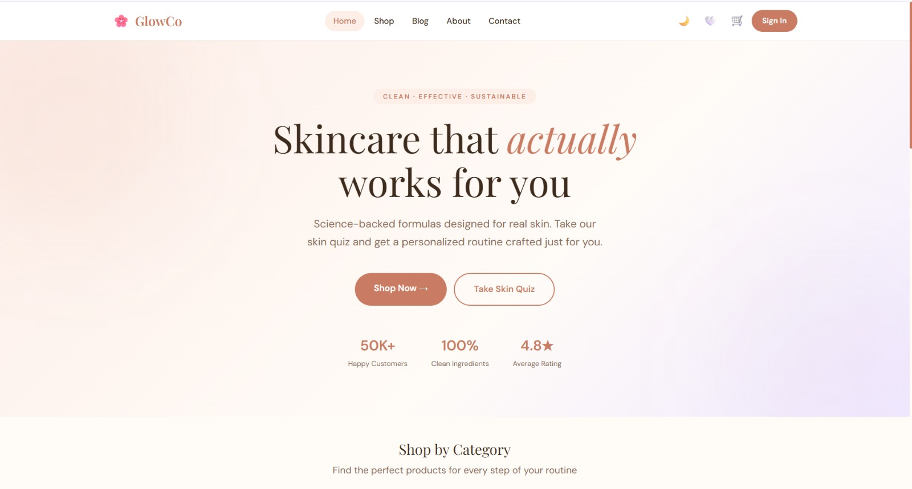
References
The development of the Glow Co project was supported by various online resources, documentation, and learning platforms that provided guidance on web development technologies and best practices. Official documentation of HTML, CSS, and JavaScript was referred to for designing the frontend interface and implementing interactivity. For backend development, Node.js and Express.js documentation were used to understand server-side programming, API creation, and request handling.
Database design and management were guided by MySQL documentation and tutorials, which helped in structuring data efficiently and performing database operations. Additionally, various online platforms such as tutorials, coding forums, and educational websites were used to gain practical knowledge and solve development-related issues.
Tools like Visual Studio Code were used for coding and debugging, while GitHub was used for version control and project management. Browser developer tools (Chrome/Edge) were also utilized for testing and debugging the application.


