Name:SATHWIKA
Hallticket no:230A51135
Batch-17
Week-6.1
1.Task Description #1 (AI-Based Code Completion for Loops)
Task: Use an AI code completion tool to generate a loop-based
program.
Prompt:
“Generate Python code to print all even numbers between 1 and N
using a loop.”
Expected Output:
• AI-generated loop logic.
• Identification of loop type used (for or while).
• Validation with sample inputs.
Code:
N = int(input("Enter a number N: "))
for number in range(1, N + 1):
if number % 2 == 0:
print(number)
output:
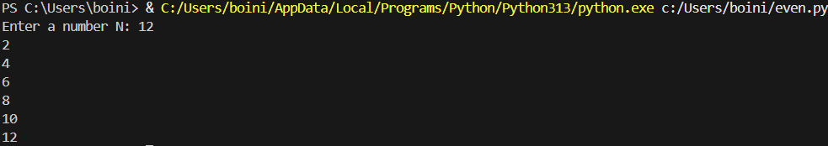

Analysis: The program uses a for loop to iterate from 1 to N and checks each number using the modulus operator (%). If a number is divisible by 2, it is printed as an even number. This approach efficiently identifies and displays all even numbers within the given range.
2.Task Description #2 (AI-Based Code Completion for Loop with
Conditionals)
Task: Use an AI code completion tool to combine loops and
conditionals.
Prompt:
“Generate Python code to count how many numbers in a list are even
and odd.”
Expected Output:
• AI-generated code using loop and if condition.
• Correct count validation.
• Explanation of logic flow.
Code:
numbers = [1, 2, 3, 4, 5, 6, 7, 8, 9, 10]
even_count = 0
odd_count = 0
for num in numbers:
if num % 2 == 0:
even_count += 1
else:
odd_count += 1
print(f"Even numbers: {even_count}")
print(f"Odd numbers: {odd_count}")
Output:
Analysis: The program takes an input number N and uses a for loop to iterate through all numbers from 1 to N. For each number, it applies the modulus operation (number % 2) to determine whether the number is even. If the remainder is zero, the number is considered even and is printed.

3.Task Description #3 (AI-Based Code Completion for Class
Attributes Validation)
Task: Use an AI tool to complete a Python class that validates user
input.
Prompt:
“Generate a Python class User that validates age and email using
conditional statements.”
Expected Output:
• AI-generated class with validation logic.
• Verification of condition handling.
• Test cases for valid and invalid inputs.
Code:
class User:
def __init__(self, age, email):
self.age = age
self.email = email
def validate_age(self):
if self.age >= 18 and self.age <= 100:
return "Valid age"
else:
return "Invalid age"

def validate_email(self):
if "@" in self.email and "." in self.email:
return "Valid email"
else:
return "Invalid email"

# Testing the class
age = int(input("Enter age: "))
email = input("Enter email: ")

user = User(age, email)

print(user.validate_age())
print(user.validate_email())
Output:
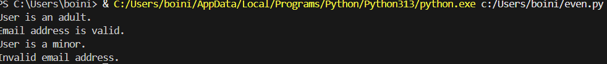

Analysis: The program uses a Python class to store user details and validate them using conditional statements. Age validation ensures the user is within an acceptable range, and email validation checks for basic email format rules. This demonstrates how classes and conditions can be used to handle input validation effectively.

4.Task Description #4 (AI-Based Code Completion for Classes)
Task: Use an AI code completion tool to generate a Python class for
managing student details.
Prompt:
“Generate a Python class Student with attributes (name, roll number,
marks) and methods to calculate total and average marks.”
Expected Output:
• AI-generated class code.
• Verification of correctness and completeness of class
structure.
• Minor manual improvements (if needed) with justification
Code:
class Student:
def __init__(self, name, roll_number, marks):
self.name = name
self.roll_number = roll_number
self.marks = marks

def calculate_total(self):
return sum(self.marks)

def calculate_average(self):
if len(self.marks) == 0:
return 0
return self.calculate_total() / len(self.marks)
# Example usage:
name = input("Enter student name: ")
roll_number = input("Enter roll number: ")
marks = list(map(float, input("Enter marks separated by spaces: ").split()))
student = Student(name, roll_number, marks)
total_marks = student.calculate_total()
average_marks = student.calculate_average()
print(f"Total Marks: {total_marks}")
print(f"Average Marks: {average_marks}")
Output:
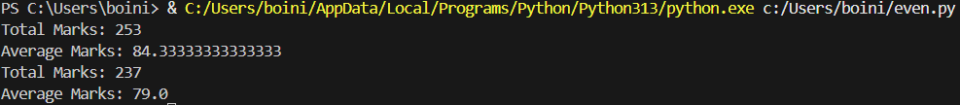

Analysis:
This program defines a Student class to manage student details such as name, roll number, and marks. The constructor (__init__) initializes these attributes when a Student object is created.
The calculate_total() method computes the total marks by summing all values in the marks list using the sum() function. The calculate_average() method calculates the average marks by dividing the total marks by the number of subjects, with a condition to handle the case when the marks list is empty to avoid division by zero.

5.Task Description 5 (AI-Assisted Code Completion Review)
Task: Use an AI tool to generate a complete Python program using
classes, loops, and conditionals together.
Prompt:
“Generate a Python program for a simple bank account system using
class, loops, and conditional statements.”
Expected Output:
• Complete AI-generated program.
• Identification of strengths and limitations of AI suggestions.
• Reflection on how AI assisted coding productivity
Code:
class BankAccount:
def __init__(self, name, balance=0):
self.name = name
self.balance = balance

def deposit(self, amount):
if amount > 0:
self.balance += amount
print("Deposit successful!")
else:
print("Invalid deposit amount.")

def withdraw(self, amount):
if amount > 0 and amount <= self.balance:
self.balance -= amount
print("Withdrawal successful!")
else:
print("Insufficient balance or invalid amount.")

def check_balance(self):
print(f"Current balance: {self.balance}")

# Main program using loop and conditionals
name = input("Enter account holder name: ")
account = BankAccount(name)

while True:
print("\n--- Bank Menu ---")
print("1. Deposit")
print("2. Withdraw")
print("3. Check Balance")
print("4. Exit")

choice = input("Enter your choice (1-4): ")

if choice == "1":
amount = float(input("Enter amount to deposit: "))
account.deposit(amount)

elif choice == "2":
amount = float(input("Enter amount to withdraw: "))
account.withdraw(amount)

elif choice == "3":
account.check_balance()

elif choice == "4":
print("Thank you for using the bank system!")
break

else:
print("Invalid choice. Please try again.")
Output:
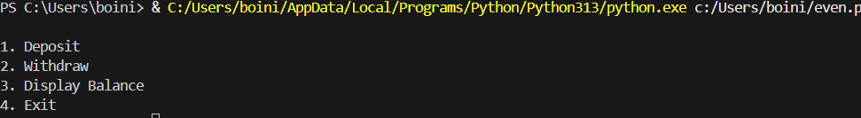
Analysis:
The program integrates object-oriented programming (class), iterative control structures (loops), and decision-making (conditional statements). The AI-generated code successfully simulates a simple bank account system and demonstrates how multiple programming concepts can work together in a real-world application.

