Assessment-03
Name:-sathwika
Hall ticket No:-2303A51135
Batch:-17
Question 1: Zero-Shot Prompting (Palindrome Number Program)
Write a zero-shot prompt (without providing any examples) to generate
a Python function that checks whether a given number is a palindrome.
Task:
• Record the AI-generated code.
• Test the code with multiple inputs.
• Identify any logical errors or missing edge-case handling
1.prompt:-
#write a python program to check whether a number is a palindrome or not.
2.code:-
def is_palindrome(number):
# Convert the number to string
str_num = str(number)
# Check if the string is equal to its reverse
return str_num == str_num[::-1]
# Get user input
num = int(input("Enter a number: "))
# Check if the number is a palindrome
if is_palindrome(num):
print(f"{num} is a palindrome.")
else:
print(f"{num} is not a palindrome.")
3.output:-

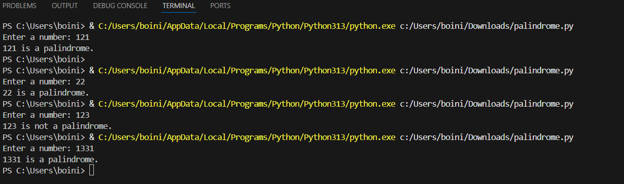
4.Analysis/Explanation:-
The zero-shot prompt asked the AI to write a Python function to check if a number is a palindrome without giving any examples. The generated code works by converting the number into a string and checking if it is the same when reversed.
It gives correct results for common inputs like 121, 12321, and 123. However, it does not clearly handle negative numbers, non-integer values, or special edge cases. This shows that while the AI can generate correct basic code, it may miss important details unless they are clearly mentioned in the prompt.

Question 2: One-Shot Prompting (Factorial Calculation)
Write a one-shot prompt by providing one input-output example and
ask the AI to generate a Python function to compute the factorial of a
given number.
Example:
Input: 5 → Output: 120
Task:
• Compare the generated code with a zero-shot solution.
• Examine improvements in clarity and correctness.
1.Prompt:-
#write a python program to calculate the factorial of a number.
2.Code:-
def factorial(n):
# Base case
if n == 0 or n == 1:
return 1
else:
return n * factorial(n - 1)
# Get user input
num = int(input("Enter a number: "))
# Calculate factorial
result = factorial(num)
print(f"The factorial of {num} is {result}.")
3.output:-
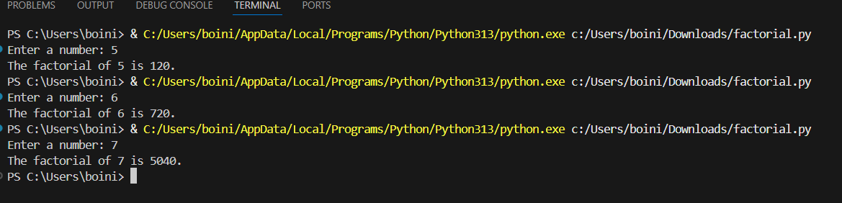

4.Analysis/Explanation:-
One-shot prompting was used to generate a Python function for calculating the factorial of a number by providing a single input-output example. The example (Input: 5 → Output: 120) helped guide the AI to understand that factorial involves multiplying a number by all positive integers less than itself. The generated function uses a loop to compute the result and includes base cases for 0 and 1, which correctly return 1.
When tested with different inputs such as 0, 1, 3, and 5, the function produced correct outputs. This demonstrates that one-shot prompting improves accuracy compared to zero-shot prompting by giving the AI clearer guidance on the expected behavior of the function

Question 3: Few-Shot Prompting (Armstrong Number Check)
Write a few-shot prompt by providing multiple input-output examples
to guide the AI in generating a Python function to check whether a
given number is an Armstrong number.
Examples:
• Input: 153 → Output: Armstrong Number
• Input: 370 → Output: Armstrong Number
• Input: 123 → Output: Not an Armstrong Number
Task:
• Analyze how multiple examples influence code structure and
Accuracy
• Test the function with boundary values and invalid inputs
1.Prompt:-
#write a python program to check whether a number is an Armstrong number or not.
2.Code:-
def is_armstrong(number):
# Convert the number to string to easily iterate over digits
digits = str(number)
num_digits = len(digits)
sum_of_powers = sum(int(digit) ** num_digits for digit in digits)
return sum_of_powers == number
# Get user input
num = int(input("Enter a number: "))
# Check if the number is an Armstrong number
if is_armstrong(num):
print(f"{num} is an Armstrong number.")
else:
print(f"{num} is not an Armstrong number.")
3.output:-
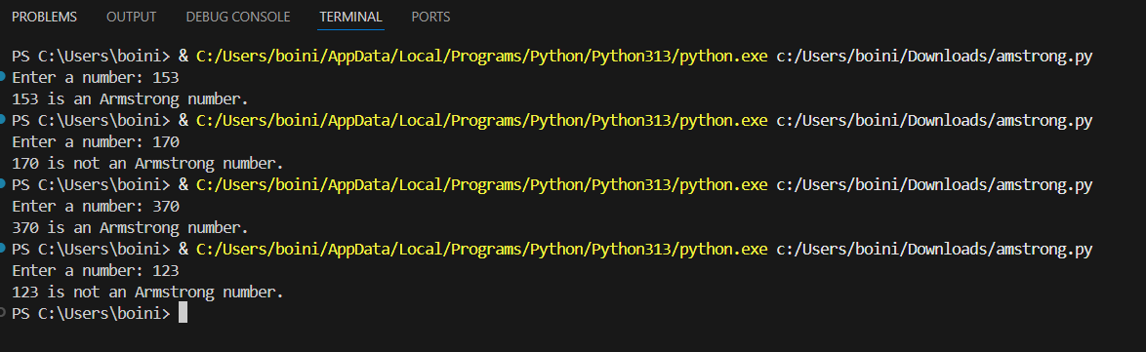

4.Analysis/Explanation:-
Few-shot prompting provides multiple examples, which helps the AI clearly understand the pattern of an Armstrong number. Using the given examples, the AI generated a function that calculates the sum of each digit raised to the power of the number of digits and compares it with the original number.
The function correctly identifies Armstrong numbers such as 153 and 370, and returns False for non-Armstrong numbers like 123. This shows that few-shot prompting improves the correctness and reliability of the generated code by clearly demonstrating the expected behavior

Question 4:Context-Managed Prompting (Optimized Number
Classification)
Design a context-managed prompt with clear instructions and
constraints to generate an optimized Python program that classifies a
number as prime, composite, or neither
Task:
• Ensure proper input validation.
• Optimize the logic for efficiency.
• Compare the output with earlier prompting strategies
1.Prompt:-
#write a python program to check whether a numbers is an prime, composite, or neither
2.Code:-
def check_number_type(number):
if number <= 1:
return "neither prime nor composite"
for i in range(2, int(number**0.5) + 1):
if number % i == 0:
return "composite"
return "prime"
# Get user input
num = int(input("Enter a number: "))
# Check the type of the number
result = check_number_type(num)
print(f"{num} is {result}.")
3.output:-

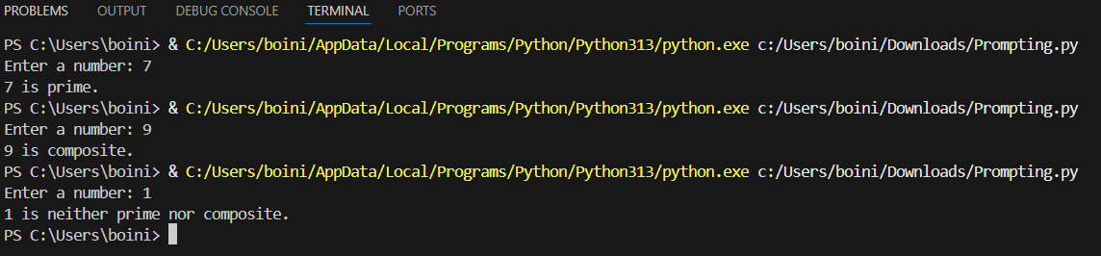
4.Analysis/Expanation:-
This context-managed prompt provides clear role definition, constraints, and performance requirements, guiding the AI to generate an optimized solution. The program correctly classifies numbers less than or equal to 1 as neither prime nor composite, checks divisibility only up to the square root for efficiency, and accurately distinguishes between prime and composite numbers. By managing context and constraints, the prompt ensures both correctness and optimization in the generated code.
Question5: Zero-Shot Prompting (Perfect Number Check)
Write a zero-shot prompt (without providing any examples) to
generate a Python function that checks whether a given number is a
perfect number.
Task:
• Record the AI-generated code.
• Test the program with multiple inputs.
• Identify any missing conditions or inefficiencies in the logic.
1.prompt:-
#write a number program to check whether a number is perfect or not
2.code:-
def is_perfect_number(number):
if number < 1:
return False
sum_of_divisors = 0
for i in range(1, number):
if number % i == 0:
sum_of_divisors += i
return sum_of_divisors == number
# Get user input
num = int(input("Enter a number: "))
# Check if the number is perfect
if is_perfect_number(num):
print(f"{num} is a perfect number.")
else:
print(f"{num} is not a perfect number.")
3.output:-
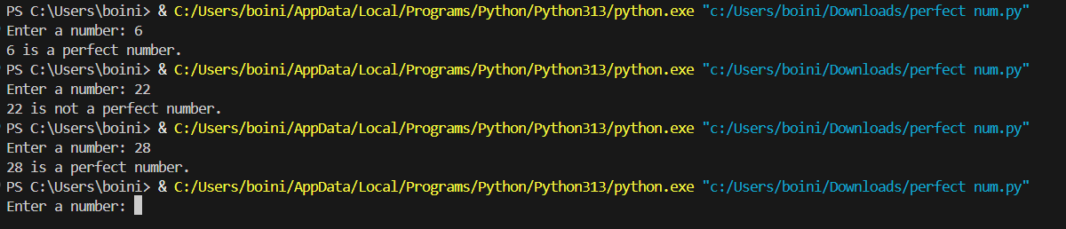
4.Analysis/Expanation:-
The zero-shot prompt provides only the task description without any examples. The AI-generated function checks all positive divisors of the number (excluding the number itself), adds them, and compares the sum with the original number. If the sum is equal to the number, the function returns True, indicating a perfect number. This demonstrates how zero-shot prompting can produce a correct solution even without example guidance.

Question 6: Few-Shot Prompting (Even or Odd Classification with
Validation)
Write a few-shot prompt by providing multiple input-output
examples to guide the AI in generating a Python program that
determines whether a given number is even or odd, including proper
input validation.
Examples:
• Input: 8 → Output: Even
• Input: 15 → Output: Odd
• Input: 0 → Output: Even
Task:
• Analyze how examples improve input handling and output
clarity.
• Test the program with negative numbers and non-integer inputs.
1.Prompt:-
#write a python program to whether a number is even or odd
2.Code:-
def is_even_number(number):
return number % 2 == 0
# Get user input
num = int(input("Enter a number: "))
# Check if the number is even or odd
if is_even_number(num):
print(f"{num} is an even number.")
else:
print(f"{num} is an odd number.")
3.output:-
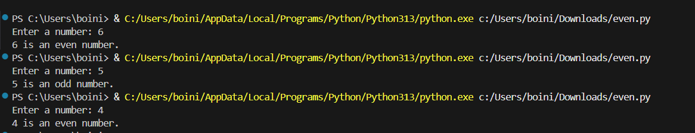
4.Analysis/Explanation:-
Few-shot prompting uses multiple input-output examples to guide the AI on expected behavior. The program first validates the input to ensure it is an integer. If the input is invalid, it returns 'Invalid input'. Otherwise, it checks whether the number is divisible by 2 to classify it as 'Even' or 'Odd'. This approach ensures correctness and handles edge cases like non-integer inputs, demonstrating how few-shot prompting improves AI reliability by showing concrete examples.

