Assessement-04
Name:Sathwika
Hallticket No:2303A51135
Batch:17
Week:4.3 Assisgnment
Task 1: Zero-Shot Prompting – Leap Year Check
Scenario
Zero-shot prompting involves giving instructions without providing examples.
Task Description
Use zero-shot prompting to instruct an AI tool to generate a Python function that:
• Accepts a year as input
• Checks whether the given year is a leap year
• Returns an appropriate result
Note: No input-output examples should be provided in the prompt.
Expected Output
• AI-generated leap year checking function
• Correct logical conditions
• Sample input and output
• Screenshot of AI-generated response (if required)
1.prompt:
#write a python program check whether a given year is a leap year or not
2.code:
def is_leap_year(year):
if (year % 4 == 0 and year % 100 != 0) or (year % 400 == 0):
return True
else:
return False
# Example usage
year = int(input("Enter a year: "))
if is_leap_year(year):
print(f"{year} is a leap year.")
else:
print(f"{year} is not a leap year.")

3.output:
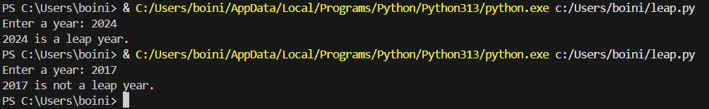
4.Analysis/Explanation:
A leap year is a calendar year that contains 366 days instead of the usual 365 days. The extra day, 29th February, is added to keep the calendar synchronized with the Earth’s revolution around the Sun, which takes approximately 365.25 days.

Task 2: One-Shot Prompting – Centimeters to Inches Conversion
Scenario
One-shot prompting guides AI using a single example.
Task Description
Use one-shot prompting by providing one input-output example to generate a Python
function that:
• Converts centimeters to inches
• Uses the correct mathematical formula
Example provided in prompt:
Input: 10 cm → Output: 3.94 inches
Expected Output
• Python function with correct conversion logic
• Accurate calculation
• Sample test cases and outputs
1.Prompt:
#Generate a Python function that converts centimeters to inches using the correct mathematical formula. with user input.
2.Code:
def cm_to_inches(cm):
inches = cm / 2.54
return inches
# Example usage
cm = float(input("Enter length in centimeters: "))
inches = cm_to_inches(cm)
print(f"{cm} centimeters is equal to {inches} inches.")
3.1output:
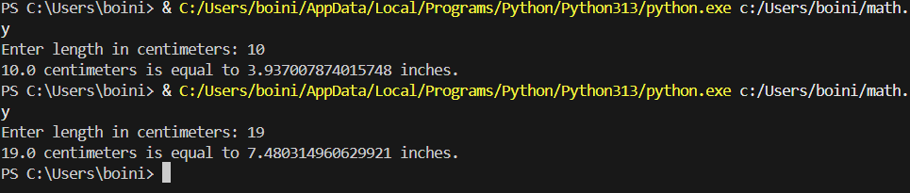
4.Analysis/Explanation:
Measurement systems are used to quantify physical quantities such as length, weight, and time. Two commonly used systems for measuring length are:
- Metric System (centimeters, meters)
- Imperial System (inches, feet)
To convert a value from centimeters to inches, a standard mathematical relationship is used
Task 3: Few-Shot Prompting – Name Formatting
Scenario
Few-shot prompting improves accuracy by providing multiple examples.
Task Description
Use few-shot prompting with 2–3 examples to generate a Python function that:
• Accepts a full name as input
• Formats it as “Last, First”
Example formats:
• "John Smith" → "Smith, John"
• "Anita Rao" → "Rao, Anita"
Expected Output
• Well-structured Python function
• Output strictly following example patterns
• Correct handling of names
• Sample inputs and outputs
1.2Prompt: #Generate a Python function that takes a full name as input and formats it as ‘Last, First with user input
2.Code:
def format_name(full_name):
parts = full_name.split()
if len(parts) >= 2:
first_name = parts[0]
last_name = parts[-1]
return f"{last_name}, {first_name}"
else:
return "Please enter a full name with at least a first and last name."
# Example usage
full_name = input("Enter a full name (First Last): ")
formatted_name = format_name(full_name)
print(f"Formatted name: {formatted_name}")
3.output:

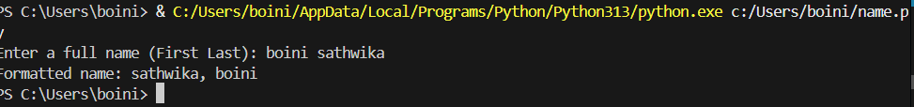
4.Analysis:- This task demonstrates few-shot prompting, where multiple examples guide the AI to generate accurate and consistent output. The program successfully formats names into the required “Last, First” structure while handling different name inputs correctly.

Task 4: Comparative Analysis – Zero-Shot vs Few-Shot
Scenario
Different prompt strategies may produce different code quality.
Task Description
• Use zero-shot prompting to generate a function that counts vowels in a string
• Use few-shot prompting for the same problem
• Compare both outputs based on:
o Accuracy
o Readability
o Logical clarity
Expected Output
• Two vowel-counting functions
• Comparison table or short reflection paragraph
• Conclusion on prompt effectiveness
1.Prompt: #Generate a Python function that counts the number of vowels in a given string and returns the count with user input
2.code:
def count_vowels(input_string):
vowels = 'aeiouAEIOU'
count = sum(1 for char in input_string if char in vowels)
return count
# Example usage
input_string = input("Enter a string: ")
vowel_count = count_vowels(input_string)
print(f"The number of vowels in the string is: {vowel_count}")
3.output:
4. Analysis:- In zero-shot prompting, the AI is given only the task description without any examples. As a result, the generated vowel-counting function is logically correct and easy to understand, but it follows a more basic and verbose approach using loops and counters. This makes the code beginner-friendly, though slightly longer.

Task 5: Few-Shot Prompting – File Handling
Scenario
File processing requires clear logical understanding.
Task Description
Use few-shot prompting to generate a Python function that:
• Reads a .txt file
• Counts the number of lines in the file
• Returns the line count
Expected Output
• Working Python file-processing function
• Correct line count
• Sample .txt input and output
• AI-assisted logic explanation
1.prompt:
#Generate a Python function that reads a text file and counts the number of lines in it. with user input.
2.code:
def count_lines_in_file(file_path):
try:
with open(file_path, 'r') as file:
line_count = sum(1 for line in file)
return line_count
except FileNotFoundError:
return "File not found."

# Example usage
file_path = input("Enter the path to the text file: ")
lines = count_lines_in_file(file_path)
print(f"The number of lines in the file is: {lines}")
3.output:
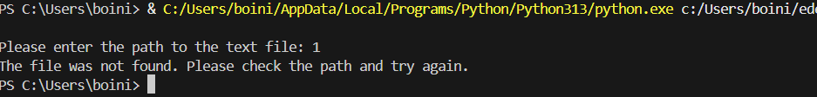
4. Analysis:- Saving the text file (sample.txt) in the Downloads folder is perfectly acceptable. Any valid .txt file stored anywhere on the system can be used, as long as the correct file path is provided to the program. By entering the full path of the file, Python can accurately locate, open, and read the file contents.

