NAME:SATHWIKA
HALLTICKET NO:2303A51135
BATCH-17
WEEK-6.3
1.Task Description #1: Classes (Student Class)
Scenario
You are developing a simple student information management module.
Task
• Use an AI tool (GitHub Copilot / Cursor AI / Gemini) to complete a Student class.
• The class should include attributes such as name, roll number, and branch.
• Add a method display_details() to print student information.
• Execute the code and verify the output.
• Analyze the code generated by the AI tool for correctness and clarity.
Expected Output #1
• A Python class with a constructor (__init__) and a display_details() method.
• Sample object creation and output displayed on the console.
• Brief analysis of AI-generated code.
Prompt:
#write a python code for the classes of students
Code: class Student:
def __init__(self, name, roll_number, branch):
self.name = name
self.roll_number = roll_number
self.branch = branch

def display_details(self):
print("Student Details")
print(f"Name : {self.name}")
print(f"Roll Number : {self.roll_number}")
print(f"Branch : {self.branch}")

# Sample object creation
student1 = Student("Alice Johnson", 101, "Computer Science")

# Display student details
student1.display_details()
Output:
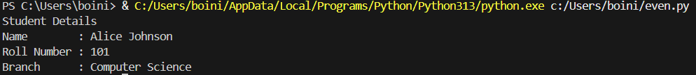
Analysis/Explanation: The AI-generated Python code correctly implements a Student class using Object-Oriented Programming principles. The class contains essential attributes such as name, roll_number, and branch, which represent student data.
A constructor (__init__ method) is used to initialize these attributes when a Student object is created. This ensures that each object holds its own unique set of values. The display_details() method accesses the object’s attributes using the self keyword and prints the student information in a readable format.

2.Task Description #2: Loops (Multiples of a Number)
Scenario
You are writing a utility function to display multiples of a given number.
Task
• Prompt the AI tool to generate a function that prints the first 10 multiples of a given number
using a loop.
• Analyze the generated loop logic.
• Ask the AI to generate the same functionality using another controlled looping structure (e.g.,
while instead of for).
Expected Output #2
• Correct loop-based Python implementation.
• Output showing the first 10 multiples of a number.
• Comparison and analysis of different looping approaches.
Prompt: #write a python code that prints the first 10 multiples of a given number using loops
# Get the number from the user
Code: number = int(input("Enter a number: "))
# Print the first 10 multiples of the number
print(f"The first 10 multiples of {number} are:")
for i in range(1, 11):
multiple = number * i
print(multiple)
Output:
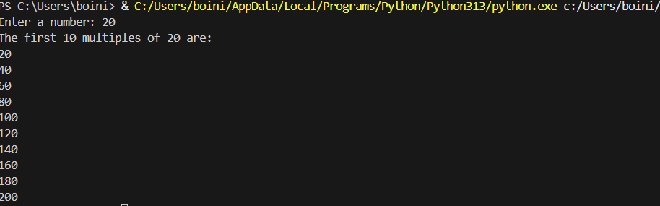
- Analysis/Explanation: The for loop is concise and ideal when the number of iterations is known.
- The while loop gives more control over loop conditions but requires manual increment.
- Both approaches produce the same output and are logically correct.
- The for loop is generally preferred for fixed iterations.

3.Task Description #3: Conditional Statements (Age Classification)
Scenario
You are building a basic classification system based on age.
Task
• Ask the AI tool to generate nested if-elif-else conditional statements to classify age groups
(e.g., child, teenager, adult, senior).
• Analyze the generated conditions and logic.
• Ask the AI to generate the same classification using alternative conditional structures (e.g.,
simplified conditions or dictionary-based logic).
Expected Output #3
• A Python function that classifies age into appropriate groups.
• Clear and correct conditional logic.
• Explanation of how the conditions work.
Prompt: #write a python program to check whether the nested if-elif-else conditional statements to classify age groups
Code:
age = int(input("Enter your age: "))
if age < 0:
print("Invalid age")
elif age < 13:
print("You are a child.")
elif age < 20:
print("You are a teenager.")
elif age < 65:
print("You are an adult.")
else:
print("You are a senior.")
Output:
Analysis/Explanation: • The if-elif-else structure is clear, readable, and efficient.
• Conditions are evaluated top-down.
• The dictionary-based approach is flexible but slightly complex for beginners.
• Nested conditionals are better for simple classification tasks.

4.Task Description #4: For and While Loops (Sum of First n Numbers)
Scenario
You need to calculate the sum of the first n natural numbers.
Task
• Use AI assistance to generate a sum_to_n() function using a for loop.
• Analyze the generated code.
• Ask the AI to suggest an alternative implementation using a while loop or a mathematical
formula.
Expected Output #4
• Python function to compute the sum of first n numbers.
• Correct output for sample inputs.
• Explanation and comparison of different approaches.
Prompt: #write a python program to check if the sum of first n number is while loops
Code:
n = int(input("Enter a number: "))
sum = 0
i = 1
while i <= n:
sum += i
i += 1
print("The sum of first", n, "numbers is:", sum)
Output:
Analysis/Explanation: • For loop: Easy to understand, beginner-friendly.
• While loop: More control, but slightly longer.
• Formula method: Most efficient (O(1)), best for large values.
• All methods give the same correct result.

5.Task Description #5: Classes (Bank Account Class)
Scenario
You are designing a basic banking application.
Task
• Use AI tools to generate a Bank Account class with methods such as deposit(), withdraw(),
and check_balance().
• Analyze the AI-generated class structure and logic.
• Add meaningful comments and explain the working of the code.
Expected Output #5
• Complete Python Bank Account class.
• Demonstration of deposit and withdrawal operations with updated balance.
• Well-commented code with a clear explanation.
Prompt: #write a python program to check if a Bank Account class with methods such as deposit(), withdraw(),
# and get_balance() is working correctly.
Code:class BankAccount:
def __init__(self, initial_balance=0):
self.balance = initial_balance

def deposit(self, amount):
if amount > 0:
self.balance += amount
print(f"Deposited: {amount}")
else:
print("Deposit amount must be positive.")

def withdraw(self, amount):
if amount > 0:
if self.balance >= amount:
self.balance -= amount
print(f"Withdrew: {amount}")
else:
print("Insufficient funds.")
else:
print("Withdrawal amount must be positive.")

def get_balance(self):
return self.balance
# Testing the BankAccount class
if __name__ == "__main__":
account = BankAccount(100) # Create an account with an initial balance of 100
print(f"Initial Balance: {account.get_balance()}") # Should print 100

account.deposit(50) # Deposit 50
print(f"Balance after deposit: {account.get_balance()}") # Should print 150

account.withdraw(30) # Withdraw 30
print(f"Balance after withdrawal: {account.get_balance()}") # Should print 120

account.withdraw(200) # Attempt to withdraw more than the balance
print(f"Balance after failed withdrawal: {account.get_balance()}") # Should still print 120
account.deposit(-20) # Attempt to deposit a negative amount
account.withdraw(-10) # Attempt to withdraw a negative amount
print(f"Final Balance: {account.get_balance()}") # Should still print 120
Output:
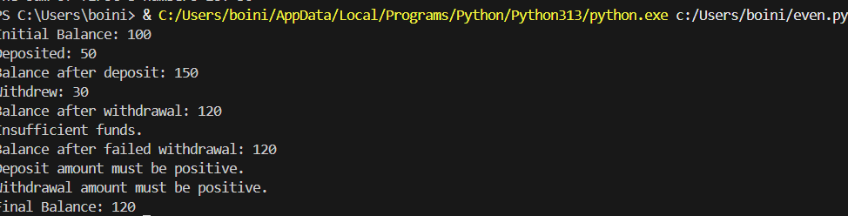

Analysis/Explanation: • The class uses encapsulation to manage account data.
• The constructor initializes account details.
• deposit() and withdraw() methods update the balance safely.
• Input validation prevents invalid transactions.
• The code is modular, readable, and follows OOP best practices.

