Table 2 Creation:

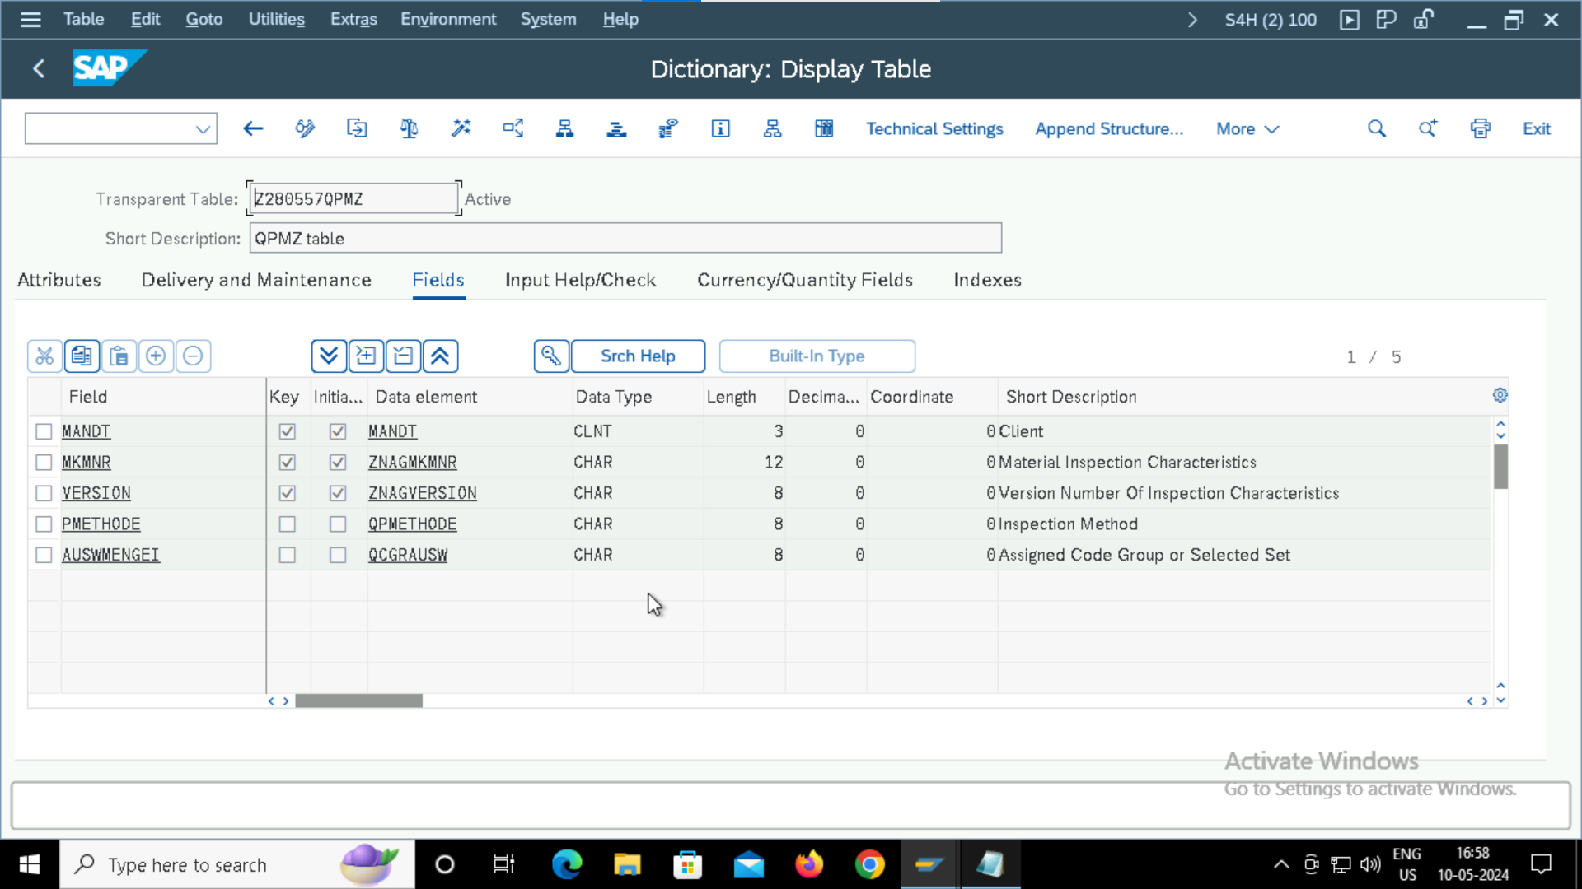

Foreign key Relation:

Table 2 data :

