Interactive Report:

Includes:

Code:

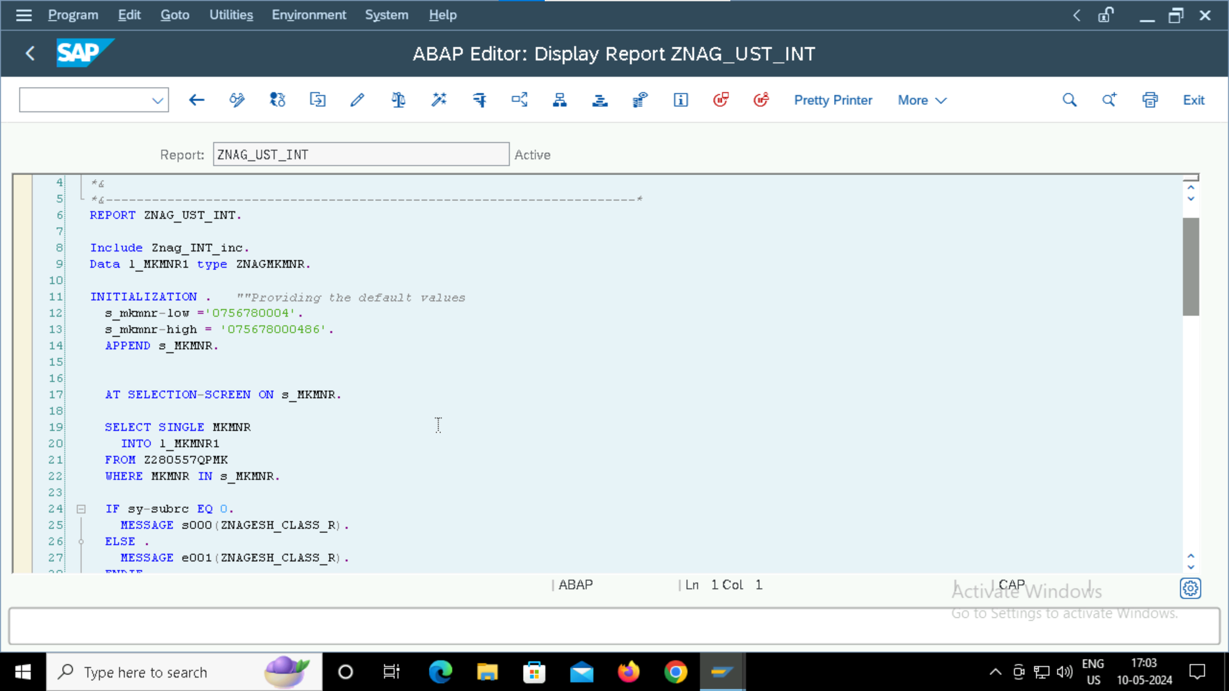

Output:

Basic List:

List 1:

