Physical activity and motor cortex neurophysiology: a systematic review and meta-analysis of transcranial magnetic stimulation indices of cortical excitability, inhibition, and facilitation

Ata Farajzadeh,¹ Kayne Park,¹ Timothée Dumas,¹ Ian M. Lahart,² Anthony N. Carlsen,³ Matthieu P. Boisgontier^{1,4}

¹School of Rehabilitation Sciences, Faculty of Health Sciences, University of Ottawa, Ottawa, Canada; ²Faculty of Education, Health and Wellbeing, Institute of Human Sciences, University of Wolverhampton, Wolverhampton, United Kingdom; ³School of Human Kinetics, Faculty of Health Sciences, University of Ottawa, Ottawa, Canada; ⁴Institut du Savoir Montfort, Hôpital Montfort, Ottawa, Ontario, Canada.
Correspondence: Ata Farajzadeh (ata.farajzadeh@uottawa.ca).

Abstract
Acute exercise transiently modulates motor cortical physiology, but whether habitual physical activity is associated with persistent differences remains unclear. We conducted a systematic review and meta-analysis to examine the association between physical activity and transcranial magnetic stimulation indices of motor neurophysiology. Following PRISMA guidelines, we searched five databases for studies assessing correlations between physical activity and TMS-derived measures of corticospinal excitability, cortical inhibition, and cortical facilitation in healthy adults. Pearson correlations were pooled using multilevel random-effects meta-analyses. Seventeen studies (632 participants) met the inclusion criteria. Meta-analyses included 15 correlations for corticospinal excitability (435 participants), 14 for cortical inhibition (451 participants), and 14 for cortical facilitation (412 participants). A small positive association was observed for cortical inhibition (r = 0.16, 95% CI 0.04 to 0.28). There was no evidence of an association between physical activity and corticospinal excitability (r = −0.01, 95% CI −0.12 to 0.11) or cortical facilitation (r = 0.07, 95% CI −0.04 to 0.18). Equivalence testing indicated that the association between physical activity and corticospinal excitability was statistically equivalent to zero, suggesting that any true relationship is negligible. Overall, these findings suggest that physical activity may relate primarily to motor cortical inhibitory processes, with little evidence for associations with corticospinal excitability or facilitatory circuits.

Keywords
motor cortex; transcranial magnetic stimulation; motor activity; exercise; physical exertion
INTRODUCTION
The primary motor cortex (M1) is a key node in the control of voluntary movement by integrating inputs from multiple cortical and subcortical regions and transforming them into descending corticospinal signals that drive skeletal muscle activity (1). In the short term, corticospinal excitability is dynamically modulated during action preparation and selection, reflecting the influence of distributed neural circuits involved in action control (2). Beyond these short-term modulations, M1 circuits exhibit plasticity and can be modified can be modified through experience and motor practice (3).
Physical activity, which includes exercise, sport, active transport, household chores, and occupational activities (4), may influence M1 plasticity. Evidence from systematic reviews and meta-analyses indicates that acute exercise can modulate several measures of motor cortical function, including corticospinal excitability as well as intracortical inhibitory and facilitatory circuits (5, 6). These acute effects typically observed within minutes to hours following exercise, may be mediated by transient neurochemical changes, including increases in circulating catecholamines and neurotrophic factors (7, 8). Whether the repeated occurrence of such acute effects through regular engagement in physical activity results in longer-term differences in M1 neurophysiology remains unclear.
Although the association between habitual physical activity, reflecting typical levels of physical activity accumulated across daily life (4), and M1 neurophysiology has not been systematically reviewed, several lines of evidence suggest that such a relationship may exist. Habitual physical activity has been associated with alterations in neural systems supporting plasticity, including increases in circulating neurotrophic factors such as brain-derived neurotrophic factor (9). Moreover, motor cortical responses to acute exercise appear to depend on habitual physical activity levels, suggesting that individual differences in physical activity may influence M1 neurophysiology (10, 11).
In humans, M1 neurophysiology can be probed non-invasively using transcranial magnetic stimulation (TMS). Single-pulse TMS allows assessment of corticospinal excitability (CSE) through motor-evoked potentials (MEPs), whereas paired-pulse TMS protocols probe inhibitory and facilitatory cortical circuits, including short-interval intracortical inhibition (SICI), long-interval intracortical inhibition (LICI), intracortical facilitation (ICF), and short-interval intracortical facilitation (SICF) (12, 13). In addition, TMS can assess inhibitory processes using measures such as the cortical silent period (cSP) and the ipsilateral silent period (iSP), which reflect cortical and interhemispheric inhibition, respectively (14). Despite growing interest in the neurobiological effects of physical activity, the relationship between habitual physical activity and these TMS-derived measures of M1 neurophysiology has not been systematically reviewed. Therefore, the objective of this study was to conduct a systematic review and meta-analysis examining the association between habitual physical activity and TMS-derived measures of motor neurophysiology.

METHODS

Search Strategy
This systematic review was conducted in accordance with the Preferred Reporting Items for Systematic Reviews and Meta-Analyses (PRISMA) guidelines (15). Potentially eligible studies were identified through systematic searches of MEDLINE (via PubMed), PsycINFO, Web of Science, SPORTDiscus, and CINAHL. The search strategy combined terms related to physical activity (e.g., physical activity, physical education, training, physical fitness, exercise, cycling, treadmill, single bout) and TMS (e.g., TMS, transcranial magnetic stimulation, motor-evoked potential, stimulus-response curve, input-output curve, intracortical inhibition, intracortical facilitation, silent period) (see Supplementary Material 1 for the full search strategy). The search included all articles published in English available up to March 2025, with no limitation on the start date. In addition, the reference lists of included articles were manually screened to identify potentially relevant studies not captured in the database searches. To reduce potential bias and enhance transparency, this systematic review was pre-registered in the International Prospective Register of Systematic Reviews (PROSPERO; registration number CRD420251016029).

Eligibility Criteria
Studies were included if they were published in a peer-reviewed journal, were written in English, reported original data collected from healthy adult participants (≥ 18 years), included at least one neurophysiological parameters of M1 assessed using TMS and at least one measure of physical activity, and formally tested the association between these variables (e.g., by reporting a Pearson’s r correlation coefficient). Measures of physical activity could be self-reported (e.g., questionnaire) or device-based (e.g., accelerometry). Eligible study designs included cross-sectional studies, cohort studies, and baseline data from clinical trials.
Studies were excluded if they were published as a review article, book chapter, study protocol, or conference abstract, or assessed laboratory-based measures of physical fitness (e.g., maximal muscle force).

Study selection
One author (AF) conducted the initial database search. After removing duplicates, the titles and abstracts of all identified records were screened according to the predefined inclusion and exclusion criteria. Studies that did not meet the eligibility criteria were excluded. In the second stage, two authors (AF, KP) independently screened the full text of the remaining articles. Both reviewers had to agree on the inclusion or exclusion of each study. Any disagreements were resolved through discussion and consensus, with a third reviewer (MPB) consulted when necessary. Reference list screening and forward citation tracking were conducted for all studies retained after the full-text screening stage (Fig. 1).

Data Extraction

Data extraction was performed independently by two reviewers (AF, KP). Any discrepancies were resolved through discussion and consensus, with a third reviewer (MPB) consulted when necessary. When insufficient data were reported, the corresponding author was contacted to request additional information.

Data were extracted from the included studies using a standardized extraction form. The extracted information included the first author’s name, article title, publication year, study design, sample size, age range, mean age, sex distribution, type of physical activity measure, duration of physical activity assessment, outcome measures, TMS parameters, and results describing the association between physical activity and neurophysiological measures. These measures included MEP amplitude (reflecting CSE); expressed as raw amplitude, percentage of peripheral M-wave amplitude, MEPMAX, or values derived from a stimulus–response curve, as well as SICI, LICI, cSP, iSP, ICF, and SICF.

Quality Assessment
The methodological quality of each included study was assessed using the Downs and Black checklist (16). This checklist can be applied to both randomized and non-randomized studies and consists of 27 items assessing reporting quality, external validity, internal validity, and statistical power. Total scores range from 0 to 28, with higher scores indicating better methodological quality. Two reviewers (AF, KP) independently assessed study quality, and discrepancies were resolved through discussion and consensus with a third reviewer (MPB).

Statistical Analyses
All analyses were conducted in the R statistical environment (17) using metafor (18) and meta packages (19).

Primary Meta-Analyses
Pearson product–moment correlations from eligible studies were pooled to examine the relationship between physical activity and TMS measures of cortico-spinal excitability, cortical inhibition, and cortical facilitation. Prior to analysis, r correlations were Fisher’s z-transformed to stabilize variance, and the corresponding sampling variances were calculated.
Meta-analyses were conducted using multilevel random-effects models implemented with the metafor package (18). This approach accounts for statistical dependence among multiple correlation estimates reported within the same study. A multilevel approach was used because several studies contributed more than one correlation estimate (e.g., different TMS outcomes or measurement conditions), which introduces statistical dependence among effect sizes. Multilevel meta-analysis appropriately accounts for this dependency without requiring aggregation of effect sizes within studies. Specifically, correlation estimates were nested within studies, resulting in a three-level model (level 1: sampling variance, level 2: correlation estimates within studies, level 3: studies). Between-study heterogeneity was estimated using the restricted maximum likelihood estimator (20). Heterogeneity was quantified using the I² statistic, which represents the proportion of total variability in observed effect sizes that is not attributable to sampling error (21). Because a multilevel meta-analytic model was used, I² values were decomposed across variance components to estimate the proportion of variability attributable to differences between studies and between effect sizes within studies.
To reduce the risk of inflated type I error rates, confidence intervals for pooled estimates were calculated using a Knapp–Hartung adjustment (22). In addition to pooled correlations and their confidence intervals, prediction intervals were calculated to estimate the range within which the true effect size of a future study is expected to fall based on the current evidence. Unlike confidence intervals, which describe the precision of the pooled estimate, prediction intervals incorporate between-study heterogeneity to reflect the expected variability of effects across future studies.
For visualization purposes, forest plots were produced using the meta package (19) with a RevMan layout. These plots were based on random-effects models equivalent to the multilevel analyses.

Subgroup Meta-Analyses
Subgroup analyses were conducted to examine whether pooled correlations differed across types of inhibitory (SICI, LICI, cSP, and iSP) and facilitatory measures (ICF and SICF).

Meta-Regressions
Meta-regression analyses were conducted to examine whether study-level characteristics, including mean age, proportion of women, and study quality were associated with the reported correlations.

Publication Bias
Potential publication bias and small-study effects were assessed using contour-enhanced funnel plots and Egger’s regression tests. Funnel plots display the Fisher’s z-transformed correlations against their standard errors to allow visual inspection of asymmetry around the pooled effect size. Egger’s regression test was used as a statistical complement to the visual inspection of funnel plots. Because no direct implementation exists for multilevel meta-analytic models, the test was conducted using a meta-regression approach in which the standard error of the effect size estimate was included as a predictor in the multilevel model (23).

Equivalence Testing
When the results of the meta-analysis were not statistically significant, equivalence testing was conducted using the two one-sided tests procedure implemented in the TOSTER package (24) to determine whether pooled correlations were statistically equivalent to zero within prespecified equivalence bounds. Because no theoretically justified smallest effect size of interest could be identified, equivalence tests were conducted using bounds corresponding to a small correlation (r = ±0.10) (25). These bounds were converted to Fisher’s z to match the metric used in the meta-analysis. The pooled correlation was considered statistically equivalent to zero and practically negligible when the 90% confidence interval of the pooled effect fell entirely within the equivalence bounds.

RESULTS
Literature Search
The primary search identified 4,162 potentially relevant articles across five databases (Fig. 1), including 1,512 duplicates. After duplicate removal, 2,650 articles were screened, of which 2,472 were excluded for being unrelated to TMS or physical activity. The remaining 178 articles underwent full-text screening, resulting in 45 studies meeting the criteria for further investigation and potential inclusion. None of these studies reported a correlation coefficient between physical activity and TMS parameters. We were able to estimate the correlation coefficient in five studies based on open data (11) or reported statistics (10, 26–28). We contacted the corresponding authors of the remaining 39 studies to request either the correlation estimate or the raw data required to compute it. At least one reminder email was sent when no response was received. Twenty-one authors responded: two provided correlation coefficients (29, 30), nine provided raw data (31–39), three reported no longer having access to the data, and seven indicated they would follow up, but the requested information was not subsequently received. One study was excluded because it relied on the same dataset as another included study (37). Reference list screening and forward citation tracking identified two additional studies, none of whose authors responded to our emails. One additional dataset from our laboratory was included (40). Ultimately, 17 studies were included in the systematic review. Detailed reasons for exclusion at each stage are provided in the PRISMA flow diagram (Fig. 1). The methodological quality scores of the included studies ranged from 11 to 18 out of 28 (mean ± standard deviation of 13.7 ± 1.9) (Table 1).

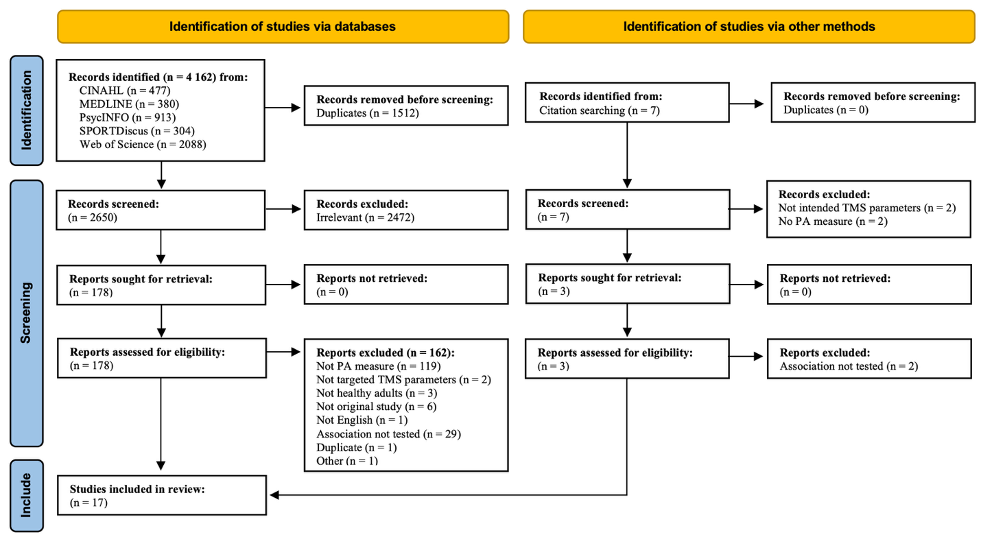Figure 1. PRISMA ﬂow diagram of study selection

Descriptive Results
Participants
The 17 articles included in the systematic review comprised 632 participants aged 19-78 years (334 males and 298 females), all of whom were healthy adults. Ten studies included only young adults (10, 11, 28, 32, 34–36, 38–40), two included only older adults (29, 30), four included both young and older adults (26, 31, 33, 37), and one study included young and middle-aged adults (27).

Physical Activity
Four studies assessed physical activity using triaxial accelerometers (30, 31, 33, 40), which were worn at the waist (ActiGraph GT3X) (31, 33, 40) or the wrist (ActivInsights GENEActiv) (30) (Table 1). Thirteen studies assessed physical activity using self-reported measures. Nine of these used the International Physical Activity Questionnaire (10, 11, 28, 32, 34, 35, 37–39). Other self-report instruments were the Leisure Time Exercise Questionnaire (26), the Physical Activity Questionnaire (36), and ad-hoc questionnaires (27, 29).
Physical activity outcomes included questionnaire scores from a questionnaire (26), MET-min/week (10, 11, 28, 32, 34, 35, 37–39), steps per day (31, 33, 40), and active time per week (27, 29, 30, 36).

Neurophysiological Parameters
Fourteen studies assessed TMS parameters in upper-extremity muscles (10, 11, 26, 27, 29, 30, 32–38, 40). Two studies examined both upper- and lower-extremity muscles (28, 39), and one examined only lower-extremity muscles (31).
CSE was assessed in thirteen studies (10, 11, 29–36, 38–40). SICI was assessed in eight studies, using an interstimulus interval (ISI) of 2 ms (10, 11, 28, 32, 35, 36, 40) or 2.5 ms (34). LICI was assessed in one study using an ISI of 100 ms (40). cSP was assessed in two studies (10, 29) and iSP in two studies (26, 27). ICF was assessed in seven studies, with ISI of 10 ms in four studies (11, 28, 35, 36) and 12 ms in three studies (34, 37, 40). SICF was assessed in three studies using ISIs of 1.2 ms (11), 1.5 ms (28, 35), and 2.5 ms (11).

Association Between Physical Activity and Neurophysiological Parameters
Two authors provided correlation coefficients for CSE (29, 30) and one for cSP (29). Ten authors provided raw data for CSE (11, 31–36, 38–40), six for SICI (11, 32, 34–36, 40), one for LICI (40), six for ICF (11, 34–37, 40), and two for and SICF (11, 35). In four studies, correlation coefficients were computed from p values or t-statistics) and sample sizes for SICI (10, 28), ICF (28); SICF (28), cSP (10), and iSP (26, 27).
Overall, the meta-analysis included 15 Pearson’s r correlation coefficients for CSE derived from 12 studies (11, 29–36, 38–40), nine for SICI from eight studies (10, 11, 28, 32, 34–36, 40), eight for ICF from seven studies (11, 28, 34–37, 40), five for SICF from three studies (11, 28, 35), two for iSP (26, 27) and two for cSP (10, 29) (Table 1).

Table 1. Characteristics of included studies and correlations between physical activity and neurophysiological measures derived from transcranial magnetic stimulation.
Study (Year) | N (% female) | Mean ± SD | Muscle | PA tool (measure) | PA outcome (Mean±SD) | TMS measure (ISI) | r | p | Quality Score
Cirillo (2009) | 28 (46) | 24.4 | FDI | IPAQ  (MET-min/wk) | Active: 5572±2075  Inactive: 491±308 | CSE  SICI (2)  cSP | 0.26  0.08  0.16 | 0.16  0.65  0.38 | 12
McGregor (2011) | 24 (53)  12 (45) | 69  24.3 | FDI | GLTEQ  (score) | Active:124.5±83  Inactive:52.4±47  67.58±33.6 | iSP  iSP | 0.44  n.a. | 0.03 | 14
McGregor (2013) | 38 (57)  21 (55) | 52.1  22.1 | FDI | Ad-hoc questionnaire  (min/week) | 76.0±33.4  64.7±32.5 | iSP  iSP | 0.48  n.a. | 0.002 | 16
Hassanlouei (2017) | 24 (50)  38 (45) | 22.4±2.2  70.2±6.1 | VL | Waist Accelerometer  (steps/day) | Active: 12326±815  Inactive: 7133±494  Active: 13565±1174  Inactive: 6381±402 | CSE  CSE | -0.18  0.02 | 0.39  0.9 | 13
Lulic (2017) | 28 (60) | 21±1.5 | FDI | IPAQ  (MET-min/wk) | High: 7631±6120  Low:1305±773 | CSE  SICI (2)  SICF (1.2)  SICF (2.5)  ICF (10) | 0.12  -0.14  0.37  -0.15  0.009 | 0.54  0.51  0.06  0.48  0.96 | 13
Houde (2018) | 26 (50) | 70 | FDI | As-hoc questionnaire  (session/wk) | ≥1: Active  <1: Inactive | CSE  cSP | 0.225  0.124 | ˃0.05  ˃0.05 | 13
El-Sayes (2019) | 34 (50) | 21±2 | FDI | IPAQ  (MET-min/wk) | 3577±1893 | CSE  SICI (2) | -0.24  0.08 | 0.17  0.65 | 13
Rozand (2019) | 27 (48)  28 (50) | 72  24 | FDI | Waist Accelerometer  (steps/day) | Active: ≥10,000  Inactive: ˂10,000 | CSE  CSE | -0.08  0.28 | 0.69  0.14 | 12
Hand (2022a) | 33 (24) | 32 | FDI  TA | IPAQ  (MET-min/wk) | Active: 6488  Inactive:1209 | SICI (2)  SICF (1.5)  ICF (10)  SICI (2)  SICF (1.5)  ICF (10) | -0.22  0.22  0.02  0.09  0.09  0.18 | 0.2  0.2  0.9  0.6  0.6  0.3 | 11
Hu (2021) | 29 (100) | 19.3±0.6 | APB | IPAQ  (MET-min/wk | Exercise: 1655±1136  Control: 1111±930 | CSE  SICI (2.5)  ICF (12) | -0.12  0.27  0.11 | 0.53  0.15  0.57 | 15
Smith (2021) | 34 (44) | 66.9 | FDI | Wrist Accelerometer (h/wk) | 6.3±0.7 | CSE | 0.185 | 0.29 | 18
Hand (2022b) | 28 (25) | 23 | FDI | IPAQ  (MET-min/wk) | Active: 5850  Inactive:1139 | CSE  SICI (2)  SICF (1.5)  ICF (10) | -0.1  0.21  -0.14  0.3 | 0.61  0.28  0.47  0.12 | 14
Curtin (2023) | 20 (70)  18 (55) | 25.3  64.1 | FDI  FDI | IPAQ  (MET-min/wk) | 5024±4831  5683±3780 | ICF | -0.18  -0.39 |  | 16
Wang (2023) | 40 (35) | 25 | FDI | PAQ  (h/wk) | High: 11.6±6.2  Low: 0.4±0.6 | CSE  SICI (2)  ICF (10) | 0.16  0.13  0.13 | 0.32  0.42  0.42 | 12
Ross (2024) | 16 (88) | 27.2 | APB | IPAQ  (MET-min/wk) | 6663±5611 | CSE | -0.02 | 0.94 | 16
Hougland (2025) | 15 (65)  16 (65) | 27  27 | FDI  VL | IPAQ  (MET-min/wk) | 5237 (4028) | CSE  CSE | 0.4  -0.6 | 0.13  0.01 | 12
Farajzadeh (2026) | 55 (64) | 32.3 | FDI | Waist Accelerometer  (steps/day) | 7029 | CSE  SICI (2)  LICI (100)  ICF (12) | -0.15  0.05  -0.04  -0.047 | 0.29  0.71  0.29  0.76 | 13
Notes. CSE = corticospinal excitability; cSP = cortical silent period, ICF = intracortical facilitation; IPAQ = International Physical Activity Questionnaire; iSP = ipsilateral silent period; ISI: interstimulus interval; LICI = long intracortical inhibition; LTEQ = Leisure Time Exercise Questionnaire; N = sample size; n.a. = not available; PA = Physical Activity; PAQ = Physical Activity Questionnaire; r = Pearson’s correlation coefﬁcient; SICF = short intracortical Facilitation; SICI = short intracortical Inhibition

Meta-Analysis
Corticospinal Excitability
A total of 15 correlation estimates from 14 studies (435 participants) were included in the meta-analysis examining the association between physical activity and corticospinal excitability. The multilevel random-effects meta-analysis indicated no significant association between physical activity and corticospinal excitability (r = −0.01, 95% CI [−0.12, 0.11], p = 0.91) (Fig. 2). The prediction interval ranged from −0.21 to 0.19, indicating that future studies would be expected to observe correlations ranging from small negative to small positive values. Between-study heterogeneity was low (total I² = 13.3%), indicating little variability in the observed correlations beyond sampling error. Variance decomposition showed that this small amount of heterogeneity occurred almost entirely between effect sizes within studies, whereas heterogeneity between studies was negligible.
To further evaluate whether the association could be considered practically negligible, an equivalence test was conducted using equivalence bounds corresponding to a small effect size (−0.10 to 0.10). The equivalence test was significant (Z = 1.72, p = 0.043), and the 90% confidence interval (−0.096 to 0.084) fell entirely within the predefined equivalence bounds, supporting the conclusion that the association between physical activity and corticospinal excitability is negligible.

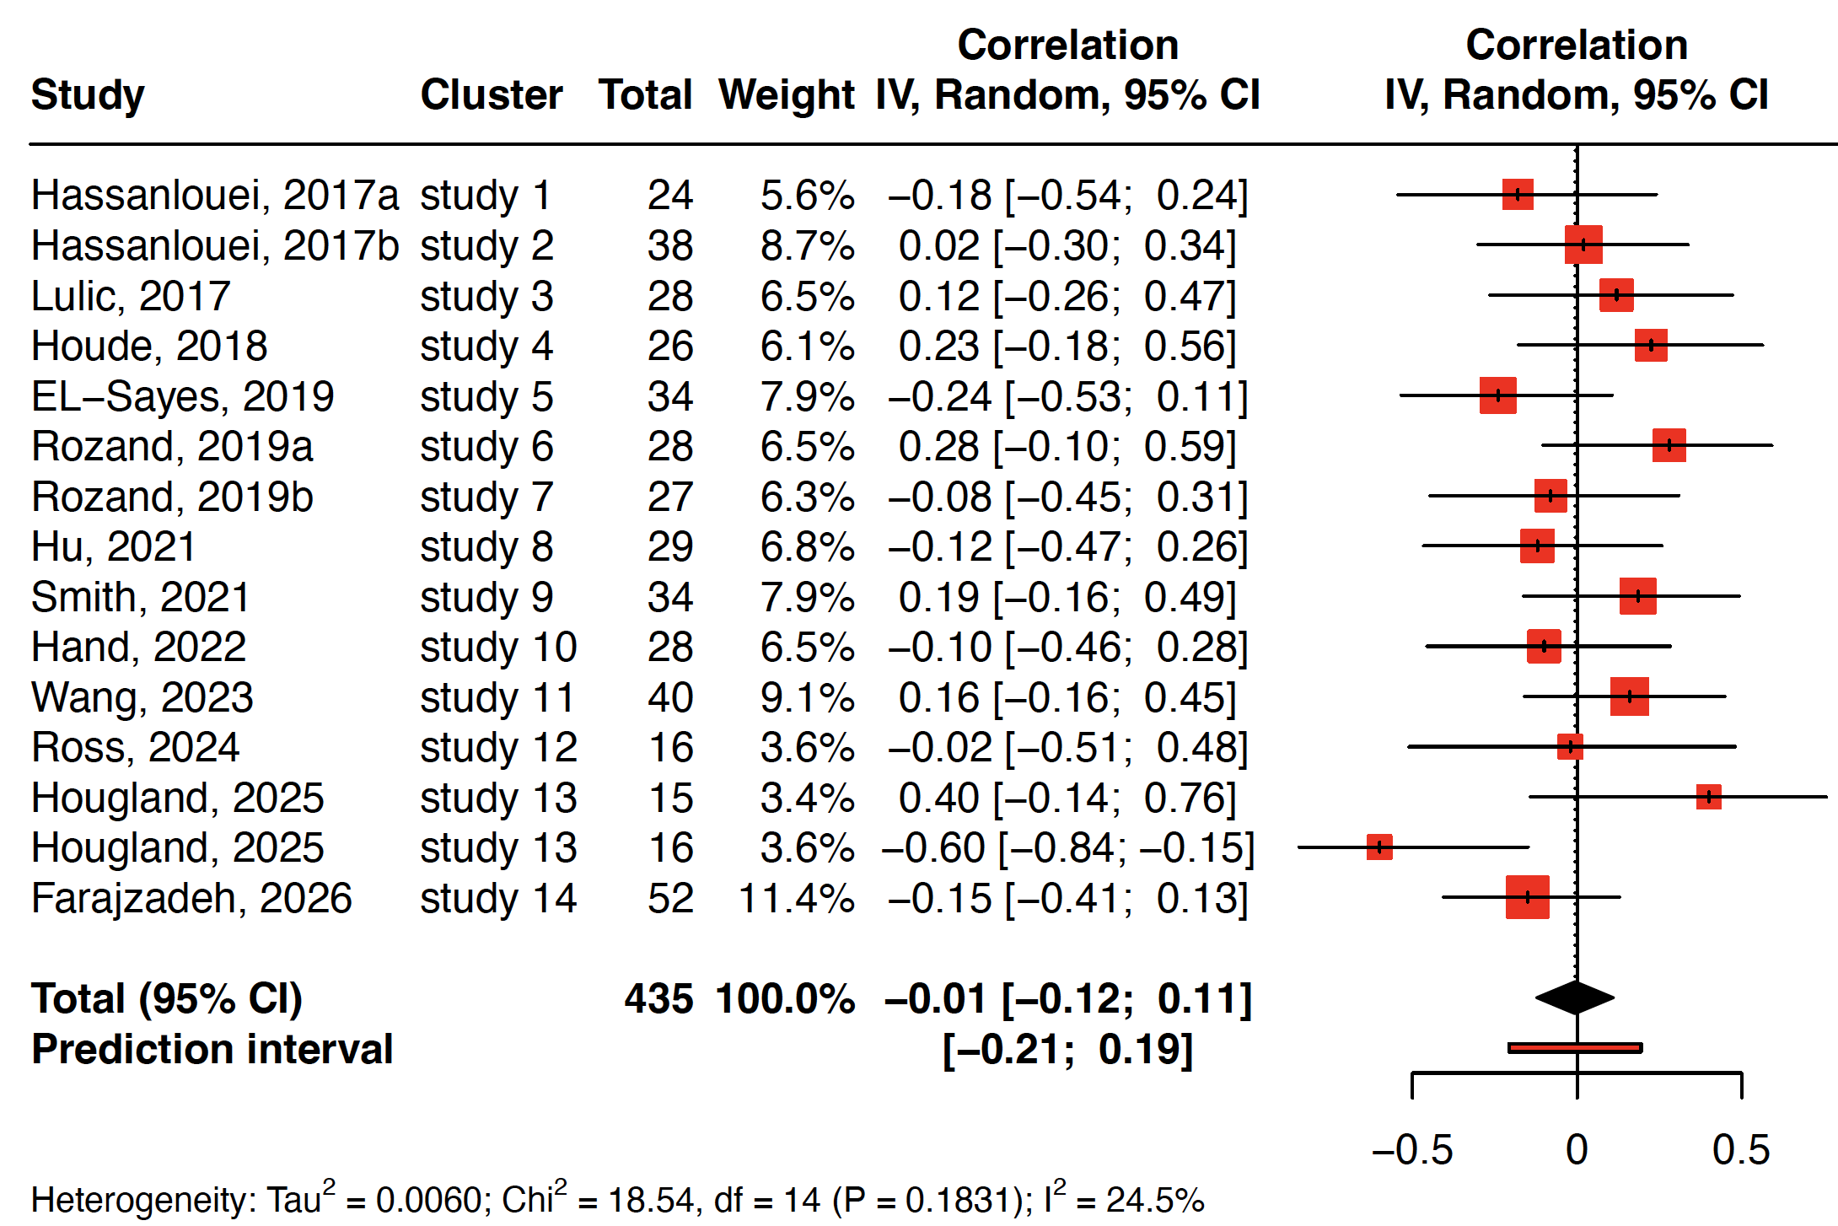

Figure 2. Forest plot of the association between physical activity and corticospinal excitability. Notes: IV = inverse variance, CI = confidence interval.

Cortical Inhibition
A total of 14 correlation estimates from 11 studies (451 participants) were included in the meta-analysis examining the association between habitual physical activity and measures of cortical inhibition. The multilevel random-effects meta-analysis indicated a significant positive association between physical activity and cortical inhibition (r = 0.16, 95% CI [0.04, 0.28], p = 0.012). This effect corresponds to a small positive correlation, suggesting that higher levels of physical activity are associated with greater cortical inhibitory activity. The prediction interval ranged from −0.05 to 0.36, indicating that although the overall association was positive, future studies could observe effects ranging from negligible to moderately positive.
Between-study heterogeneity was low, with a total I² of 16.18%, indicating that most of the variability in observed correlations was attributable to sampling error. Variance decomposition showed that 16.18% of the variability occurred between studies, while no meaningful heterogeneity was observed between effect sizes within studies.
Subgroup analyses examining differences across inhibitory mechanisms (SICI, LICI, cSP, and iSP) revealed no statistically significant differences between modulation types (Q = 2.95, df = 3, p = 0.085) (Fig. 3). Nevertheless, point estimates suggested that the association was strongest for interhemispheric inhibition (iSP) (r = 0.47) and smaller for SICI (r = 0.12) and cSP (r = 0.14), while the estimate for LICI was close to zero.

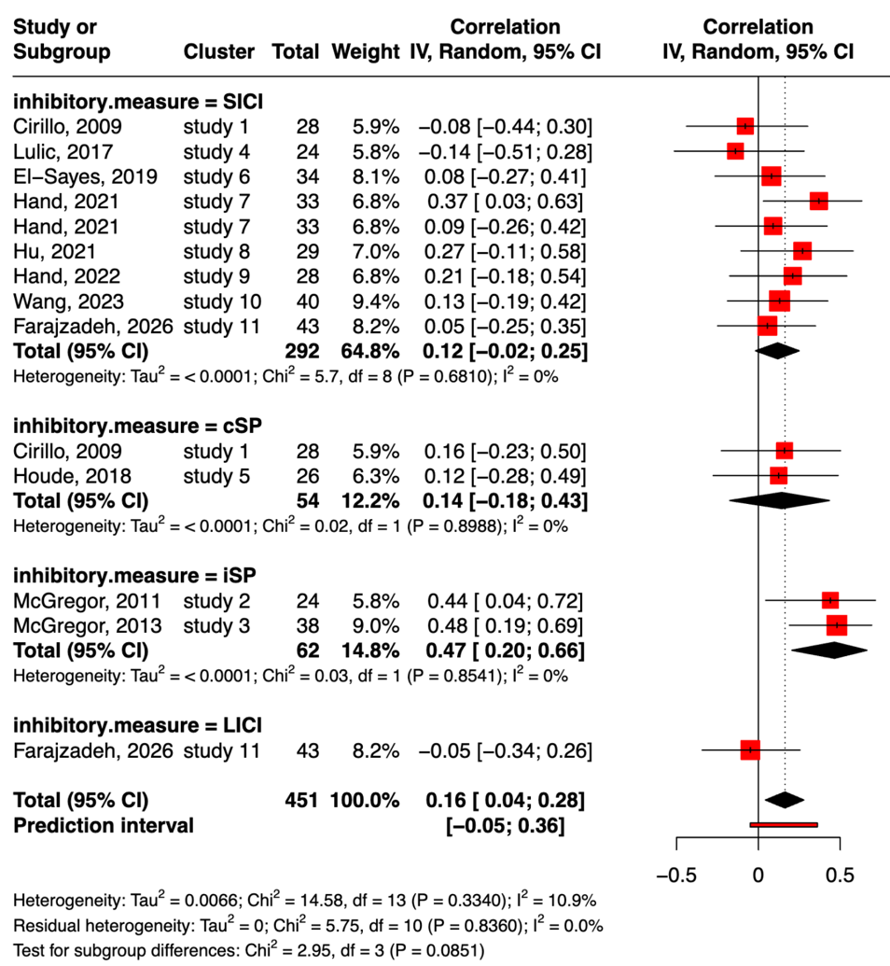

Figure 3. Forest plot of the association between habitual physical activity and TMS measures of cortical inhibition. Notes: SICI = short-interval intracortical inhibition, LICI = long-interval intracortical inhibition, cSP = cortical silent period, iSP = ipsilateral silent period, IV = inverse variance, CI = confidence interval.

Intracortical Facilitation
A total of 14 correlation estimates from 8 studies (412 participants) were included in the meta-analysis examining the association between habitual physical activity and TMS measures of cortical facilitation. The multilevel random-effects meta-analysis indicated no statistically significant association between physical activity and cortical facilitation (r = 0.07, 95% CI [−0.04, 0.18], p = 0.22). The prediction interval ranged from −0.04 to 0.18, indicating that future studies would be expected to observe correlations ranging from slightly negative to small positive values.
No meaningful heterogeneity was observed across studies (I² = 0%), indicating that variability in the observed correlations was entirely attributable to sampling error. Variance decomposition confirmed that neither between-study nor within-study variance components contributed meaningfully to heterogeneity.
The equivalence test was not significant (Z = −0.63, p = 0.26), and the 90% confidence interval (−0.018 to 0.153) extended beyond the predefined equivalence bounds. Thus, equivalence could not be concluded.
Subgroup analyses comparing facilitatory measures (ICF vs. SICF) showed no significant difference between measure types (Q = 0.00, df = 1, p = 0.97) (Fig. 4). Point estimates were similar for ICF (r = 0.07) and SICF (r = 0.06).
Taken together, these results suggest that the current evidence is inconclusive regarding whether the association between habitual physical activity and cortical facilitation is negligible or small.
`
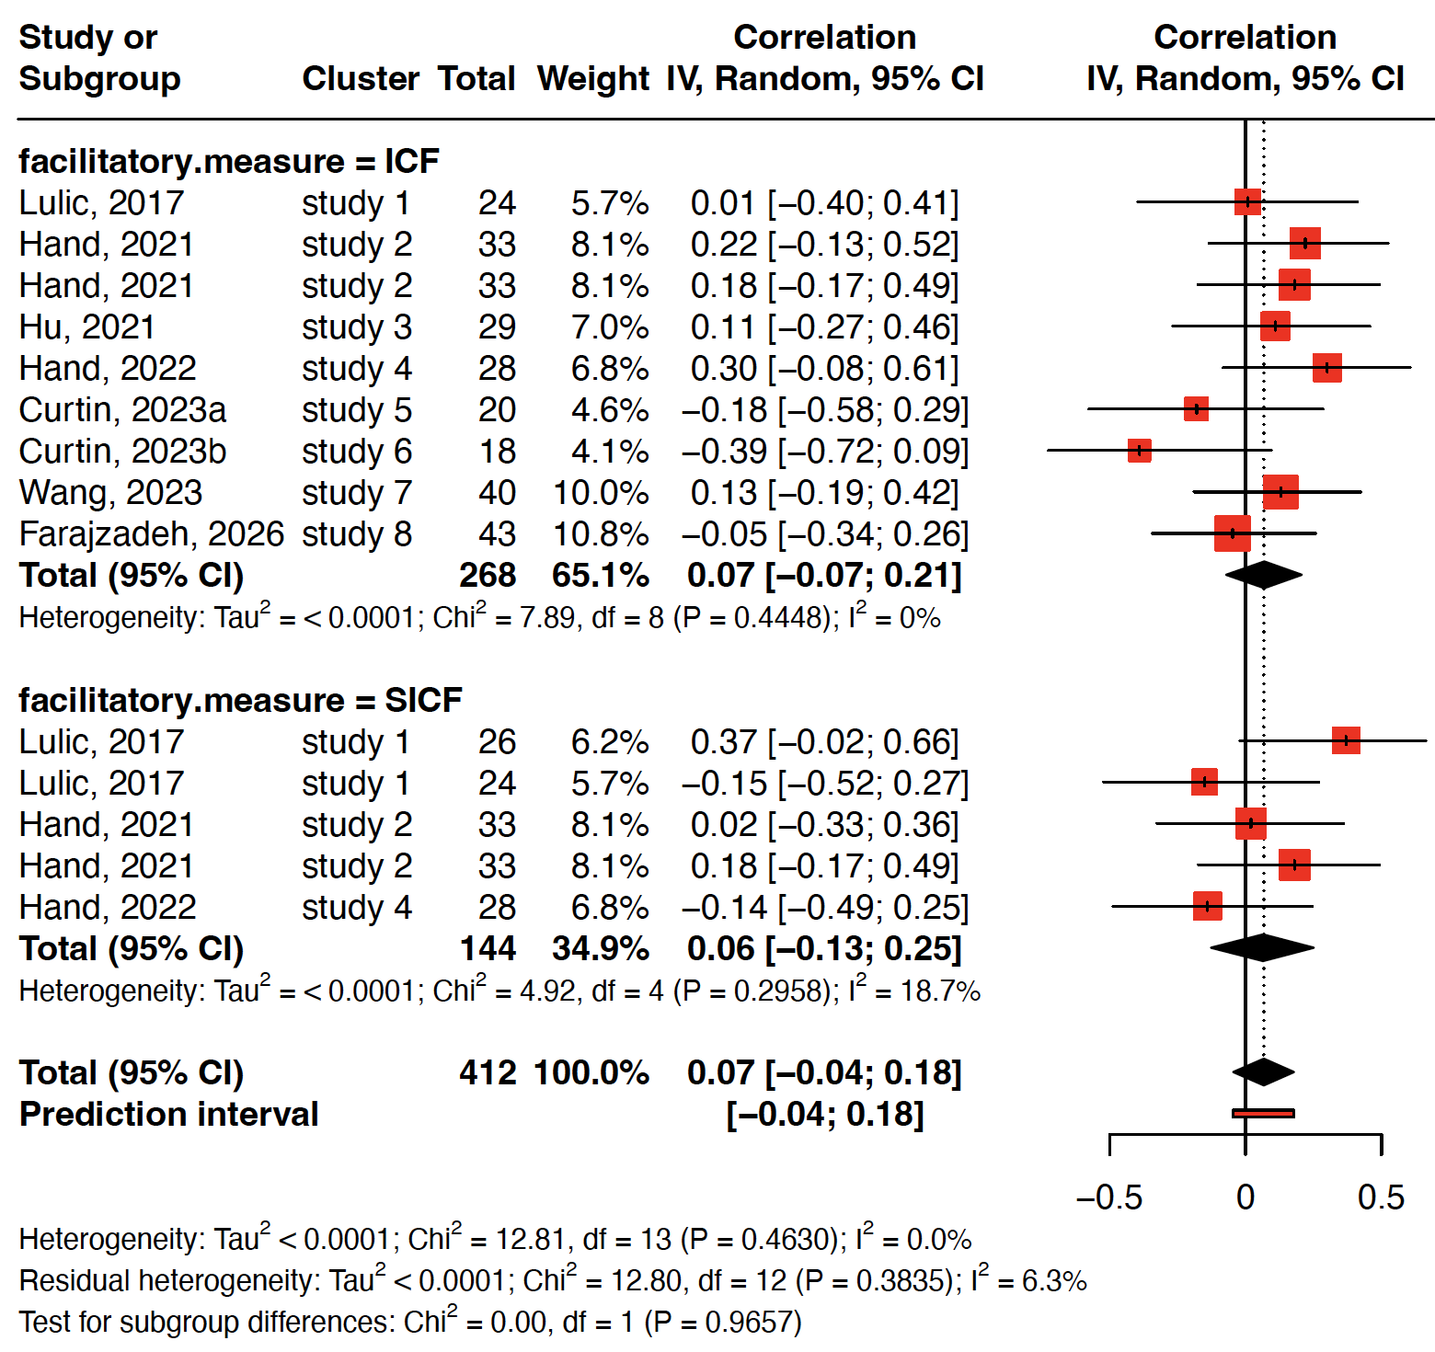

Figure 4. Forest plot of the association between habitual physical activity and transcranial magnetic stimulation measures of intracortical facilitation. Notes: ICF = intracortical facilitation, SICF = short-interval intracortical facilitation, IV = inverse variance, CI = confidence interval.

Meta-Regressions
Meta-regression analyses indicated that the association between physical activity and TMS measures was not significantly moderated by the proportion of women, mean participant age, or study quality (all p ≥ 0.096).

Publication Bias
Potential publication bias and small-study effects were assessed using contour-enhanced funnel plots and Egger’s regression tests. Visual inspection of the funnel plots for corticospinal excitability, cortical inhibition, and cortical facilitation did not reveal substantial asymmetry around the pooled effect sizes.
Egger’s regression tests conducted using the meta-regression approach were not statistically significant for any of the meta-analyses. The regression coefficient for the standard error was not significant for corticospinal excitability (p = 0.86), cortical inhibition (p = 0.93), or cortical facilitation (p = 0.16). These results indicate that smaller studies did not systematically report larger effect sizes.
Taken together, these results did not suggest the presence of publication bias or small-study effects in the included studies.

DISCUSSION

DATA AVAILABILITY

GRANTS

DISCLOSURES
No conﬂicts of interest, ﬁnancial, or otherwise, are declared by the authors.

AUTHOR CONTRIBUTIONS

REFERENCES
- Strick PL, Dum RP, Rathelot JA. The cortical motor areas and the emergence of motor skills: a neuroanatomical perspective. Annu Rev Neurosci 44: 425–447, 2021. doi:10.1146/annurev-neuro-070918-050216.
- Derosiere G, Duque J. Tuning the corticospinal system: how distributed brain circuits shape human actions. Neuroscientist 26: 359–379, 2020. doi:10.1177/1073858419896751.
- Pascual-Leone A, Amedi A, Fregni F, Merabet LB. The plastic human brain cortex. Annu Rev Neurosci 28: 377–401, 2005. doi:10.1146/annurev.neuro.27.070203.144216.
- Bull FC, Al-Ansari SS, Biddle S, Borodulin K, Buman MP, Cardon G, Carty C, Chaput JP, Chastin S, Chou R, Dempsey PC, DiPietro L, Ekelund U, Firth J, Friedenreich CM, Garcia L, Gichu M, Jago R, Katzmarzyk PT, Lambert E, Leitzmann M, Milton K, Ortega FB, Ranasinghe C, Stamatakis E, Tiedemann A, Troiano RP, van der Ploeg HP, Wari V, Willumsen JF. World Health Organization 2020 guidelines on physical activity and sedentary behaviour. Br J Sports Med 54: 1451–1462, 2020. doi:10.1136/bjsports-2020-102955.
- Mellow ML, Goldsworthy MR, Coussens S, Smith AE. Acute aerobic exercise and neuroplasticity of the motor cortex: a systematic review. J Sci Med Sport 23: 408–414, 2020. doi:10.1016/j.jsams.2019.10.015.
- Youssef L, Harroum N, Francisco BA, Johnson L, Arvisais D, Pageaux B, Romain AJ, Hayward KS, Neva JL. Neurophysiological effects of acute aerobic exercise in young adults: a systematic review and meta-analysis. Neurosci Biobehav Rev 164: 105811, 2024. doi: 10.1016/j.neubiorev.2024.105811.
- Rasmussen P, Brassard P, Adser H, Pedersen MV, Leick L, Hart E, Secher NH, Pedersen BK, Pilegaard H. Evidence for a release of brain-derived neurotrophic factor from the brain during exercise. Exp Physiol 94: 1062–1069, 2009. doi:10.1113/expphysiol.2009.048512.
- Skriver K, Roig M, Lundbye-Jensen J, Pingel J, Helge JW, Kiens B, Nielsen JB. Acute exercise improves motor memory: exploring potential biomarkers. Neurobiol Learn Mem 116: 46–58, 2014. doi:10.1016/j.nlm.2014.08.004.
- El-Sayes J, Harasym D, Turco CV, Locke MB, Nelson AJ. Exercise-induced neuroplasticity: a mechanistic model and prospects for promoting plasticity. Neuroscientist 25: 65–85, 2019. doi:10.1177/1073858418771538.
- Cirillo J, Lavender AP, Ridding MC, Semmler JG. Motor cortex plasticity induced by paired associative stimulation is enhanced in physically active individuals. J Physiol 587: 5831–5842, 2009. doi:10.1113/jphysiol.2009.181834.
- Lulic T, El-Sayes J, Fassett HJ, Nelson AJ. Physical activity levels determine exercise-induced changes in brain excitability. PLoS One 12: e0173672, 2017. doi:10.1371/journal.pone.0173672.
- Kujirai T, Caramia MD, Rothwell JC, Day BL, Thompson PD, Ferbert A, Wroe S, Asselman P, Marsden CD. Corticocortical inhibition in human motor cortex. J Physiol 471: 501–519, 1993. doi:10.1113/jphysiol.1993.sp019912.
- Ziemann U, Rothwell JC, Ridding MC. Interaction between intracortical inhibition and facilitation in human motor cortex. J Physiol 496: 873–881, 1996. doi:10.1113/jphysiol.1996.sp021734.
- Hupfeld KE, Swanson CW, Fling BW, Seidler RD. TMS-induced silent periods: A review of methods and call for consistency. J Neurosci Methods 346: 108950, 2020. doi:10.1016/j.jneumeth.2020.108950.
- Page MJ, Moher D, Bossuyt PM, Boutron I, Hoffmann TC, Mulrow CD, Shamseer L, Tetzlaff JM, Akl EA, Brennan SE, Chou R, Glanville J, Grimshaw JM, Hróbjartsson A, Lalu MM, Li T, Loder EW, Mayo-Wilson E, McDonald S, McGuinness LA, Stewart LA, Thomas J, Tricco AC, Welch VA, Whiting P, McKenzie JE. PRISMA 2020 explanation and elaboration: updated guidance and exemplars for reporting systematic reviews. BMJ 372: n160, 2021. doi:10.1136/bmj.n160.
- Downs SH, Black N. The feasibility of creating a checklist for the assessment of the methodological quality both of randomised and non-randomised studies of health care interventions. J Epidemiol Community Health 52: 377–384, 1998. doi:10.1136/jech.52.6.377.
- R Core Team. R: a language and environment for statistical computing. R Foundation for Statistical Computing. Version 4.4.1 (software), 2024. R-project.org.
- Viechtbauer W. metafor: meta-analysis package for R. Version 4.6-0 (R package), 2023. Available from: https://cran.r-project.org/web/packages/metafor/metafor.pdf.
- Schwarzer G. meta: general package for meta-analysis. Version 8.1-0 (R package), 2023. cran.r-project.org/web/packages/meta.
- Viechtbauer W. Bias and efficiency of meta-analytic variance estimators in the random-effects model. J Educ Behav Stat 30: 261–293, 2005. doi:10.3102/10769986030003261.
- Higgins JPT, Thompson SG. Quantifying heterogeneity in a meta-analysis. Stat Med 21: 1539–1558, 2022. doi:10.1002/sim.1186.
- Knapp G, Hartung J. Improved tests for a random effects meta-regression with a single covariate. Stat Med 22: 2693–2710, 2003. doi:10.1002/sim.1482.
- Egger M, Davey Smith G, Schneider M, Minder C. Bias in meta-analysis detected by a simple, graphical test. BMJ 315: 629–634, 1997. doi:10.1136/bmj.315.7109.62.
- Lakens D, Caldwell A. TOSTER: Two One-Sided Tests (TOST) equivalence testing. Version 0.8.4 (R package), 2025. cran.r-project.org/web/packages/TOSTER.
- Lakens D. Equivalence tests: a practical primer for t tests, correlations, and meta-analyses. Soc Psychol Personal Sci 8: 355–362, 2017. doi:10.1177/1948550617697177.
- McGregor KM, Zlatar Z, Kleim E, Sudhyadhom A, Bauer A, Phan S, Seeds L, Ford A, Manini TM, White KD, Kleim J, Crosson B. Physical activity and neural correlates of aging: a combined TMS/fMRI study. Behav Brain Res 222: 158–168, 2011. doi:10.1016/j.bbr.2011.03.042.
- McGregor KM, Nocera JR, Sudhyadhom A, Patten C, Manini TM, Kleim JA, Crosson B, Butler AJ. Effects of aerobic fitness on aging-related changes of interhemispheric inhibition and motor performance. Front Aging Neurosci 5: 66, 2013. doi:10.3389/fnagi.2013.00066.
- Hand BJ, Opie GM, Sidhu SK, Semmler JG. Motor cortex plasticity and visuomotor skill learning in upper and lower limbs of endurance-trained cyclists. Eur J Appl Physiol 122: 169–184, 2022a. doi:10.1007/s00421-021-04825-y.
- Houde F, Laroche S, Thivierge V, Martel M, Harvey MP, Daigle F, Olivares-Marchant A, Beaulieu LD, Leonard G. Transcranial magnetic stimulation measures in the elderly: reliability, smallest detectable change and the potential influence of lifestyle habits. Front Aging Neurosci 10: 379, 2018. doi:10.3389/fnagi.2018.00379.
- Smith AE, Dumuid D, Goldsworthy MR, Graetz L, Hodyl N, Thornton NLR, Ridding MC. Daily activities are associated with non-invasive measures of neuroplasticity in older adults. Clin Neurophysiol 132: 984–992, 2021. doi:10.1016/j.clinph.2021.01.016.
- Hassanlouei H, Sundberg CW, Smith AE, Kuplic A, Hunter SK. Physical activity modulates corticospinal excitability of the lower limb in young and old adults. J Appl Physiol 123: 364–374, 2017. doi:10.1152/japplphysiol.01078.2016.
- El-Sayes J, Turco CV, Skelly LE, Nicolini C, Fahnestock M, Gibala MJ, Nelson AJ. The effects of biological sex and ovarian hormones on exercise-induced neuroplasticity. Neuroscience 410: 29–40, 2019. doi:10.1016/j.neuroscience.2019.04.054.
- Rozand V, Senefeld JW, Sundberg CW, Smith AE, Hunter SK. Differential effects of aging and physical activity on corticospinal excitability of upper and lower limb muscles. J Neurophysiol 122: 241–250, 2019. doi:10.1152/jn.00077.2019.
- Hu M, Zeng N, Gu Z, Zheng Y, Xu K, Xue L, Leng L, Lu X, Shen Y, Huang J. Short-term high-intensity interval exercise promotes motor cortex plasticity and executive function in sedentary females. Front Hum Neurosci 15: 620958, 2021. doi:10.3389/fnhum.2021.620958.
- Hand BJ, Opie GM, Sidhu SK, Semmler JG. Motor cortex plasticity is greater in endurance-trained cyclists following acute exercise. J Appl Physiol 133: 932–944, 2022b. doi:10.1152/japplphysiol.00213.2022.
- Wang YR, Lefebvre G, Picard M, Lamoureux-Andrichuk A, Ferland MC, Therrien-Blanchet JM, Boré A, Tremblay J, Descoteaux M, Champoux F, Théoret H. Physiological, anatomical and metabolic correlates of aerobic fitness in human primary motor cortex: a multimodal study. Neuroscience 517: 70–83, 2023. doi:10.1016/j.neuroscience.2023.03.007.
- Curtin D, Cadwallader CJ, Taylor EM, Andrews SC, Stout JC, Hendrikse JJ, Chong TT, Coxon JP. Ageing attenuates exercise-enhanced motor cortical plasticity. J Physiol 601: 5733–5750, 2023. doi:10.1113/JP285243.
- Ross RE, Saladin ME, George MS, Gregory CM. Acute effects of aerobic exercise on corticomotor plasticity in individuals with and without depression. J Psychiatr Res 176: 108–118, 2024. doi:10.1016/j.jpsychires.2024.06.002.
- Hougland JR, Proessl F, Meglino N, Canino MC, Sterczala AJ, Connaboy C, Nindl BC, Flanagan SD. Agreement and consistency of absolute and relative corticospinal stimulus-response curves for upper, lower, and axial musculature in healthy adults. J Clin Neurophysiol 42: 264–271, 2025. doi:10.1097/WNP.0000000000001109.
- Farajzadeh, 2026.

