Game Design Document

Fill up the following document

1. Write the title of your project.

“Warrior Rumble”

1. What is the goal of the game?

The goal of the game is to defeat the various waves of enemy warriors that spawn.

1. Write a brief story of your game.

The story involves the invasion of Playing Character’s Kingdom’s

invasion. He has to defeat the enemies alone, or with his allies.

1. Which are the playing characters of this game?

* Playing characters are the ones who respond to the user based on the input from the user.
* Cars, monkeys, dinos, wizards, etc., are the playing characters in the game.

|  |  |  |
| --- | --- | --- |
| Number | Character Name | What can this character do? |
| 1 | Le Achmos | The Warrior Hero, he has to defeat the enemy kingdom. |
| 2 | Bos Dieto | Achmos’ ally(Warrior) |
| 3 | Di Kaspet | Another ally(Warrior) |
| 4 |  |  |
| 5 |  |  |
| 6 |  |  |
| 7 |  |  |
| 8 |  |  |

1. Which are the Non-Playing Characters of this game?

* Non-Playing characters are the ones that don't have an action or behavior when the user interacts with the game.
* Hurdles, stones, bananas, coins, etc., are non-playing characters in the game.

|  |  |  |
| --- | --- | --- |
| Number | Character Name | What can this character do? |
| 1 | Footsoldiers | Constitute the first wave of enemies. |
| 2 | Ranked Warriors | Constitute the second wave of enemies. |
| 3 | Evil Sorcerers | Constitute the third wave. |
| 4 | The brawny King | The final boss-enemy |
| 5 |  |  |
| 6 |  |  |
| 7 |  |  |
| 8 |  |  |

Draw your imagination of this game. What does this game look like?

* Draw the game either on your computer or on paper.
* Add images of the game scenes to show each of the playing and non-playing characters at least once.

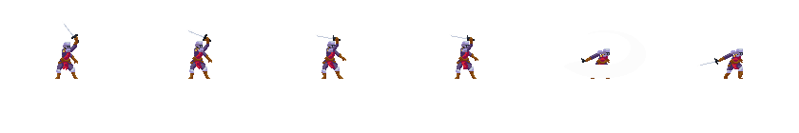

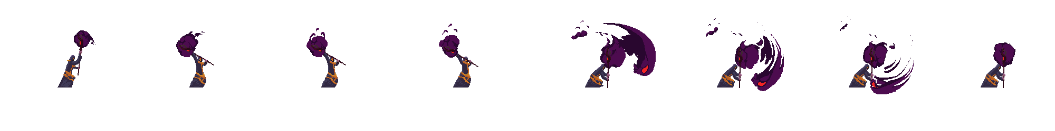

How do you plan to make your game engaging?

The game will be engaging with extensive use of Animations, Sound Fx and appealing Storyline. The challenge of defeating each wave, that grows stronger as the game proceeds, will create an element of difficulty, that will be perfect for people to play it.