PRN232 Assignment 01 - Building ASP.NET Core Web API and Web Application

1. Introduction
A News Management System (NMS) is a software application that helps universities and educational institutions to efficiently manage, organize, and publish news and content to their website and other channels. The NMS typically includes features such as content creation, approval workflow, scheduling, publishing, and analytics. This can help universities to arrange appropriately their news operations, improve communication with students and the wider community, and better engage with their target audience.
Imagine you're a developer of a News Management System named FUNewsManagementSystem. To implement a part of this system your tasks include:
- Manage account information.
- Manage news article.
The application has a default account (admin account) whose email is “admin@FUNewsManagementSystem.org” and password is “@@abc123@@” that stored in the appsettings.json.
The application has to support adding, viewing, modifying, and removing information - a
standardized usage action verb better known as Create, Read, Update, Delete (CRUD) and Search.
This assignment explores creating an ASP.NET Core Web API OData with C# and Entity Framework Core, the client application can be used as Web Application (ASP.NET Core
Web MVC or Razor Pages). An MS SQL Server database will be
created to persist the data and it will be used for reading and managing data.

2. Assignment Objectives
In this assignment, you will:
- Use the Visual Studio.NET to create a Web application and ASP.NET Core Web API
project (with OData support).
- Perform CRUD actions using Entity Framework Core.
- Apply 3-layers architecture to develop the application.
- Apply Repository pattern and Singleton pattern in a project.
- Add CRUD and searching actions to the Client application with ASP.NET Core Web API.
- Apply to validate data type for all fields.
- Run the project and test the actions of the Client Web app and ASP.NET Core Web API

3. Database Design
A part of News Management Database:

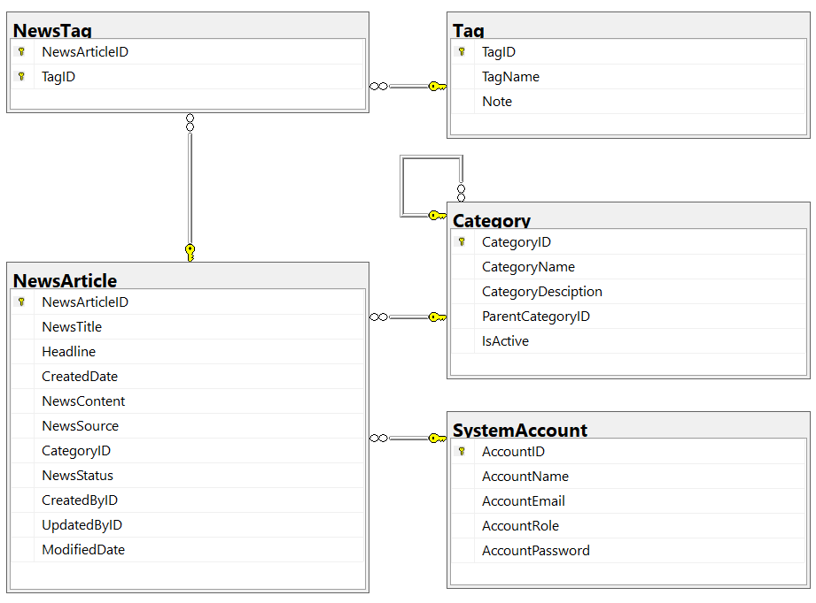
- A news article will belong to only one news category (Category).
- An account with staff’s role can create many news articles in this system. (Staff role = 1, Lecturer role = 2; Admin role will get from appsettings.json file).
- A news article will have many tags and one tag will belong to zero or one news article (News status = active(1)/inactive(0)).
- Category status = active(1)/inactive(0).

4. Main Functions
- Do not need authentication to view the news article (news status must be active) in this system.
- Member (Admin/Staff) authentication by Email and Password.
- Create Web API:
  - “Admin” role: Account management (CRUD, the delete action will delete an account in the case this account is not belong to any news articles (created), if the account is already created any news article, cannot delete.)
  - “Staff” role:
    - Category management (The delete action will delete an item in the case this item is not belong to any news articles. If the item is already stored in a news article cannot delete.)
    - , and News article management (Read, Create, Update and Delete actions).
- Create Client application (with Desktop/Web application) interactive with Web API to
perform these functions:
  - If the user is an “Admin” then his/her is allowed
    - Manage account information.
    - Create a report statistic by the period from StartDate to EndDate (it depends to the news’ created date), and sort data in descending order.
  - If user is a “Staff”, this staff role is allowed to:
    - Manage category information.
    - Manage news article (includes tags)
    - Manage his/her the profile.
    - View news history created by him/her.
  - Note that: News article Management, Account Management, and Category Management: Read, Create, Update, Delete and Search actions. Creating and Updating actions must be performed by popup dialog. Delete action always combines with confirmation.

5. Note
- You must use Visual Studio 2019 or above (.NET8), MSSQL Server 2012 or above for your development tools.
- To do your BE program, you must use ASP.NET Core Web API. Note that you are not allow to connect direct to database from API Controller, every database connection must be used through Repository and Data Access Objects. The database connection string must get from appsettings.json file.
- Create 2 Solutions in Visual Studio named NguyenTrongThu_SE1856_A01_BE.sln, StudentName_ClassCode_ A01_FE.sln.
Technical Requirements & Design Standards (PRN232)
1. Architecture & Project Structure
● Áp dụng kiến trúc 3-layer:
○ API Layer (Presentation – Controllers)
○ Service Layer (Business Logic)
○ Repository Layer (Data Access)
● Mỗi layer có trách nhiệm rõ ràng, không chồng chéo
● Controller không được chứa business logic
● Quy ước đặt tên project:
○ PRN232.[ProjectName].API
○ PRN232.[ProjectName].Services
○ PRN232.[ProjectName].Repo
2. Data Model Specification
● Bắt buộc sử dụng đúng 4 loại model:
○ Entity Model: dùng tại Repository, ánh xạ trực tiếp với DB
○ Business Model: dùng tại Service, xử lý nghiệp vụ
○ Request Model: dùng tại API để nhận dữ liệu từ client
○ Response Model: dùng tại API để trả dữ liệu cho client
● Không được trả Entity Model trực tiếp trong API response
● Không dùng Request/Response Model trong Service hoặc Repository
3. RESTful API Design & Naming Convention
● Thiết kế API theo chuẩn REST
● Endpoint theo hướng resource-based
● URL sử dụng danh từ số nhiều, không dùng động từ
● Ví dụ đúng: /api/products, /api/products/{id}
● Query string dùng cho:
○ Search
○ Filtering
○ Sorting
○ Paging
○ Field selection
● Tên query parameter:
○ Theo camelCase
○ Phản ánh rõ ý nghĩa nghiệp vụ
4. GET Resource by ID
● Trả về đầy đủ thông tin liên quan của resource
● Kiểm soát độ sâu dữ liệu:
○ Không gây circular reference
○ Không đệ quy vô hạn
● Nếu resource không tồn tại:
○ Trả 404 Not Found
○ Kèm message rõ ràng
5. GET Collection Resource (List API)
● Bắt buộc hỗ trợ:
○ Search
○ Filtering
○ Sorting
○ Paging
○ Field selection
● Response phải kèm metadata phân trang, bao gồm:
○ page
○ pageSize
○ totalItems
○ totalPages
6. Response Format & HTTP Status Codes
● Tất cả API phải trả response theo format thống nhất
● Response phải bao gồm:
○ success
○ message
○ data
○ errors
● Không trả raw object trực tiếp từ controller
● Sử dụng HTTP status code đúng ngữ nghĩa:
○ 200 – Success
○ 201 – Created
○ 400 – Bad Request
○ 401 – Unauthorized
○ 403 – Forbidden
○ 404 – Not Found
○ 500 – Internal Server Error
7. Authentication & Authorization
● Hệ thống phải có API authentication
● JWT (JSON Web Token) là bắt buộc
● Sau khi login:
○ Trả access token cho client
● Khi gọi API bảo vệ:
○ Gửi header Authorization: Bearer <token>
8. Validation & Exception Handling
● Validate dữ liệu đầu vào thông qua Request Model
● Khi validation fail:
○ Trả response lỗi theo format chuẩn
○ Message rõ ràng, dễ hiểu
● Xử lý exception bằng Global Exception Handler
● Không try–catch tràn lan trong controller
● Không expose stack trace hoặc thông tin nội bộ
9. Separation of Responsibilities
● Controller:
○ Nhận request
○ Validate input
○ Gọi service
○ Trả response
● Service:
○ Xử lý toàn bộ business logic
○ Mapping giữa các model
● Repository:
○ Truy xuất dữ liệu
○ Không chứa nghiệp vụ
10. Additional Requirements
● Sử dụng đúng HTTP method:
○ GET, POST, PUT, PATCH, DELETE
● Khuyến khích sử dụng Swagger / OpenAPI để:
○ Mô tả endpoint
○ Mô tả request/response
○ Liệt kê status code
● Không để lộ:
○ Entity Model
○ Cấu trúc DB
○ Chi tiết triển khai nội bộ
11. Evaluation Checklist
● Đúng kiến trúc 3-layer và naming project
● Sử dụng đúng 4 loại model
● RESTful endpoint và query string hợp lệ
● Có search, filter, sort, paging, selection
● GET LIST có pagination metadata
● Response format và status code chuẩn
● Có JWT authentication
● Có global exception handling
● Không leak Entity hoặc DB detail

