**VAAL UNIVERSITY OF TECHNOLOGY**



**FACULTY:** Applied and Computer Sciences

**DEPARTMENT:** Computer Sciences

**SUBJECT:** Web Development 3.2

**SUBJECT CODE:** AIWEY3A

**LECTURER:** MR N Leduma

**MODERATOR:**  Mr X.Piyose

**YEAR:** 2024

ASSESSMENT NAME: PART 1 ASSIGNMENT (document)

ASSESSMENT DATE: 07 NOVEMBER 2024

|  |  |
| --- | --- |
| NS NOBYANE | 222021365 |
| N MABASA | 221898441 |
| BA SHANDU | 221876545 |
| JJA SANTOS | 222374918 |
| M NDUMO | 222024895 |

**Table of contents**

* 1. WEBSITE DEVELOPMENT BRIEF (project context) ………………………………………………………….
  2. COMPANY OVERVIEW………………………………………………………………………………………………….
  3. WEBSITE REQUIREMENTS…………………………………………………………………………………………….
  4. WEBSITE ARCHITECTURE………………………………………………………………………………………………
  5. SPECIAL FUNCTIONALITY………………………………………………………………………………………………
  6. GRAPHIC DESIGN………………………………………………………………………………………………………….
  7. ADDITIONAL DETAILS……………………………………………………………………………………………………

**Ubuhle Scent E-commerce Solution**

1.1 **WEBSITE DEVELOPMENT BRIEF (Project Context)**

**Current State:**

Ubuhle Scents is a traditional, physical company with a little internet. Although it provides a useful service to the community, in the increasingly digital age, it struggles to reach a larger audience and make its products easily accessible.

**Desired Future State:**

Ubuhle Scents aims to establish itself as one of the best online fragrance marketplaces by providing a wide range of high-quality scents that are reasonably priced and accessible to everyone. By creating a lively online community of fragrance lovers, the platform seeks to close the gap between traditional retail and the digital era and make it simpler for consumers to browse and buy top-notch fragrances.

**Website development Brief:**

Ubuhle Scents aims to enhance its market presence by developing a dedicated e-commerce website that allows it to reach customers beyond local boundaries. The proposed website will serve as a comprehensive online platform, providing customers with the convenience of browsing a product catalog featuring high-quality images, making secure online purchases, and engaging with the brand through customer reviews. By leveraging modern web development technologies such as HTML, CSS, and JavaScript, the website will ensure a visually appealing and responsive design that meets the needs of diverse users across various devices.  
  
The primary objectives of this e-commerce solution include increasing sales by tapping into a global market, improving customer engagement through enhanced online interaction, and elevating brand visibility within the competitive fragrance industry. To achieve these goals, the website will incorporate essential e-commerce functionalities, including shopping carts, secure payment processing, and effective product management. Additionally, the implementation of SEO strategies and marketing tools will be crucial in driving traffic to the site and expanding Ubuhle Scents' online presence. This comprehensive approach will facilitate a smooth transition into the e-commerce space, positioning Ubuhle Scents for sustained growth and success in a digital marketplace.

The primary objectives for the e-commerce solution for Ubuhle Scents are centered around expanding market reach, increasing sales, and enhancing customer engagement. By developing a dedicated e-commerce platform, Ubuhle Scents aims to tap into a global audience, allowing the brand to grow its customer base beyond local physical stores and social media channels. The website will implement features that facilitate online transactions, thereby boosting overall sales by providing customers with a convenient shopping experience.

1.2 **COMPANY OVERVIEW**

**Product & Service Description**: Ubuhle Scents exclusively sells a curated selection of fragrance bottles, featuring a diverse range of scent profiles from luxury and niche brands. The key attributes and benefits of these products include a broad selection of fragrance profiles, beautiful bottle designs, great and unique smells, lasting scents, long-lasting projection, quality, and blend ingredients. These features come together to provide a high-quality fragrance experience for customers with refined tastes.

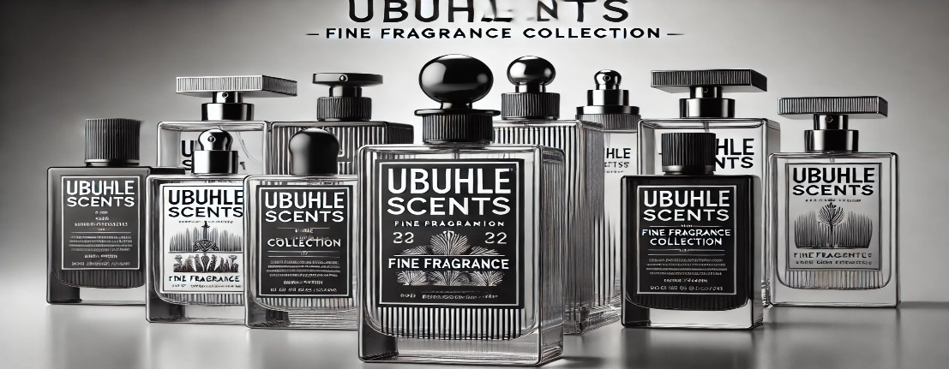

**Manufacturing:** the manufacturing process is done upon receiving the bottles, the oil essence, and alcohol from our main supplier ScentLabs, we combine the elements together, so it can come as a perfect fragrance formula.

**Distribution Channels**: Ubuhle Scents currently sells its products through direct customer contact and social media platforms, where customers can place orders. With the launch of the new e-commerce website, the company will expand its reach by offering an online store as a new sales channel, making it easier for customers to browse and purchase products from anywhere.

**Market Size:**

* **Value**: The market value is estimated to be worth around **R500 000 annually**, with a growth rate of approximately **5-7% per year.**
* **Volume**: The market volume is significant, with an estimated **5,000 units of perfumes** sold annually across the country.

**Customer Usage Data**:

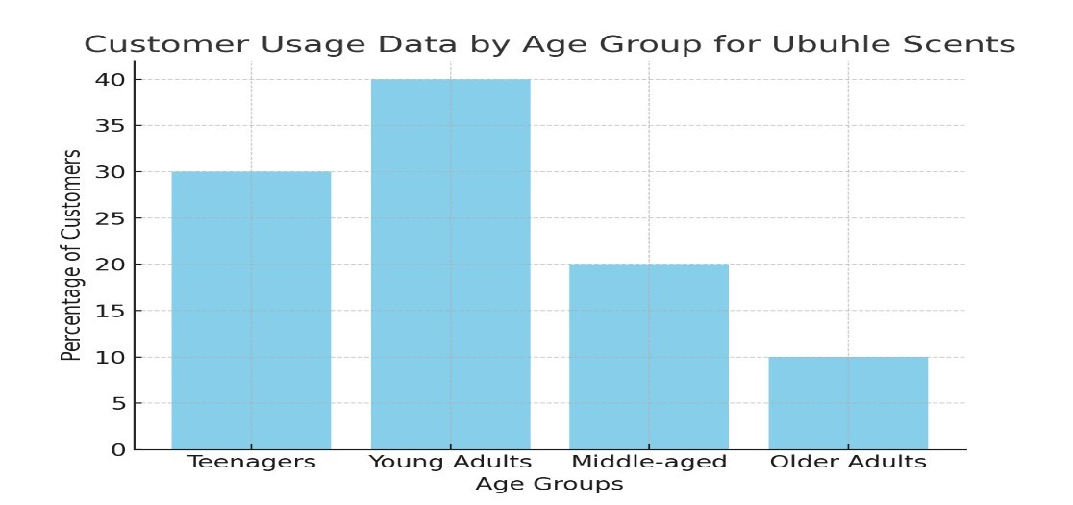

**Company’s Brand Positioning**

caters to offer fragrances to young adults who are looking for affordability on prices and at the same hand to ware high-quality fragrances, that will provide unique, long-lasting scents, making customers to feel confident, joyful and relaxed.

**History of brand communication**

Ubuhle Scents emphasizes customer-centricity, trend responsiveness, and effective social media marketing to connect with and serve our audience.

1.3 **WEB REQUIREMENTS**

**Business needs:**

**Revenue growth and Market expansion** - Expanding Ubuhle Scents' market reach beyond local clients is the main objective, which would boost its potential revenue and brand awareness.  
  
**Improving the convenience of customers** – As the business is online, customers will not have to travel, they will purchase while they are comfortably staying in their homes.

**Increased Brand Visibility** - Ubuhle Scents will increase its visibility in the very competitive fragrance sector by providing an internet presence.

**Improved Customer Interaction and** Engagement - Additionally, the website will have a customer-focused, interactive area featuring reviews, direct communication with the company, and easily accessible product information (such as live chat).

**Problems to be addressed**

* **Limited Market Reach:** Currently, Ubuhle Scents operates primarily through physical stores and social media, limiting its reach to local customers.
* **Lack of Customer Convenience:** Today’s customers prefer the convenience of online shopping, but Ubuhle Scents’ current model does not meet that level.
* The existing processes for handling orders and inventory may be inefficient and manual.

**Implementation Methods and Approaches**

* Creating an e-commerce platform that allows users to create accounts, order products, track their orders, and also add addresses for delivery.
* Features a detailed catalog of fragrance products with descriptions, pricing, availability, and customer reviews.
* Users will be able to search for products and apply filters based on categories, scents, and price ranges.
* The website will enable customers to add items to their cart, review their selections, and complete a secure checkout process using integrated payment gateways.
* A backend system and database will be established to manage stock levels, product availability, and customer inquiries efficiently.

**Desired Goal**

Develop a fully functional e-commerce website that aligns with Ubuhle Scents' business objectives of expanding its market presence and improving customer engagement.

Provide an online platform that engages customers with an intuitive shopping experience, offering easy access to the full range of fragrance products.

Increase online sales and drive higher revenue.

Post-project, the platform should support secure online payments, offer seamless home delivery options, and provide an easy-to-navigate shopping experience that enhances customer satisfaction.

Provide a valuable service to the local community and nationwide through accessible online shopping options.

Strengthen Ubuhle Scents' online presence, positioning the brand competitively within the fragrance industry and attracting new customers through digital marketing efforts.

**Timeframe and Budget**

The project is estimated to take approximately 4-6 months to complete, depending on the complexity of features and integrations. Costs may include website development, server/hosting expenses, third-party integrations for payment processing and delivery services, as well as ongoing maintenance and updates to ensure the site remains current and functional.

**Marketing Plan Alignment**

To ensure the e-commerce site is optimized for visibility and reach, SEO strategies will be used, including keyword-rich content, metadata, and detailed product descriptions. Marketing efforts will focus on promoting products and special offers through social media platforms like Instagram and Facebook, directly engaging a broader audience. Additionally, email marketing campaigns will be implemented to keep customers informed about promotions, new arrivals, and cart reminders, fostering ongoing communication and engagement with the brand.

1.4 **WEBSITE ARCHITECTURE**

**Site map**

The Ubuhle Scents website is designed to be intuitive and user-friendly

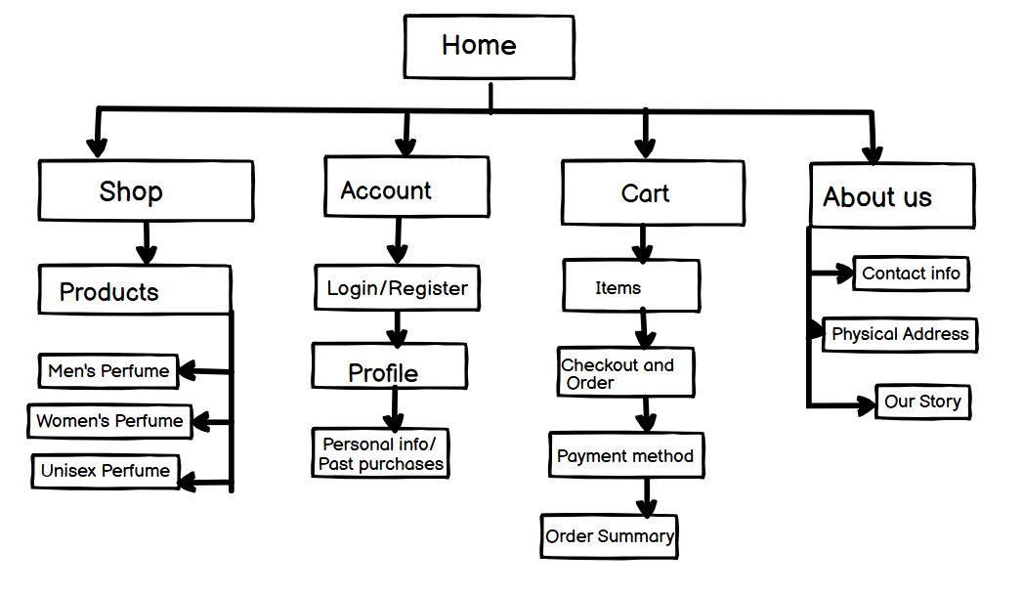

**Layout of the homepage**The homepage layout is designed to offer a seamless and visually attractive

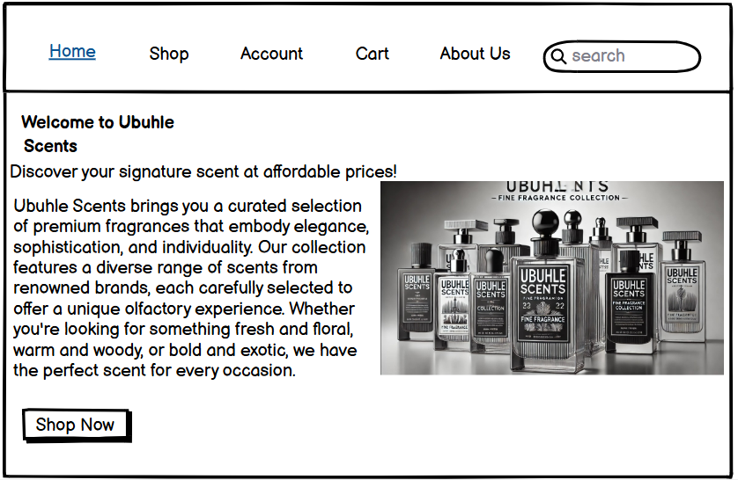

Design of the Navigation Buttons



1.5 **SPECIAL FUNCTIONALITY**

The proposed e-commerce website for Ubuhle Scents will feature several special functionalities that enhance user experience.

* **Customer account management**: Users will have the ability to create and manage their accounts, where they can buy, view order history, save favorite products, and manage shipping addresses. This feature will facilitate personalized shopping experiences and allow customers to easily track their purchases.
* **Product Reviews and Ratings**: The website will enable customers to leave reviews and ratings for products they have purchased. This functionality encourages user-generated content, helps build community trust, and provides valuable feedback for other potential buyers.
* **Wishlist Feature**: Customers can create wishlists for products they are interested in, allowing them to save items for future purchases. This feature not only enhances user experience but also encourages users to return to the site to complete their purchases.
* **Live Chat Support**: A live chat support feature will be integrated, providing real-time assistance to customers as they navigate the site. This will improve service delivery by addressing questions or concerns promptly, enhancing customer satisfaction.
* **Chatbot:** We planning the implementation of a chatbot that is going to provide answers or assist the customers 24/7, it will also give recommendations based on their past purchases. Enhancing the user experience and it will be user-friendly.
* **Social Media Sharing**: Integration of social media sharing options will allow customers to share their favourite products or purchases on platforms like Instagram and Facebook. This functionality can help increase brand visibility and encourage organic promotion through customer interactions.

1.6 **GRAPHIC DESIGN**

Below are the graphical representations of the website's design

Homepage design showing the search and navigation options:

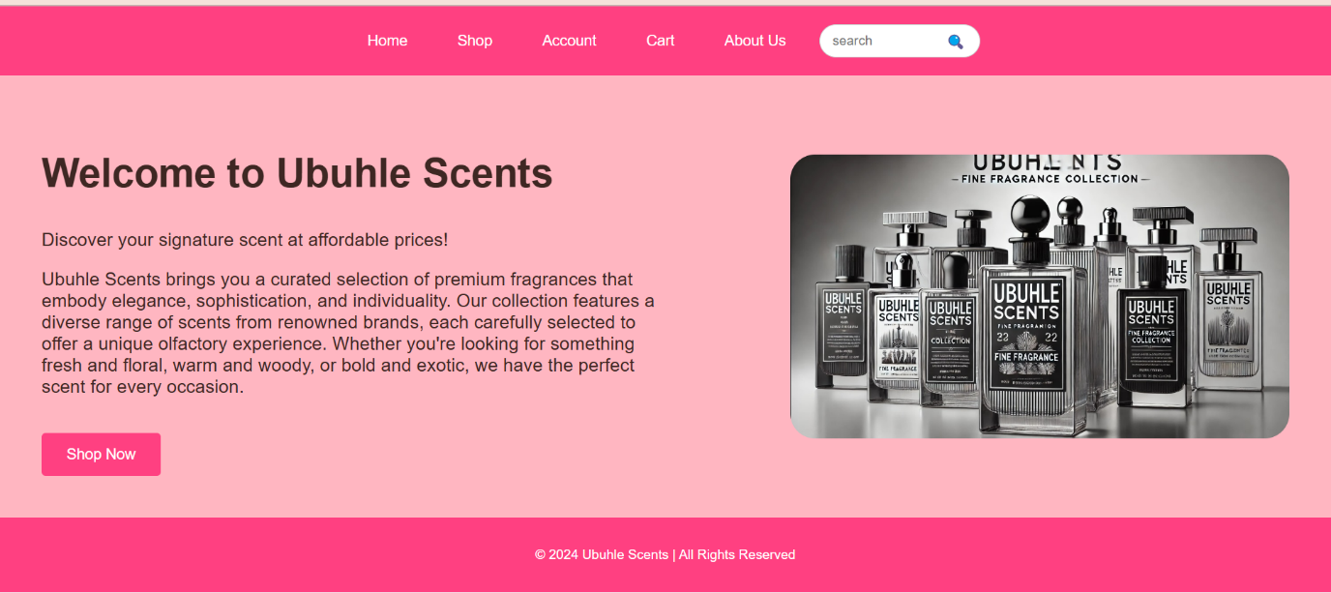

Registration form design: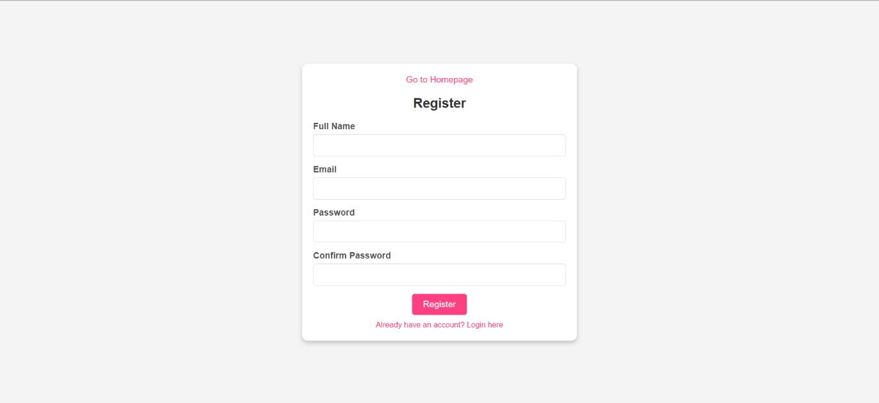

Login form design:



The shop page with search and navigation options:

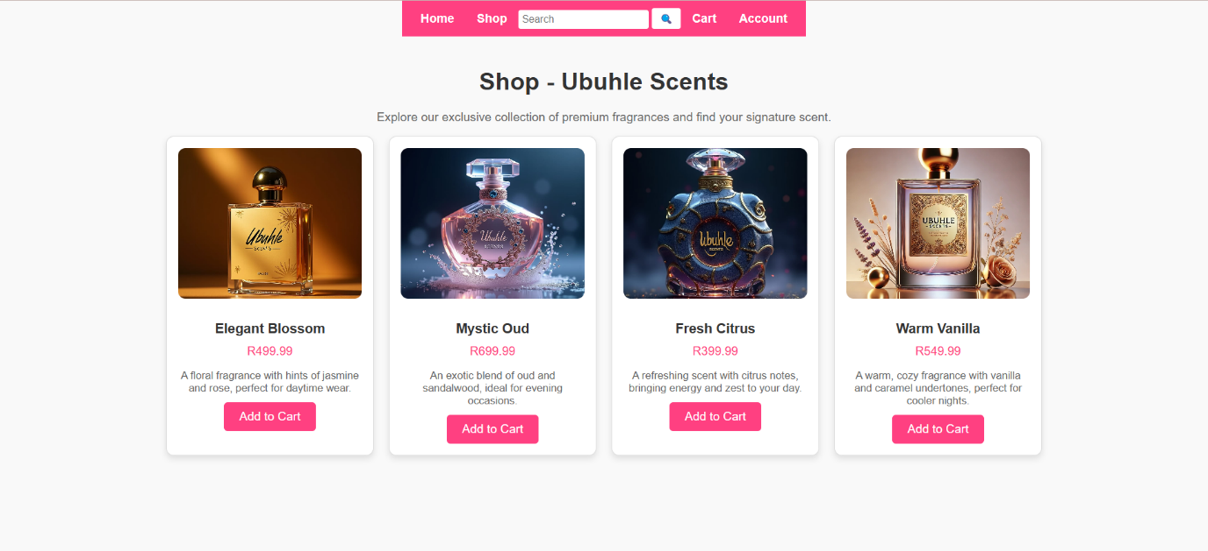

The cart page with search and navigation options:

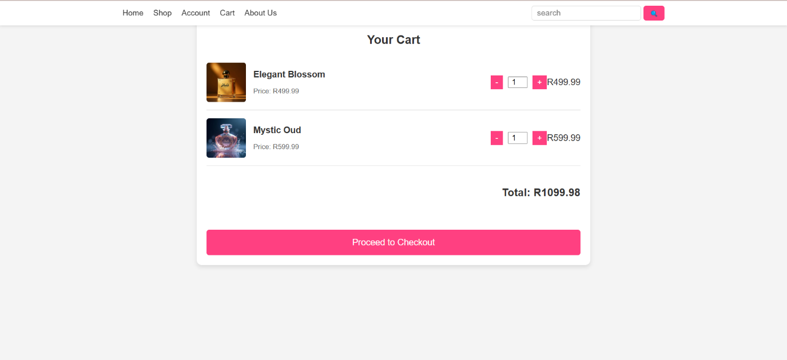

The About Us page:

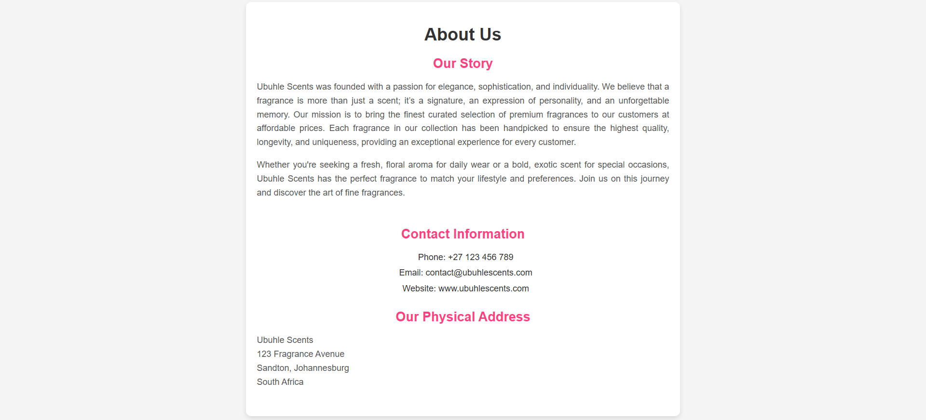

The interaction:

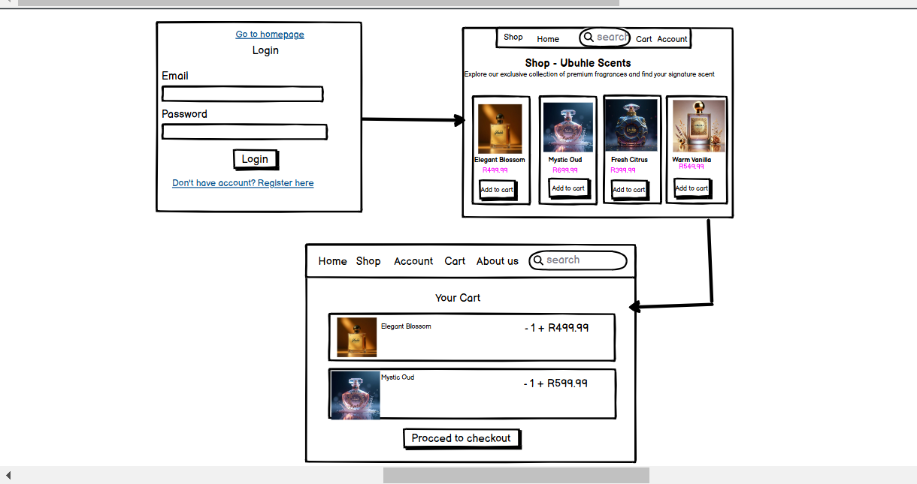

1.7 **ADDITIONAL DETAILS**

In developing the e-commerce website for Ubuhle Scents, several additional details should be considered to ensure a successful project outcome and alignment with the overall business goals:

* **Target Audience Analysis:** Understanding the demographics and preferences of Ubuhle Scents' target audience is crucial. Conducting market research to identify customer interests, shopping behaviors, and preferred payment methods will guide the design and functionality of the website. This analysis will help tailor the user experience to meet the specific needs of potential customers.
* **Branding and Visual Identity:** Establishing a cohesive branding strategy is essential for the website's design. High-quality images, consistent color schemes, and typography that reflect the essence of Ubuhle Scents will enhance brand recognition and create an appealing aesthetic that resonates with the target audience.
* **SEO and Digital Marketing Strategy:** A comprehensive SEO strategy should be developed in conjunction with the website to improve search engine visibility and drive traffic. This includes keyword research, optimizing product descriptions, and creating engaging content for the blog section. Additionally, integrating social media marketing and email campaigns will be vital for promoting the website and keeping customers informed about new products and offers.
* **Mobile Responsiveness:** Given the increasing use of mobile devices for online shopping, ensuring the website is fully responsive across various screen sizes and devices is crucial. A mobile-friendly design will enhance user experience and accessibility, catering to a broader audience.
* **Security Measures:** Implementing robust security measures to protect customer data, including SSL certificates for secure transactions and compliance with data protection regulations, will build trust with customers and enhance the overall credibility of the e-commerce platform.
* **Ongoing Maintenance and Support:** Planning for ongoing website maintenance and technical support after launch is essential to address any issues that may arise, implement updates, and ensure the website continues to operate smoothly and securely.
* **Feedback Mechanism:** Establishing a feedback mechanism, such as surveys or comment sections, will allow customers to share their experiences and suggestions. This information can be valuable for continuous improvement of the website and customer service.