Future Projects

Everything will be free, Work hard Change your Life

For any queries or questions email mail me on
nextgentechera07@gmail.com
or do comment and if you like my content do considering subscribing too it will motivate me to create new advanced contents

Will Create 50 Projects

Every alternate day

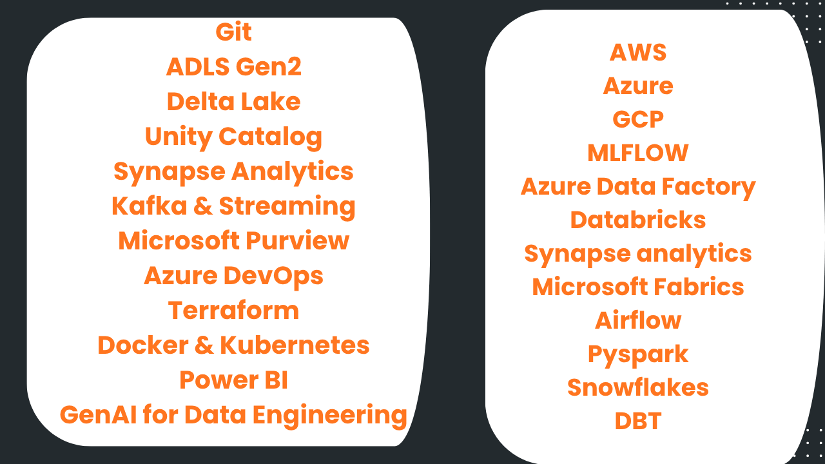

 | Service / Technology | Role in the Project
1 | Azure Resource Group | Hosts and organizes all project resources
2 | Azure Data Lake Storage Gen2 (ADLS Gen2) | Central data lake for Raw, Bronze, Silver and Gold data
3 | Azure Data Factory (ADF) | Data ingestion/orchestration layer mentioned as part of the project architecture
4 | Azure Databricks | Main data processing and transformation platform
5 | Databricks Unity Catalog | Data governance, catalog, schemas, external locations and table management
6 | Apache Spark / PySpark | Data processing, cleansing, transformations and aggregations
7 | Delta Lake | Stores Bronze, Silver and Gold data as Delta tables
8 | Databricks Access Connector | Managed identity-based access from Databricks to ADLS
9 | Azure RBAC / IAM | Grants Storage Blob Data Contributor permissions to Databricks
10 | Azure Synapse Analytics | Analytics/serving layer connected to the Gold data in ADLS

 | Databricks Component | Role in the Project
1 | Databricks Workspace | Central environment for developing, running and managing Databricks notebooks and workloads
2 | Databricks Cluster | Provides Spark compute resources for executing PySpark and Spark SQL workloads
3 | Databricks Unity Catalog | Provides centralized data governance, catalog management, schemas, external locations and table management
4 | Storage Credential | Provides secure identity-based access from Databricks to ADLS Gen2
5 | External Locations | Defines and manages secure access to Raw, Bronze, Silver and Gold ADLS locations
6 | Catalog | Top-level Unity Catalog namespace used to organize the healthcare data assets
7 | Bronze / Silver / Gold Schemas | Implements the Medallion Architecture for raw, cleaned and analytics-ready data
8 | Delta Tables | Stores healthcare data in Delta format across Bronze, Silver and Gold layers
9 | PySpark DataFrames | Used for reading, processing, cleansing, transforming and writing healthcare datasets
10 | Spark SQL | Used to create and manage catalogs, schemas, tables and perform SQL-based data analysis
11 | Window Functions | Used for analytical calculations such as revenue growth and ranking-based analysis
12 | Data Cleansing & Enrichment | Performs deduplication, standardization, null handling, derived columns and data validation
13 | Aggregations & Business KPIs | Generates healthcare analytics such as Patient 360, financial metrics, appointment trends and doctor performance

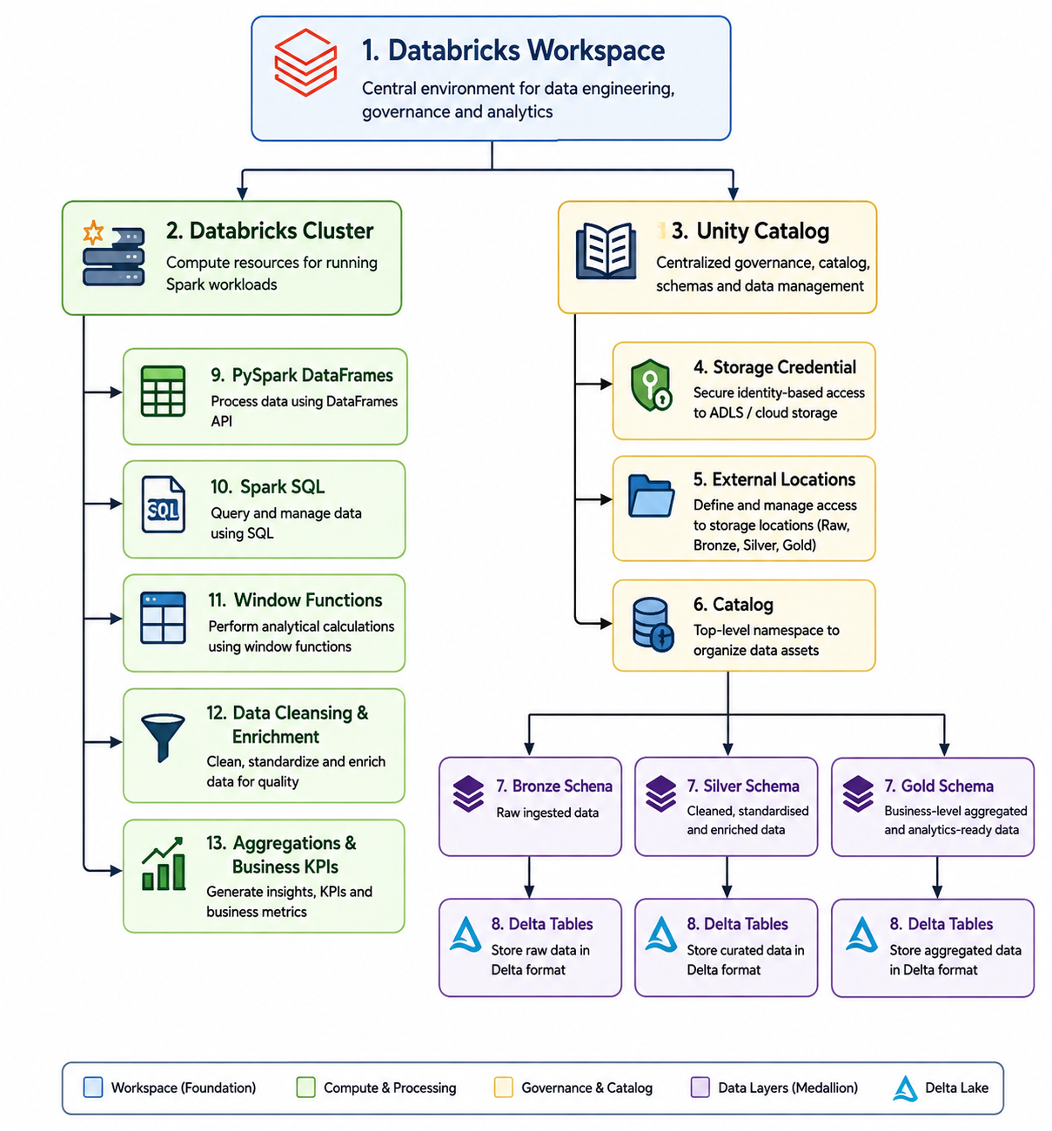

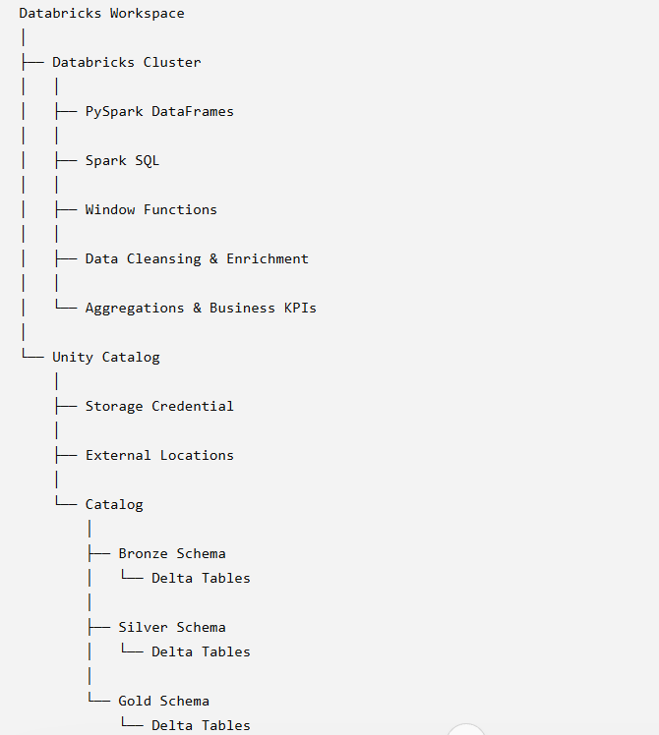
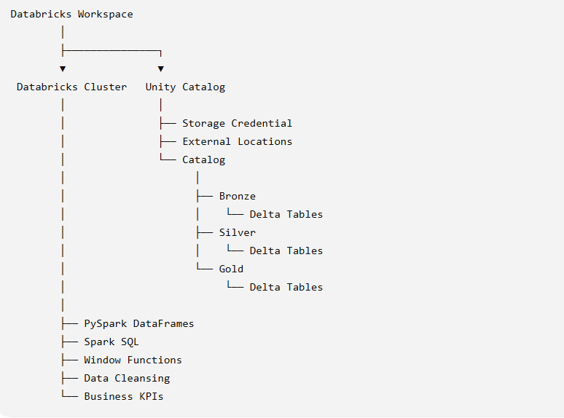

Databricks

Databricks is a cloud-based data, analytics, and AI platform that helps organizations collect, process, analyze, and use large amounts of data from one place. It was founded in 2013 by the original creators of Apache Spark, and is best known for pioneering the data lakehouse architecture.
A simple way to think about it:
- A database stores application data.
- A data warehouse stores structured business data for reporting.
- A data lake stores raw data of all types (structured, semi-structured, and unstructured).
- Databricks combines the strengths of data lakes and data warehouses into a single platform, often called a lakehouse, so engineers, analysts, and data scientists can all work from the same data.

What can you do with Databricks?
Organizations use Databricks to:
- Data engineering: Build ETL/ELT pipelines to clean and transform data.
- Data analytics: Run SQL queries and create dashboards.
- Machine learning: Train, deploy, and monitor ML models.
- Generative AI: Build AI applications such as chatbots, retrieval-augmented generation (RAG), and AI agents using enterprise data.
- Real-time analytics: Process streaming data from applications, IoT devices, or logs.

Core technologies

Databricks is built around several important technologies:
- Apache Spark – Distributed data processing engine.
- Delta Lake – Adds ACID transactions, versioning, and reliability to data lakes.
- Unity Catalog – Centralized governance, security, and data catalog.
- MLflow – Open-source platform for managing the machine learning lifecycle.
- Databricks SQL – SQL analytics and business intelligence.

Why companies choose Databricks
Some of the main benefits are:
- One platform for data engineering, analytics, and AI.
- Scales to very large datasets.
- Works across major cloud providers (AWS, Azure, and Google Cloud).
- Supports open-source technologies, reducing vendor lock-in.
- Built-in governance and collaboration features.

Core Components of Databricks
Databricks consists of several key components that work together to build modern data engineering, analytics, and AI solutions.

1. Workspace
The Workspace is where developers collaborate.
It contains:
- Notebooks
- SQL queries
- Dashboards
- Repositories (Git)
- Libraries
Purpose: Write and manage code using Python, SQL, Scala, or R.

2. Compute (Clusters)
A Cluster is a group of virtual machines that runs your workloads.
Types:
- All-Purpose Cluster (interactive development)
- Job Cluster (created for scheduled jobs)
- Serverless Compute (managed by Databricks, where available)

3. Delta Lake
Delta Lake is the storage layer used in Databricks.
Features:
- ACID transactions
- Schema enforcement
- Time Travel
- Data versioning
- High performance
Typical Medallion Architecture:
Raw Data
│
▼
Bronze
│
▼
Silver
│
▼
Gold

What is Unity Catalog
Unity Catalog is Databricks' centralized data governance and metadata management service. It allows you to manage data, AI models, files, notebooks, permissions, and access policies across your entire Databricks workspace from one place.
Think of it like this:
Databricks = The Office Building
Unity Catalog = The Security Office + Library Catalog
It decides:
- Who can access the data
- Which tables they can see
- What files they can use
- Who created or modified data
- Where the data is stored

Without Unity Catalog

Multiple Workspaces

Workspace A
├── Tables
├── Permissions
└── Users

Workspace B
├── Tables
├── Permissions
└── Users

Problem:
❌ Separate permissions
❌ Difficult to manage
❌ No central governance

With Unity Catalog
Unity Catalog
(Central Governance)

│
┌────────────────┼────────────────┐
│ │ │
Workspace A Workspace B Workspace C
│ │ │
└────────── Same Security ────────┘
Same Users
Same Permissions
Same Metadata

Unity Catalog Hierarchy

Metastore
│
├── Catalog
│ │
│ ├── Schema
│ │ │
│ │ ├── Tables
│ │ ├── Views
│ │ └── Functions

Example:
Metastore
│
├── Sales
│ ├── Bronze
│ │ ├── customers
│ │ ├── orders
│ │
│ ├── Silver
│ │ ├── customers_clean
│ │ ├── orders_clean
│ │
│ └── Gold
│ ├── sales_summary
│ ├── customer_dashboard

Unity Catalog Object Hierarchy

Metastore
│
Catalog
│
Schema (Database)
│
Table

Example SQL:

sales.bronze.orders
Where:
sales → Catalog
bronze → Schema
orders → Table

What Can Unity Catalog Manage?

Object | Example
Tables | Customer, Orders
Views | Sales Report
Files | CSV, JSON, Parquet
Volumes | Raw Files
Models | Machine Learning Models
Functions | SQL Functions
AI Assets | Vector Search, AI Models

Permission Example

Suppose you have three teams.
Data Engineers
│
├── Read
├── Write
└── Modify

Data Analysts
│
├── Read
└── Query

Data Scientists
│
├── Read
├── Train Models
└── Create Features
Note - Using Unity Catalog, permissions can be assigned once and enforced consistently.

Benefits of Unity Catalog
- Centralized security and governance
- Fine-grained access control (catalog, schema, table, column, row)
- Data lineage to trace where data comes from
- Audit logs for compliance
- Cross-workspace sharing
- Simplified data discovery
- Support for Delta tables, files, ML models, and AI assets

Interview Questions

Q1. What is Unity Catalog.
A centralized governance and metadata service in Databricks that manages data access, permissions, lineage, and discovery across workspaces.

Q2. What is the hierarchy in Unity Catalog.
Metastore → Catalog → Schema → Table/View/Function

Q3. What is a Catalog.
The top-level container that organizes related schemas, such as sales or finance.

Q4. What is a Schema.
A logical grouping of database objects (similar to a database in many systems) within a catalog.

Q5. What is the difference between Hive Metastore and Unity Catalog.
Hive Metastore | Unity Catalog
Workspace-level | Account-level governance
Limited security | Fine-grained permissions
No centralized governance | Centralized governance
Limited lineage | Built-in lineage
Basic metadata | Rich metadata and auditing

5. Notebooks
Databricks notebooks allow interactive development.
Supported languages:
- Python
- SQL
- Scala
- R
Example:
df = spark.read.csv("/mnt/orders.csv")
display(df)

6. Databricks SQL
Databricks SQL is designed for analytics and reporting.
Example:
SELECT customer_name,
SUM(amount) AS total_sales
FROM sales.gold.orders
GROUP BY customer_name;
Use cases:
- Dashboards
- BI reports
- Ad hoc SQL analysis

7. Workflows (Jobs)
Workflows automate tasks such as:
- Running notebooks
- Executing SQL
- Launching Spark jobs
- Scheduling ETL pipelines
Example workflow:
ADF
│
▼
Databricks Job
│
▼
Notebook
│
▼
Delta Table

8. MLflow
MLflow manages the machine learning lifecycle.
Capabilities:
- Experiment tracking
- Model versioning
- Model registry
- Model deployment
Typical flow:
Train Model
│
▼
Track Experiment
│
▼
Register Model
│
▼
Deploy

9. Repos (Git Integration)
Repos connect Databricks with Git providers.
Supported operations:
- Clone
- Commit
- Push
- Pull
- Branch management
Common providers:
- GitHub
- Azure DevOps
- GitLab
- Bitbucket

10. Databricks File System (DBFS) / Volumes
Databricks provides managed storage access for files.
Typical locations:
CSV Files
JSON Files
Parquet Files
Images
Models
With Unity Catalog, managed Volumes are generally preferred for governed file storage.

Complete Azure Data Engineering Flow

Oracle / SQL Server / SAP / REST API
│
▼
Azure Data Factory
│
▼
ADLS Gen2
│
▼
Databricks
├── Workspace
├── Clusters
├── Notebooks
├── Delta Lake
├── Unity Catalog
├── Workflows
├── MLflow
└── Databricks SQL
│
▼
Power BI / Synapse / AI Applications

Summary Table

Component | Purpose
Workspace | Collaborative development environment
Compute (Clusters) | Runs Spark, SQL, and ML workloads
Delta Lake | Reliable, transactional storage layer
Unity Catalog | Centralized governance and security
Notebooks | Interactive coding and analysis
Databricks SQL | SQL analytics and dashboards
Workflows | Job orchestration and scheduling
MLflow | Machine learning lifecycle management
Repos | Git-based version control
DBFS / Volumes | File storage and data access

