Question 1

In My STP protocol, I implement three-way hank shake at the beginning of data transforming. During the data transforming, there are several functions, like timer, window size control, fast retransmission, and wait for the acknowledge number from receiver and make decision about to resend the packet or send next package.

For the timer, I used the time function in Python and by it, I can record the time, and using the time out to control whether to send or resend the packet. This is important in the real life for achieving high transforming speed.

For the window size control, I used basic python functions about the list for preserving sending the least item and new item as long as I received a new and different acknowledge number from the receiver.

For the fast retransforming, I make sure the that the if the sender receiver two same number from receiver, then we resend the least sequence item in the window list, this helps the programing to processing faster and make sure the packet can be retransferred, this improve the efficiency of the data transforming, and reduce the risk for the packet lost during the transform processing.

If the sender does not receive anything from the receiver, the sender will send the packet as default.

These functions make the programing safe to be utilized as the transferring data,

Question 2:

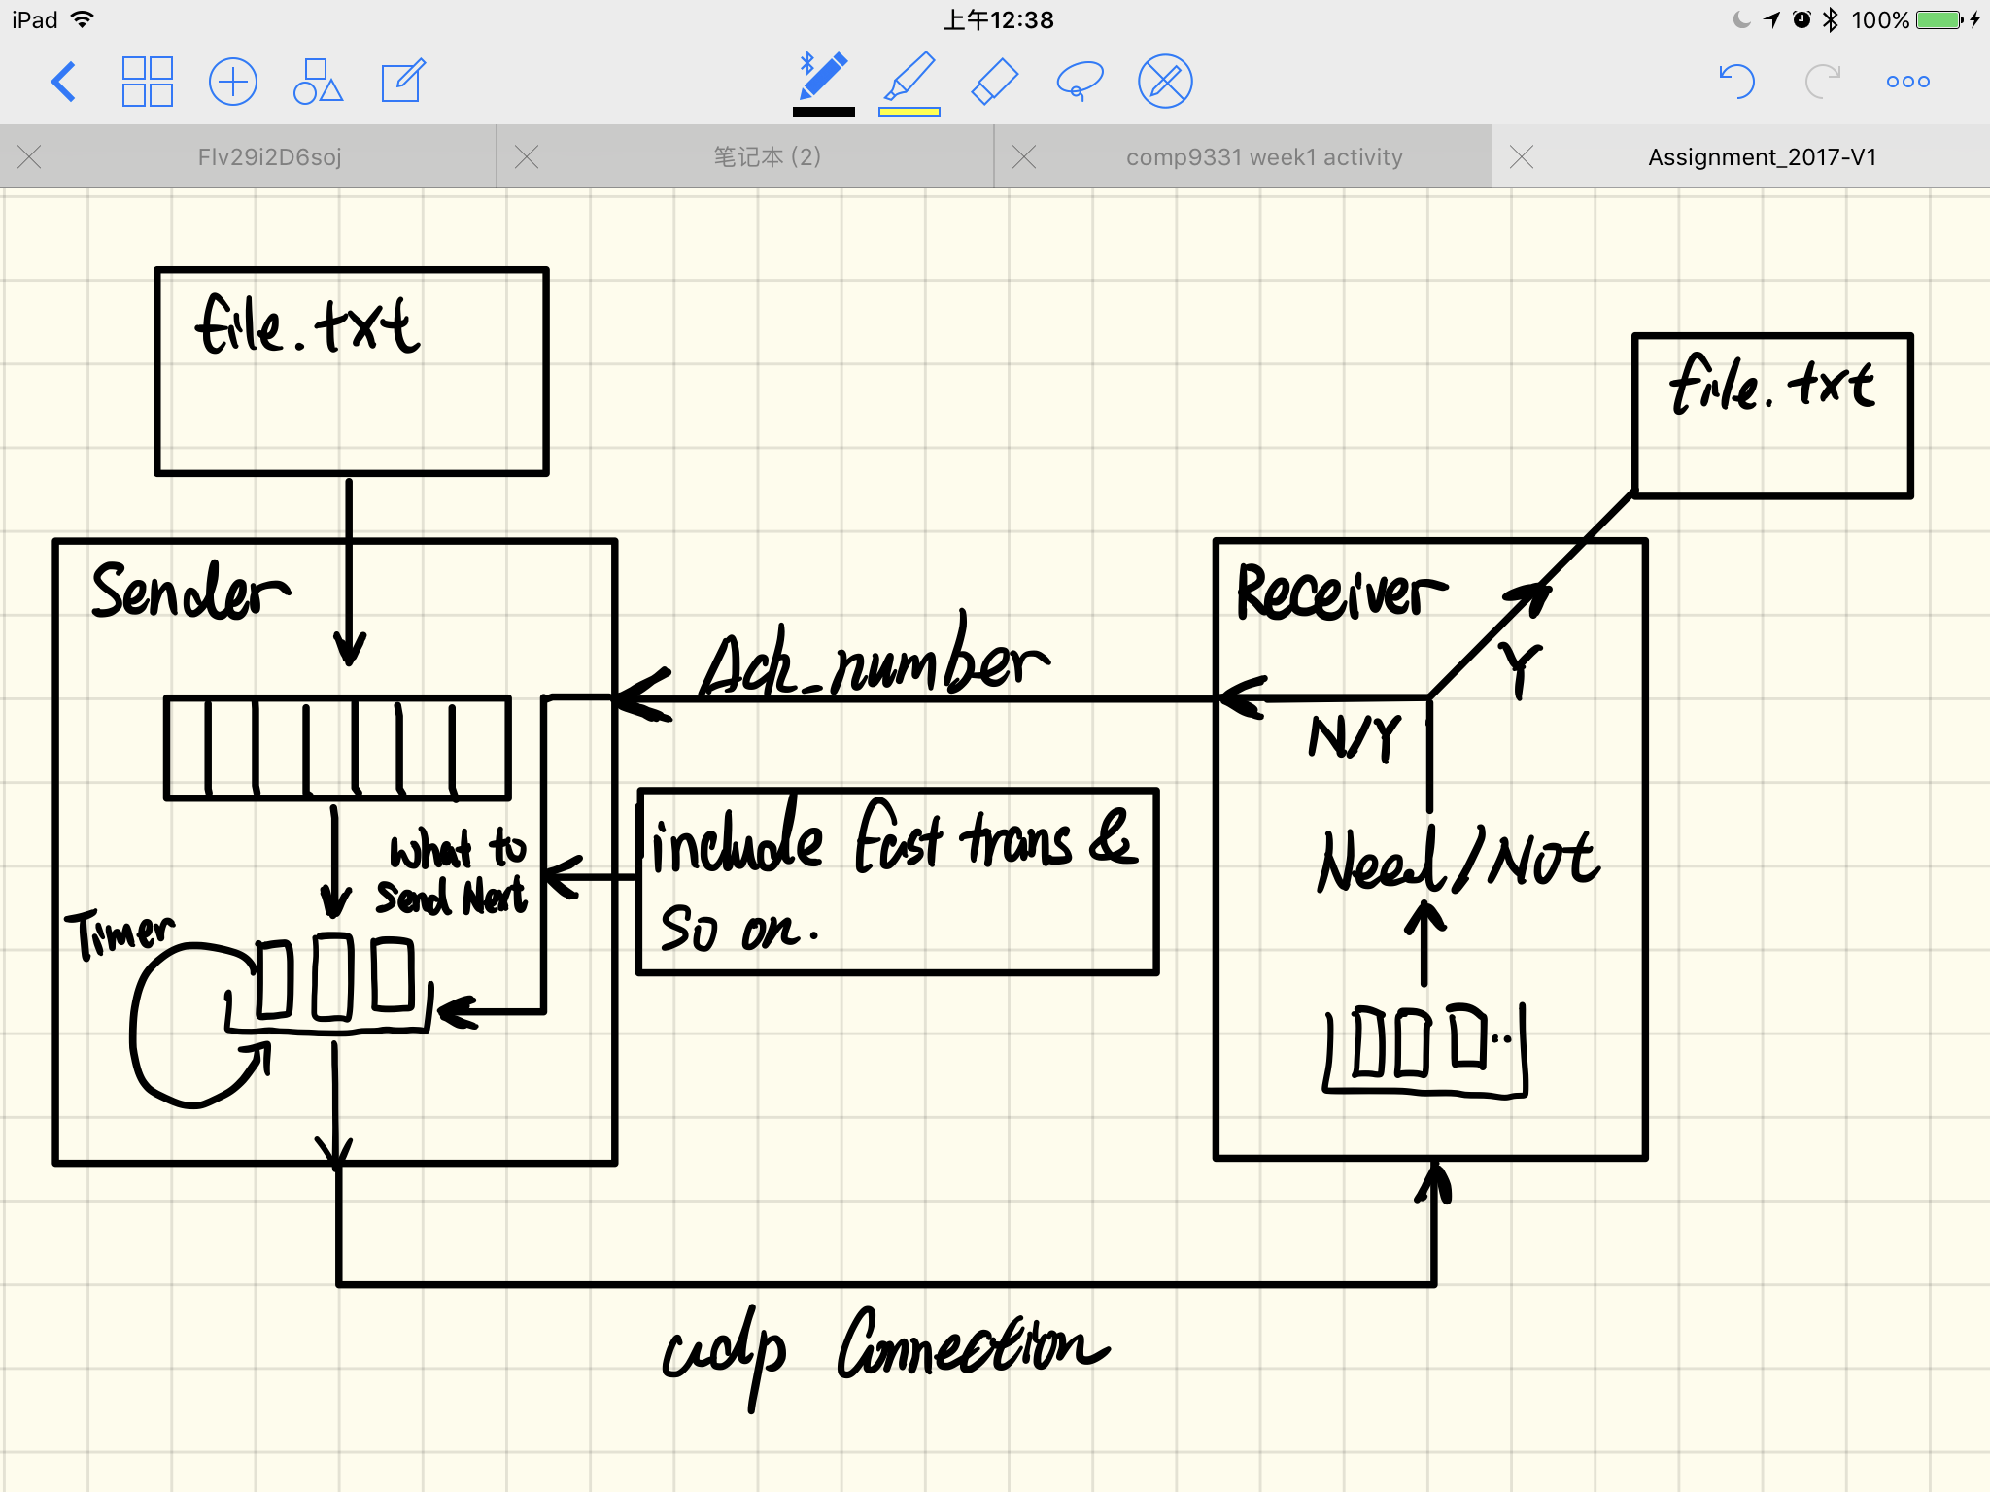

Question 3:

A: First timeout means the sender wait for how long to response to the receiver, if the response time is larger than the sending time, then the sender will no longer wait for the receiver, and re-send the packet. So, for answering the question, we need to know the size of a packet. This is important for answering the question. In the programing, if we have a long txt file, and we need to cut the file into serval packets, if the packet is very large, and then the if we set the short timeout value will not be efficiency for the situation. If the cut file is small, and if we set a long timeout, then the setting will not be reasonable. So, the answer is the timeout is depending on the cut file size, and we need to set the timeout according to the need of the file.