[1. LOGIN PROCEDURE (REACT)](https://confluence.ttweb.net/pages/viewpage.action?pageId=59868406)

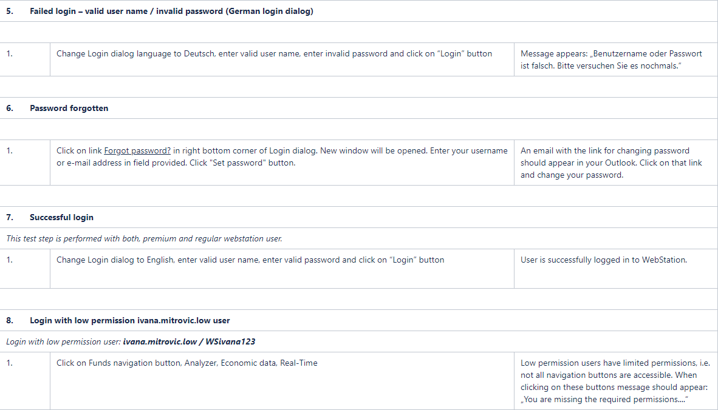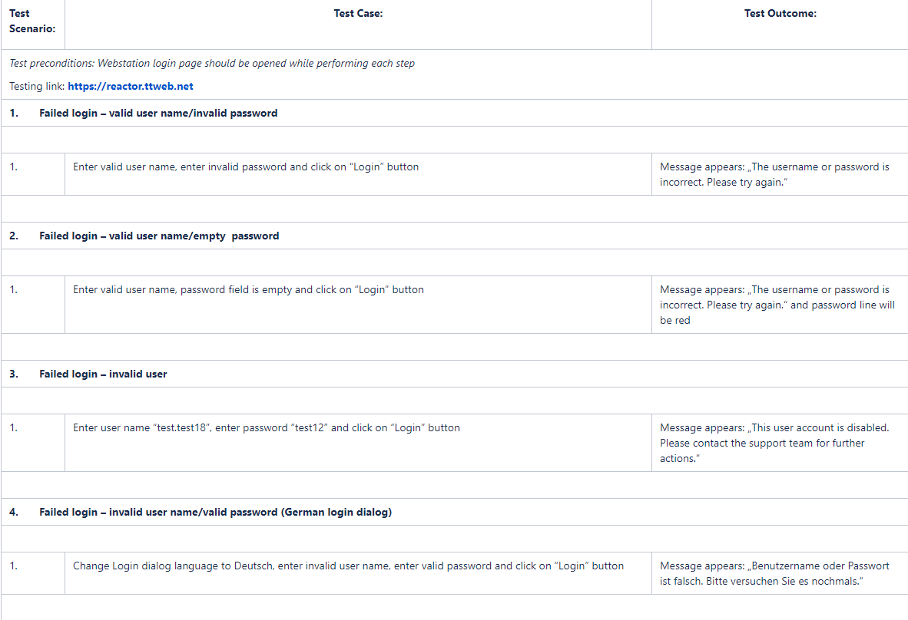

# [2. HEADER FUNCTIONALITIES (REACT)](https://confluence.ttweb.net/pages/viewpage.action?pageId=59868425)

# 

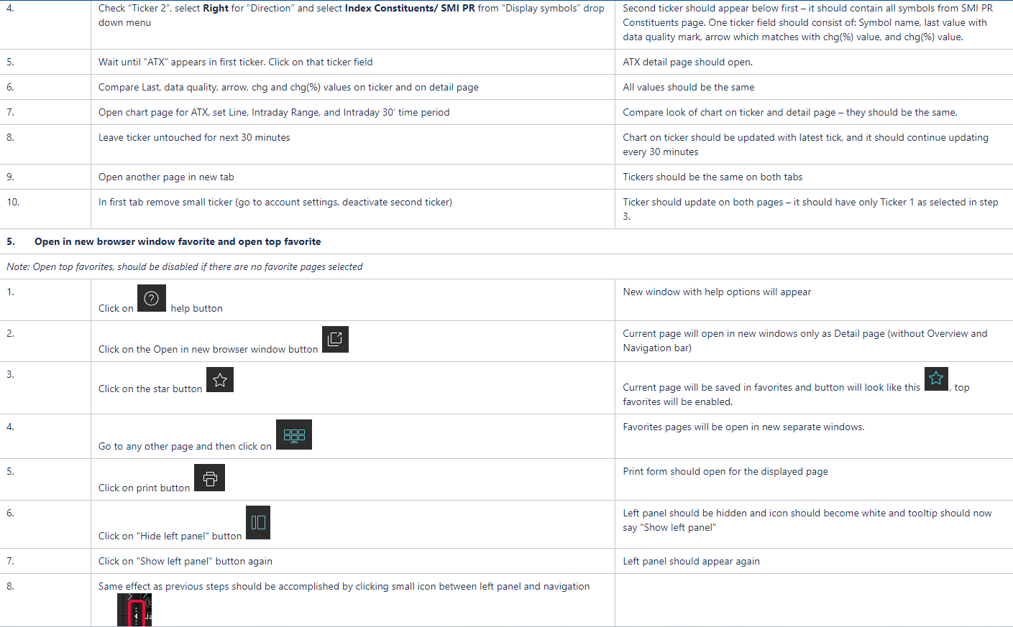

# [3. ACCOUNT SETTINGS (REACT)](https://confluence.ttweb.net/pages/viewpage.action?pageId=63931469)

# 

# 

# [4. OVERVIEW PAGE/LEFT PANEL (REACT)](https://confluence.ttweb.net/pages/viewpage.action?pageId=63931479)

# 

# 

# 

# 

# [6. NAVIGATION PAGES (REACT)](https://confluence.ttweb.net/pages/viewpage.action?pageId=63931559)

# [6.1 EQUITIES (REACT)](https://confluence.ttweb.net/pages/viewpage.action?pageId=63931615)

# 

# 

# 



# [6.2 CURRENCIES (REACT)](https://confluence.ttweb.net/pages/viewpage.action?pageId=63931633)

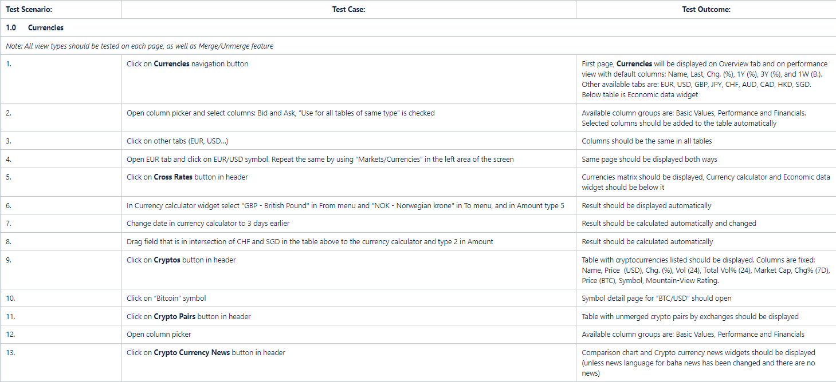

# [6.3 COMMODITIES (REACT)](https://confluence.ttweb.net/pages/viewpage.action?pageId=63931635)

# 

# [6.4 BONDS (REACT)](https://confluence.ttweb.net/pages/viewpage.action?pageId=63931637)

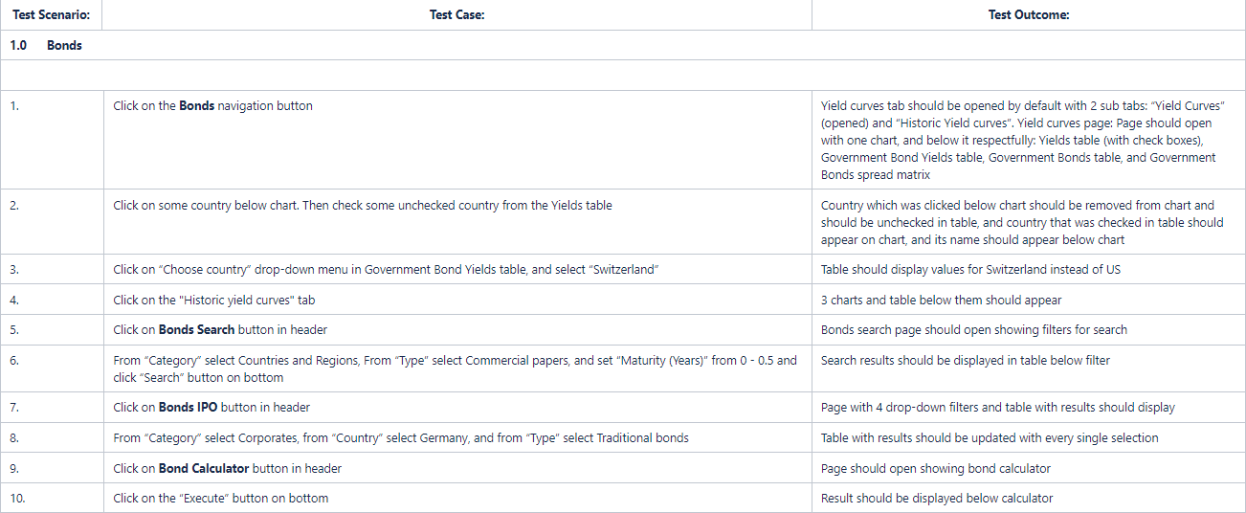

# [6.5 FUTURES (REACT)](https://confluence.ttweb.net/pages/viewpage.action?pageId=63931639)

# 

# [6.6 baha NEWS (REACT)](https://confluence.ttweb.net/pages/viewpage.action?pageId=63931641)

# 

# 

# [6.7 WORKSPACE (REACT)](https://confluence.ttweb.net/pages/viewpage.action?pageId=63931651)

# 

# 

# 

# [6.8 WATCHLIST (REACT)](https://confluence.ttweb.net/pages/viewpage.action?pageId=63931657)

# 

# 

# 

# 

# [6.10 FUNDS (REACT)](https://confluence.ttweb.net/pages/viewpage.action?pageId=67141978)

# 

# [6.11 MONEY MARKETS (REACT)](https://confluence.ttweb.net/pages/viewpage.action?pageId=69862516)

# 

# [6.12 PORTFOLIO (REACT)](https://confluence.ttweb.net/pages/viewpage.action?pageId=69862579)

# 

# 

# 

# [6.13 SCREENER (REACT)](https://confluence.ttweb.net/pages/viewpage.action?pageId=74810100)

# 