CASE STUDY 6

AWS Cloud Automation & Serverless Data Processing
Item | Description
Project Type | Cloud Automation / Serverless Data Processing
Role | Software QA Engineer / Python Backend & AWS Cloud Developer
Development Type | Serverless Cloud Application
Programming Language | Python
Development Environment | Visual Studio Code / AWS Management Console / Google Colab
Version Control | Git & GitHub
Project Status | Completed

Project Overview
This project demonstrates the implementation of a serverless cloud-based data processing solution using Amazon Web Services (AWS) and Python.
The solution automatically retrieves multiple CSV datasets from Amazon S3, processes and aggregates the data using Pandas, and uploads the generated analytical results back to Amazon S3.
The project integrates several AWS services including AWS Lambda, Amazon S3, IAM, EventBridge and CloudWatch to demonstrate event-driven automation, secure cloud resource access and serverless data processing.
Throughout the project, emphasis was placed on clean Python development, reusable code organization, cloud architecture, technical documentation and automation best practices.
This project was completed as part of my practical AWS Cloud and Python Automation training and demonstrates my ability to develop structured serverless solutions using modern cloud technologies.

Project Objective
The objectives of this project were:
- Design a serverless cloud solution using AWS.
- Store datasets in Amazon S3.
- Process multiple CSV files automatically.
- Develop reusable Python modules.
- Implement AWS Lambda functions.
- Automate cloud workflows.
- Configure IAM permissions.
- Monitor execution using CloudWatch.
- Document cloud architecture.
- Improve practical AWS development skills.

Development Environment
Component | Description
Programming Language | Python
IDE | Visual Studio Code / Google Colab
Cloud Platform | Amazon Web Services (AWS)
Cloud Services | Lambda, S3, IAM, EventBridge, CloudWatch
Operating System | Windows 11
Version Control | Git
Libraries | boto3, pandas
Development Approach | Serverless Cloud Automation

Project Scenarios
The project included implementation of the following practical activities:
- Creating Amazon S3 buckets.
- Uploading CSV datasets.
- Reading data from Amazon S3.
- Processing datasets using Pandas.
- Aggregating statistical information.
- Uploading processed files.
- Executing AWS Lambda functions.
- Monitoring execution logs.
- Implementing scheduled automation.
- Organizing reusable cloud project structure.

Development Approach
The project follows a modular serverless architecture based on AWS managed services.
CSV datasets are stored in Amazon S3 and processed using AWS Lambda. The Python application retrieves all available datasets, performs validation and aggregation using Pandas, and uploads the generated analytical report back to Amazon S3.
IAM roles provide secure access between AWS services, while CloudWatch enables execution monitoring and troubleshooting. EventBridge can be used to automate scheduled executions.
The solution emphasizes maintainability, scalability and reusable Python components.

Challenges & Solutions
Several practical challenges were encountered during the project.
- Configuring secure IAM permissions.
- Managing communication between AWS services.
- Reading multiple CSV datasets from Amazon S3.
- Organizing reusable Python modules.
- Improving project documentation.
- Designing maintainable serverless architecture.

Results
The completed project successfully demonstrated:
- Successful implementation of serverless architecture.
- Automated CSV processing.
- Successful integration of Amazon S3 and AWS Lambda.
- Reliable cloud-based data processing.
- Practical implementation of boto3 library.
- Well-structured project documentation.
- Improved understanding of AWS cloud services.

Lessons Learned
The most valuable lessons learned include:
- Serverless architecture simplifies application deployment.
- Amazon S3 provides scalable object storage.
- AWS Lambda enables event-driven automation.
- IAM is essential for secure cloud communication.
- CloudWatch simplifies monitoring and debugging.
- Modular Python code improves maintainability.
- Documentation significantly improves project quality.

Technologies Used
Python • AWS Lambda • Amazon S3 • IAM • EventBridge • CloudWatch • boto3 • Pandas • CSV Processing • Serverless Computing • Cloud Automation • Git • GitHub

Key Skills Demonstrated
Competency | Demonstrated
Python Programming | ✔
AWS Lambda | ✔
Amazon S3 | ✔
boto3 | ✔
Pandas | ✔
Serverless Architecture | ✔
Cloud Automation | ✔
CSV Processing | ✔
IAM | ✔
EventBridge | ✔
CloudWatch | ✔
Git Version Control | ✔
Technical Documentation | ✔

Project Screenshot

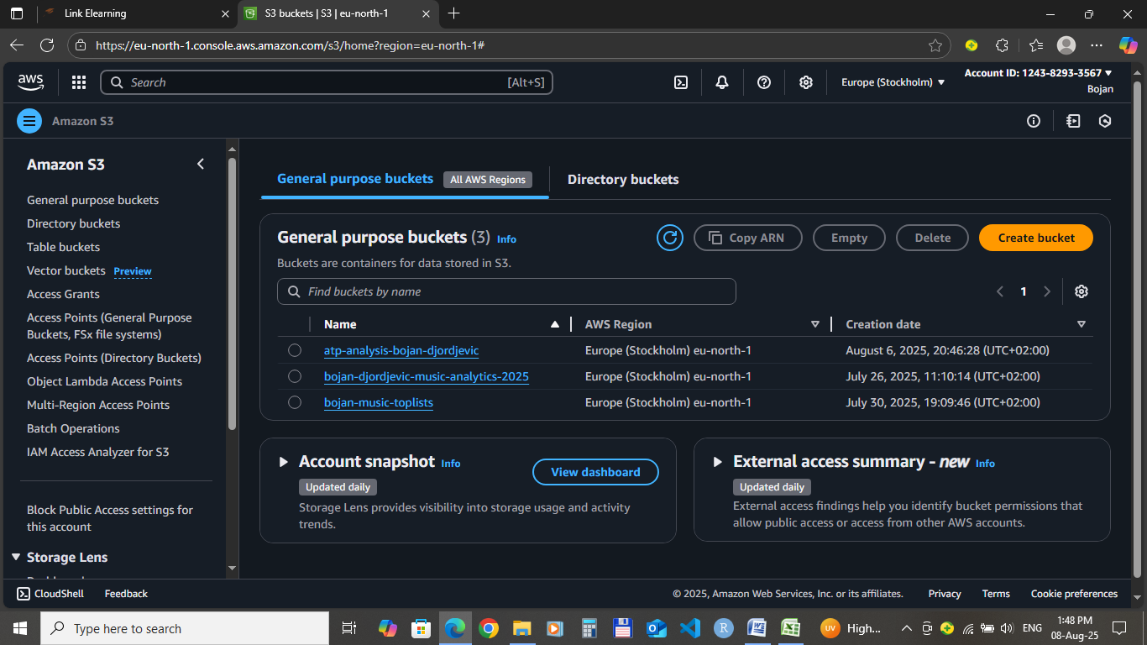
Figure 1 - S3_Bucket_Overview.png

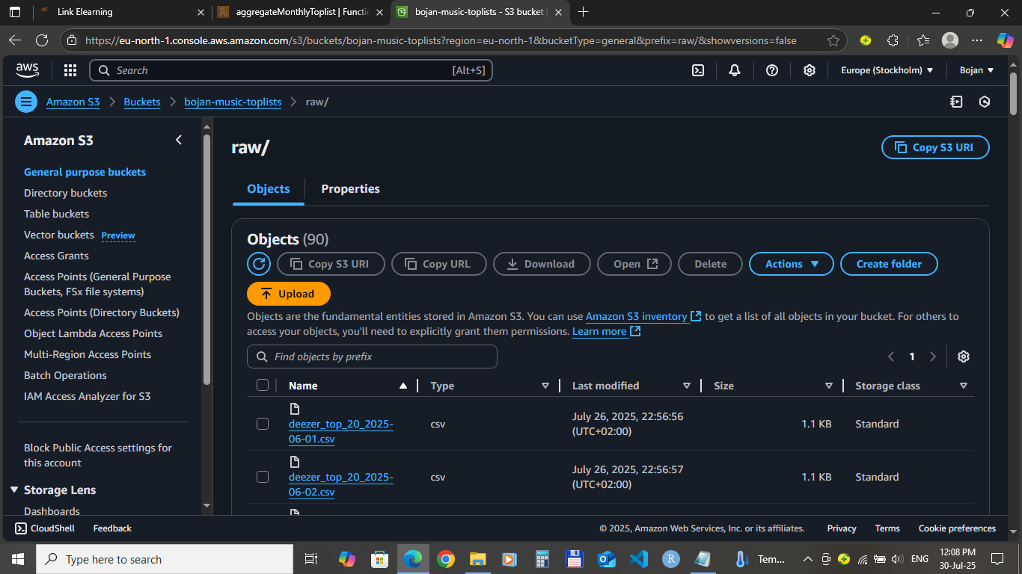

Figure 2 - Raw_CSV_Files.png

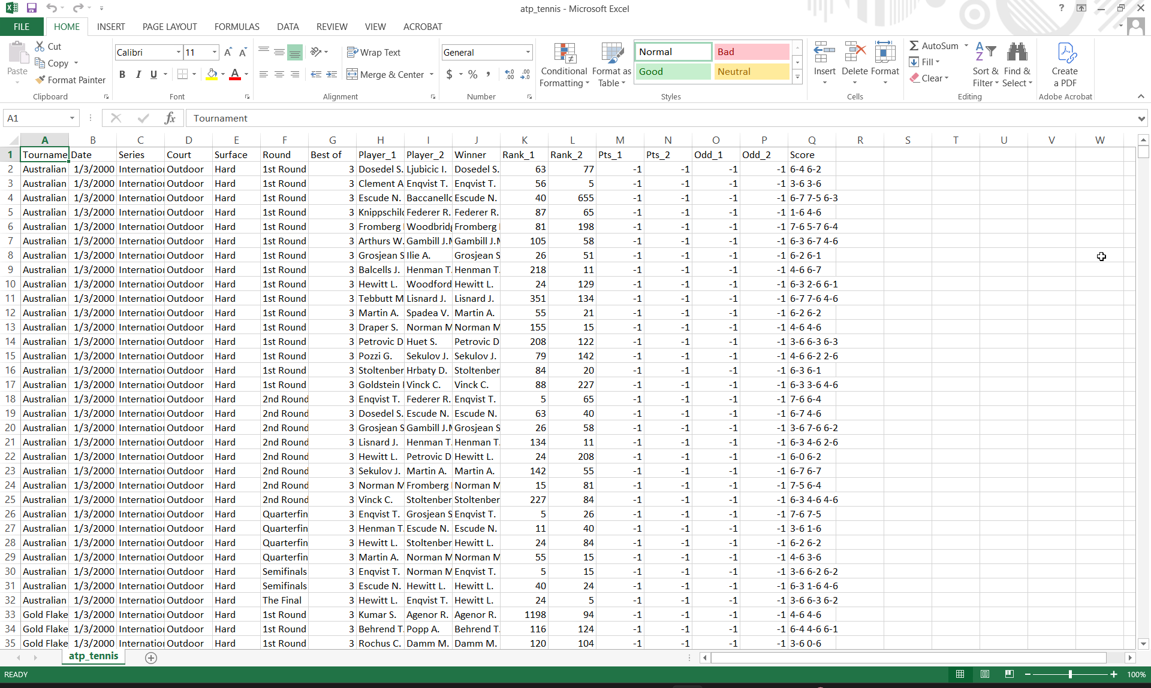
Figure 3 - CSV_Dataset_Preview.png

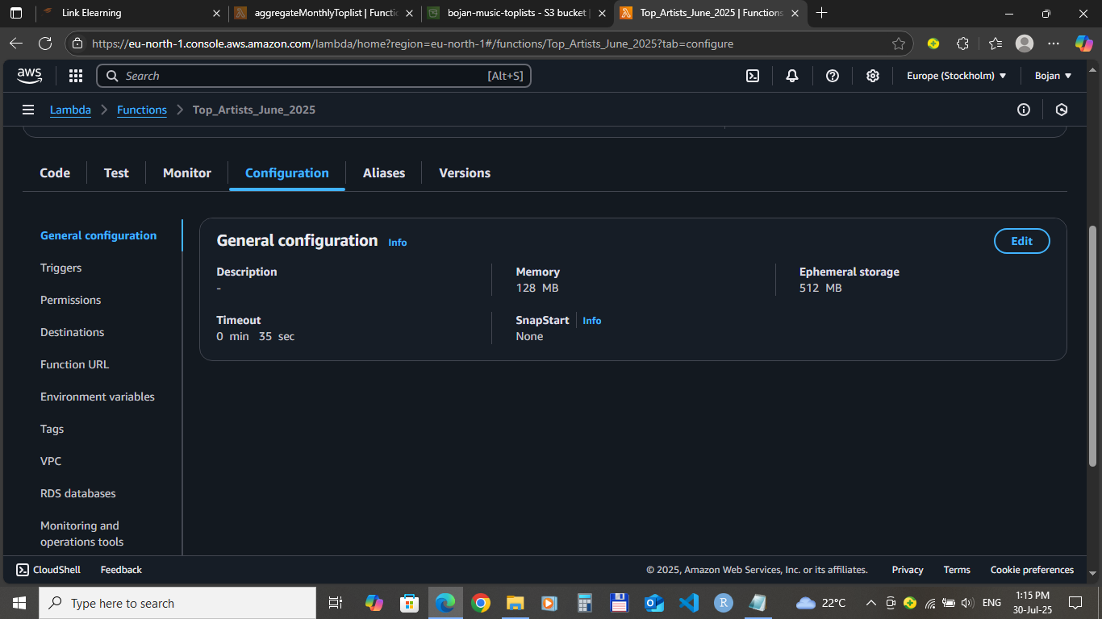

Figure 4 - S3_Object_Details.png

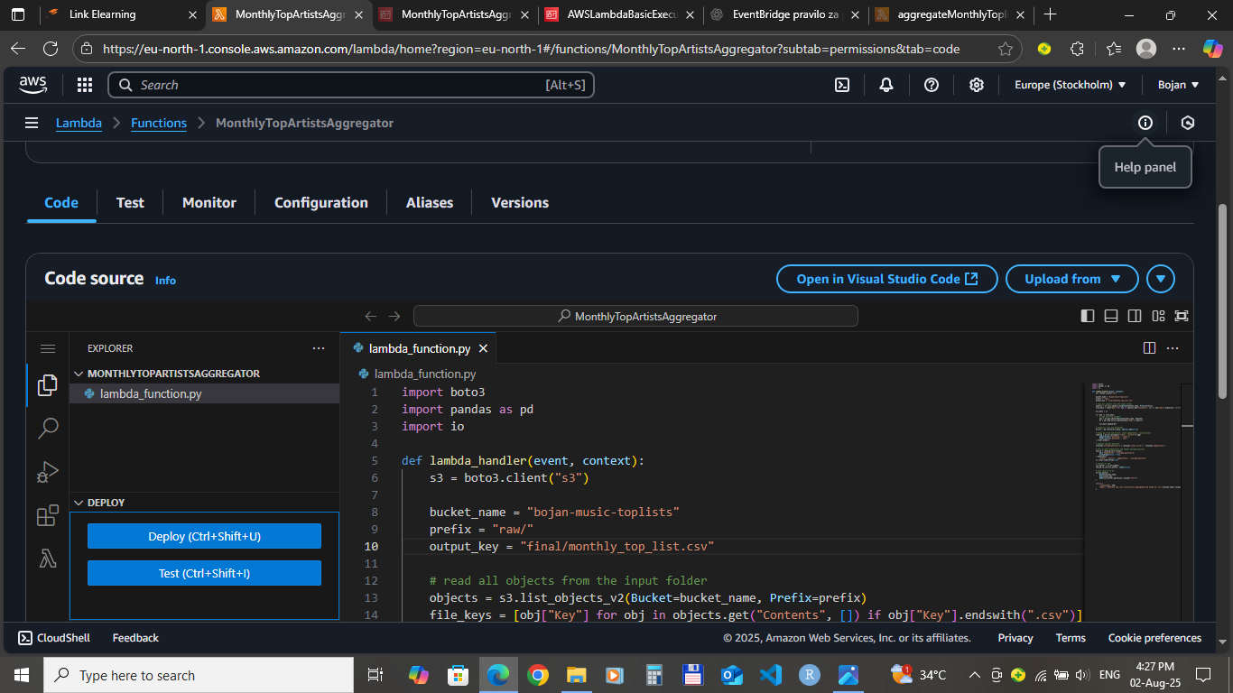

Figure 5 - Lambda_Function.png

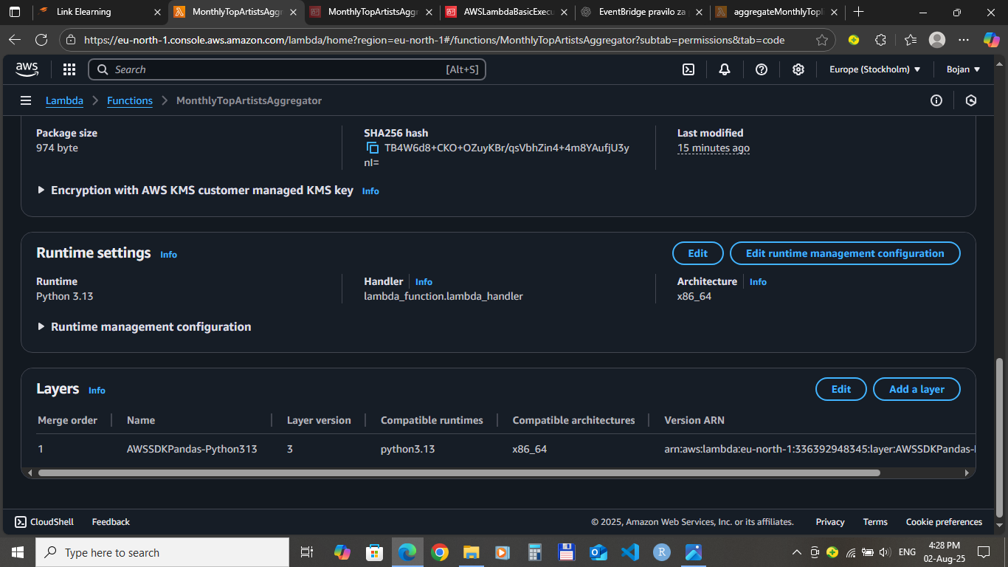

Figure 6 - Lambda_Configuration.png

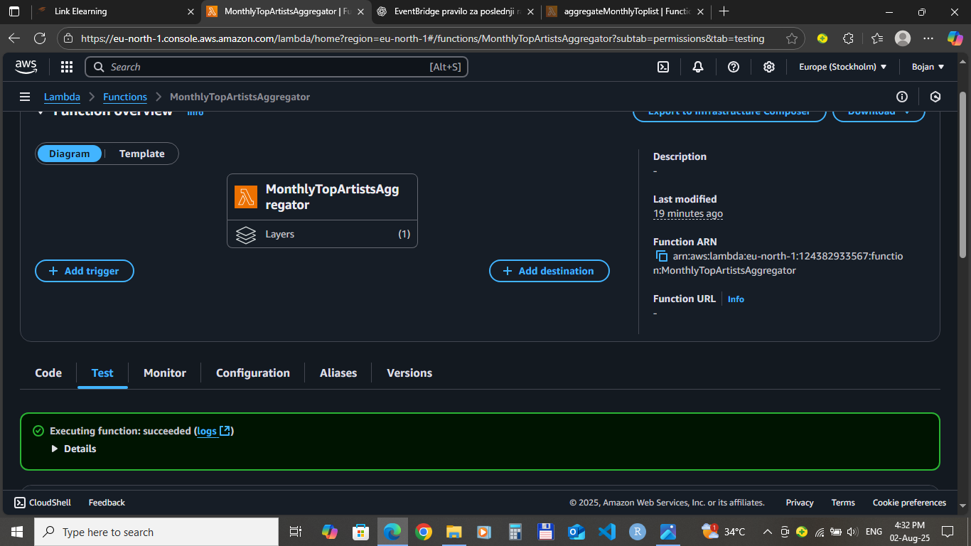
Figure 7 - Lambda_Test_Even.png

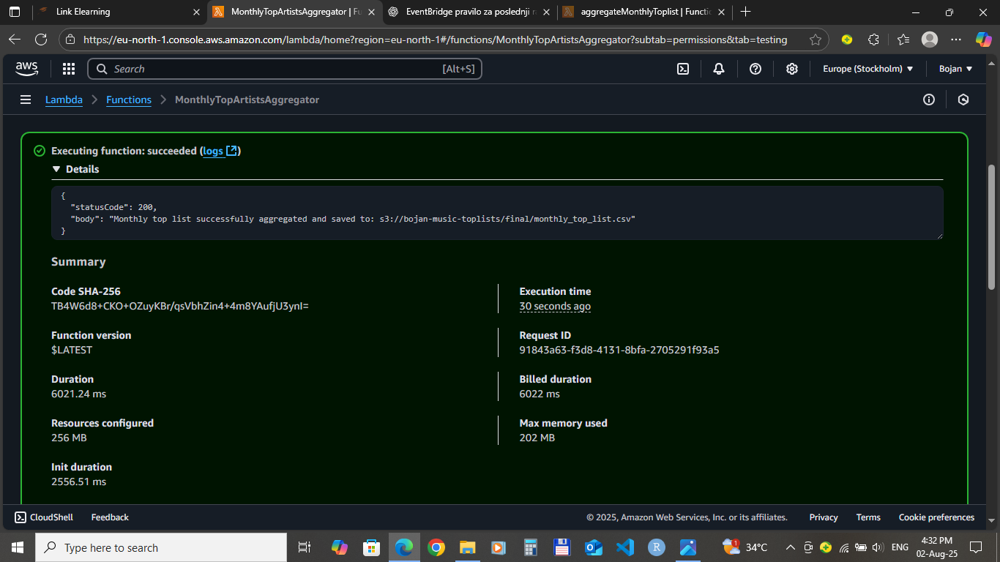

Figure 8 - Lambda_Execution_Result.png

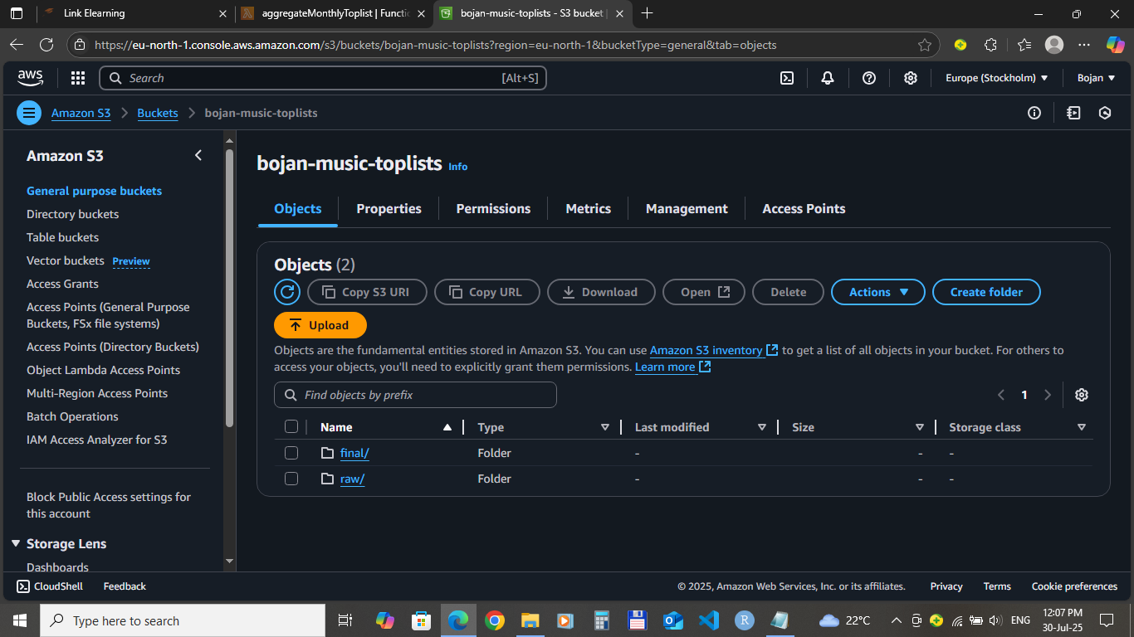

Figure 9 - Final_Output_File.png

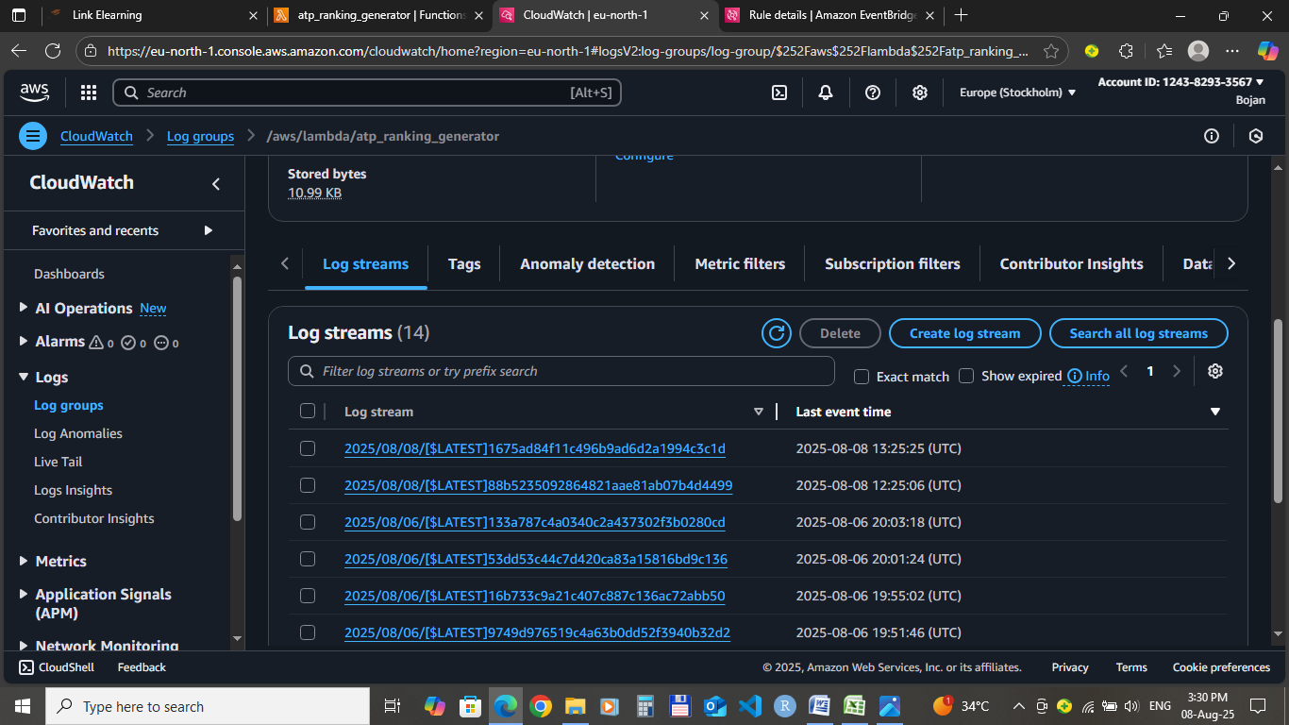

Figure 10 - CloudWatch_Logs.png

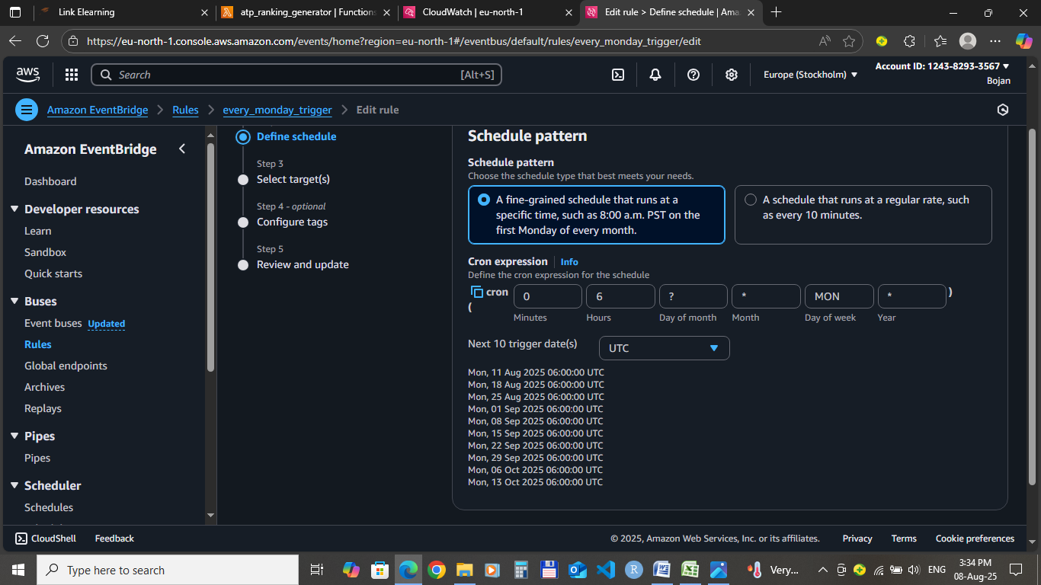

Figure 11 - EventBridge_Rule.png

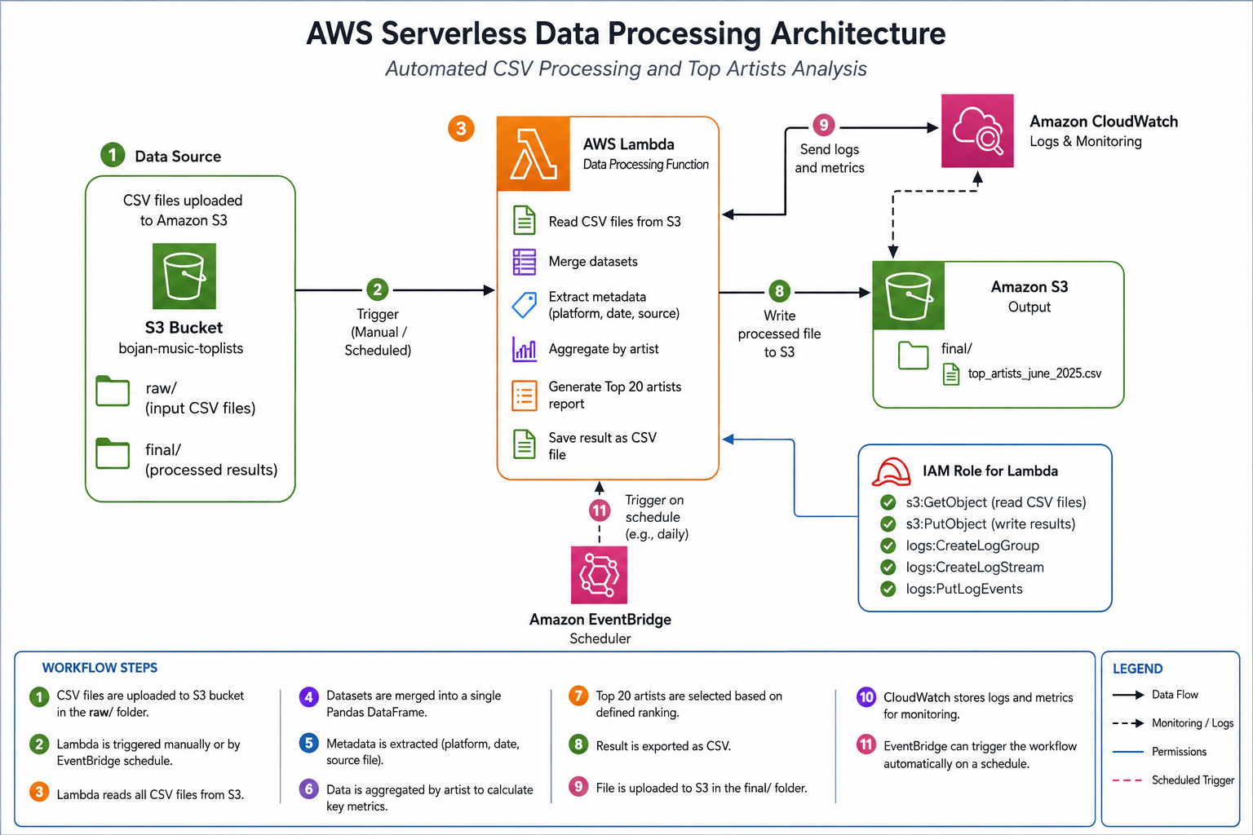

Figure 12 - Project_Architecture.png

GitHub Repository
View AWS Cloud Automation & Serverless Data Processing Project on GitHub

Recruiter Summary
This project demonstrates practical experience in designing and implementing serverless cloud solutions using Amazon Web Services and Python. It highlights my ability to integrate multiple AWS services, automate cloud workflows, process structured datasets and develop maintainable Python applications. The project reflects a structured engineering approach, combining cloud infrastructure, backend development and technical documentation into a complete real-world solution.

