**Kriging**

**Ordinary Kriging**

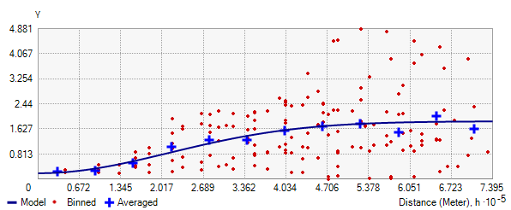

Semivariogram Ordinary kriging

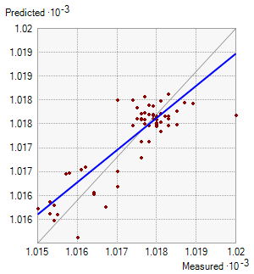

Mean - 0.01562160616377355

Root mean square - 0.545959160037911

|  |  |
| --- | --- |
| *Ordinary Kriging Srbija* | *Spherical Kriging Srbija* |
| *Kriging Exponential Srbija* | *Kriging Gaussian Srbija* |