**Functional & Technical Specification**

**Name:** Reporter – Reports Exporter

**Version:** 1.0.0.0

**Developer:** Bojan Gluvacevic

**Contact:** bojan@gluvacevic.eu

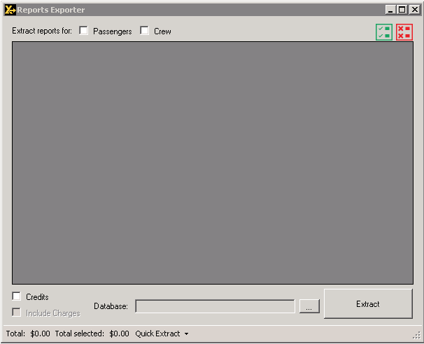

**Short description:**

Reporter can be used as backup to Convert reporting feature and/or as alternative for daily usage.

It connects to the Convert database and reads all information from it, does not alter or change them in any way. Connection to the DSIBilling.mdb database is strictly read only.

**Basic Interface Explanation:**



1. Select the type of reports for export. This is the main switch for fetching reports. You can select individual or combined reports.
2. Select or deselect all available packages on display.



1. Toggle between type of reports you desire
   1. Credits – Display only credits for desired type of reports (See 1)
   2. Include Charges – Display combined summary taking in consideration both charges and credits for desired type of reports (See 1).
2. Selection of DSIBilling.mdb database. If the Reporter is run on the DSI Server, it will automatically recognize the database upon start. In case we want to pull out a report from a different database file, this is where we would browse for the Access database file.

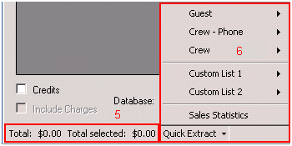

1. Total displays summary of Amount Due for all fetched and displayed items in the grid, while Total selected displays summary of Amount Due only for selected items.
2. Quick Extract will generate the same extract like Convert for either Guest, Crew – Phone, or Crew (Internet).
   1. Custom List 1 and Custom List 2 are user defined packages that are being extracted on a frequent basis. Instead of filtering through full extract, this can extract charges, credits or combined reports of both with one click.
   2. Sales Statistics will generate report for charges made to the point of extract in following order:
      1. Passenger Internet Statistics
         1. Breakdown per day for each Passenger package that displays how amount of $ revenue for the date
         2. Percentage of participation for the package in total revenue for the day
         3. Percentage of sales of the package considering the total revenue up to the date of extract.
      2. Crew Internet Statistics
         1. Same like Passenger Internet Statistics but only with Crew Internet Packages
      3. Crew Phone Statistics
         1. Same as above, but only for the OceanPhone sales
      4. Combined Cruise Sales Statistics
         1. Same as above but combines Passenger, Crew Internet, Crew Phone packages for full daily report.
      5. Cruise Package - Passenger Summary
         1. Displays breakdown of all Passenger packages with count of packages sold (amount displayed is total = (sold – refunded)
         2. Unique users tells us how many purchases were unique (same person buying 2 packages will count as 1)
         3. Grand Total – summary of revenue for the package up to the point of extract
         4. % of Revenue Total – participation of the package in total cruise revenue up to the point of extract
      6. Cruise Package - Crew Internet Summary
         1. Same as above, just for the Crew Internet packages
      7. Cruise Package - Crew Phone Summary
         1. Same as above, just for the OceanPhone sales
      8. Cruise Package - Summary All
         1. Same as above but combined view for Passenger, Crew Internet and Crew Phone packages

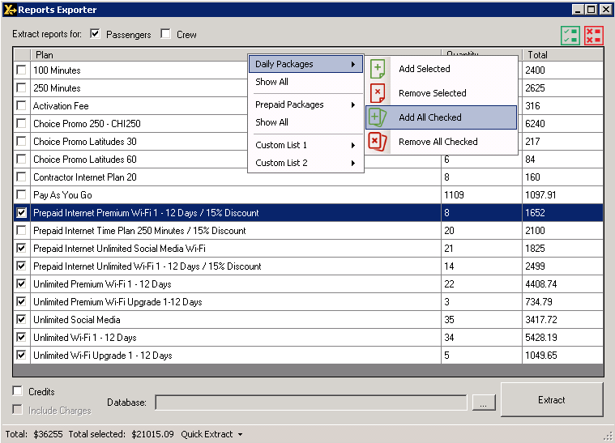

1. When Records are displayed, right click on the grid will bring a menu that offers adding Selected/Checked items to following lists:
   1. Daily packages (*)
   2. Prepaid packages
   3. Custom List 1 – User defined list for quick extract
   4. Custom List 2 - User defined list for quick extract

(*) If you add a package to Daily Packages then the quantity displayed for package will be recalculated to unique number of activations (eq. 1 Unlimited Package for 7 days is actually Quantity of 7 daily packages of X amount of $ if not added to Daily Packages list, while on the list is counted as 1).

List preferences are stored in the Packages.ini file in the application root directory. Deleting the file won’t affect application stability. For more precise calculations (and easier reading) it is advised to have daily plans added to the list.

1. By pressing the Extract button, checked packages will be extracted into the applications root folder in Extract.csv document.