1. Dataset Overview and Data-Quality Findings
Check | Result | Check | Result
Raw observations | 2,070,834 | Raw columns | 9
Date range | 22 Jan 2008 - 6 May 2021 | Trading dates | 3,347
Conventional missing values | 0 | Duplicate market rows | 638,054
Rows after duplicate removal | 1,432,780 | Backward time jumps | 2,443
Invalid HIGH / LOW rows | 0 / 0 | VWAP outside HIGH-LOW | 4
Complete 390-minute days | 3,320 (99.19%)

The file contains no conventional NA values, but it is not analysis-ready. Duplicate observations and chronological ordering must be corrected before return or forecasting calculations.
2. Temporal Coverage and Price-Level Behaviour
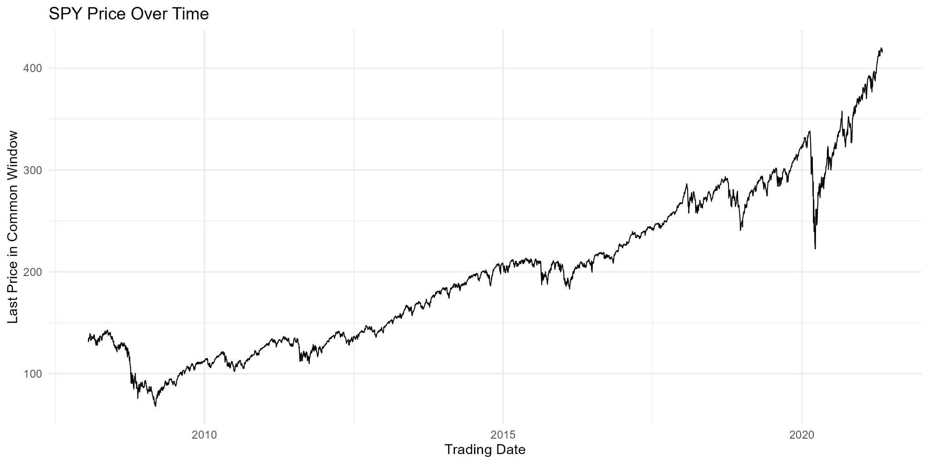
Figure 1. SPY price level using the last price in the common observation window.
- The price level shows a pronounced long-run upward trend with large drawdowns, especially around 2008-2009 and 2020.
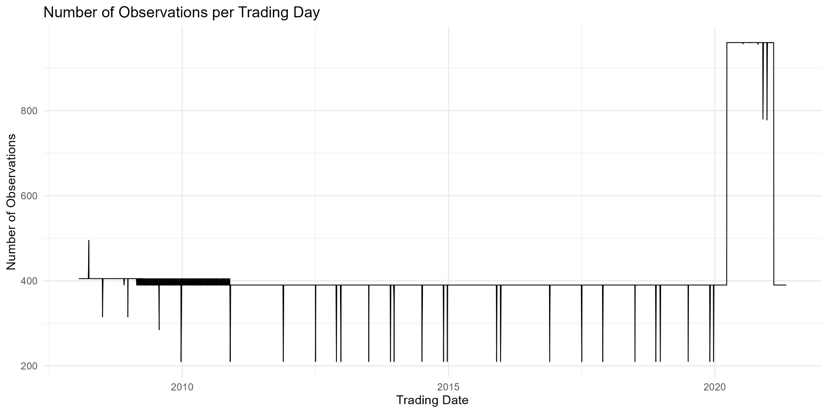
Figure 2. Number of one-minute observations recorded on each trading date.
- The intraday observation window is not constant across the full sample: most days contain 390 observations, while some periods contain approximately 405 or 960 observations and a small set of shortened days contain fewer.
- Using the dominant common window 07:30-13:59 produces 3,320 complete 390-minute days (99.19% of all trading dates).
3. Intraday Structure
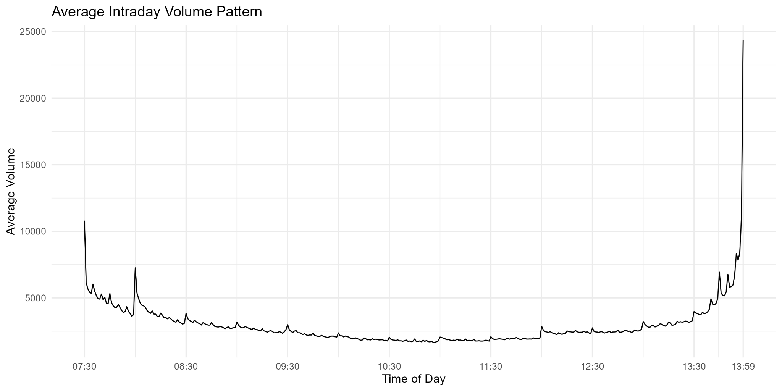
Figure 3. Average intraday volume over complete 390-minute days.
- Trading volume displays a clear U-shaped intraday pattern: activity is high near the beginning of the common window, lower through the middle, and rises sharply near the end.
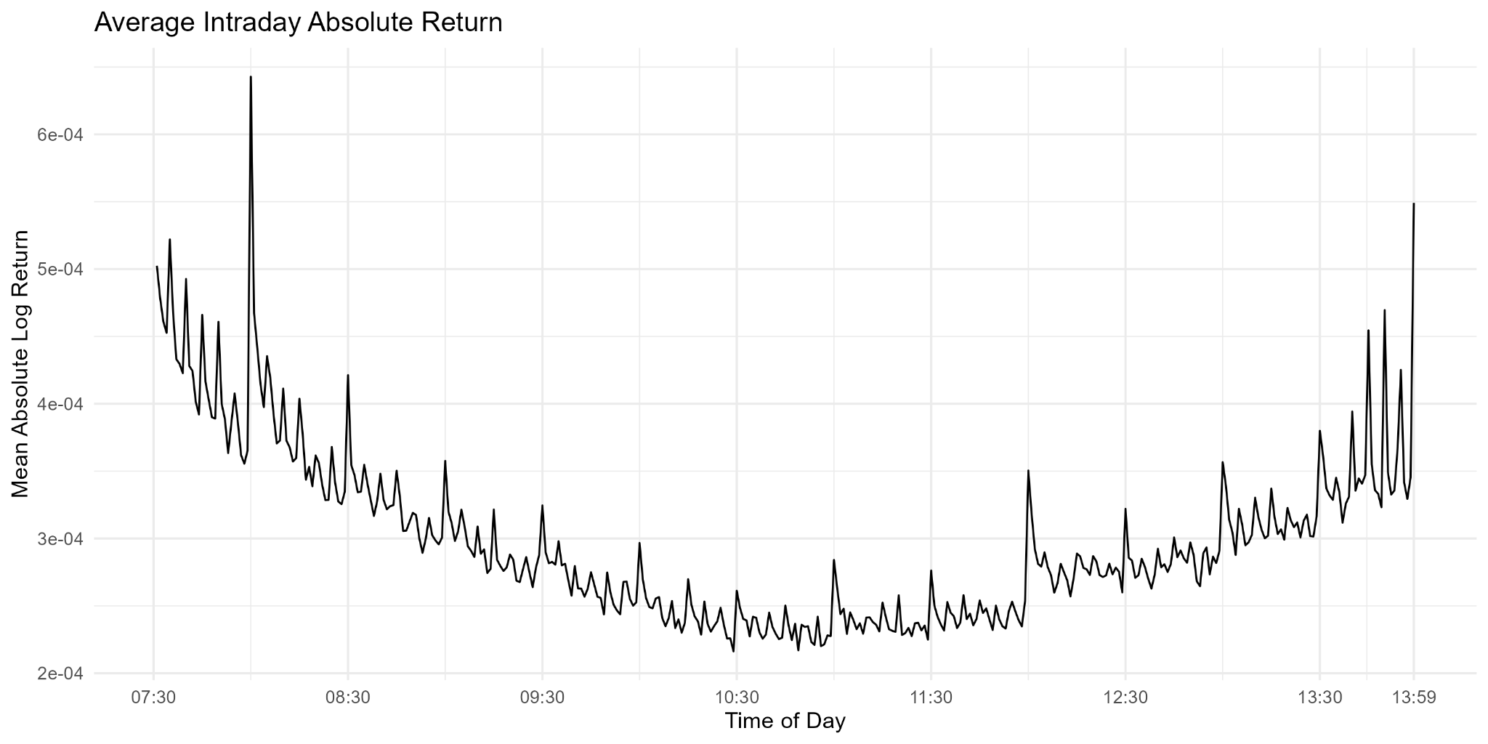
Figure 4. Mean absolute one-minute log return over complete 390-minute days.
- Absolute returns show a similar time-of-day pattern, with higher volatility near the beginning and end and lower volatility around the middle of the window.
- These patterns provide preliminary evidence of strong intraday periodicity and support treating time-of-day structure explicitly in the forecasting representation.
4. Volatility
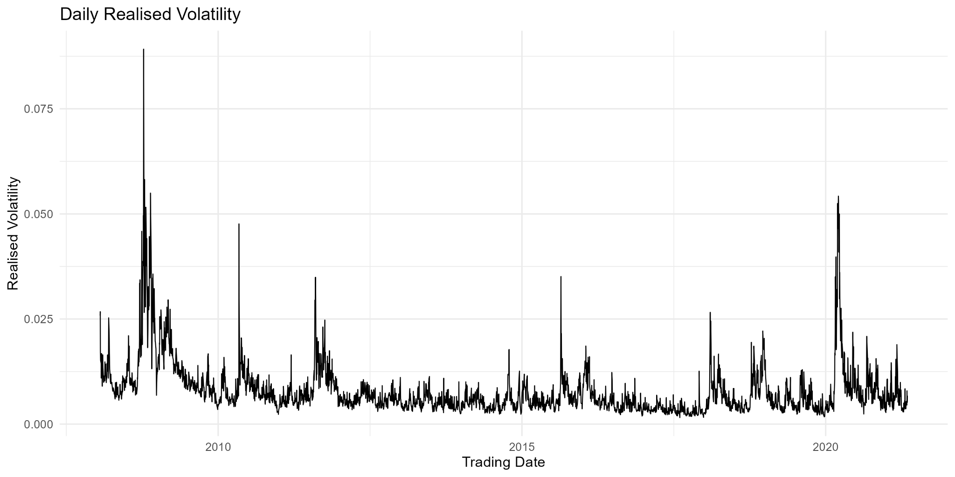
Figure 5. Daily realised volatility calculated from one-minute returns in the common window.
- Realised volatility exhibits clear clustering: high-volatility periods tend to persist, with especially large spikes around 2008-2009 and 2020.
5. Candidate Data Representations
Candidate | Why it fits the data
High-frequency time series | The raw data are observed at one-minute frequency and exhibit strong time-of-day effects.
Functional time series | Each complete trading day can be represented as a 390-point intraday curve; 3,320 complete curves are available.
Multivariate / regression time series | OHLC, volume, trade count and average/VWAP-related information can be used jointly or as explanatory variables.

The functional/high-frequency route is the leading candidate, but the final decision should follow the Week 2 literature review and clarification of the forecasting target and horizon.

