UX CASE STUDY
ArchPro
Designing a dual-portal project management platform for architecture firms
End-to-end UI/UX design — research, IA, design system, hi-fi UI, and responsive web + native mobile delivery

ROLE
Lead Product Designer (UI/UX) — solo design, end to end
TIMELINE
12 weeks, discovery through dev handoff
PLATFORMS
Responsive web (admin + client portals) and native iOS/Android companion app

Contents

1. Project summary

The brief
Small and mid-sized architecture firms run every active project across a scatter of disconnected tools — WhatsApp threads for client feedback, email for drawing approvals, spreadsheets for stage tracking. Nothing in that stack gives a client a self-serve answer to “is my project on track?”, and nothing gives a project manager a single view across every job they’re running. ArchPro was commissioned as the system of record for that entire lifecycle: one platform, two distinct experiences — an internal workspace for the firm’s team, and a lightweight portal for clients to track, review, and approve.

My role
Engaged as solo product designer for the full engagement: stakeholder discovery, competitive and contextual research, information architecture, wireframes, a from-scratch design system, high-fidelity UI for both web portals, a native mobile companion app sharing the same design language, and a structured handoff into development. I also stayed engaged through the build to QA design fidelity against shipped screens.

The outcome
A navy-branded admin workspace and a green-branded client portal, sharing one component library and one design-token system, covering 26 screens on web and full native parity on iOS/Android. The signature interaction — an 8-stage visual lifecycle tracker — appears everywhere a project's status matters, giving both audiences the same mental model of where a job stands, in language tailored to what each side actually needs to do next.

WHY TWO PORTALS, NOT ONE
The earliest stakeholder interviews surfaced a sharp asymmetry: admins manage 5–8 concurrent projects and need density, filtering, and bulk oversight; clients track exactly one project and need reassurance, clarity, and a small number of high-stakes decisions presented with zero ambiguity. Designing one interface for both would have forced a compromise neither side needed — so the system was split into two portals from the IA stage onward, sharing a component library but diverging in density, navigation pattern, and tone.

2. Discovery & research

2.1 Research approach
Discovery combined three lightweight methods chosen to fit a 12-week timeline rather than a full quarter-long research phase:
- Stakeholder interviews — four sessions with the commissioning firm's principal architect, project manager, and two recent residential clients, focused on current workflow and breakdown points.
- Contextual inquiry — shadowed one live project's status update cycle (a phone call plus a WhatsApp photo thread) to map the actual sequence of who-tells-whom-what.
- Competitive teardown — reviewed three adjacent categories (construction PM tools, legal client portals, healthcare patient portals) for patterns in how each handles the same underlying problem: a professional managing many cases, and a layperson tracking one.

2.2 Key findings
Finding | Evidence | Design implication
Status visibility is the #1 complaint on both sides | Every interview independently raised “I don't know what's happening” — from opposite ends | A persistent, always-visible stage tracker became the system's signature component
Clients fear that asking questions looks demanding | Two of two client interviewees said they “didn't want to bother” the architect with status questions | Self-serve status removes the social cost of simply checking in
Rejections without a reason cause the worst delays | Contextual inquiry showed a 2-day delay caused by a vague “not quite right” text message | Comment became a required field on “request changes,” not optional
PMs context-switch across 5–8 projects per day | Stakeholder interview — principal estimated 30+ status check-ins weekly across active jobs | Admin dashboard prioritizes scan-ability: KPI strip, stage-colored badges, one-glance progress bars

2.3 Personas
Two personas anchored every subsequent design decision — referenced explicitly in design reviews to settle disagreements about scope and priority.
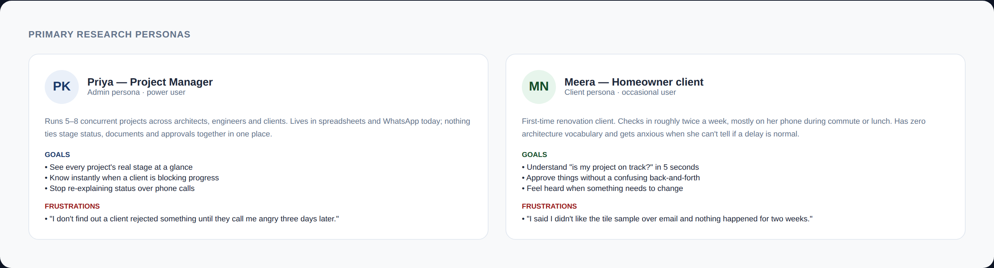
Primary personas synthesized from stakeholder interviews and contextual inquiry.
"I don't find out a client rejected something until they call me angry three days later." — Principal architect, stakeholder interview
"I said I didn't like the tile sample over email and nothing happened for two weeks." — Client interviewee

3. Define: information architecture & flows

3.1 Information architecture
The sitemap deliberately encodes the asymmetry surfaced in discovery: the admin portal carries 15 screens including five org-wide management surfaces (team, clients, reports, notifications, settings) that simply don't exist for clients. The client portal's 11 screens are scoped tightly to tracking and deciding — nothing the client can misconfigure, nothing extra to learn.
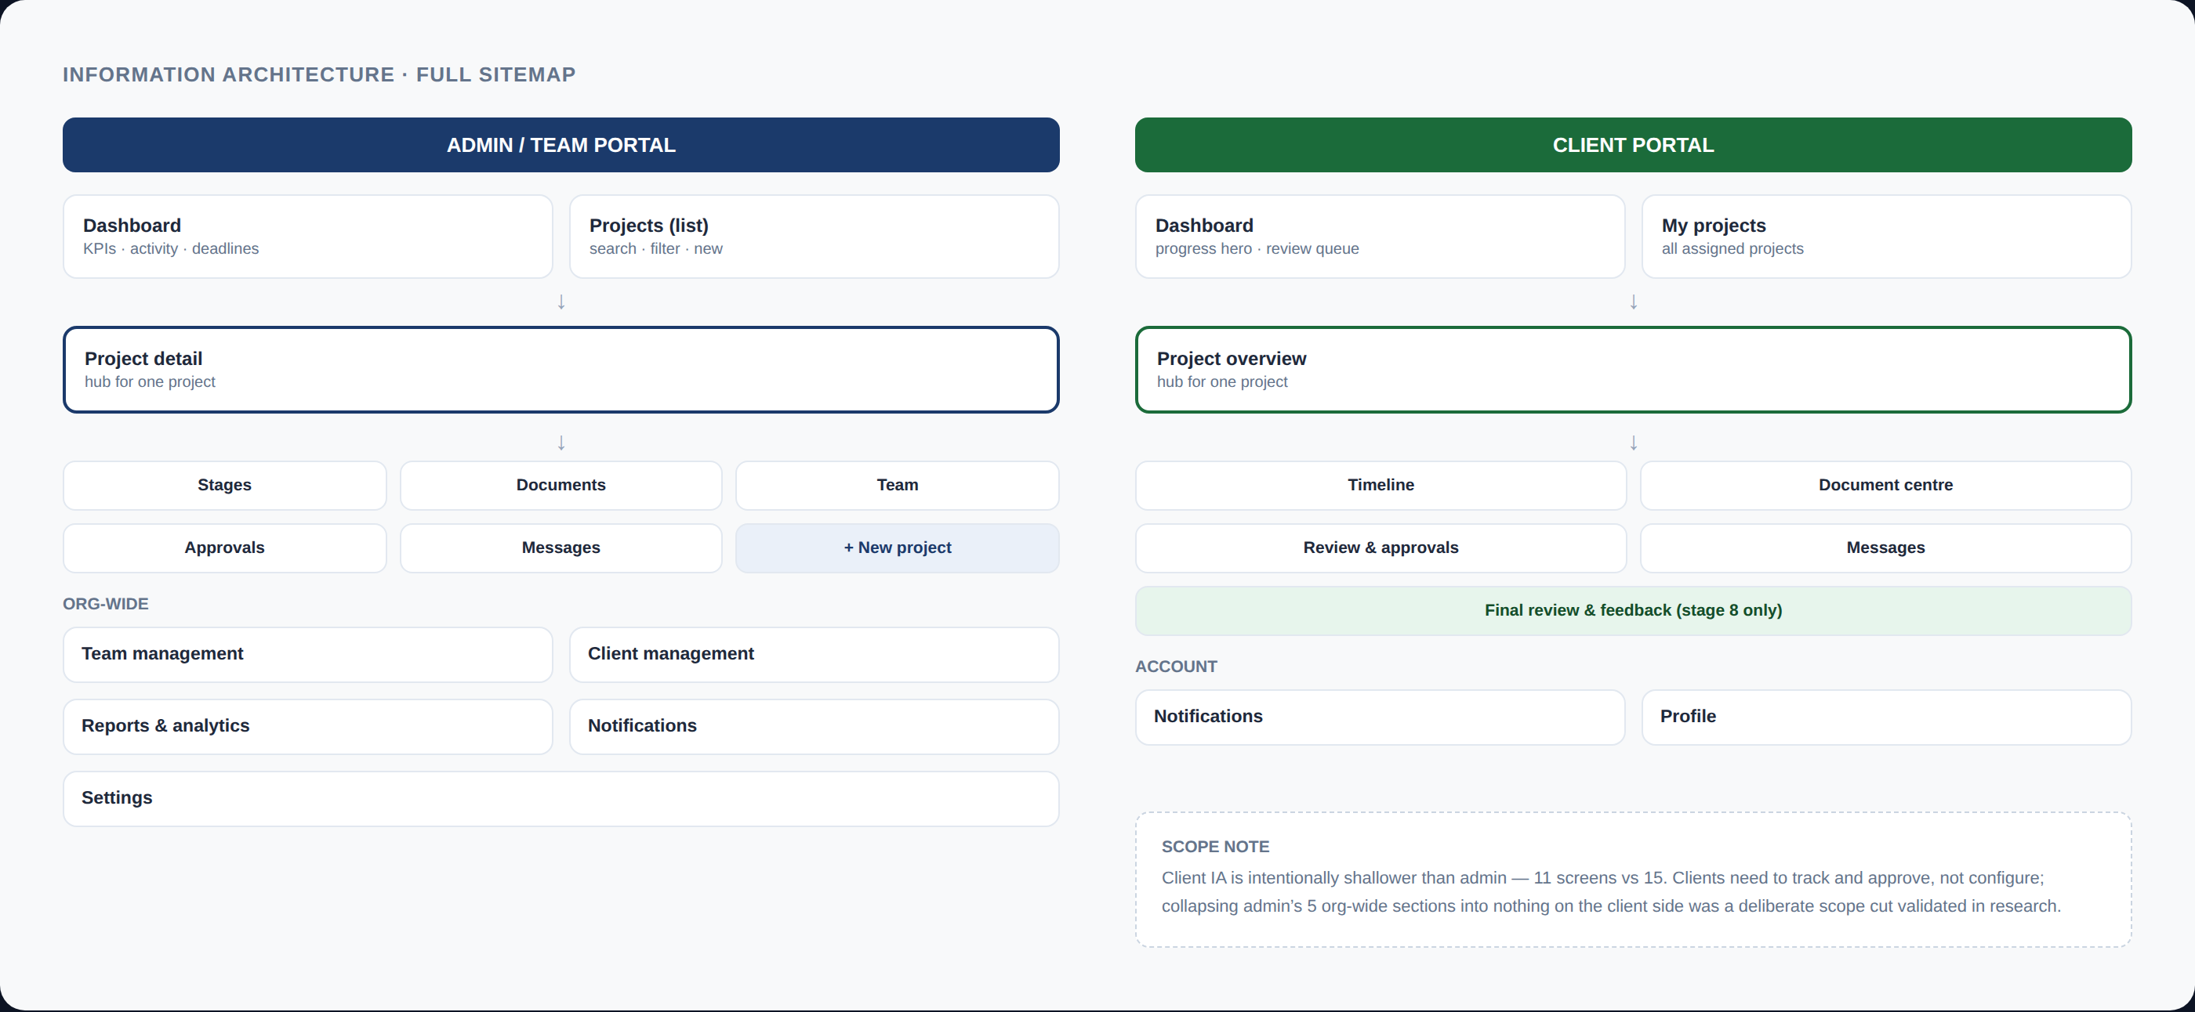

3.2 Critical user flow: stage approval
Of every flow in the system, the approve/reject decision carries the most business risk — it's the single moment a client can stall a project indefinitely with vague feedback, or unblock it instantly with one tap. This flow received the most iteration of any in the system.
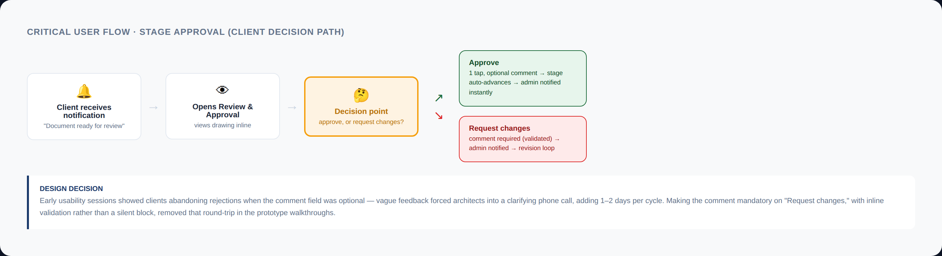

3.3 The 8-stage lifecycle model
Every architecture project in the firm's pipeline moves through the same eight stages, from initial enquiry to final handover. Modeling this explicitly — rather than leaving “status” as a free-text field, which is what the firm used before — is the single structural decision that makes the rest of the system legible. Once stage is a first-class, finite, ordered concept, it can drive navigation, color, notifications, and permissions consistently everywhere.
# | Stage | Who acts | Client-facing label
1 | Project Initiation | Admin | New
2 | Site Survey & Analysis | Admin | In Progress
3 | Concept Design | Admin | Design Development
4 | Preliminary Design | Both | Review Pending
5 | Detailed Design & Documentation | Admin | Documentation
6 | Approval & Permissions | Admin + authorities | Govt Approval
7 | Construction Support | Admin | Execution
8 | Final Review & Submission | Both | Completed

4. Ideate: low-fidelity exploration

4.1 Why low-fi first
With the IA and the core approval flow settled, the next risk was layout density on the admin dashboard — the screen a PM opens 10+ times a day. Three layout directions were sketched in grayscale wireframes and walked through with the principal architect before any color or type decisions were made, deliberately keeping the conversation on hierarchy and information density rather than aesthetics.

4.2 Three directions tested
Direction | Approach | Outcome
A — Feed-first | Chronological activity feed as the primary surface, stats secondary | Rejected — PM said it “felt like a Twitter timeline,” not a workspace; couldn't answer “which projects need me right now” at a glance
B — Table-first | Dense spreadsheet-style project table with sortable columns | Rejected — too close to the spreadsheet workflow we were trying to replace; lost visual stage encoding
C — Card + KPI hybrid | KPI strip up top, scannable project cards with embedded progress bars below | Selected — tested well for “glance and decide” use; carried forward to hi-fi

A NOTE ON FIDELITY
Wireframes for this engagement were deliberately low-resolution sketches reviewed live in working sessions rather than a polished Figma deliverable — the firm's stakeholders responded far better to fast pen-and-paper iteration than to a deck. The artifact that matters for this case study is the decision record above, not a wireframe gallery; the real design thinking shows up in how those decisions shaped the design system and hi-fi screens that follow.

5. Design system

5.1 Principles
- Token-driven, not page-driven — every color, radius, and spacing value traces back to a single token file; nothing is a one-off hex code on a screen.
- One system, two skins — the admin and client portals share every component; only a single “portal accent” token swaps between navy and green at the root.
- Stage color is sacred — the 8-stage palette is the one piece of color-coding that must never collide with semantic color (success/warning/danger), so it was defined as its own independent ramp from day one.
- Built for two renderers — every token had to resolve cleanly in both Tailwind CSS (web) and React Native StyleSheets (mobile) from the same source values, which ruled out anything clever like CSS calc() chains.

5.2 Token reference
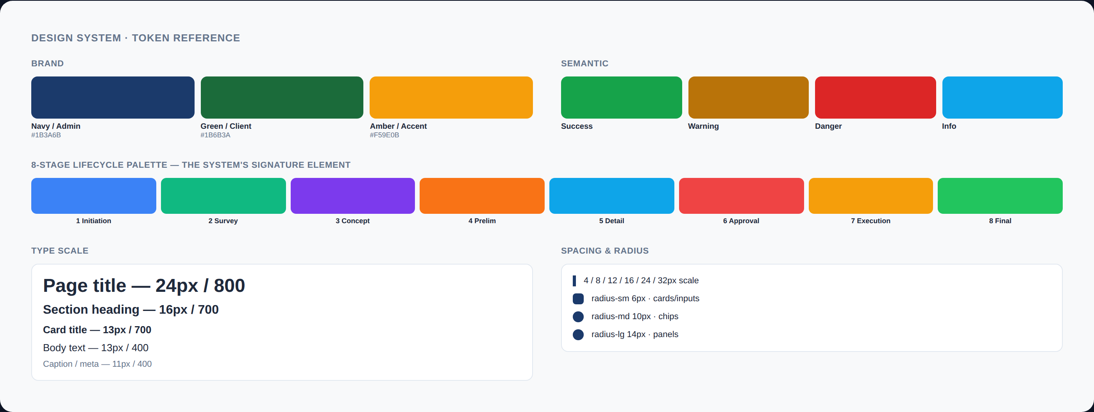

5.3 Component inventory
36 components were built into the shared library, documented and reused across all 26 web screens and their mobile equivalents. The highest-leverage components:
Component | Purpose | Used on
StageTracker | The 8-node lifecycle visual — horizontal scroll on compact views, vertical timeline on dedicated timeline screens | 12 of 26 screens
StageBadge | Pill badge auto-colored from the same stage palette as the tracker | Every project list/card
ProgressHero | Client-only gradient card combining stage badge, % complete, and ETA in one glanceable block | Client dashboard, overview
MessageThread | Shared chat UI for admin↔client communication, with own/other bubble alignment | Both portals' messaging screens
ApprovalQueueList / ReviewQueueList | Differently-worded, identically-structured queues — admin sees “awaiting client,” client sees “needs your review” | Both dashboards

5.4 A system decision worth flagging
Icons are rendered as inline SVG path data rather than an icon font. This was not an aesthetic choice — it was a resilience one: icon-font CDNs are a common single point of failure, and a missing glyph silently renders as a blank box that's easy to miss in QA. Inlining the actual path data (shared verbatim between the web and React Native codebases) means an icon either renders correctly or the build fails loudly. Small decision, but it's the kind of robustness thinking that separates a portfolio mockup from a system built to actually ship.

6. High-fidelity UI — web
Twenty-six screens across both portals were taken to full visual fidelity. The four below represent the range of UI complexity in the system — a data-dense dashboard, a hub-and-spoke detail page, a stateful workflow screen, and the dark-mode variant proving the token system holds up under a full theme swap.

6.1 Admin dashboard
The scan-and-decide surface a project manager opens first every day. KPI strip up top answers “how's my book of business doing” in one glance; the project list below carries the stage badge and progress bar pairing established in the design system; the lifecycle tracker for the most urgent project anchors the bottom of the fold.
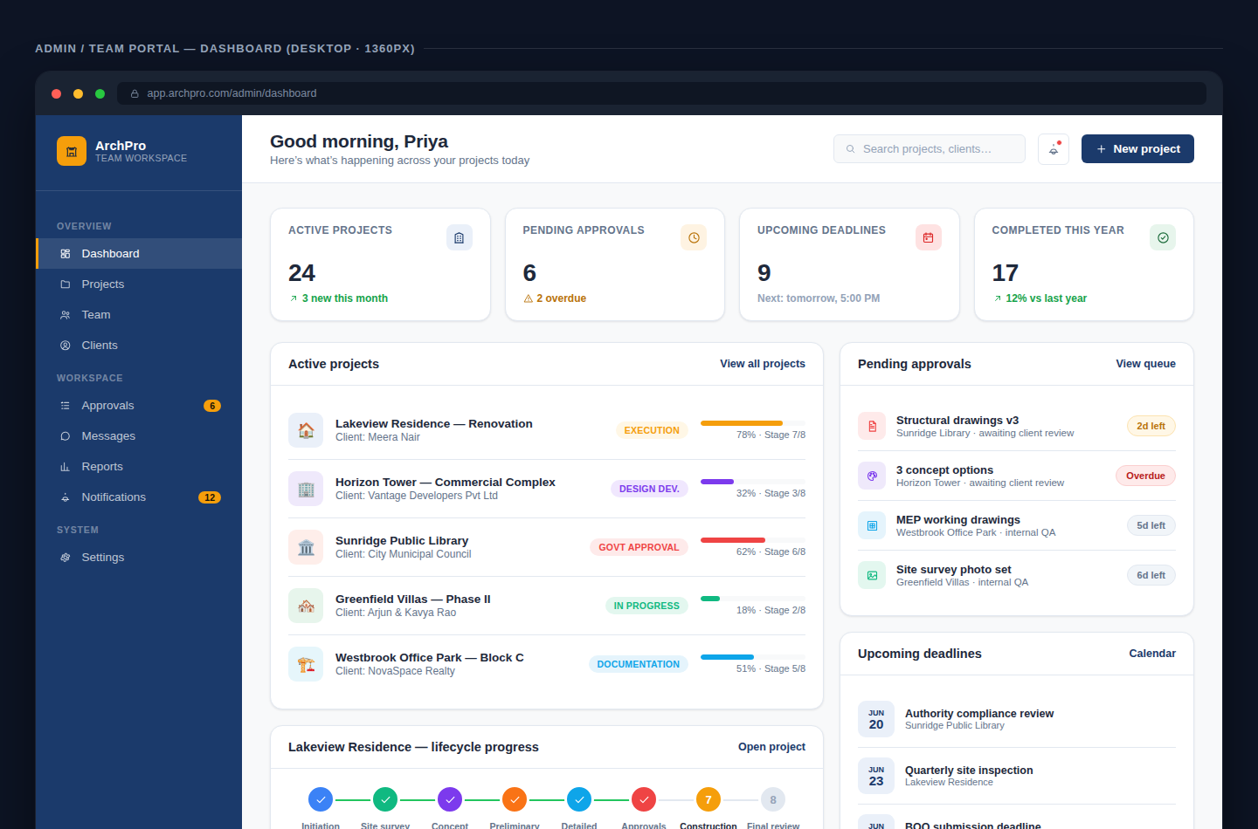

6.2 Project detail — the cross-portal hub
Every admin project collapses into this one screen: status, budget, the lifecycle tracker, and five quick-link cards into stage management, documents, team, approvals, and messages. This hub-and-spoke pattern, established here, is the same structural pattern the client portal's “Project overview” screen uses — intentionally, so a user moving between admin context and a client-facing screenshot during a support call recognizes the shape instantly.
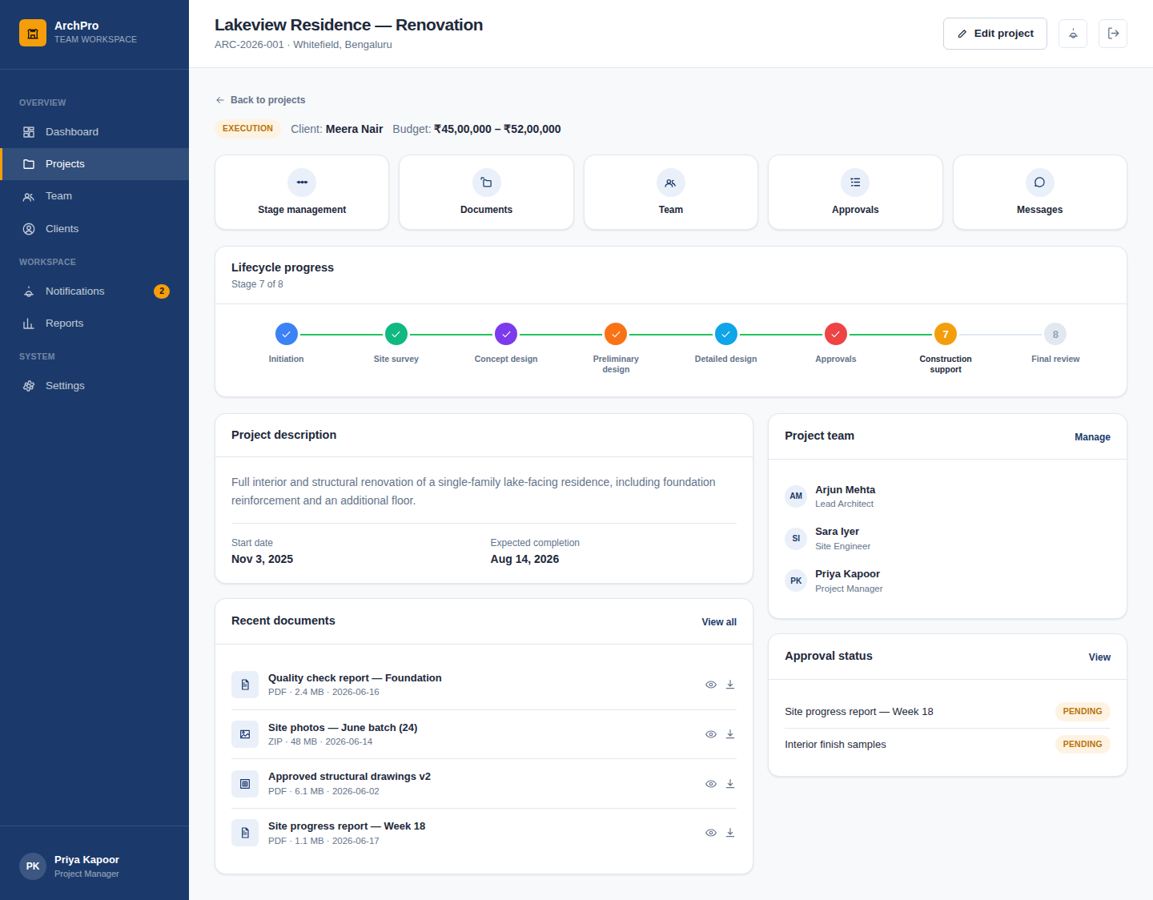

6.3 Stage management — the most stateful screen in the system
This is where the milestone-checklist interaction lives: an admin works through stage-specific tasks, watches a live progress bar update, and the primary action — “Request client approval” — stays disabled until every milestone is checked. That disabled-until-complete pattern recurs everywhere in the system a high-stakes action follows a checklist (it reappears verbatim in the client's Final Review screen on mobile, shown in section 8).
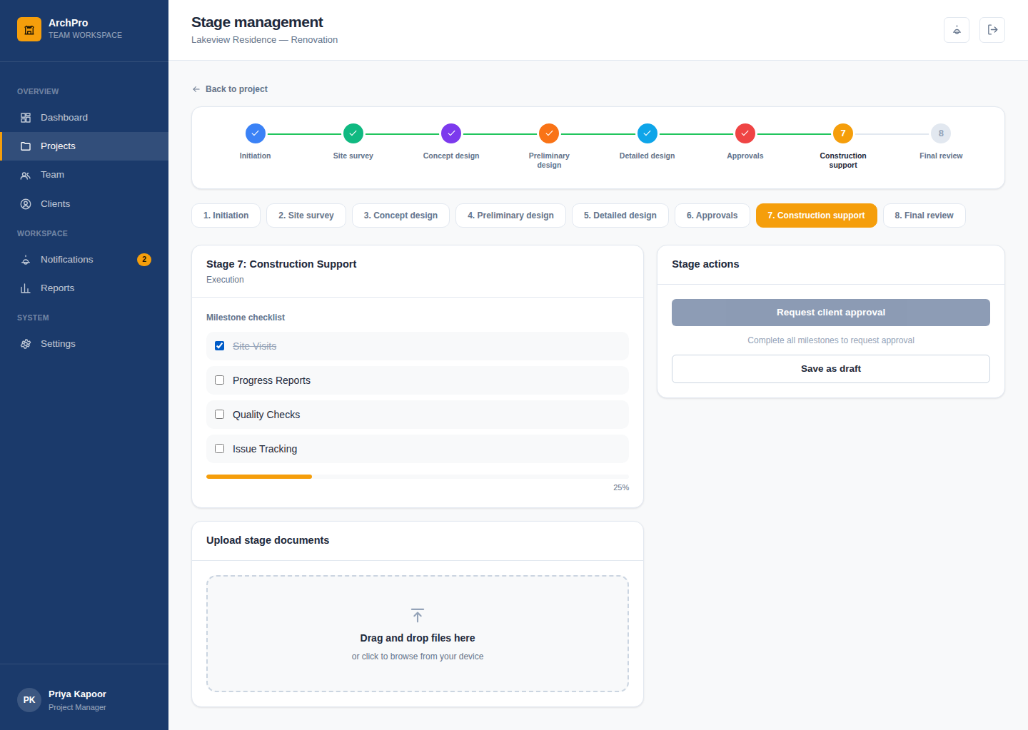

6.4 Dark mode — stress-testing the token system
Dark mode was treated as a token-system test, not a separate design pass. The first attempt revealed a real legibility bug: icon chips that sat on a tinted background (e.g. a light-blue circle behind a folder icon) used the same blue for both background and icon in dark mode, rendering the icon invisible. The fix was a dedicated on-tint token — a color guaranteed to stay legible against its own tinted background regardless of theme — rather than a one-off patch, so the same class of bug can't recur as new components are added.
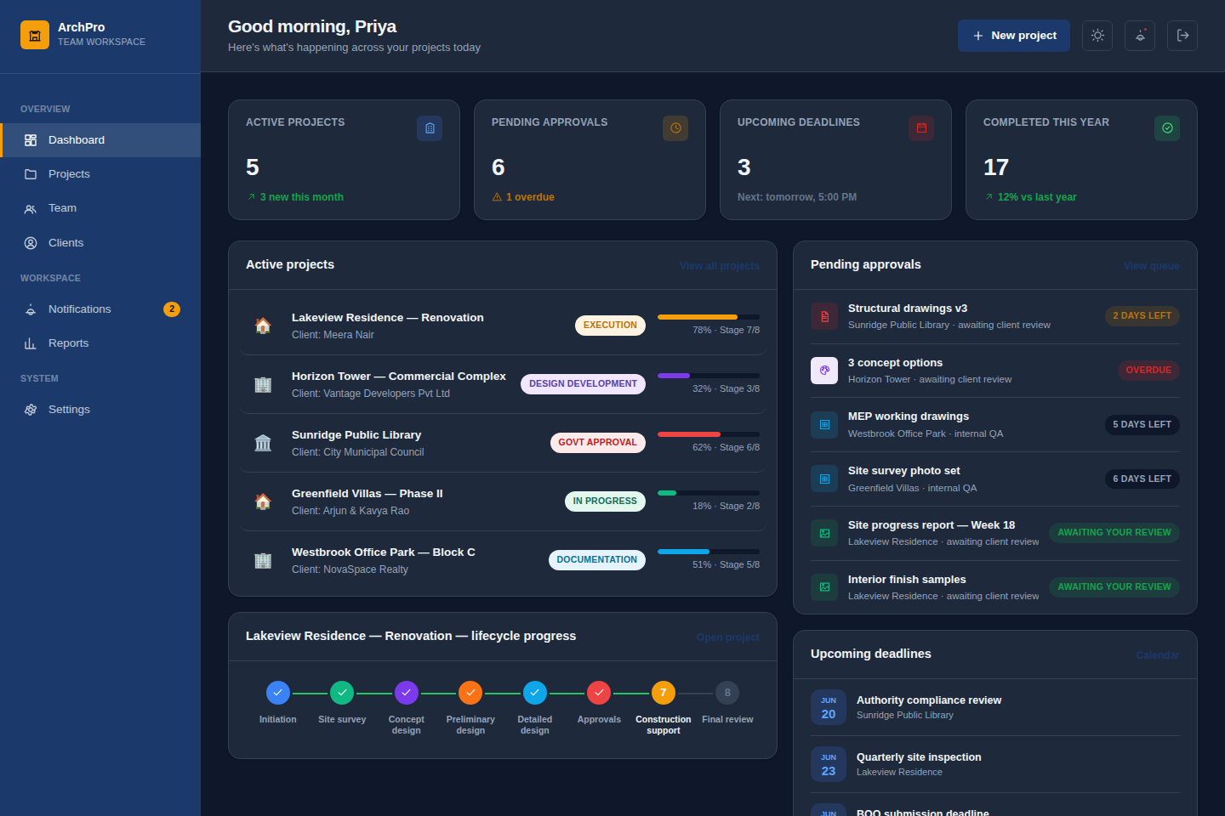

7. Native mobile adaptation

7.1 Why native, not just responsive
The web app is fully responsive, but client research made clear that the client side of this product is overwhelmingly a phone-first habit — checked twice a week, mid-commute, in short sessions. Rather than ship a cramped responsive view of an admin-density web layout, the decision was to design a true native companion app (React Native / Expo) for both portals, sharing the design tokens and component logic but rebuilt for native interaction patterns: bottom tab bars instead of a sidebar, native pickers instead of dropdowns, swipe-back gestures, and a keyboard-aware chat composer.

7.2 Translating the design system to native
The hardest constraint of this phase: React Native has no CSS custom properties, so the web app's runtime theme-swap (one root attribute changes navy to green) had no direct equivalent. The solution was a React Context that resolves the same logical tokens — portal accent, light/dark — into a flat color object every component reads from. Same mental model as the web token system, different plumbing underneath.
Web pattern | Native equivalent | Why it had to change
CSS variables + [data-portal] attribute | React Context resolving a flat palette object | No CSS custom properties in React Native
Sidebar navigation | Bottom tab bar + nested stack navigators | Touch-first navigation convention on mobile
Drag-and-drop file upload | Native document picker (tap to open OS file browser) | No drag-and-drop concept on a touchscreen
CSS linear-gradient on the client progress hero | expo-linear-gradient native module | CSS gradients have no React Native equivalent
HTML <table> for org-wide lists | Stacked card list | Tables don't reflow usably below ~400px width

7.3 High-fidelity mobile screens
Full screen-for-screen parity was carried to native: all 26 web screens have a corresponding mobile screen. The set below shows the same signature lifecycle tracker, KPI grid, and approval pattern established on web, now in a 375pt-wide iOS frame with the platform's own status bar and home indicator.
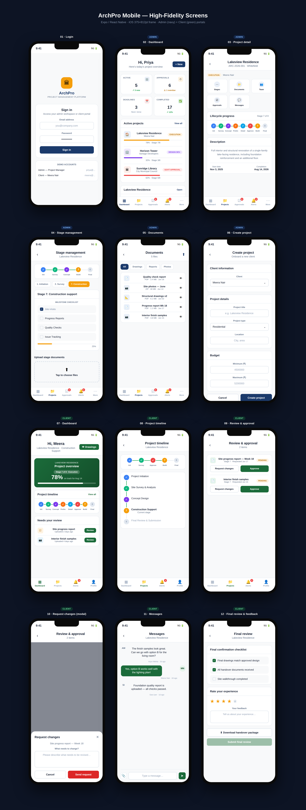
All 12 representative mobile screens — admin (navy) and client (green) portals, iOS frame.

7.4 Detail: the request-changes modal
The mandatory-comment decision from the core approval flow (section 3.2) carries through to mobile as a bottom-sheet pattern — the native convention for a focused, dismissible action, versus the centered dialog used on web. Same rule, same validation, platform-appropriate presentation.
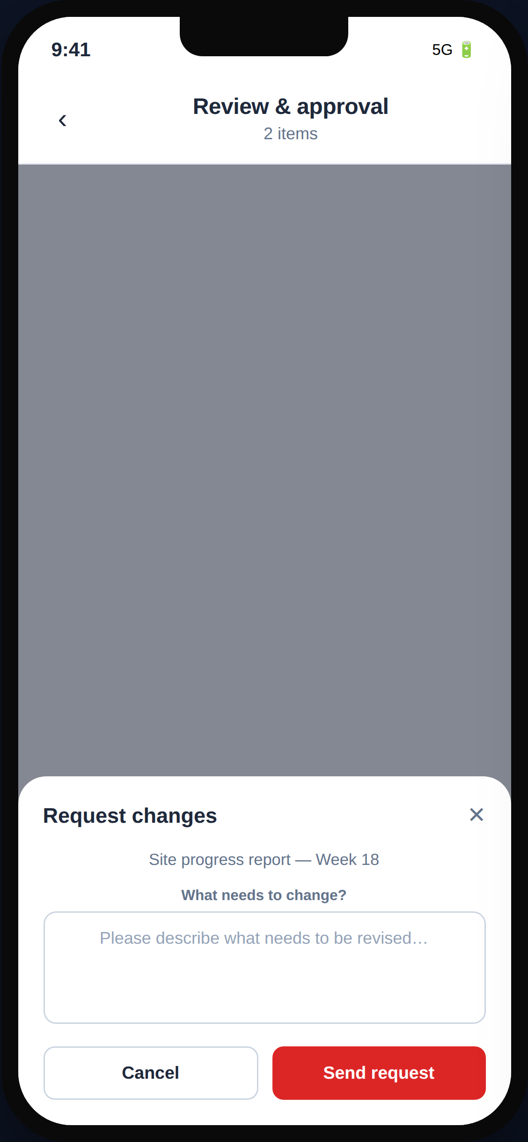

8. Usability validation

8.1 Method
Five moderated remote sessions were run against the high-fidelity prototype before development handoff — three with admin-side participants (project managers from outside the commissioning firm, to avoid bias) and two with people matching the client persona who had no prior exposure to the product. Each session used a think-aloud protocol across three scripted tasks: find a specific project's current stage, upload a document and route it for client approval, and (client-side) reject a document with feedback.

8.2 What broke, and what changed
Issue observed | Severity | Resolution
2 of 3 admin participants didn't notice the disabled state on “Request client approval” — tried clicking it repeatedly | High | Added an inline helper line — “Complete all milestones to request approval” — directly under the button rather than relying on opacity alone to communicate disabled state
Both client participants hesitated before tapping “Approve” — unsure if it was reversible | Medium | Added a lightweight confirmation step showing exactly what they were approving before the action commits
One participant didn't realize the colored stage dots were tappable history, not just decoration | Low | Deferred — logged as a future enhancement rather than blocking the dots' core purpose as a status display
Stage names (“Concept Design,” “Detailed Design & Documentation”) read as jargon to client participants | Medium | Kept internal admin labels accurate to industry terms, but the client-facing status badge uses the plain-language equivalent (e.g. “In Progress”) established back in section 3.3's stage table

"Oh — I get it now, I just couldn't tell it was greyed out on my screen." — Admin participant, session 2, on the disabled-button finding

9. Handoff & developer collaboration

9.1 What shipped to engineering
- A single source-of-truth token file per platform (CSS variables for web, a parallel JS token object for native) — engineering was instructed to treat these as the only place color/spacing/radius values may originate.
- A component inventory mapped 1:1 to the code's actual component names, so design review comments could reference “StageBadge” and have that mean the same thing to design and engineering.
- Annotated flow diagrams for every multi-step interaction (the approval flow in section 3.2 was the template for the rest).
- A written rationale doc for every place mobile diverges from web behavior, so engineering wouldn't “fix” an intentional platform difference back to parity.

9.2 Staying engaged through build
I continued through implementation as the design-fidelity reviewer rather than handing off and disengaging — catching exactly the kind of drift that’s invisible in a static spec: the disabled-button helper text from usability testing initially shipped without it (a regression from an earlier build), and a dark-mode icon-contrast issue identical in kind to the one caught in section 6.4 reappeared on a screen added after the initial design pass. Both were caught and corrected before release by treating every new screen as a real audit against the token system, not just a visual approval.

OUTCOME
26 web screens and full native parity shipped from one design system, two color skins, and zero one-off components. The lifecycle tracker established in week 3 of discovery appears, unmodified in structure, on the very last screen built in week 12 — the strongest evidence that the early information-architecture decision to make “stage” a first-class concept was the right one.

10. Reflection

10.1 What I'd do differently
- Run the usability sessions one phase earlier — against the mid-fidelity wireframes rather than waiting for full hi-fi. The disabled-button confusion in section 8.2 was a layout/affordance issue, not a visual one, and could have been caught (and fixed more cheaply) before color and type were finalized.
- Recruit client-persona testers with more variation in age and tech comfort — both client-side participants were relatively tech-fluent; the real client base skews toward less frequent app users, and I'd want more signal on whether the approval flow holds up for someone less confident on a touchscreen.
- Define the dark-mode token rules (section 6.4) before the first hi-fi screen, not after — retrofitting the on-tint token across already-built screens cost more time than designing with that constraint from the start would have.

10.2 What carried the project
The single decision that paid off the most was the earliest one: treating “stage” as a finite, ordered, first-class data structure rather than a status string. Every other significant design decision in this case study — the shared component library, the two-portal IA split, the badge and tracker components, even the dark-mode token fix — was downstream of that one structural choice holding up under real use.

IN ONE SENTENCE
ArchPro is a case study in letting a single, well-modeled domain concept — the 8-stage project lifecycle — drive information architecture, visual system, and cross-platform consistency, rather than treating each as a separate design exercise.

