VISOKA ŠKOLA STRUKOVNIH STUDIJA ZA INFORMACIONE I KOMUNIKACIONE TEHNOLOGIJE

Dokumentacija
Praktikum iz web programiranja PHP / Web Programiranje PHP2
Skar Sneakers

Milan Bojkovski 9/22

Sadržaj
Uvod 3
Korisćene tehnologije 3
Opis funkcionalnosti 3
Template 4
Struktura projekta 5
Struktura baze podataka 6
Funkcionalnost sajta 6
Home stranica 7
Products stranica 8
Product details stranica 9
Cart stranica 9
Orders stranica 10
Order details stranica 10
Registracija 11
Login 12
Admin Dashboard stranica 12
Admin Statistics stranica 13
Admin Products stranica 14
Admin Add Product stranica 15
Admin Edit Product stranica 15
Admin Delete Product modal 16
Admin Users stranica 16
Author stranica 17
Dokumentacija 17
Kodovi 18
index.php 18
ajax/products.php 30
assets/css/style.css 31
assets/js/main.js 34
config/connection.php 39
helpers/mail.php 40
models/auth.php 42
models/cart.php 44
models/order.php 45
models/product.php 47
models/user.php 51
views/layout/head.php 56
views/layout/top-nav.php 57
views/layout/footer.php 60
views/pages/activate 61
views/pages/author.php 62
views/pages/cart.php 64
views/pages/home.php 67
views/pages/login.php 70
views/pages/logout.php 74
views/pages/my_orders.php 74
views/pages/order_details.php 76
views/pages/product.php 79
views/pages/products.php 81
views/pages/register.php 84
views/pages/admin/dashboard.php 89
views/pages/admin/product_add.php 93
views/pages/admin/product_edit.php 96
views/pages/admin/products.php 100
views/pages/admin/stats.php 105
views/pages/admin/users.php 110

Uvod

Korisćene tehnologije
Projekat je razvijen koristeći PHP, MySQL, HTML, CSS i JavaScript uz Bootstrap framework za frontend stilizaciju i responzivni dizajn.

Opis funkcionalnosti
- Sistem omogućava registraciju novih korisnika uz osnovnu validaciju unetih podataka, kao i aktivaciju naloga putem linka poslatog na email adresu korisnika. Implementiran je login sistem sa zaštitom od brute-force napada, gde se nalog privremeno zaključava nakon više neuspešnih pokušaja prijave.
- Aplikacija koristi role-based sistem gde se korisnici dele na obične korisnike i administratore, pri čemu administratori imaju dodatne privilegije u upravljanju sistemom.
- Korisnici mogu pregledati listu proizvoda koja podržava filtriranje po brendu i kategoriji, kao i sortiranje po različitim kriterijumima kao što su cena i datum dodavanja.
- Svaki proizvod ima svoj detaljan prikaz sa osnovnim informacijama, cenom, opisom i slikom proizvoda.
- Korisnici mogu dodavati proizvode u korpu, menjati količinu proizvoda u korpi ili ih u potpunosti ukloniti iz nje.
- Implementiran je checkout proces koji omogućava kreiranje porudžbine na osnovu sadržaja korpe, nakon čega se korpa prazni.
- Korisnici imaju mogućnost pregleda svojih porudžbina, kao i detaljan uvid u svaku pojedinačnu porudžbinu uključujući proizvode, količine i ukupnu cenu.
- Svaka porudžbina ima status koji može biti pending, completed ili cancelled, a administratori imaju mogućnost da odobre ili otkažu porudžbine.
- Administratorski panel omogućava pregled svih korisnika sistema, kao i promenu njihovih uloga između običnog korisnika i administratora.
- Takođe je omogućeno da administrator vidi sve porudžbine određenog korisnika i upravlja njihovim statusom.
- U okviru admin panela implementirano je upravljanje proizvodima kroz CRUD operacije, uključujući dodavanje, izmenu i brisanje proizvoda.
- Lista proizvoda u admin panelu podržava pretragu u realnom vremenu radi lakšeg upravljanja većim brojem proizvoda.
- Brisanje proizvoda je zaštićeno potvrdom putem modalnog prozora kako bi se sprečile slučajne akcije.
- Sistem beleži statistiku poseta stranica, koja se koristi za analizu najposećenijih delova sajta.
- Dodatno se prati statistika uspešnih prijava korisnika radi uvida u aktivnost sistema.
- Sistem koristi session baziranu korpu koja se čuva tokom sesije korisnika.
- Omogućena je logout funkcionalnost koja briše korisničku sesiju i vraća korisnika na početnu stranicu.
- Admin rute su zaštićene i dostupne isključivo korisnicima sa administratorskom ulogom.
- Sistem takođe beleži logove aktivnosti korisnika, uključujući posete stranica, radi osnovne analitike i praćenja ponašanja korisnika.

Template
Za izradu sajta nije korišćen gotov template, već je ceo frontend razvijen ručno koristeći Bootstrap kao osnovni CSS framework za layout i komponentnu strukturu.

Struktura projekta
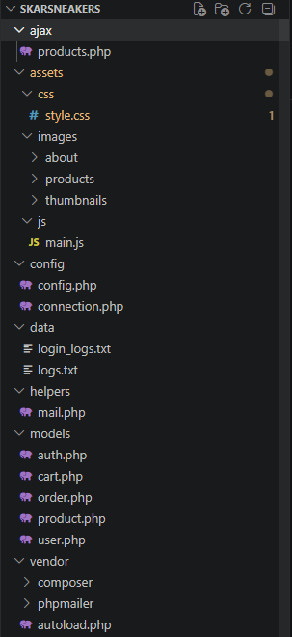v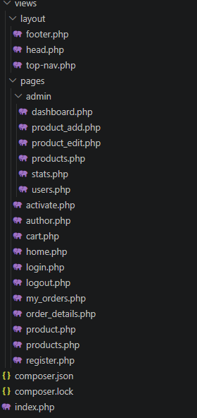

Struktura baze podataka
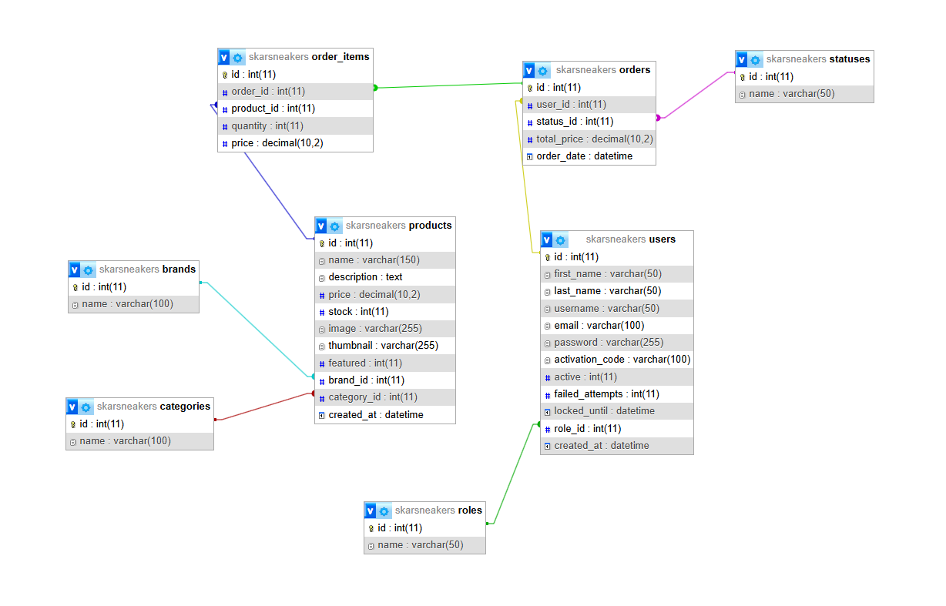

Funkcionalnost sajta

Home stranica
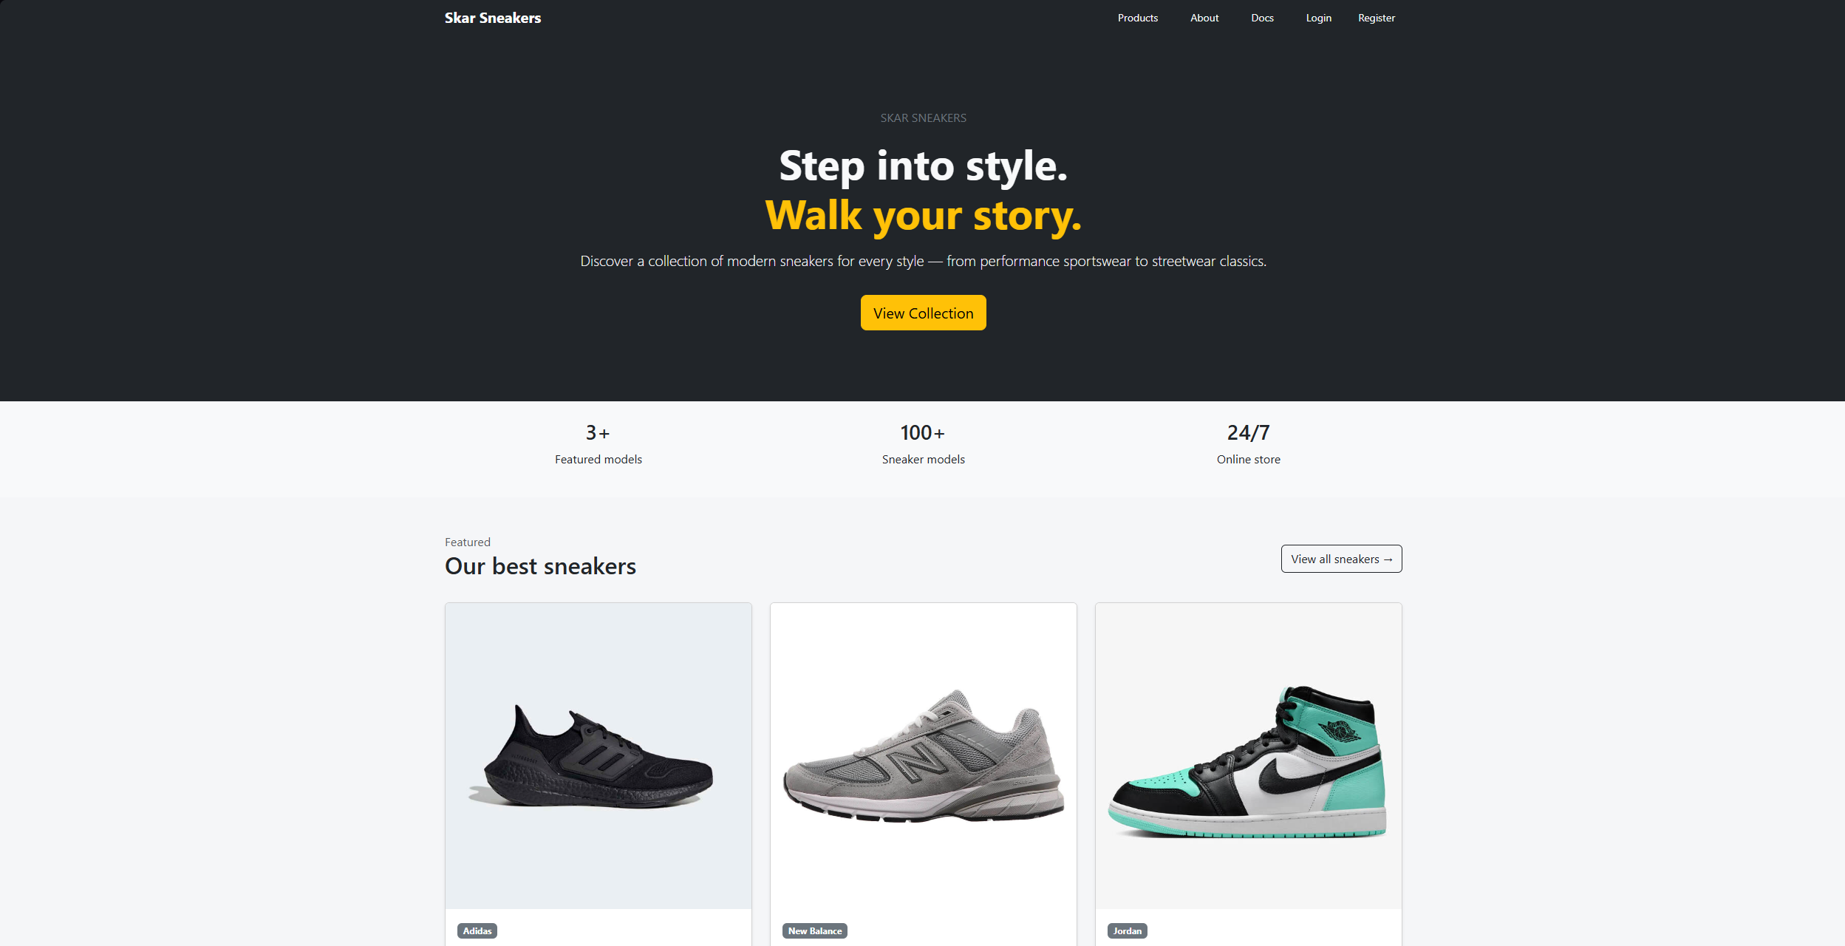
Početna stranica sajta koja prikazuje istaknute proizvode kako bi korisnik odmah dobio pregled ponude. Takođe omogućava brzu navigaciju ka ostalim delovima sajta kao što su proizvodi, korpa i prijava.

Products stranica
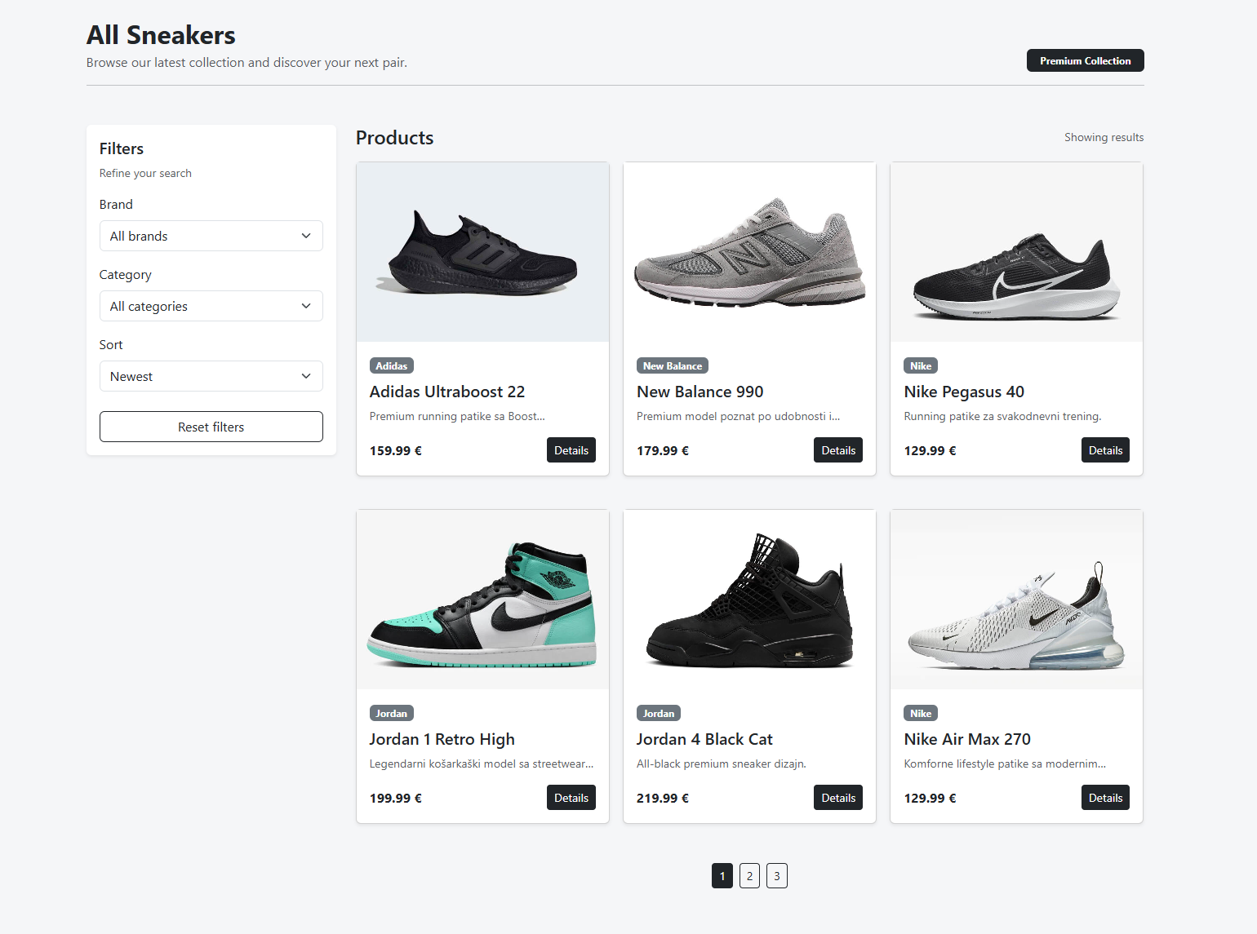
Products stranica prikazuje kompletnu listu proizvoda iz ponude. Korisnici mogu da filtriraju proizvode po brendu i kategoriji, kao i da ih sortiraju po ceni ili novim proizvodima.

Product details stranica
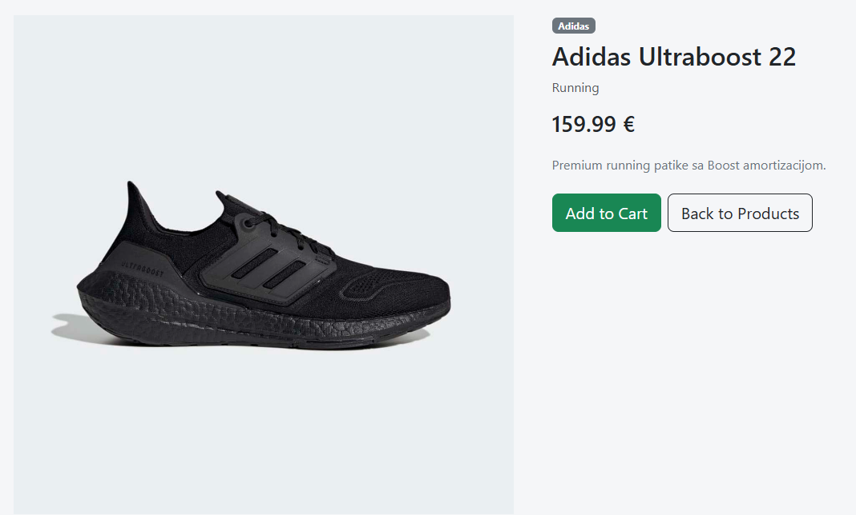
Product details stranica prikazuje detaljne informacije o odabranom proizvodu, uključujući sliku, cenu, opis i pripadnost brendu i kategoriji. Korisnik sa ove stranice može direktno dodati proizvod u korpu.

Cart stranica
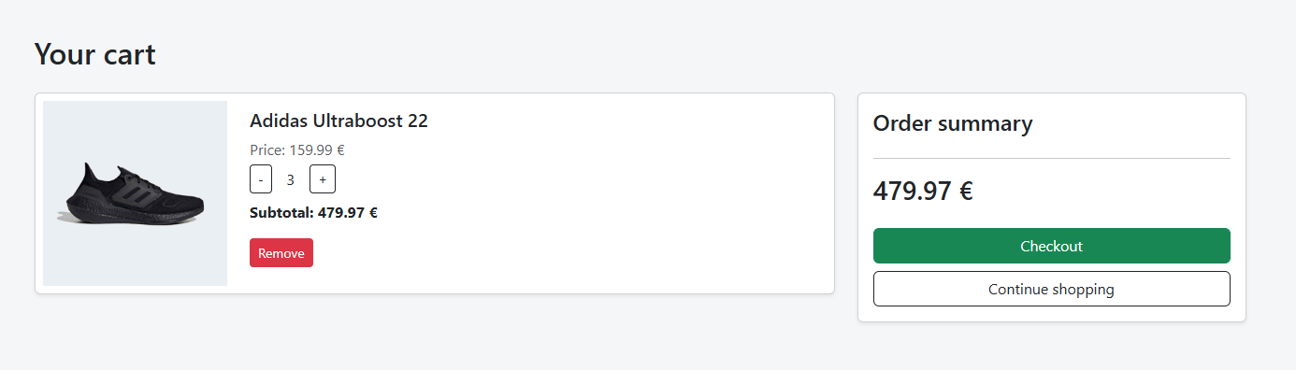
Cart stranica prikazuje sve proizvode koje je korisnik dodao u korpu. Omogućava izmenu količine, uklanjanje proizvoda i prelazak na checkout.

Orders stranica
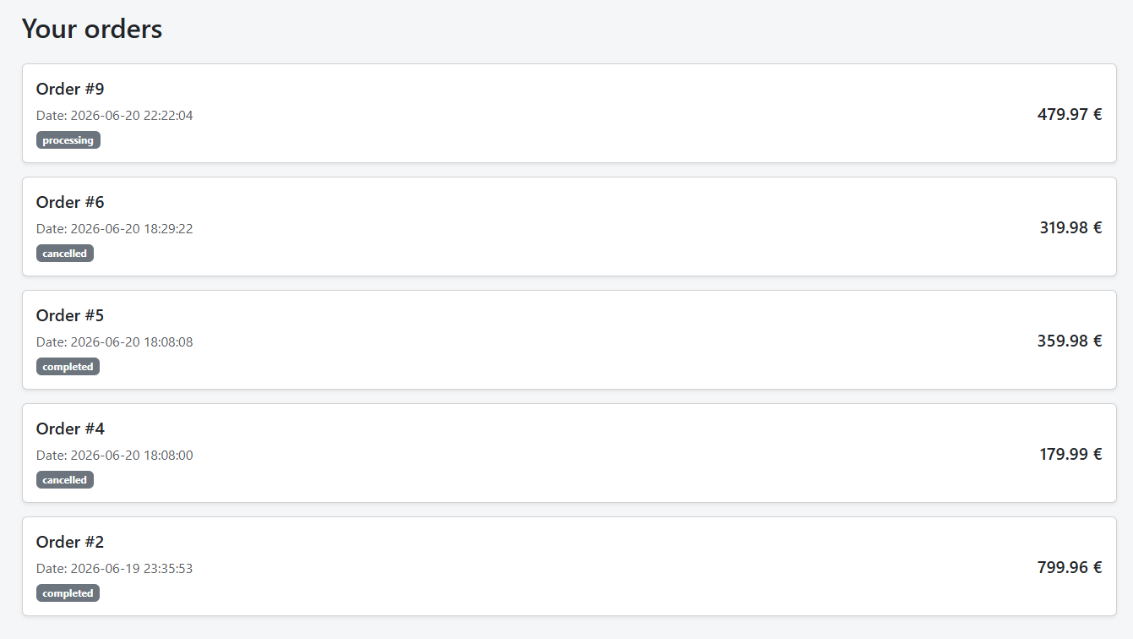
Orders stranica prikazuje sve porudžbine ulogovanog korisnika sa informacijama o datumu, statusu i ukupnoj ceni. Korisnik ovde može da prati status svojih narudžbina.

Order details stranica
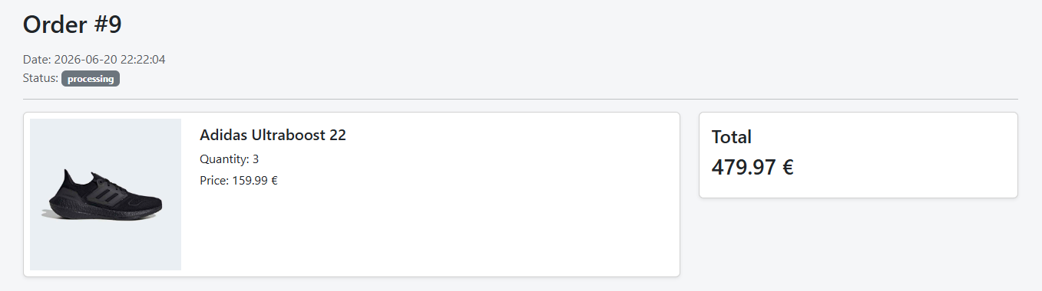
Order details stranica prikazuje detalje jedne porudžbine, uključujući listu proizvoda, količine, cene i ukupnu vrednost. Takođe prikazuje datum i status porudžbine.

Registracija
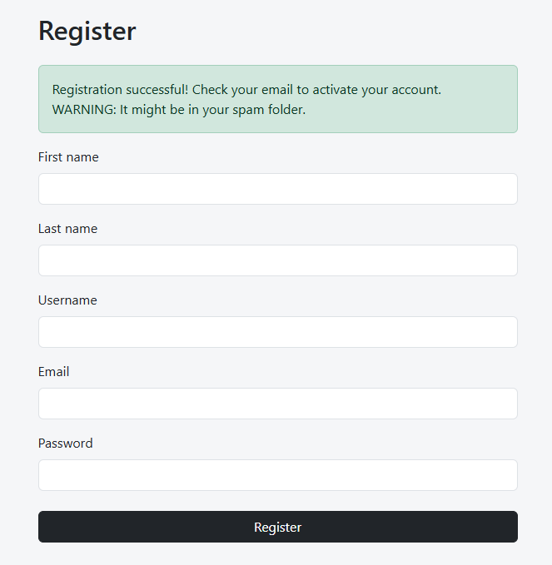
Register stranica omogućava kreiranje novog korisničkog naloga uz osnovnu validaciju podataka. Nakon uspešne registracije korisniku se prikazuje poruka o uspehu i šalje aktivacioni email za potvrdu naloga.

Login
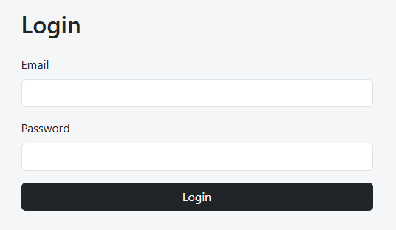
Login stranica omogućava prijavu postojećih korisnika u sistem. U slučaju više uzastopnih pogrešnih pokušaja, nalog se privremeno zaključava na određeni vremenski period radi zaštite od brute-force napada.

Admin Dashboard stranica
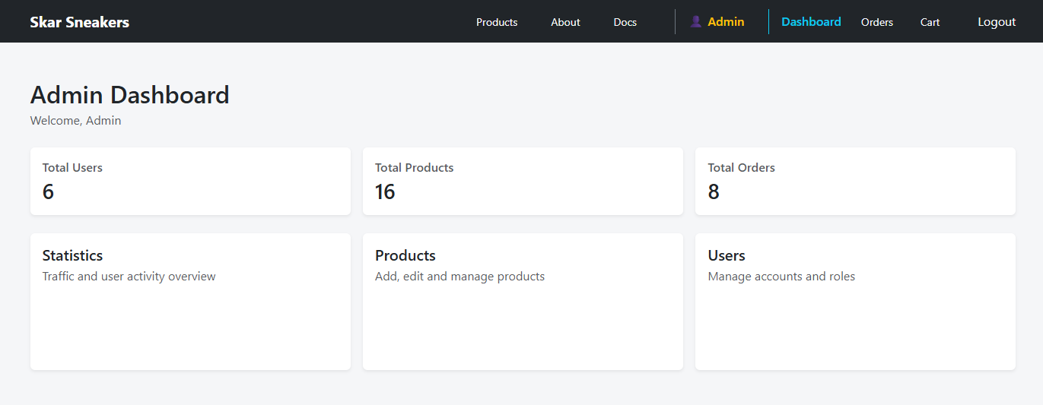
Admin dashboard stranica predstavlja centralni panel za upravljanje sistemom. Omogućava brzi pristup ključnim sekcijama kao što su proizvodi, korisnici i statistika.

Admin Statistics stranica
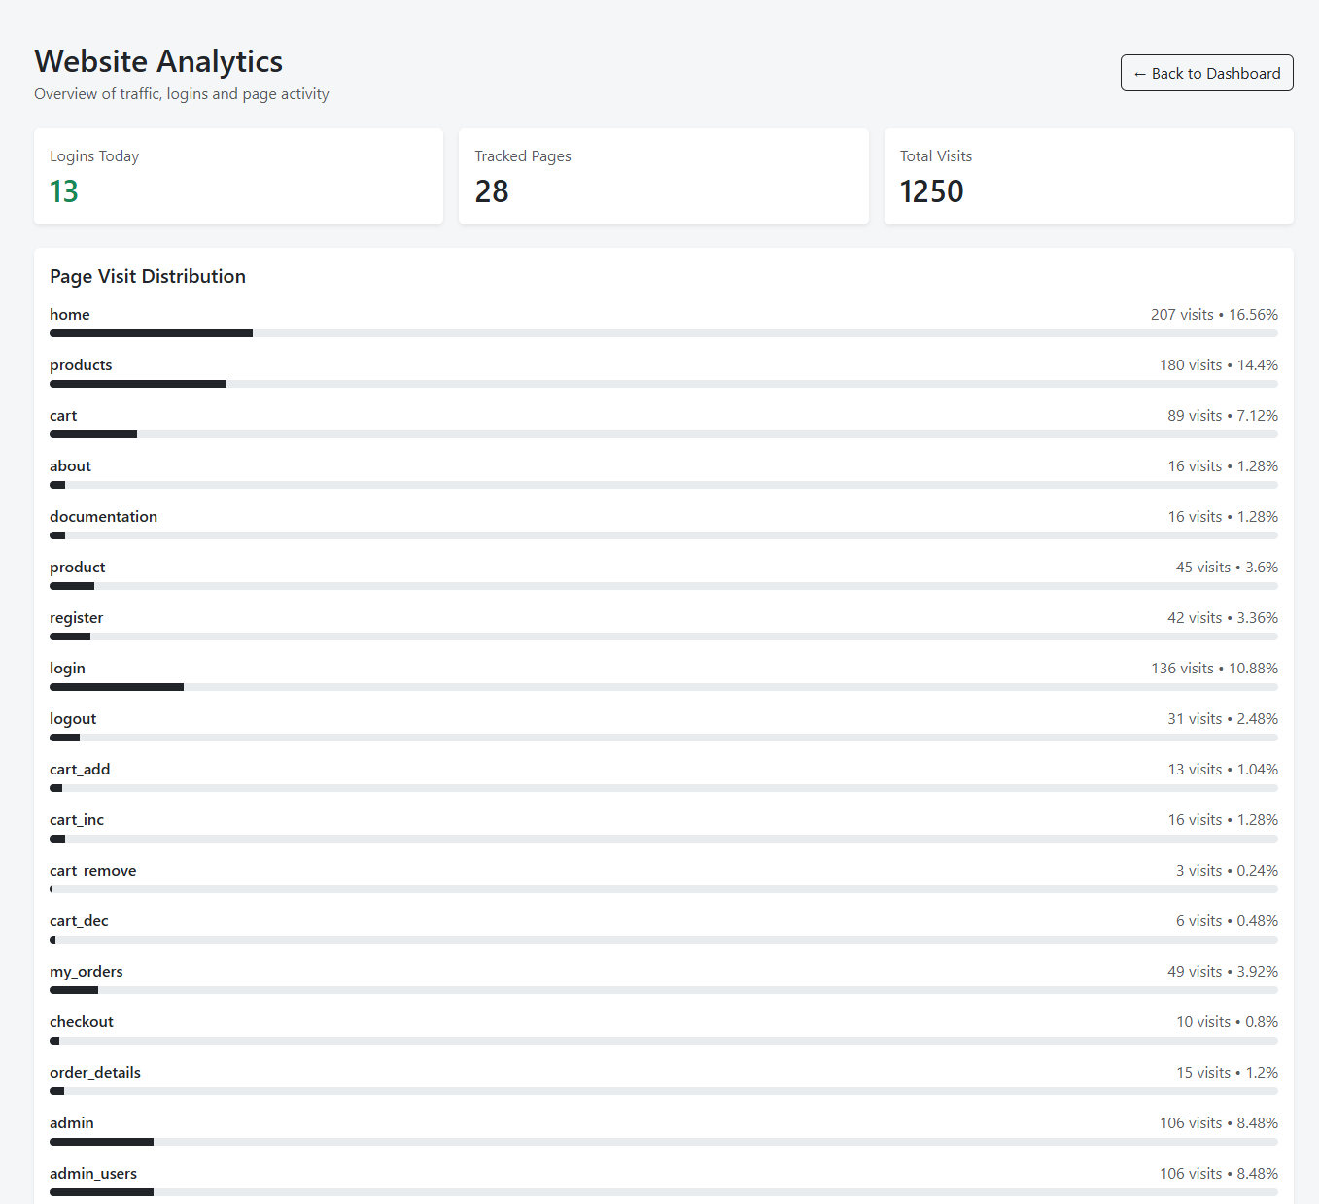
Stats stranica prikazuje analitiku sajta, uključujući statistiku poseta stranica i broj uspešnih prijava korisnika. Podaci su prikazani kroz grafike i progres barove radi lakšeg pregleda aktivnosti sistema.

Admin Products stranica
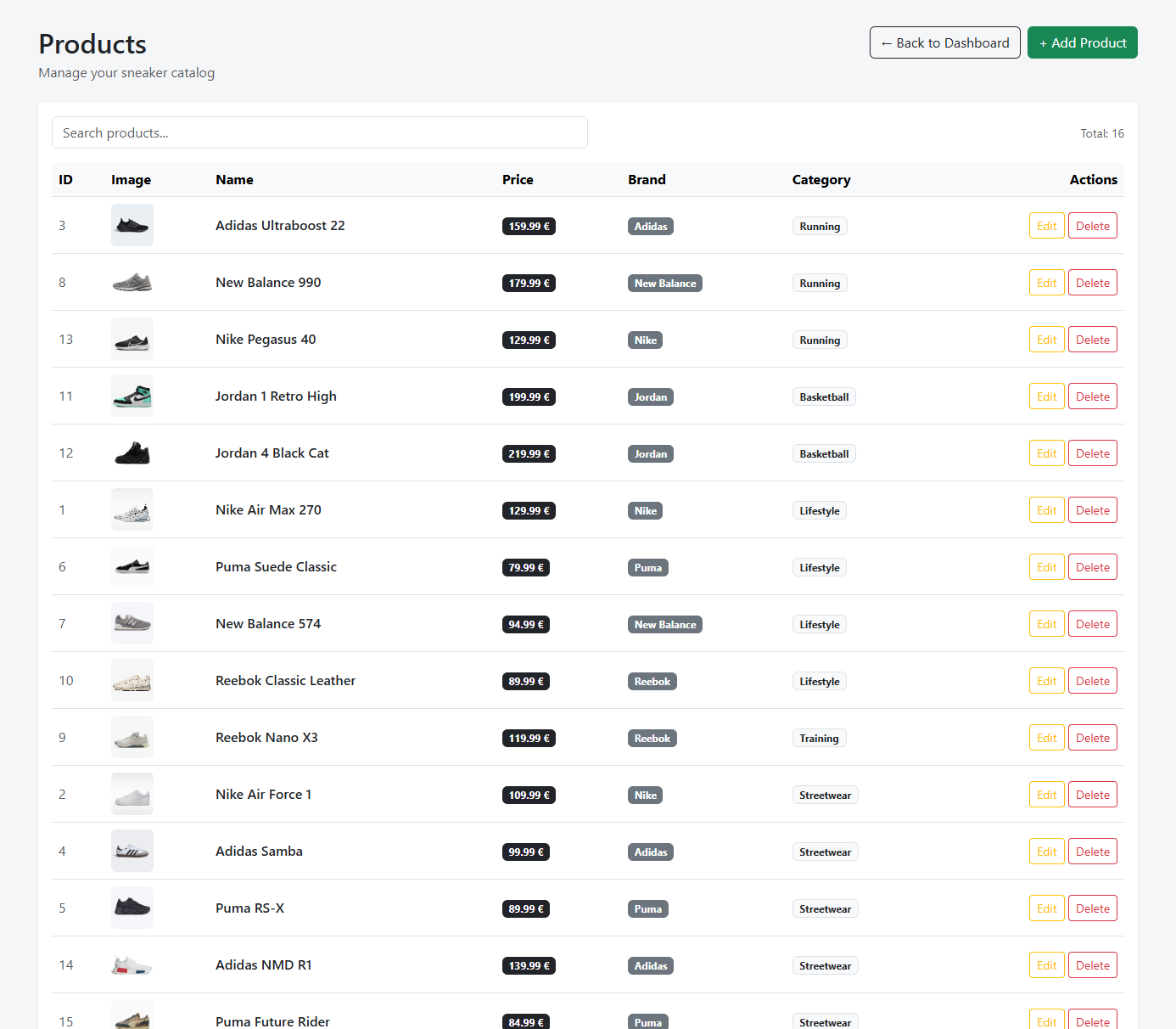
Admin products stranica omogućava administratoru pregled, pretragu i upravljanje svim proizvodima u sistemu. Sa ove stranice moguće je dodavanje, izmena i brisanje proizvoda.

Admin Add Product stranica
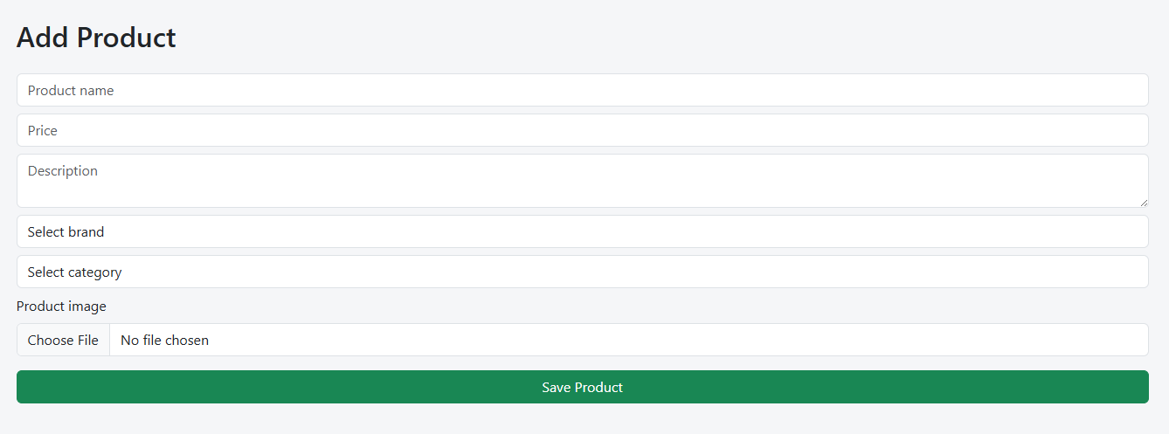
Add product stranica omogućava administratoru dodavanje novih proizvoda u sistem unosom osnovnih informacija kao što su naziv, cena, opis, slika i kategorija. Nakon unosa, proizvod se čuva u bazi i postaje dostupan na sajtu.

Admin Edit Product stranica
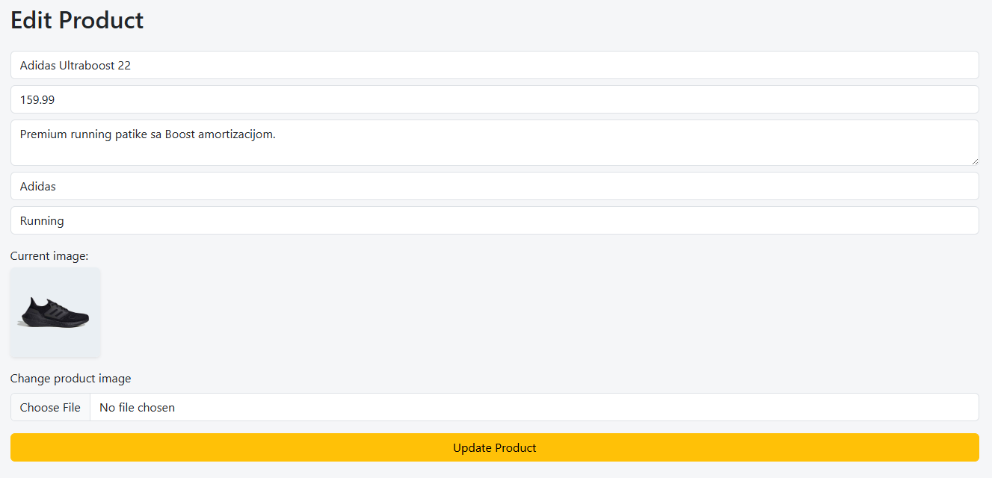
Edit product stranica omogućava administratoru izmenu postojećih proizvoda, uključujući naziv, cenu, opis, sliku i kategoriju. Izmene se odmah čuvaju u bazi i ažuriraju prikaz na sajtu.

Admin Delete Product modal
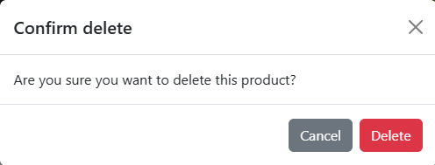
Delete product modal je potvrdni prozor koji se prikazuje pre brisanja proizvoda. Administrator mora potvrditi akciju kako bi se proizvod trajno uklonio iz baze podataka.

Admin Users stranica
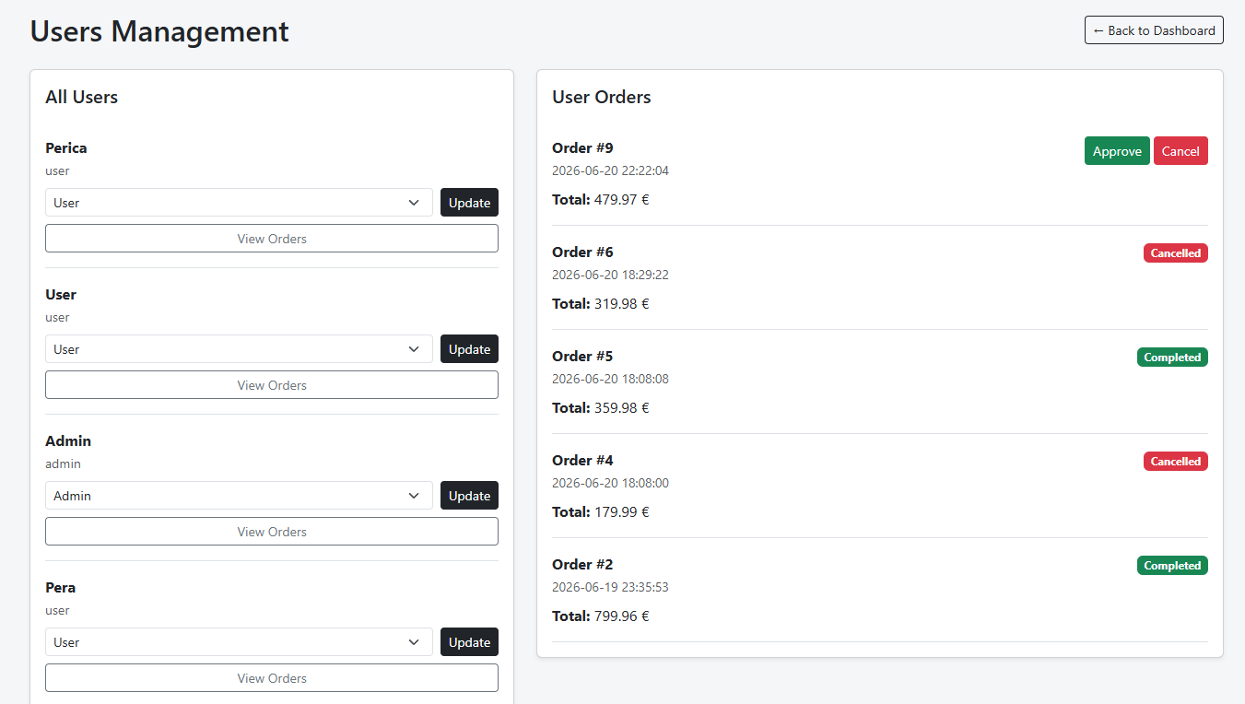
Admin users stranica omogućava pregled svih korisnika sistema i promenu njihovih uloga. Takođe omogućava pregled porudžbina po izabranom korisniku i upravljanje njihovim statusima.

Author stranica

Author stranica prikazuje informacije o autoru projekta, uključujući sliku i kratak opis.

Dokumentacija
Dokumentacija sajta se može naći u navigacionom meniju pod “Docs”.

Kodovi

index.php
<?php
session_start();

require_once "config/connection.php";
require_once "models/product.php";
require_once "models/user.php";
require_once "models/auth.php";

$page = $_GET['strana'] ?? 'home';

$logLine = date("Y-m-d H:i:s") . " - $page\n";
file_put_contents("data/logs.txt", $logLine, FILE_APPEND);

require_once "views/layout/head.php";
require_once "views/layout/top-nav.php";

echo '<div class="page-wrapper">';

if ($page == 'home') {

$featuredProducts = getFeaturedProducts($conn);
require_once "views/pages/home.php";

} elseif ($page == 'products') {

require_once "views/pages/products.php";

} elseif ($page == 'register') {

require_once "views/pages/register.php";

} elseif ($page == 'login') {

require_once "views/pages/login.php";

} elseif ($page == 'logout') {

require_once "views/pages/logout.php";

} elseif ($page == 'activate') {

require_once "views/pages/activate.php";

} elseif ($page == 'product') {

require_once "views/pages/product.php";

}

elseif ($page == 'cart_add') {

require_once "models/cart.php";

$id = $_GET['id'];
$product = getProductById($conn, $id);

if ($product) {
addToCart($product);
}

header("Location: index.php?strana=cart");
exit;

} elseif ($page == 'cart') {

require_once "views/pages/cart.php";

} elseif ($page == 'cart_inc') {

$id = $_GET['id'];

if (isset($_SESSION['cart'][$id])) {
$_SESSION['cart'][$id]['quantity']++;
}

header("Location: index.php?strana=cart");
exit;

} elseif ($page == 'cart_dec') {

$id = $_GET['id'];

if (isset($_SESSION['cart'][$id])) {
$_SESSION['cart'][$id]['quantity']--;

if ($_SESSION['cart'][$id]['quantity'] <= 0) {
unset($_SESSION['cart'][$id]);
}
}

header("Location: index.php?strana=cart");
exit;

} elseif ($page == 'cart_remove') {

$id = $_GET['id'];

if (isset($_SESSION['cart'][$id])) {
unset($_SESSION['cart'][$id]);
}

header("Location: index.php?strana=cart");
exit;
}

elseif ($page == 'checkout') {

require_once "models/order.php";
require_once "models/cart.php";

if (!isset($_SESSION['user'])) {
header("Location: index.php?strana=login");
exit;
}

$userId = $_SESSION['user']['id'];
$cart = $_SESSION['cart'] ?? [];

if (empty($cart)) {
header("Location: index.php?strana=cart");
exit;
}

$total = 0;

foreach ($cart as $item) {
$total += $item['price'] * $item['quantity'];
}

$orderId = createOrder($conn, $userId, 1, $total);

foreach ($cart as $item) {
addOrderItem(
$conn,
$orderId,
$item['id'],
$item['quantity'],
$item['price']
);
}

unset($_SESSION['cart']);

header("Location: index.php?strana=my_orders");
exit;

} elseif ($page == 'my_orders') {

require_once "models/order.php";

if (!isset($_SESSION['user'])) {
header("Location: index.php?strana=login");
exit;
}

$orders = getOrdersByUser($conn, $_SESSION['user']['id']);

require_once "views/pages/my_orders.php";

} elseif ($page == 'order_details') {

require_once "views/pages/order_details.php";

}

elseif ($page == 'admin') {

if (!isset($_SESSION['user']) || $_SESSION['user']['role_id'] != 1) {
header("Location: index.php?strana=home");
exit;
}

require_once "views/pages/admin/dashboard.php";

} elseif ($page == 'admin_stats') {

if (!isset($_SESSION['user']) || $_SESSION['user']['role_id'] != 1) {
header("Location: index.php?strana=home");
exit;
}

require_once "views/pages/admin/stats.php";

} elseif ($page == 'admin_products') {

if (!isset($_SESSION['user']) || $_SESSION['user']['role_id'] != 1) {
header("Location: index.php?strana=home");
exit;
}

require_once "models/product.php";

$products = getAllProducts($conn);
require_once "views/pages/admin/products.php";

} elseif ($page == 'admin_product_add') {

if (!isset($_SESSION['user']) || $_SESSION['user']['role_id'] != 1) {
header("Location: index.php?strana=home");
exit;
}

require_once "models/product.php";
require_once "views/pages/admin/product_add.php";

} elseif ($page == 'admin_product_edit') {

if (!isset($_SESSION['user']) || $_SESSION['user']['role_id'] != 1) {
header("Location: index.php?strana=home");
exit;
}

require_once "models/product.php";

$id = $_GET['id'];
$product = getProductById($conn, $id);

if (!$product) {
echo "Product not found";
exit;
}

require_once "views/pages/admin/product_edit.php";

} elseif ($page == 'admin_product_delete') {

if (!isset($_SESSION['user']) || $_SESSION['user']['role_id'] != 1) {
header("Location: index.php?strana=home");
exit;
}

$id = $_GET['id'];

$stmt = $conn->prepare("DELETE FROM products WHERE id = ?");
$stmt->execute([$id]);

header("Location: index.php?strana=admin_products");
exit;

} elseif ($page == 'admin_users') {

if (!isset($_SESSION['user']) || $_SESSION['user']['role_id'] != 1) {
header("Location: index.php?strana=home");
exit;
}

require_once "models/auth.php";
require_once "models/order.php";

$users = getAllUsers($conn);

$selectedUser = null;
$userOrders = [];

if (isset($_GET['user_id'])) {

$selectedUser = $_GET['user_id'];
$userOrders = getOrdersByUser($conn, $selectedUser);
}

require_once "views/pages/admin/users.php";
} elseif ($page == 'admin_order_complete') {

if (!isAdmin($_SESSION['user']['role_id'])) {
header("Location: index.php");
exit;
}

require_once "models/auth.php";

updateOrderStatus($conn, $_GET['id'], 2);

$userId = $_GET['user_id'] ?? null;

header("Location: index.php?strana=admin_users&user_id=" . $userId);
exit;

} elseif ($page == 'admin_order_cancel') {

if (!isAdmin($_SESSION['user']['role_id'])) {
header("Location: index.php");
exit;
}

require_once "models/auth.php";

updateOrderStatus($conn, $_GET['id'], 3);

$userId = $_GET['user_id'] ?? null;

header("Location: index.php?strana=admin_users&user_id=" . $userId);
exit;

} elseif ($page == 'admin_user_update_role') {

if (!isset($_SESSION['user']) || $_SESSION['user']['role_id'] != 1) {
header("Location: index.php");
exit;
}

$userId = $_POST['user_id'];
$roleId = $_POST['role_id'];

$stmt = $conn->prepare("UPDATE users SET role_id = ? WHERE id = ?");
$stmt->execute([$roleId, $userId]);

header("Location: index.php?strana=admin_users");
exit;
}

elseif ($page == 'author') {
require_once "views/pages/author.php";

} elseif ($page == 'documentation') {
require_once "views/pages/documentation.php";

} else {

echo "<div class='container py-5'>404 - Stranica ne postoji</div>";
}

echo '</div>';
require_once "views/layout/footer.php";

ajax/products.php
<?php

require_once "../config/connection.php";
require_once "../models/product.php";

header("Content-Type: application/json");

$brand = isset($_GET['brand']) ? (int)$_GET['brand'] : 0;
$category = isset($_GET['category']) ? (int)$_GET['category'] : 0;
$sort = $_GET['sort'] ?? '';
$page = isset($_GET['page']) ? (int)$_GET['page'] : 1;

$limit = 6;
$offset = ($page - 1) * $limit;

$products = getProductsAjax($conn, $brand, $category, $sort, $limit, $offset);
$total = countProductsAjax($conn, $brand, $category);

echo json_encode([
"products" => $products,
"total" => $total,
"limit" => $limit
]);

?>

assets/css/style.css
html, body {
height: 100%;
}

body {
min-height: 100vh;
display: flex;
flex-direction: column;
background-color: #f5f6f8;
}

.page-wrapper {
flex: 1;
}

.nav-link-custom {
color: #ddd;
text-decoration: none;
padding: 6px 10px;
border-radius: 8px;
transition: 0.2s ease;
font-size: 14px;
}

.nav-link-custom:hover {
background: rgba(255, 255, 255, 0.08);
color: #fff;
}

.product-img {
width: 100%;
height: 220px;
object-fit: cover;
object-position: center;
}

.product-desc {
display: -webkit-box;
-webkit-line-clamp: 1;
-webkit-box-orient: vertical;
overflow: hidden;
}

.product-main-image {
transition: transform 0.3s ease;
}

.product-main-image:hover {
transform: scale(1.03);
}

.card img {
transition: transform 0.3s ease;
}

.card:hover img {
transform: scale(1.05);
}

.dashboard-card {
min-height: 180px;
transition: 0.2s ease;
cursor: pointer;
}

.dashboard-card:hover {
transform: translateY(-3px);
box-shadow: 0 8px 20px rgba(0,0,0,0.12);
}

assets/js/main.js
document.addEventListener("DOMContentLoaded", function () {

const brandFilter = document.querySelector("#brandFilter");
const categoryFilter = document.querySelector("#categoryFilter");
const sortFilter = document.querySelector("#sortFilter");
const applyBtn = document.querySelector("#applyFilters");

const productsContainer = document.querySelector("#productsContainer");

let currentPage = 1;

function loadProducts(page = 1) {

const brand = brandFilter ? brandFilter.value : 0;
const category = categoryFilter ? categoryFilter.value : 0;
const sort = sortFilter ? sortFilter.value : "";

fetch(`ajax/products.php?brand=${brand}&category=${category}&sort=${sort}&page=${page}`)
.then(res => res.json())
.then(data => {

productsContainer.innerHTML = "";

if (data.products.length === 0) {
productsContainer.innerHTML = `
<p class="text-muted">Nema proizvoda za izabrani filter.</p>
`;
return;
}

data.products.forEach(product => {

productsContainer.innerHTML += `
<div class="col-md-4 mb-4">

<div class="card h-100 shadow-sm">

<img class="product-img" src="assets/images/thumbnails/${product.thumbnail}"
class="card-img-top"
alt="${product.name}">

<div class="card-body">

<span class="badge bg-secondary">
${product.brand_name}
</span>

<h5 class="mt-2">
${product.name}
</h5>

<p class="text-muted small product-desc">
${product.description.substring(0, 60)}
</p>

<div class="d-flex justify-content-between align-items-center">

<strong>${product.price} €</strong>

<a href="index.php?strana=product&id=${product.id}"
class="btn btn-sm btn-dark">
Details
</a>

</div>

</div>

</div>

</div>
`;
});

renderPagination(data.total, data.limit, page);
});
}

function renderPagination(total, limit, page) {

const paginationContainer = document.querySelector("#pagination");
if (!paginationContainer) return;

let pages = Math.ceil(total / limit);

paginationContainer.innerHTML = "";

for (let i = 1; i <= pages; i++) {

paginationContainer.innerHTML += `
<button class="btn btn-sm ${i === page ? 'btn-dark' : 'btn-outline-dark'}"
data-page="${i}">
${i}
</button>
`;
}

document.querySelectorAll("#pagination button").forEach(btn => {
btn.addEventListener("click", function () {
loadProducts(this.dataset.page);
});
});
}

const resetBtn = document.querySelector("#resetFilters");

if (resetBtn) {
resetBtn.addEventListener("click", function () {

if (brandFilter) brandFilter.value = 0;
if (categoryFilter) categoryFilter.value = 0;
if (sortFilter) sortFilter.value = "newest";

loadProducts(1);
});
}

if (brandFilter) {
brandFilter.addEventListener("change", function () {
loadProducts(1);
});
}

if (categoryFilter) {
categoryFilter.addEventListener("change", function () {
loadProducts(1);
});
}

if (sortFilter) {
sortFilter.addEventListener("change", function () {
loadProducts(1);
});
}

loadProducts();

});

config/connection.php
<?php

$server = "localhost";
$database = "skarsneakers";
$username = "root";
$password = "";

try {

$conn = new PDO(
"mysql:host=$server;dbname=$database;charset=utf8mb4",
$username,
$password
);

$conn->setAttribute(PDO::ATTR_ERRMODE, PDO::ERRMODE_EXCEPTION);

} catch (PDOException $e) {
echo $e->getMessage();
}

helpers/mail.php
<?php

use PHPMailer\PHPMailer\PHPMailer;
use PHPMailer\PHPMailer\Exception;

require_once __DIR__ . '/../vendor/autoload.php';

function sendActivationEmail($toEmail, $activationLink)
{
$mail = new PHPMailer(true);

try {
$mail->isSMTP();
$mail->Host = 'smtp.gmail.com';
$mail->SMTPAuth = true;
$mail->Username = 'milan.bojkovski.9.22@ict.edu.rs';
$mail->Password = 'rzcf ciwx yhhr wqxx';
$mail->SMTPSecure = PHPMailer::ENCRYPTION_STARTTLS;
$mail->Port = 587;

$mail->setFrom('milan.bojkovski.9.22@ict.edu.rs', 'Skar Sneakers');
$mail->addAddress($toEmail);

$mail->isHTML(true);
$mail->Subject = 'Activate your Skar Sneakers account';

$mail->Body = "
<h2>Welcome to Skar Sneakers</h2>
<p>Click the link below to activate your account:</p>
<a href='$activationLink'>Activate Account</a>
";

$mail->send();

return true;

} catch (Exception $e) {
return false;
}
}

models/auth.php
<?php

function isAdmin() {
return isset($_SESSION["user"]) && $_SESSION["user"]["role_id"] == 1;
}

function updateProduct($conn, $id, $name, $price, $description, $brand_id, $category_id, $thumbnail = null)
{
if ($thumbnail) {

$query = "
UPDATE products
SET name = ?, price = ?, description = ?, brand_id = ?, category_id = ?, thumbnail = ?
WHERE id = ?
";

$params = [$name, $price, $description, $brand_id, $category_id, $thumbnail, $id];

} else {

$query = "
UPDATE products
SET name = ?, price = ?, description = ?, brand_id = ?, category_id = ?
WHERE id = ?
";

$params = [$name, $price, $description, $brand_id, $category_id, $id];
}

$stmt = $conn->prepare($query);
return $stmt->execute($params);
}

function getAllUsers($conn)
{
$stmt = $conn->query("
SELECT u.*, r.name AS role_name
FROM users u
INNER JOIN roles r ON u.role_id = r.id
ORDER BY u.id DESC
");

return $stmt->fetchAll(PDO::FETCH_OBJ);
}

function updateOrderStatus($conn, $orderId, $statusId)
{
$stmt = $conn->prepare("
UPDATE orders
SET status_id = ?
WHERE id = ?
");

return $stmt->execute([$statusId, $orderId]);
}

?>

models/cart.php
<?php

function addToCart($product)
{
if (!isset($_SESSION['cart'])) {
$_SESSION['cart'] = [];
}

$id = $product->id;

if (isset($_SESSION['cart'][$id])) {
$_SESSION['cart'][$id]['quantity']++;
} else {
$_SESSION['cart'][$id] = [
"id" => $product->id,
"name" => $product->name,
"price" => $product->price,
"image" => $product->thumbnail,
"quantity" => 1
];
}
}

?>

models/order.php
<?php

function createOrder($conn, $userId, $statusId, $totalPrice)
{
$query = "
INSERT INTO orders (user_id, status_id, total_price)
VALUES (?, ?, ?)
";

$stmt = $conn->prepare($query);
$stmt->execute([$userId, $statusId, $totalPrice]);

return $conn->lastInsertId();
}

function addOrderItem($conn, $orderId, $productId, $quantity, $price)
{
$query = "
INSERT INTO order_items (order_id, product_id, quantity, price)
VALUES (?, ?, ?, ?)
";

$stmt = $conn->prepare($query);
return $stmt->execute([$orderId, $productId, $quantity, $price]);
}

function getOrdersByUser($conn, $userId)
{
$query = "
SELECT o.*, s.name AS status_name
FROM orders o
INNER JOIN statuses s ON o.status_id = s.id
WHERE o.user_id = ?
ORDER BY o.order_date DESC
";

$stmt = $conn->prepare($query);
$stmt->execute([$userId]);

return $stmt->fetchAll(PDO::FETCH_OBJ);
}

?>

models/product.php
<?php

function getFeaturedProducts($conn)
{
$query = "
SELECT p.*, b.name AS brand_name, c.name AS category_name
FROM products p
INNER JOIN brands b ON p.brand_id = b.id
INNER JOIN categories c ON p.category_id = c.id
WHERE p.featured = 1
ORDER BY p.created_at DESC
LIMIT 3
";

return $conn->query($query)->fetchAll(PDO::FETCH_OBJ);
}

function getAllProducts($conn)
{
$query = "
SELECT p.*, b.name AS brand_name, c.name AS category_name
FROM products p
INNER JOIN brands b ON p.brand_id = b.id
INNER JOIN categories c ON p.category_id = c.id
ORDER BY p.created_at DESC
";

return $conn->query($query)->fetchAll(PDO::FETCH_OBJ);
}

function getProductById($conn, $id)
{
$query = "
SELECT p.*, b.name AS brand_name, c.name AS category_name
FROM products p
INNER JOIN brands b ON p.brand_id = b.id
INNER JOIN categories c ON p.category_id = c.id
WHERE p.id = ?
";

$stmt = $conn->prepare($query);
$stmt->execute([$id]);

return $stmt->fetch(PDO::FETCH_OBJ);
}

function getProductsAjax($conn, $brand, $category, $sort, $limit, $offset)
{
$limit = (int)$limit;
$offset = (int)$offset;

$query = "
SELECT p.*, b.name AS brand_name, c.name AS category_name
FROM products p
INNER JOIN brands b ON p.brand_id = b.id
INNER JOIN categories c ON p.category_id = c.id
WHERE 1=1
";

$params = [];

if ($brand != 0) {
$query .= " AND p.brand_id = ?";
$params[] = $brand;
}

if ($category != 0) {
$query .= " AND p.category_id = ?";
$params[] = $category;
}

if ($sort == "price_asc") {
$query .= " ORDER BY p.price ASC";
} else if ($sort == "price_desc") {
$query .= " ORDER BY p.price DESC";
} else {
$query .= " ORDER BY p.created_at DESC";
}

$query .= " LIMIT $limit OFFSET $offset";

$stmt = $conn->prepare($query);
$stmt->execute($params);

return $stmt->fetchAll(PDO::FETCH_OBJ);
}

function countProductsAjax($conn, $brand, $category)
{
$query = "SELECT COUNT(*) FROM products WHERE 1=1";
$params = [];

if ($brand != 0) {
$query .= " AND brand_id = ?";
$params[] = $brand;
}

if ($category != 0) {
$query .= " AND category_id = ?";
$params[] = $category;
}

$stmt = $conn->prepare($query);
$stmt->execute($params);

return $stmt->fetchColumn();
}

function getAllBrands($conn)
{
$query = "SELECT * FROM brands ORDER BY name ASC";
return $conn->query($query)->fetchAll(PDO::FETCH_OBJ);
}

function getAllCategories($conn)
{
$query = "SELECT * FROM categories ORDER BY name ASC";
return $conn->query($query)->fetchAll(PDO::FETCH_OBJ);
}

models/user.php
<?php

function getUserByEmail($conn, $email)
{
$query = "SELECT * FROM users WHERE email = ?";

$stmt = $conn->prepare($query);
$stmt->execute([$email]);

return $stmt->fetch(PDO::FETCH_OBJ);
}

function getUserByUsername($conn, $username)
{
$query = "SELECT * FROM users WHERE username = ?";

$stmt = $conn->prepare($query);
$stmt->execute([$username]);

return $stmt->fetch(PDO::FETCH_OBJ);
}

function registerUser(
$conn,
$firstName,
$lastName,
$username,
$email,
$password,
$activationCode
)
{
$query = "
INSERT INTO users
(
first_name,
last_name,
username,
email,
password,
activation_code,
role_id
)
VALUES
(
?, ?, ?, ?, ?, ?, 2
)
";

$stmt = $conn->prepare($query);

return $stmt->execute([
$firstName,
$lastName,
$username,
$email,
$password,
$activationCode
]);
}

function loginUser($conn, $email)
{
$query = "SELECT * FROM users WHERE email = ? LIMIT 1";

$stmt = $conn->prepare($query);
$stmt->execute([$email]);

return $stmt->fetch(PDO::FETCH_OBJ);
}

function activateUser($conn, $token)
{
$query = "
UPDATE users
SET active = 1,
activation_code = NULL
WHERE activation_code = ?
";

$stmt = $conn->prepare($query);
return $stmt->execute([$token]);
}

function incrementFailedLogin($conn, $userId)
{
$query = "
UPDATE users
SET failed_attempts = failed_attempts + 1
WHERE id = ?
";

$stmt = $conn->prepare($query);
return $stmt->execute([$userId]);
}

function lockUser($conn, $userId)
{
$query = "
UPDATE users
SET locked_until = DATE_ADD(NOW(), INTERVAL 5 MINUTE),
failed_attempts = 0
WHERE id = ?
";

$stmt = $conn->prepare($query);
return $stmt->execute([$userId]);
}

function resetFailedLogin($conn, $userId)
{
$query = "
UPDATE users
SET failed_attempts = 0,
locked_until = NULL
WHERE id = ?
";

$stmt = $conn->prepare($query);
return $stmt->execute([$userId]);
}

views/layout/head.php
<!DOCTYPE html>
<html>
<head>
<title>Skar Sneakers</title>

<link href="https://cdn.jsdelivr.net/npm/bootstrap@5.3.0/dist/css/bootstrap.min.css" rel="stylesheet">
<link rel="stylesheet" href="assets/css/style.css">
</head>
<body>

views/layout/top-nav.php
<nav class="navbar navbar-dark bg-dark px-3">
<div class="container">
<a class="navbar-brand fw-bold" href="index.php?strana=home">
Skar Sneakers
</a>
<div class="d-flex align-items-center gap-4">
<a href="index.php?strana=products" class="text-light text-decoration-none nav-link-custom">
Products
</a>
<a href="index.php?strana=author" class="text-light text-decoration-none nav-link-custom">
About
</a>
<a href="dokumentacija.pdf" target="_blank" class="text-light text-decoration-none nav-link-custom">
Docs
</a>
<?php if (isset($_SESSION["user"])): ?>
<div class="d-flex align-items-center gap-3 ms-3 ps-3 border-start border-secondary">
<span class="text-warning fw-semibold">
👤 <?= $_SESSION["user"]["username"] ?>
</span>
<?php if ($_SESSION["user"]["role_id"] != 1): ?>
<a href="index.php?strana=my_orders" class="text-light text-decoration-none nav-link-custom">
Orders
</a>
<a href="index.php?strana=cart"
class="text-light text-decoration-none position-relative nav-link-custom">
Cart
<?php
$cartCount = 0;
if (isset($_SESSION['cart'])) {
foreach ($_SESSION['cart'] as $item) {
$cartCount += $item['quantity'];
}
}
?>
<?php if ($cartCount > 0): ?>
<span class="badge bg-warning text-dark ms-1">
<?= $cartCount ?>
</span>
<?php endif; ?>
</a>
<?php endif; ?>
<?php if ($_SESSION["user"]["role_id"] == 1): ?>
<div class="d-flex align-items-center gap-3 ms-3 ps-3 border-start border-info">
<a href="index.php?strana=admin" class="text-info text-decoration-none fw-semibold">
Dashboard
</a>
<a href="index.php?strana=my_orders" class="text-light text-decoration-none nav-link-custom">
Orders
</a>
<a href="index.php?strana=cart" class="text-light text-decoration-none nav-link-custom position-relative">
Cart
<?php
$cartCount = 0;
if (isset($_SESSION['cart'])) {
foreach ($_SESSION['cart'] as $item) {
$cartCount += $item['quantity'];
}
}
?>
<?php if ($cartCount > 0): ?>
<span class="badge bg-warning text-dark ms-1">
<?= $cartCount ?>
</span>
<?php endif; ?>
</a>
</div>
<?php endif; ?>
</div>
<a href="index.php?strana=logout" class="text-light text-decoration-none ms-3">
Logout
</a>
<?php else: ?>
<div class="d-flex align-items-center gap-3">
<a href="index.php?strana=login" class="text-light text-decoration-none nav-link-custom">
Login
</a>
<a href="index.php?strana=register" class="text-light text-decoration-none nav-link-custom">
Register
</a>
</div>
<?php endif; ?>
</div>
</div>
</nav>

views/layout/footer.php
<footer class="bg-dark text-light text-center p-3 mt-5">
Skar Sneakers © <?= date("Y") ?>
</footer>

<script src="https://cdn.jsdelivr.net/npm/bootstrap@5.3.0/dist/js/bootstrap.bundle.min.js"></script>
<script src="assets/js/main.js"></script>

</body>
</html>

views/pages/activate
<?php

require_once "models/user.php";

$token = $_GET['token'] ?? null;

$message = "";
$error = "";

if (!$token) {
$error = "Nevalidan aktivacioni link.";
} else {

$success = activateUser($conn, $token);

if ($success) {

$message = "Nalog je uspešno aktiviran. Sada se možete ulogovati.";

} else {

$error = "Aktivacioni link je nevažeći ili je već iskorišćen.";
}
}
?>

<div class="container py-5">

<?php if ($error): ?>
<div class="alert alert-danger"><?= $error ?></div>
<?php endif; ?>

<?php if ($message): ?>
<div class="alert alert-success"><?= $message ?></div>
<a href="index.php?strana=login" class="btn btn-dark mt-3">
Idi na login
</a>
<?php endif; ?>

</div>

views/pages/author.php
<div class="container py-5">
<div class="text-center mb-5">
<h1 class="fw-bold">About the Author</h1>
<p class="text-muted">
O autoru
</p>
</div>
<div class="row align-items-center">
<div class="col-md-4 text-center mb-4 mb-md-0">
<img src="assets/images/about/author.png"
alt="Author photo"
class="img-fluid rounded shadow-sm"
style="max-width: 280px;">
</div>
<div class="col-md-8">
<h3 class="fw-semibold">Milan Bojkovski 9/22</h3>
<p class="text-muted">
I am a student passionate about web development and backend systems.
This project represents my work in building a fully functional e-commerce platform
using PHP, MySQL, and JavaScript.
</p>
<p class="text-muted">
During my studies, I gained experience working with HTML, CSS, JavaScript, PHP,
and relational databases. This project helped me combine all of these technologies
into a single functional system.
</p>
<hr>
<ul class="list-unstyled text-muted">
<li><strong>Technologies:</strong> HTML, CSS, JavaScript, PHP, MySQL</li>
<li><strong>Project type:</strong> E-commerce Web Application</li>
<li><strong>Role:</strong> Full-stack Development</li>
</ul>
</div>
</div>
</div>

views/pages/cart.php
<?php
require_once "models/product.php";

if (!isset($_SESSION['cart']) || empty($_SESSION['cart'])) {
?>
<div class="container py-5 text-center">
<div class="py-5">
<h3 class="mb-3">Your cart is empty</h3>
<p class="text-muted mb-4">
You haven’t added any products yet.
</p>
<a href="index.php?strana=products" class="btn btn-dark">
Browse sneakers
</a>
</div>
</div>
<?php
return;
}

$cart = $_SESSION['cart'];
$total = 0;
?>

<div class="container py-5">
<div class="d-flex justify-content-between align-items-center mb-4">
<h2 class="mb-0">Your cart</h2>
</div>
<div class="row">
<div class="col-md-8">
<?php foreach ($cart as $item): ?>

<?php
$subtotal = $item['price'] * $item['quantity'];
$total += $subtotal;
?>
<div class="card mb-3 shadow-sm">
<div class="row g-0">
<div class="col-md-3">
<img src="assets/images/thumbnails/<?= $item['image'] ?>"
class="img-fluid p-2"
alt="<?= $item['name'] ?>">
</div>
<div class="col-md-9">
<div class="card-body">
<h5><?= $item['name'] ?></h5>
<p class="text-muted mb-1">
Price: <?= $item['price'] ?> €
</p>
<div class="d-flex gap-2 align-items-center mb-2">
<a href="index.php?strana=cart_dec&id=<?= $item['id'] ?>"
class="btn btn-sm btn-outline-dark">-</a>

<span class="px-2"><?= $item['quantity'] ?></span>
<a href="index.php?strana=cart_inc&id=<?= $item['id'] ?>"
class="btn btn-sm btn-outline-dark">+</a>
</div>
<p>
<strong>Subtotal: <?= $subtotal ?> €</strong>
</p>
<a href="index.php?strana=cart_remove&id=<?= $item['id'] ?>"
class="btn btn-sm btn-danger">
Remove
</a>
</div>
</div>
</div>
</div>
<?php endforeach; ?>
</div>
<div class="col-md-4">
<div class="card shadow-sm p-3">
<h4>Order summary</h4>
<hr>
<h3><?= $total ?> €</h3>
<a href="index.php?strana=checkout" class="btn btn-success w-100 mt-3">
Checkout
</a>
<a href="index.php?strana=products" class="btn btn-outline-dark w-100 mt-2">
Continue shopping
</a>
</div>
</div>
</div>
</div>

views/pages/home.php
<section class="bg-dark text-light py-5">
<div class="container text-center py-5">
<p class="text-uppercase text-secondary">
Skar Sneakers
</p>
<h1 class="display-4 fw-bold">
Step into style.<br>
<span class="text-warning">Walk your story.</span>
</h1>
<p class="lead mt-3">
Discover a collection of modern sneakers for every style — from performance sportswear to streetwear classics.
</p>
<a href="index.php?strana=products" class="btn btn-warning btn-lg mt-3">
View Collection
</a>
</div>
</section>

<section class="py-4 bg-light">
<div class="container text-center">
<div class="row">
<div class="col-md-4">
<h3><?= count($featuredProducts) ?>+</h3>
<p>Featured models</p>
</div>
<div class="col-md-4">
<h3>100+</h3>
<p>Sneaker models</p>
</div>
<div class="col-md-4">
<h3>24/7</h3>
<p>Online store</p>
</div>
</div>
</div>
</section>

<section class="py-5">
<div class="container">
<div class="d-flex justify-content-between align-items-center mb-4">
<div>
<p class="text-muted mb-0">Featured</p>
<h2>Our best sneakers</h2>
</div>
<a href="index.php?strana=products" class="btn btn-outline-dark">
View all sneakers →
</a>
</div>
<div class="row">
<?php foreach (array_slice($featuredProducts, 0, 3) as $product): ?>
<div class="col-md-4 mb-4">
<div class="card shadow-sm h-100">
<img src="assets/images/thumbnails/<?= $product->thumbnail ?>"
class="card-img-top"
alt="<?= $product->name ?>">
<div class="card-body">
<span class="badge bg-secondary">
<?= $product->brand_name ?>
</span>
<h5 class="mt-2">
<?= $product->name ?>
</h5>
<p class="text-muted">
<?= substr($product->description, 0, 80) ?>...
</p>
<div class="d-flex justify-content-between align-items-center">
<strong><?= $product->price ?> €</strong>
<a href="index.php?strana=product&id=<?= $product->id ?>"
class="btn btn-sm btn-dark">
Details
</a>
</div>
</div>
</div>
</div>
<?php endforeach; ?>
</div>
</div>
</section>

views/pages/login.php
<?php

require_once "config/connection.php";
require_once "models/user.php";
require_once "models/auth.php";

$errors = [];
$email = "";
$password = "";

if ($_SERVER["REQUEST_METHOD"] == "POST") {

$email = trim($_POST["email"]);
$password = $_POST["password"];

$user = loginUser($conn, $email);

if (!$user) {
$errors[] = "Korisnik ne postoji.";
}

else {
if ($user->locked_until && strtotime($user->locked_until) > time()) {
$errors[] = "Nalog je zaključan. Pokušajte kasnije.";
}

elseif ($user->active == 0) {
$errors[] = "Nalog nije aktiviran.";
}

elseif (!password_verify($password, $user->password)) {

incrementFailedLogin($conn, $user->id);

$user->failed_attempts++;

if ($user->failed_attempts >= 3) {
lockUser($conn, $user->id);
}

$errors[] = "Pogrešna lozinka.";
}

else {

resetFailedLogin($conn, $user->id);

$_SESSION["user"] = [
"id" => $user->id,
"username" => $user->username,
"email" => $user->email,
"role_id" => $user->role_id
];

if ($user->role_id == 1) {
$_SESSION["user"]["is_admin"] = true;
header("Location: index.php?strana=admin");
exit;
}

$logLine = date("Y-m-d H:i:s") . " - LOGIN - " . $user->id . "\n";
file_put_contents("data/login_logs.txt", $logLine, FILE_APPEND);

header("Location: index.php?strana=home");
exit;
}
}
}
?>

<div class="container py-5" style="max-width:500px;">
<h2 class="mb-4">Login</h2>
<?php if(count($errors)): ?>
<div class="alert alert-danger">
<?php foreach($errors as $error): ?>
<div><?= $error ?></div>
<?php endforeach; ?>
</div>
<?php endif; ?>
<form method="POST">
<div class="mb-3">
<label class="form-label">Email</label>
<input type="email" name="email" class="form-control"
value="<?= htmlspecialchars($email) ?>" required>
</div>
<div class="mb-3">
<label class="form-label">Password</label>
<input type="password" name="password" class="form-control" required>
</div>
<button class="btn btn-dark w-100">
Login
</button>
</form>
</div>

views/pages/logout.php
<?php
session_start();
session_destroy();

header("Location: index.php?strana=home");
exit;

views/pages/my_orders.php
<div class="container py-5">
<h2 class="mb-4">Your orders</h2>
<?php if (empty($orders)): ?>
<div class="alert alert-info">
You don’t have any orders yet.
</div>
<?php else: ?>
<div class="row">
<div class="col-12">
<?php foreach ($orders as $order): ?>
<a href="index.php?strana=order_details&id=<?= $order->id ?>" class="text-decoration-none text-dark">
<div class="card mb-3 shadow-sm">
<div class="card-body">
<div class="d-flex justify-content-between align-items-center">
<div>
<h5>Order #<?= $order->id ?></h5>
<p class="mb-1 text-muted">
Date: <?= $order->order_date ?>
</p>
<span class="badge bg-secondary">
<?= $order->status_name ?>
</span>
</div>
<div class="text-end">
<h5 class="mb-0">
<?= $order->total_price ?> €
</h5>
</div>
</div>
</div>
</div>
</a>
<?php endforeach; ?>
</div>
</div>
<?php endif; ?>
</div>

views/pages/order_details.php
<?php
require_once "models/order.php";
require_once "models/product.php";

$orderId = $_GET["id"] ?? 0;
$userId = $_SESSION["user"]["id"] ?? 0;

$query = "
SELECT o.*, s.name AS status_name
FROM orders o
INNER JOIN statuses s ON o.status_id = s.id
WHERE o.id = ? AND o.user_id = ?
";

$stmt = $conn->prepare($query);
$stmt->execute([$orderId, $userId]);

$order = $stmt->fetch(PDO::FETCH_OBJ);

if (!$order) {
echo "<div class='container py-5'>Order not found.</div>";
return;
}

$queryItems = "
SELECT oi.*, p.name, p.thumbnail
FROM order_items oi
INNER JOIN products p ON oi.product_id = p.id
WHERE oi.order_id = ?
";

$stmt = $conn->prepare($queryItems);
$stmt->execute([$orderId]);

$items = $stmt->fetchAll(PDO::FETCH_OBJ);
?>

<div class="container py-5">

<h2 class="mb-3">Order #<?= $order->id ?></h2>

<p class="text-muted">
Date: <?= $order->order_date ?><br>
Status:
<span class="badge bg-secondary">
<?= $order->status_name ?>
</span>
</p>

<hr>
<div class="row">
<div class="col-md-8">
<?php foreach ($items as $item): ?>
<div class="card mb-3 shadow-sm">
<div class="row g-0">
<div class="col-md-3">
<img src="assets/images/thumbnails/<?= $item->thumbnail ?>"
class="img-fluid p-2"
alt="<?= htmlspecialchars($item->name) ?>">
</div>
<div class="col-md-9">
<div class="card-body">
<h5><?= $item->name ?></h5>
<p class="mb-1">
Quantity: <?= $item->quantity ?>
</p>
<p class="mb-0">
Price: <?= $item->price ?> €
</p>
</div>
</div>
</div>
</div>
<?php endforeach; ?>
</div>
<div class="col-md-4">
<div class="card p-3 shadow-sm">
<h4>Total</h4>
<h3><?= $order->total_price ?> €</h3>
</div>
</div>
</div>
</div>

views/pages/product.php
<?php
require_once "models/product.php";

$id = $_GET['id'] ?? 0;

$product = getProductById($conn, $id);

if (!$product) {
echo "<div class='container py-5'><h3>Product not found</h3></div>";
return;
}
?>

<div class="container py-5">
<div class="row g-5">
<div class="col-md-6">
<div class="product-image-wrapper">
<img src="assets/images/products/<?= $product->image ?>"
class="img-fluid product-main-image"
alt="<?= htmlspecialchars($product->name) ?>">
</div>
</div>
<div class="col-md-6">
<span class="badge bg-secondary mb-2">
<?= $product->brand_name ?>
</span>
<h2 class="mb-2">
<?= $product->name ?>
</h2>
<p class="text-muted mb-3">
<?= $product->category_name ?>
</p>
<h3 class="mb-4">
<?= $product->price ?> €
</h3>
<p class="mb-4 text-secondary">
<?= $product->description ?>
</p>
<div class="d-flex gap-2">
<a href="index.php?strana=cart_add&id=<?= $product->id ?>"
class="btn btn-success btn-lg">
Add to Cart
</a>
<a href="index.php?strana=products"
class="btn btn-outline-dark btn-lg">
Back to Products
</a>
</div>
</div>
</div>
</div>

views/pages/products.php
<?php
require_once "models/product.php";

$brands = getAllBrands($conn);
$categories = getAllCategories($conn);
?>

<div class="container py-4">
<div class="mb-5">
<div class="d-flex justify-content-between align-items-end flex-wrap gap-3">
<div>
<h2 class="mb-1 fw-bold">All Sneakers</h2>
<p class="text-muted mb-0">
Browse our latest collection and discover your next pair.
</p>
</div>
<span class="badge bg-dark px-3 py-2">
Premium Collection
</span>
</div>
<hr class="mt-3">
</div>

<div class="row">
<div class="col-md-3">
<div class="card shadow-sm border-0 p-3 mb-3">
<h5 class="mb-2">Filters</h5>
<p class="text-muted small mb-3">
Refine your search
</p>
<div class="mb-3">
<label class="form-label">Brand</label>
<select id="brandFilter" class="form-select">
<option value="0">All brands</option>
<?php foreach ($brands as $brand): ?>
<option value="<?= $brand->id ?>">
<?= $brand->name ?>
</option>
<?php endforeach; ?>
</select>
</div>
<div class="mb-3">
<label class="form-label">Category</label>
<select id="categoryFilter" class="form-select">
<option value="0">All categories</option>
<?php foreach ($categories as $category): ?>
<option value="<?= $category->id ?>">
<?= $category->name ?>
</option>
<?php endforeach; ?>
</select>
</div>
<div class="mb-3">
<label class="form-label">Sort</label>
<select id="sortFilter" class="form-select">
<option value="newest">Newest</option>
<option value="price_asc">Price ↑</option>
<option value="price_desc">Price ↓</option>
</select>
</div>
<button id="resetFilters" class="btn btn-outline-dark w-100 mt-2">
Reset filters
</button>
</div>
</div>
<div class="col-md-9">
<div class="d-flex justify-content-between align-items-center mb-3">
<h4 class="mb-0">Products</h4>
<span class="text-muted small">
Showing results
</span>
</div>
<div class="row g-3" id="productsContainer"></div>
<div id="pagination" class="mt-4 d-flex justify-content-center gap-2"></div>
</div>
</div>
</div>

views/pages/register.php
<?php
require_once "models/user.php";
require_once "helpers/mail.php";

$errors = [];
$message = "";

$firstName = "";
$lastName = "";
$username = "";
$email = "";

if ($_SERVER["REQUEST_METHOD"] == "POST") {

$firstName = trim($_POST["first_name"]);
$lastName = trim($_POST["last_name"]);
$username = trim($_POST["username"]);
$email = trim($_POST["email"]);
$password = $_POST["password"];

// VALIDACIJA
if (strlen($firstName) < 3) {
$errors[] = "Ime mora imati najmanje 3 karaktera.";
}

if (strlen($lastName) < 3) {
$errors[] = "Prezime mora imati najmanje 3 karaktera.";
}

if (strlen($username) < 4) {
$errors[] = "Korisničko ime mora imati najmanje 4 karaktera.";
}

if (!filter_var($email, FILTER_VALIDATE_EMAIL)) {
$errors[] = "Email nije ispravan.";
}

if (strlen($password) < 6) {
$errors[] = "Lozinka mora imati najmanje 6 karaktera.";
}

if (getUserByEmail($conn, $email)) {
$errors[] = "Email je već zauzet.";
}

if (getUserByUsername($conn, $username)) {
$errors[] = "Korisničko ime je već zauzeto.";
}

if (count($errors) == 0) {

$hash = password_hash($password, PASSWORD_DEFAULT);

$activationCode = md5(time() . $email);

$success = registerUser(
$conn,
$firstName,
$lastName,
$username,
$email,
$hash,
$activationCode
);

if ($success) {

$activationLink =
"http://localhost/skarsneakers/index.php?strana=activate&token=" .
$activationCode;

sendActivationEmail($email, $activationLink);

$message = "Registration successful! Check your email to activate your account. WARNING: It might be in your spam folder.";

$firstName = "";
$lastName = "";
$username = "";
$email = "";

} else {
$errors[] = "Greška prilikom registracije.";
}
}
}
?>

<div class="container py-5" style="max-width:600px;">
<h2 class="mb-4">Register</h2>
<?php if(count($errors)): ?>
<div class="alert alert-danger">
<?php foreach($errors as $error): ?>
<div><?= $error ?></div>
<?php endforeach; ?>
</div>
<?php endif; ?>
<?php if($message): ?>
<div class="alert alert-success">
<?= $message ?>
</div>
<?php endif; ?>
<form method="POST">
<div class="mb-3">
<label class="form-label">First name</label>
<input type="text" class="form-control" name="first_name"
value="<?= htmlspecialchars($firstName) ?>" required>
</div>
<div class="mb-3">
<label class="form-label">Last name</label>
<input type="text" class="form-control" name="last_name"
value="<?= htmlspecialchars($lastName) ?>" required>
</div>
<div class="mb-3">
<label class="form-label">Username</label>
<input type="text" class="form-control" name="username"
value="<?= htmlspecialchars($username) ?>" required>
</div>
<div class="mb-3">
<label class="form-label">Email</label>
<input type="email" class="form-control" name="email"
value="<?= htmlspecialchars($email) ?>" required>
</div>
<div class="mb-4">
<label class="form-label">Password</label>
<input type="password" class="form-control" name="password" required>
</div>
<button class="btn btn-dark w-100">
Register
</button>
</form>
</div>

views/pages/admin/dashboard.php
<?php
if (!isset($_SESSION["user"]) || !isAdmin($_SESSION["user"]["role_id"])) {
header("Location: index.php?strana=home");
exit;
}

require_once "config/connection.php";

$totalUsers = $conn->query("SELECT COUNT(*) FROM users")->fetchColumn();
$totalProducts = $conn->query("SELECT COUNT(*) FROM products")->fetchColumn();
$totalOrders = $conn->query("SELECT COUNT(*) FROM orders")->fetchColumn();
?>

<div class="container py-5">
<div class="mb-4">
<h2 class="mb-1">Admin Dashboard</h2>
<p class="text-muted mb-0">
Welcome, <?= htmlspecialchars($_SESSION["user"]["username"]) ?>
</p>
</div>
<div class="row mb-4 g-3">
<div class="col-md-4">
<div class="card shadow-sm border-0 p-3">
<h6 class="text-muted mb-1">Total Users</h6>
<h3 class="mb-0"><?= $totalUsers ?></h3>
</div>
</div>
<div class="col-md-4">
<div class="card shadow-sm border-0 p-3">
<h6 class="text-muted mb-1">Total Products</h6>
<h3 class="mb-0"><?= $totalProducts ?></h3>
</div>
</div>
<div class="col-md-4">
<div class="card shadow-sm border-0 p-3">
<h6 class="text-muted mb-1">Total Orders</h6>
<h3 class="mb-0"><?= $totalOrders ?></h3>
</div>
</div>
</div>
<div class="row g-3">
<div class="col-md-4">
<a href="index.php?strana=admin_stats"
class="text-decoration-none text-dark">
<div class="card shadow-sm border-0 h-100 dashboard-card">
<div class="card-body">
<h5 class="mb-1">Statistics</h5>
<p class="text-muted mb-0">
Traffic and user activity overview
</p>
</div>
</div>
</a>
</div>
<div class="col-md-4">
<a href="index.php?strana=admin_products"
class="text-decoration-none text-dark">
<div class="card shadow-sm border-0 h-100 dashboard-card">
<div class="card-body">
<h5 class="mb-1">Products</h5>
<p class="text-muted mb-0">
Add, edit and manage products
</p>
</div>
</div>
</a>
</div>
<div class="col-md-4">
<a href="index.php?strana=admin_users"
class="text-decoration-none text-dark">
<div class="card shadow-sm border-0 h-100 dashboard-card">
<div class="card-body">
<h5 class="mb-1">Users</h5>
<p class="text-muted mb-0">
Manage accounts and roles
</p>
</div>
</div>
</a>
</div>
</div>
</div>

views/pages/admin/product_add.php
<?php

require_once "config/connection.php";

$errors = [];

$brandsStmt = $conn->query("SELECT id, name FROM brands");
$brands = $brandsStmt->fetchAll(PDO::FETCH_OBJ);

$categoriesStmt = $conn->query("SELECT id, name FROM categories");
$categories = $categoriesStmt->fetchAll(PDO::FETCH_OBJ);

if ($_SERVER["REQUEST_METHOD"] == "POST") {

$name = $_POST["name"];
$price = $_POST["price"];
$description = $_POST["description"];
$brand_id = $_POST["brand_id"];
$category_id = $_POST["category_id"];

$imageName = $_FILES["image"]["name"];
$tmp = $_FILES["image"]["tmp_name"];

$path = "assets/images/thumbnails/" . $imageName;

move_uploaded_file($tmp, $path);

$stmt = $conn->prepare("
INSERT INTO products
(name, price, description, brand_id, category_id, thumbnail, image)
VALUES (?, ?, ?, ?, ?, ?, ?)
");

$stmt->execute([
$name,
$price,
$description,
$brand_id,
$category_id,
$imageName,
$imageName
]);

header("Location: index.php?strana=admin_products");
exit;
}
?>

<div class="container py-5">
<h2 class="mb-4">Add Product</h2>
<form method="POST" enctype="multipart/form-data">
<input class="form-control mb-2" name="name" placeholder="Product name" required>
<input class="form-control mb-2" name="price" placeholder="Price" required>
<textarea class="form-control mb-2" name="description" placeholder="Description"></textarea>
<select class="form-control mb-2" name="brand_id" required>
<option value="">Select brand</option>
<?php foreach ($brands as $brand): ?>
<option value="<?= $brand->id ?>">
<?= $brand->name ?>
</option>
<?php endforeach; ?>
</select>
<select class="form-control mb-2" name="category_id" required>
<option value="">Select category</option>
<?php foreach ($categories as $category): ?>
<option value="<?= $category->id ?>">
<?= $category->name ?>
</option>
<?php endforeach; ?>
</select>
<div class="mb-3">
<label class="form-label">Product image</label>
<input class="form-control" type="file" name="image" required>
</div>
<button class="btn btn-success w-100">
Save Product
</button>
</form>
</div>

views/pages/admin/product_edit.php
<?php
require_once "config/connection.php";

$brandsStmt = $conn->query("SELECT id, name FROM brands");
$brands = $brandsStmt->fetchAll(PDO::FETCH_OBJ);

$categoriesStmt = $conn->query("SELECT id, name FROM categories");
$categories = $categoriesStmt->fetchAll(PDO::FETCH_OBJ);

$errors = [];

if ($_SERVER["REQUEST_METHOD"] == "POST") {

$name = $_POST["name"];
$price = $_POST["price"];
$description = $_POST["description"];
$brand_id = $_POST["brand_id"];
$category_id = $_POST["category_id"];

$imageName = null;

if (!empty($_FILES["image"]["name"])) {

$imageName = $_FILES["image"]["name"];
$tmp = $_FILES["image"]["tmp_name"];

move_uploaded_file($tmp, "assets/images/thumbnails/" . $imageName);
}

$sql = "
UPDATE products
SET name = ?, price = ?, description = ?, brand_id = ?, category_id = ?
";

$params = [$name, $price, $description, $brand_id, $category_id];

if ($imageName) {
$sql .= ", thumbnail = ?, image = ?";
$params[] = $imageName;
$params[] = $imageName;
}

$sql .= " WHERE id = ?";
$params[] = $product->id;

$stmt = $conn->prepare($sql);
$stmt->execute($params);

header("Location: index.php?strana=admin_products");
exit;
}
?>

<div class="container py-5">

<h2 class="mb-4">Edit Product</h2>

<form method="POST" enctype="multipart/form-data">
<input class="form-control mb-2"
name="name"
value="<?= htmlspecialchars($product->name) ?>"
required>

<input class="form-control mb-2"
name="price"
value="<?= $product->price ?>"
required>

<textarea class="form-control mb-2"
name="description"><?= htmlspecialchars($product->description) ?></textarea>

<select class="form-control mb-2" name="brand_id" required>
<?php foreach ($brands as $brand): ?>
<option value="<?= $brand->id ?>"
<?= $brand->id == $product->brand_id ? 'selected' : '' ?>>
<?= $brand->name ?>
</option>
<?php endforeach; ?>
</select>
<select class="form-control mb-2" name="category_id" required>
<?php foreach ($categories as $category): ?>
<option value="<?= $category->id ?>"
<?= $category->id == $product->category_id ? 'selected' : '' ?>>
<?= $category->name ?>
</option>
<?php endforeach; ?>
</select>

<p class="mt-3 mb-1">Current image:</p>
<img src="assets/images/thumbnails/<?= $product->thumbnail ?>"
width="120"
class="mb-3 rounded shadow-sm">

<div class="mb-3">
<label class="form-label">Change product image</label>
<input class="form-control" type="file" name="image">
</div>

<button class="btn btn-warning w-100">
Update Product
</button>
</form>
</div>

views/pages/admin/products.php
<?php require_once "models/product.php"; ?>

<div class="container py-5">
<div class="d-flex justify-content-between align-items-start mb-4">
<div>
<h2 class="mb-1">Products</h2>
<p class="text-muted mb-0">
Manage your sneaker catalog
</p>
</div>
<div class="d-flex gap-2">
<a href="index.php?strana=admin"
class="btn btn-outline-dark">
← Back to Dashboard
</a>
<a href="index.php?strana=admin_product_add"
class="btn btn-success">
+ Add Product
</a>
</div>
</div>
<div class="card shadow-sm border-0">
<div class="card-body">
<div class="d-flex justify-content-between align-items-center mb-3">
<input type="text"
id="searchInput"
class="form-control w-50"
placeholder="Search products...">
<small class="text-muted">
Total: <?= count($products) ?>
</small>
</div>
<div class="table-responsive">
<table class="table align-middle table-hover">
<thead class="table-light sticky-top">
<tr>
<th>ID</th>
<th>Image</th>
<th>Name</th>
<th>Price</th>
<th>Brand</th>
<th>Category</th>
<th class="text-end">Actions</th>
</tr>
</thead>
<tbody id="productTable">
<?php foreach ($products as $p): ?>
<tr>
<td class="text-muted"><?= $p->id ?></td>
<td>
<img src="assets/images/thumbnails/<?= $p->thumbnail ?>"
width="50"
height="50"
style="object-fit: cover;"
class="rounded">
</td>
<td class="fw-semibold">
<?= $p->name ?>
</td>
<td>
<span class="badge bg-dark">
<?= $p->price ?> €
</span>
</td>
<td>
<span class="badge bg-secondary">
<?= $p->brand_name ?? '-' ?>
</span>
</td>
<td>
<span class="badge bg-light text-dark border">
<?= $p->category_name ?? '-' ?>
</span>
</td>
<td class="text-end">
<a href="index.php?strana=admin_product_edit&id=<?= $p->id ?>"
class="btn btn-sm btn-outline-warning">
Edit
</a>
<button
class="btn btn-sm btn-outline-danger"
data-bs-toggle="modal"
data-bs-target="#deleteModal"
onclick="setDeleteId(<?= $p->id ?>)">
Delete
</button>
</td>
</tr>
<?php endforeach; ?>
</tbody>
</table>
</div>
</div>
</div>
</div>

<div class="modal fade" id="deleteModal" tabindex="-1">
<div class="modal-dialog">
<div class="modal-content">
<div class="modal-header">
<h5 class="modal-title">Confirm delete</h5>
<button type="button" class="btn-close" data-bs-dismiss="modal"></button>
</div>
<div class="modal-body">
Are you sure you want to delete this product?
</div>
<div class="modal-footer">
<button type="button" class="btn btn-secondary" data-bs-dismiss="modal">
Cancel
</button>
<a id="deleteBtn" href="#" class="btn btn-danger">
Delete
</a>
</div>
</div>
</div>
</div>

<script>

function setDeleteId(id) {
document.getElementById("deleteBtn").href =
"index.php?strana=admin_product_delete&id=" + id;
}
document.getElementById("searchInput").addEventListener("keyup", function () {

let value = this.value.toLowerCase();
let rows = document.querySelectorAll("#productTable tr");

rows.forEach(row => {
row.style.display = row.innerText.toLowerCase().includes(value) ? "" : "none";
});

});

</script>

views/pages/admin/stats.php
<?php

if (!isset($_SESSION["user"]) || $_SESSION["user"]["role_id"] != 1) {
header("Location: index.php");
exit;
}

$logFile = "data/logs.txt";
$loginLogFile = "data/login_logs.txt";

$pageStats = [];

if (file_exists($logFile)) {
$lines = file($logFile, FILE_IGNORE_NEW_LINES | FILE_SKIP_EMPTY_LINES);

foreach ($lines as $line) {
$parts = explode(" - ", $line);

if (count($parts) == 2) {
$page = trim($parts[1]);

if (!isset($pageStats[$page])) {
$pageStats[$page] = 0;
}
$pageStats[$page]++;
}
}
}

$totalPages = array_sum($pageStats);

$loginsToday = 0;

if (file_exists($loginLogFile)) {
$lines = file($loginLogFile, FILE_IGNORE_NEW_LINES | FILE_SKIP_EMPTY_LINES);
$today = date("Y-m-d");

foreach ($lines as $line) {
if (strpos($line, $today) === 0) {
$loginsToday++;
}
}
}

?>

<div class="container py-5">
<div class="mb-4 d-flex justify-content-between align-items-center">
<div>
<h2 class="mb-1">Website Analytics</h2>
<p class="text-muted mb-0">
Overview of traffic, logins and page activity
</p>
</div>
<a href="index.php?strana=admin"
class="btn btn-outline-dark">
← Back to Dashboard
</a>
</div>
<div class="row g-3 mb-4">
<div class="col-md-4">
<div class="card border-0 shadow-sm h-100">
<div class="card-body">
<p class="text-muted mb-1">Logins Today</p>
<h2 class="mb-0 text-success"><?= $loginsToday ?></h2>
</div>
</div>
</div>
<div class="col-md-4">
<div class="card border-0 shadow-sm h-100">
<div class="card-body">
<p class="text-muted mb-1">Tracked Pages</p>
<h2 class="mb-0"><?= count($pageStats) ?></h2>
</div>
</div>
</div>
<div class="col-md-4">
<div class="card border-0 shadow-sm h-100">
<div class="card-body">
<p class="text-muted mb-1">Total Visits</p>
<h2 class="mb-0"><?= $totalPages ?></h2>
</div>
</div>
</div>
</div>

<div class="card border-0 shadow-sm">
<div class="card-body">
<h5 class="mb-3">Page Visit Distribution</h5>
<?php if ($totalPages == 0): ?>
<p class="text-muted mb-0">No analytics data available yet.</p>
<?php else: ?>
<?php foreach ($pageStats as $page => $count): ?>
<?php
$percent = round(($count / $totalPages) * 100, 2);
?>
<div class="mb-3">
<div class="d-flex justify-content-between mb-1">
<span class="fw-semibold"><?= htmlspecialchars($page) ?></span>
<span class="text-muted"><?= $count ?> visits • <?= $percent ?>%</span>
</div>
<div class="progress" style="height: 8px;">
<div class="progress-bar bg-dark"
role="progressbar"
style="width: <?= $percent ?>%">
</div>
</div>
</div>
<?php endforeach; ?>
<?php endif; ?>
</div>
</div>
</div>

views/pages/admin/users.php
<?php
$selectedUserId = $_GET['user_id'] ?? null;
$selectedUser = null;
$userOrders = [];

if ($selectedUserId) {

$stmt = $conn->prepare("SELECT * FROM users WHERE id = ?");
$stmt->execute([$selectedUserId]);
$selectedUser = $stmt->fetch(PDO::FETCH_OBJ);

if ($selectedUser) {

$stmt = $conn->prepare("
SELECT o.*, s.name AS status_name
FROM orders o
INNER JOIN statuses s ON o.status_id = s.id
WHERE o.user_id = ?
ORDER BY o.id DESC
");

$stmt->execute([$selectedUserId]);
$userOrders = $stmt->fetchAll(PDO::FETCH_OBJ);
}
}
?>

<div class="container py-5">
<div class="d-flex justify-content-between align-items-center mb-4">
<h2 class="mb-0">Users Management</h2>
<a href="index.php?strana=admin"
class="btn btn-outline-dark btn-sm">
← Back to Dashboard
</a>
</div>
<div class="row">
<div class="col-md-5">
<div class="card shadow-sm">
<div class="card-body">
<h5 class="mb-3">All Users</h5>

<?php foreach ($users as $user): ?>

<div class="border-bottom py-3">
<div class="mb-2">
<strong><?= htmlspecialchars($user->username) ?></strong><br>
<small class="text-muted"><?= $user->role_name ?></small>
</div>
<form method="POST"
action="index.php?strana=admin_user_update_role"
class="d-flex gap-2 mb-2">
<input type="hidden" name="user_id" value="<?= $user->id ?>">
<select name="role_id" class="form-select form-select-sm">
<option value="2" <?= $user->role_id == 2 ? 'selected' : '' ?>>
User
</option>
<option value="1" <?= $user->role_id == 1 ? 'selected' : '' ?>>
Admin
</option>
</select>
<button class="btn btn-sm btn-dark">
Update
</button>
</form>
<a href="index.php?strana=admin_users&user_id=<?= $user->id ?>"
class="btn btn-sm btn-outline-secondary w-100">
View Orders
</a>
</div>
<?php endforeach; ?>
</div>
</div>
</div>
<div class="col-md-7">
<div class="card shadow-sm">
<div class="card-body">
<h5 class="mb-3">User Orders</h5>

<?php if (!$selectedUser): ?>

<p class="text-muted">
Select a user to view orders.
</p>

<?php else: ?>

<?php if (empty($userOrders)): ?>

<p class="text-muted">
This user has no orders.
</p>

<?php else: ?>

<?php foreach ($userOrders as $order): ?>

<?php $uid = $selectedUser->id; ?>

<div class="border-bottom py-3">
<div class="d-flex justify-content-between">
<div>
<strong>Order #<?= $order->id ?></strong><br>
<small class="text-muted">
<?= $order->order_date ?>
</small>
</div>

<div>
<?php if ($order->status_id == 1): ?>
<a href="index.php?strana=admin_order_complete&id=<?= $order->id ?>&user_id=<?= $uid ?>"
class="btn btn-sm btn-success">
Approve
</a>
<a href="index.php?strana=admin_order_cancel&id=<?= $order->id ?>&user_id=<?= $uid ?>"
class="btn btn-sm btn-danger">
Cancel
</a>
<?php elseif ($order->status_id == 2): ?>
<span class="badge bg-success">
Completed
</span>

<?php else: ?>
<span class="badge bg-danger">
Cancelled
</span>
<?php endif; ?>
</div>
</div>
<div class="mt-2">
<strong>Total:</strong>
<?= $order->total_price ?> €
</div>
</div>
<?php endforeach; ?>
<?php endif; ?>
<?php endif; ?>
</div>
</div>
</div>
</div>
</div>

