**Platformer 2D Game Documentation**

**for**

**“Jumpero”**

Bojoga Andrei

Grupa: 1306A

Grupa Veche: 1208B

**Gameplay**

Jumpero is a single player, platformer game, in which the player travels across the map, collecting coins (marked as points) which will help him in the future to get stronger and eliminating zombies who put his life at danger. He must travel in the wild realm to the end of the forest to get to safety without dying, where he will find a great treasure.

**Story**

A man woke up in a foreign land, immediately discovering that he was the last human left alive, the others transforming to zombies. He knew that the only thing he has to do to survive was to confront these zombies or run from them to get to safety. He though to himself: “This world is now cursed” and believed there is something off with this, so he adventured to find out more. He equipped father suit for extra protection against zombies and started the journey.

**Characters**

* The Main Character, Johnny “Jumpero”.
* The zombies who chase him.

**Mechanics**

Playing as Johnny “Jumpero”, the player must get to the end of the forest without getting touched/attacked 3 times from the zombies. The only way to achieve this is to run from them, jump above them or even stomp on their head to incapacitate them. Collecting coins and killing the zombies rewards the player with extra coins, achieving a higher score.

In order for the player to move, he must press the Left, Up and Right Arrows on the keyboard.

**Spritesheets**

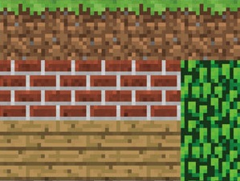



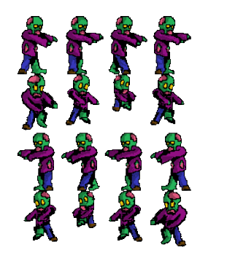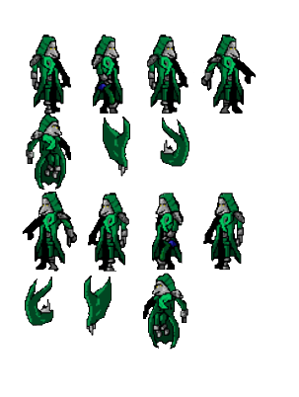

Doxygen: