**HTML Validation:**

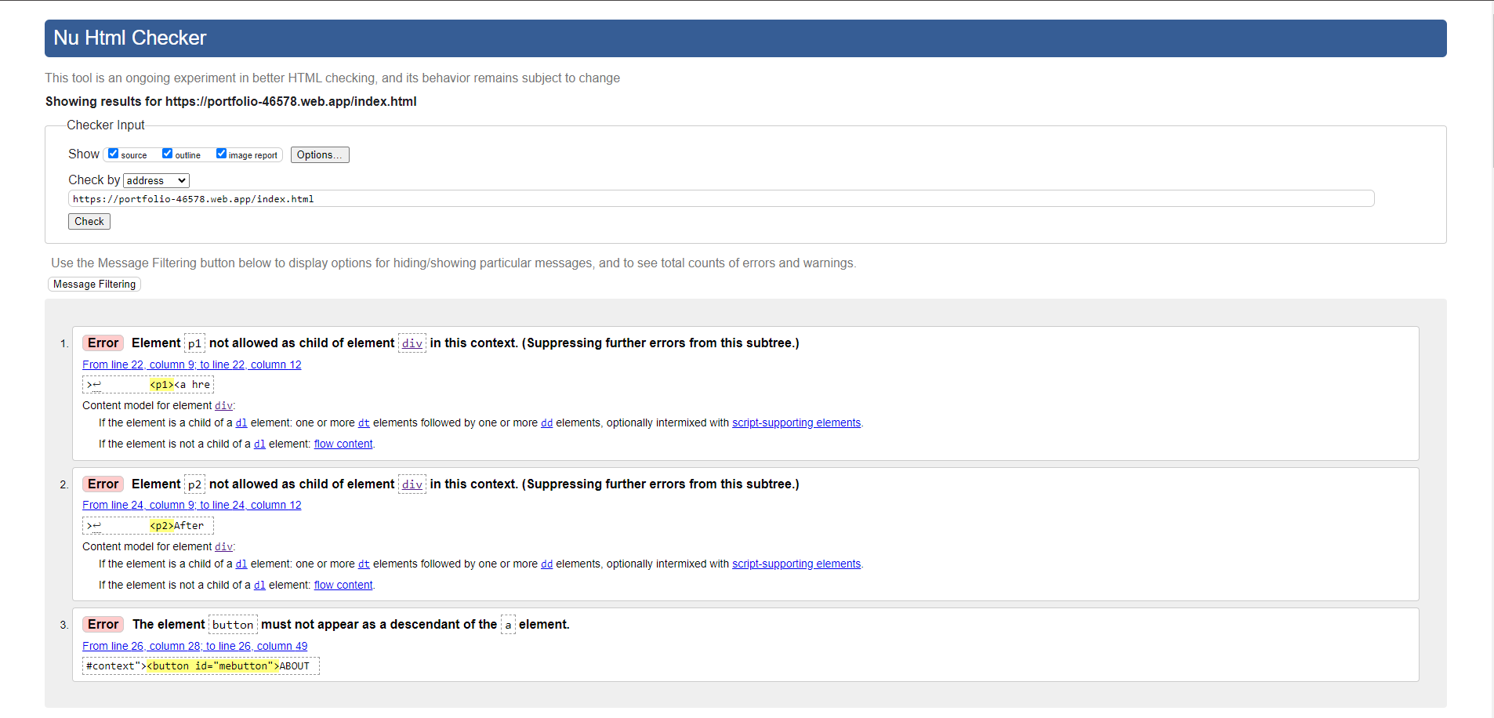

**CSS Validation:**



**Lighthouse:**

* Mobile:
* 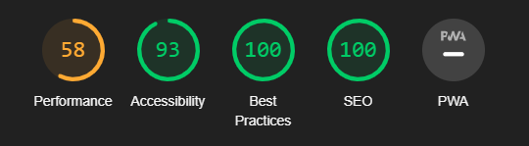Desktop: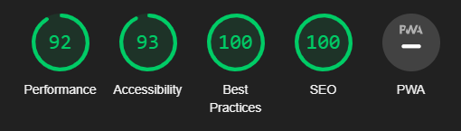

Accessbility using WAVE: <https://wave.webaim.org/report#/https://portfolio-46578.web.app/>

**Wireframe:**

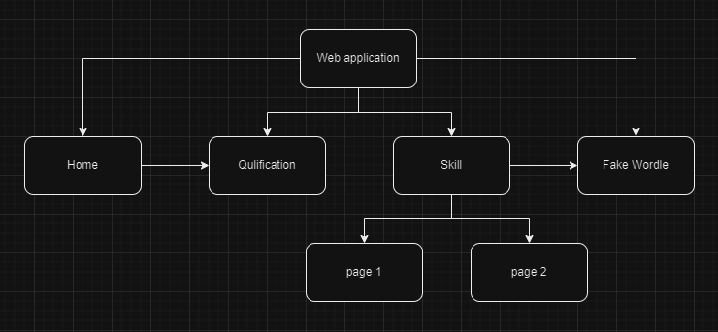

**Wordle test plan:**

|  |  |  |  |  |  |
| --- | --- | --- | --- | --- | --- |
| **Test number** | **Description** | **Step** | **Expected Result** | **Actual Result** | **Pass/Fail** |
| 1 | Word Genertion | Check the generated word | The word should be choose randomly from the dictionary | Algae (does choose random) | Pass |
| 2 | Guess the correct letter | Guess the correct letter in the correct order of that word | The box contain correct letter should display green color | Does show green | Pass |
| 3 | Guess the wrong letter | Guess the correct letter of the word but in the incorrect order | The box contain wrong letter should display yellow color | Does show yellow | Pass |
| 4 | Guess the complete word | Guess a complete word within the word limit | The game should reveal the correctness of each letter | Does show which letter is in the right order, wrong order, or not in the word | Pass |
| 5 | Guess the incomplete word | Guess an incomplete word within the word limit | The game will not submit the word | Does not submit the word | Pass |
| 6 | Winning the game | Successful guess the correct word | Should show a message says “Congratulation” | Does have a message “Congratualtion” | Pass |
| 7 | Losing the game | Cannot guess the word after try all the attempts | Should sho a message says “You are so bad” | Does have a message “You are so bad” | Pass |
| 8 | Responsive | Testing the game on various device with different screen size | The game should responsive | Cannot work on mobile device (except laptop) | Fail |
| 9 | Compatibility-  Chrome Browser | Testing the game on Chrome | The game should work without issue | Working flawlessly (except on mobile device) | Pass |