INSTITUTIONAL DETERMINANTS OF PRIVACY DESIGN IN CENTRAL BANK DIGITAL CURRENCIES
Martin Bok – Dominik Stroukal
Abstract
Central bank digital currencies (CBDCs) force an explicit decision about transaction privacy that physical cash leaves implicit. This paper asks which institutional factors determine the privacy that central banks actually commit to in their CBDC designs. From a corpus of 100 official and quasi-official documents across forty-seven jurisdictions and two institutional composites we extract 6,139 own-design statements, of which 5,624 survive a two-level document reconciliation, and we separate privacy vocabulary (aspirational language about protecting users) from the documented privacy posture, an aggregate of design choices (decisions weighted above proposals) that determine whether a design can withhold transaction data from the state. Estimated with pairwise-complete data, bootstrap intervals and family-wise correction, no macro condition robustly predicts documented commitment: the once-reported democracy association (r = 0.47) was a listwise-deletion artefact, and on the present corpus even the vocabulary-side association vanishes (r = −0.17; commitment r = −0.01). The informal economy shows the only directionally consistent commitment-side signal (r = −0.28) but is not significant after correction. The robust finding is measurement itself: the privacy-family share and the documented privacy posture share only about 18 % of variance. The dataset is released in full.
Key words: central bank digital currency, privacy, institutional determinants, content analysis, informal economy
JEL Code: E42, E58, G28
Introduction
Around 90% of central banks now report some form of work on a central bank digital currency, and a growing share have moved from research to pilots and live issuance (Kosse & Mattei, 2022). As that work advances, few design questions are as consequential, or as contested, as privacy. Whether a retail CBDC reproduces the informational properties of cash or replaces them with a fully traceable ledger is a deliberate architectural choice, not a technical inevitability.
That choice matters because privacy in payments is welfare-relevant in its own right. Money has long been understood to provide privacy precisely because a cash purchase, unlike a credit purchase, does not identify the buyer (Kahn, McAndrews, & Roberds, 2005). Garratt and van Oordt (2021) show that payment privacy has the character of a public good, under-supplied by a purely private payments market. A CBDC is the instrument through which a central bank can decide how much of that public good to preserve.
The design literature treats privacy mainly as one parameter in a set of trade-offs. Agur, Ari, and Dell’Ariccia (2022) model CBDC design as a balance between cash-like and deposit-like features, with privacy and anonymity on one side and financial-integrity and monetary-control objectives on the other. Auer and Böhme (2020) map the technological choices, direct versus intermediated architectures and account- versus token-based access, that determine how much transaction data a CBDC necessarily exposes. The political economy of these choices is itself contested. Cukierman (2020) argues that the welfare and distributional consequences of a CBDC depend heavily on the political and institutional environment in which it is issued.
Set against the case for privacy is the financial-integrity agenda. Anti-money-laundering and counter-terrorist-financing standards push in the opposite direction, toward identifiability and traceability, and a CBDC inherits the tension directly, because the same ledger that could preserve cash-like privacy could also deliver unprecedented transaction visibility to the authorities. How a given jurisdiction resolves that tension is not dictated by the technology. It is a choice, and choices vary across countries. The empirical question this paper takes up is what drives the variation, and in particular whether it is the political character of a regime or the structural features of its economy that does the explanatory work.
What this literature largely lacks is a systematic, cross-jurisdictional measure of what central banks actually commit to, as opposed to what they say, and of what institutional factors explain the variation. The natural intuition, that democracies will build privacy-preserving CBDCs and authoritarian states will not, is widely assumed but rarely tested against the documents themselves. A separate strand offers a structural rather than political hypothesis. Auer, Cornelli, and Frost (2023), assembling a database of CBDC projects, find that retail CBDC work is more advanced where the informal economy is larger, suggesting that the pressure to bring untaxed and untraceable activity onto a monitored ledger is a material driver of CBDC effort. If structural-economic pressure drives whether a country pursues a CBDC, it may also shape how much privacy that CBDC is designed to allow.
This paper addresses the gap directly. We build a document-based measure of privacy that distinguishes vocabulary from commitment, apply it uniformly across forty-seven jurisdictions and two institutional composites, and test which institutional determinants, whether political regime, region, central-bank independence, or the size of the informal economy, predict the privacy a CBDC is designed to deliver. The contribution is threefold. It offers a reproducible measure of the documented privacy posture, evidence that the much-assumed link between democracy and privacy does not survive scrutiny (part vocabulary artefact, part missing-data artefact), and a demonstration that no tested macro condition robustly predicts documented commitment, which relocates the burden of proof from regime labels to measurement.
1 Data and method
1.1 Corpus and coding
The corpus consists of one hundred official and quasi-official documents (eighty-nine institution-voice; eleven staff- or consortium-attributed, flagged in the released registry), central-bank design papers, technical reports, legal frameworks, and international-institution publications, covering forty-nine entities. Jurisdictions enter the corpus when at least one official own-voice CBDC publication could be located via central-bank sites and public trackers up to the corpus cut-off; roughly seventy-five further countries listed by public trackers, mostly at an early research stage, lack such documents and are excluded, so document availability, transparency and language plausibly correlate with regime and region — a selection constraint we flag rather than model. Ninety-three documents yield codable content, including ten 2024–2025 official updates added in revision (among them the ECB’s closing report on the digital euro preparation phase and the HKMA’s e-HKD Phase 2 report). A frozen large-language-model union extractor reads every substantive page (very short pages are skipped and long pages truncated at a fixed character budget) and extracts 6,139 own-design statements, each anchored to a verbatim quote in the source language with an English rendering; a second frozen classifier pass assigns final codes with mandatory quoted evidence, and a deterministic document-level reconciliation — applied to the token-architecture, remuneration and programmability families, where a document’s own conclusions override isolated statements — replayable offline from the released archives, retains 5,624 statements (release v1.1 of 17 August 2026).
1.2 Measuring privacy: family share versus documented posture
The central methodological move is to measure privacy in two different ways. The privacy-family share (our vocabulary measure) counts privacy-related language, such as references to anonymity, data protection, confidentiality, and user privacy. The documented privacy posture (our commitment measure) aggregates design choices that determine informational exposure — weighting decisions twice as heavily as proposals — such as whether the architecture supports offline anonymity, whether it incorporates privacy-enhancing technologies or data minimisation, and, crucially, whether transaction data is withheld from the state or merely from commercial counterparties. A design can speak at length about protecting user privacy while committing to full state visibility of every transaction, so vocabulary and commitment then point in opposite directions. Inter-coder reliability for the multi-dimensional coding scheme is being assessed with Krippendorff’s α on a 15% double-coded sample (Krippendorff, 2019), which is appropriate because the coding spans several dimensions and is not restricted to two coders.
1.3 Institutional determinants and specification
To test what shapes privacy commitment, we match each jurisdiction to four institutional covariates, namely a V-Dem liberal-democracy score (Coppedge et al., 2024), a measure of central-bank independence (Romelli, 2024), the size of the informal economy (World Bank Informal Economy Database, DGE estimate, 2020 values; Elgin et al., 2021), and a Basel AML risk score (Basel Institute on Governance, 2024). The complete set of covariates is available for thirty-three jurisdictions. The privacy-family share is available for thirty-seven. We relate the privacy measures to these covariates by correlation and by a small linear model, estimated as in equation (1), with a probit on the dichotomised outcome as a secondary specification.
P_{i} = β₀ + β₁D_{i} + β₂C_{i} + β₃S_{i} + β₄A_{i} + ε_{i} (1)
where P_{i} is the documented privacy posture index for jurisdiction i, D_{i} its V-Dem liberal-democracy score, C_{i} central-bank independence, S_{i} the size of the informal economy, A_{i} the Basel AML risk score, and ε_{i} an error term.
1.4 Use of large language models
We disclose two uses of large language models. In the extraction tier (§1.1) the model performs constrained generative extraction and coding: it locates candidate statements, produces an English rendering, and applies the locked codebook under a fixed written protocol; every coded passage is anchored to a verbatim quotation from the source in its original language, and reclassification and stance outputs are archived, with first-pass extraction reproducible at the level of the frozen protocol (on the emerging methodology see Gilardi et al., 2023; Ziems et al., 2024; Halterman & Keith, 2024). Document-level stance fields are estimated from sampled high-density sections rather than a full read and are treated as approximations. As with human coding, it is reproducible at the level of the protocol and codebook, with reliability assessed by independent double-coding (§1.2); human adjudication of the present release is in progress. The authors are responsible for all content. The protocol, codebook, coded-segment data, and analysis code are released in the public repository at cbdcdataset.org.
2 The composition of CBDC purpose
A CBDC is rarely built for a single reason. Across the corpus, six recurring strategic purposes account for almost everything a central bank says a retail CBDC is for, namely preserving public money as cash declines (cash substitution), extending low-cost access to the unbanked and underbanked (financial inclusion), making payments faster, interoperable, and more competitive (payment modernisation), giving monetary policy a more direct instrument (monetary transmission), defending monetary sovereignty against stablecoins, big-tech money, and foreign currencies (sovereignty and competition), and securing traceability, monitoring, and law-enforcement access (state control). We call these gravitational centres because few projects sit at exactly one. Most are pulled toward a dominant purpose while feeling the attraction of others.
Fig. 1: Composition of CBDC purpose across the six gravitational centres
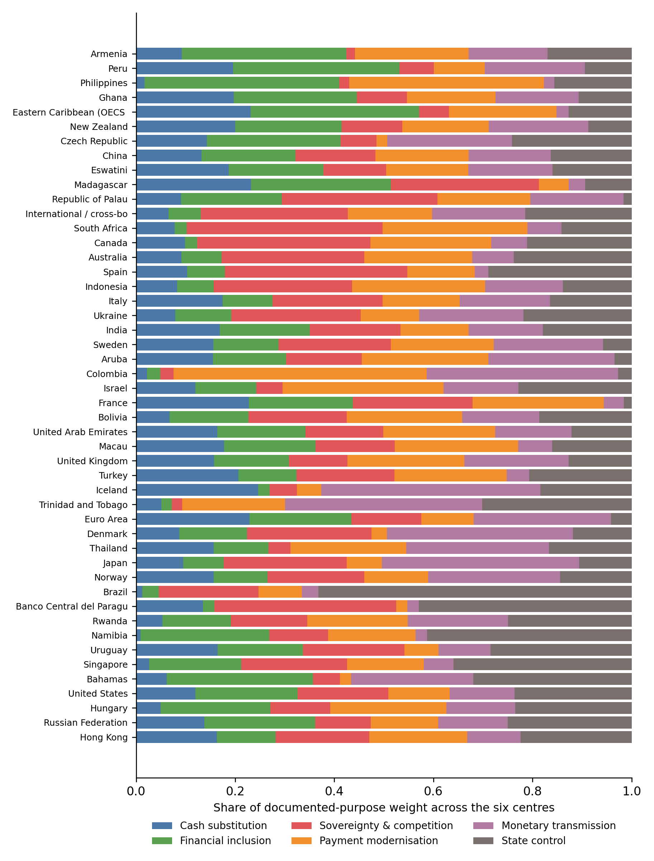
Source: authors’ computation. Each jurisdiction is a horizontal bar split into its six membership shares and grouped by its dominant centre. The largest segment marks the dominant purpose and the next-largest the secondary pull.
Figure 1 plots that composition. No single purpose dominates the field. Sovereignty and competition leads with twelve jurisdictions, state control follows with eleven, payment modernisation and financial inclusion with nine each and monetary transmission with seven. Cash substitution dominates nowhere under the headline construction: thirteen jurisdictions invoke cash-like motives strongly, but the headline score conditions cash on state-facing privacy actually being committed; removing that gate would make cash the dominant centre in nine jurisdictions. The absence of cash dominants is thus a property of the documented-commitment construction — cash is freely invoked but rarely underwritten by state-facing privacy — and the six-centre typology should accordingly be read as exploratory. The field is also genuinely mixed: nineteen of the forty-eight entities with codable statements carry two comparably weighted purposes.
What matters for the present paper is that the six purposes differ sharply in the privacy they imply. The state-control centre is low-privacy by design, since its defining features are traceability and law-enforcement visibility, while the cash-substitution centre is its opposite, because preserving cash means preserving cash-like informational boundaries. The other four sit in between, their privacy posture turning on design choices rather than on the purpose itself.
3 Privacy: vocabulary versus commitment
The gap between what CBDC documents say about privacy and what they actually commit to building, is the empirical pivot of the analysis, and the clearest illustration is China’s digital yuan. The Chinese documentation discusses managed anonymity at length (anonymity from the counterparty for small payments, with full traceability available to the state) alongside extensive language about replacing cash. Conditioning the privacy score on whether data is actually withheld from the state, rather than on how often privacy is mentioned, separates the two and places the design where its architecture, not its rhetoric, puts it.
The analysis that follows uses the commitment measure as the dependent construct and keeps the privacy-family share only as a diagnostic, so that the gap between the two can itself be read as evidence.
4 Institutional determinants of privacy
4.1 Regime is largely a vocabulary effect
The most widely held expectation is that a political regime predicts CBDC approach to user privacy, with democracies protecting it and authoritarian states eroding it. Measured by vocabulary on the present corpus, the association is absent: r = −0.17 (95 % bootstrap CI [−0.44, 0.16], permutation p = 0.32). The r = 0.47 once reported arises only under listwise deletion on a smaller corpus; successive corrections move the estimate from 0.47 to 0.26 and now past zero, the signature of an artefact rather than of a regime effect. Measured by commitment, the association is likewise indistinguishable from zero (r = −0.01, CI [−0.30, 0.32]; Tab. 1).
Fig. 2: How the privacy correlation shifts from vocabulary to commitment (with bootstrap 95 % CIs)
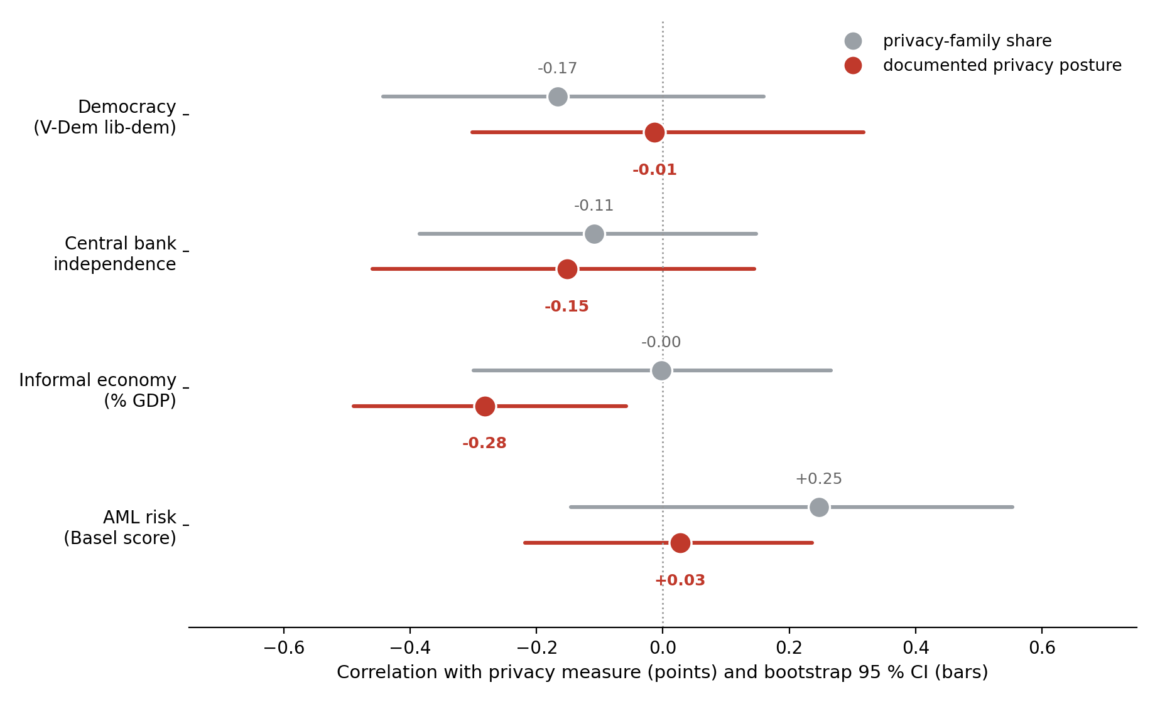
Source: authors’ computation. Grey, privacy-family share; red, documented privacy posture; bars, bootstrap 95 % CIs (n = 35–39 by condition).
4.2 The informal economy: a commitment-side signal, insufficient power
The informal economy is the one candidate that registers on the commitment side: r = −0.28 on commitment (CI [−0.49, −0.06], permutation p = 0.09), against essentially zero on vocabulary (r = −0.00). Where more activity is untaxed and unobserved, documents commit to less privacy, and the signal appears precisely in the posture measure rather than in the rhetoric. The estimate does not survive Holm correction across the eight-test family (corrected p = 0.68), and with at most 39 jurisdictions the design is powered only for large effects; we therefore report a promising hypothesis, not a finding. The structural pressure that, in Auer, Cornelli, and Frost’s (2023) data, motivates a country to pursue a CBDC may thus also shape how much privacy that CBDC is designed to allow.
The remaining institutional covariates follow the regime pattern rather than the informal-economy pattern, as Figure 2 makes visible. Central-bank independence is −0.11 on vocabulary and −0.15 on commitment; the Basel AML risk score falls from 0.25 on vocabulary to 0.03 on commitment. Neither approaches significance after correction. Of the four candidate determinants, only the informal economy registers on the commitment side at all. Every institutional or political correlation that looks meaningful on vocabulary is attenuated or reversed once the documented design choices are isolated. The pattern sits more comfortably with enforcement-pressure explanations than with value-based ones, though the study is underpowered to establish either.
Tab. 1: Correlation between privacy and macro conditions under the two privacy measures
Macro condition | Corr. with privacy-family share | Corr. with documented privacy posture | Reading
Democracy (V-Dem) | −0.17 [−0.44, 0.16] | −0.01 [−0.30, 0.32] | Artefact; ≈ 0 on both measures
Informal economy (size) | −0.00 [−0.30, 0.27] | −0.28 [−0.49, −0.06] | Commitment-side; n.s. after Holm
Source: authors’ computation. Privacy-family share n = 35–38; documented privacy posture n = 36–39 (pairwise-complete).
Note: pairwise-complete estimates; bootstrap 95 % CIs in brackets; permutation p-values, Holm-corrected across the eight-test family. No association survives correction (all corrected p ≥ 0.68).
5 From statements to documents: the two-level dataset
The dataset analysed above is itself the product of a two-level reading introduced in this revision. Each statement is classified with mandatory verbatim evidence, and each document contributes a separate document-level stance that can overrule statement-level enthusiasm. The gap between the levels is the point: of 170 statements that read, in isolation, as decided token-architecture choices, only five survive the document’s own conclusions, in a corpus where only four of the ninety-three yielding documents are policy decisions. Interest-bearing design shows the same asymmetry: 41 explicit rejections, 54 considerations, not a single documented commitment to remunerate.
The programme also tags each jurisdiction’s development stage from its latest official document (one live deployment, ten pilots, thirteen active and twenty-three paused research programmes), separating decided facts from directional leanings. Human adjudication of the model layers is in progress; the reconciliation layer is deterministic and replayable offline from the released archives. Its direction reinforces the central claim that official CBDC texts overstate decidedness.
Conclusion
This paper set out to identify the institutional determinants of privacy design in central bank digital currencies, using the documents central banks themselves publish. Its central finding is that the most intuitive determinant, political regime, is a poor one. The apparent association between democracy and CBDC privacy is an artefact of vocabulary. Democracies use more privacy-protective language, but that language does not translate into documented design choices to withhold transaction data from the state. When privacy is measured as documented commitment rather than as rhetoric, and when estimation is done on pairwise-complete data, the democracy association is indistinguishable from zero on both measures (vocabulary r = −0.17, commitment r = −0.01), and the earlier r = 0.47 stands revealed as a listwise-deletion artefact.
The measurement result is directionally stable across every specification we test (decision-only, document-balanced, minimum-evidence, wholesale-excluded and leave-one-document-out variants keep the informal-economy association between −0.22 and −0.37): privacy vocabulary and the documented privacy posture share only about 18 % of their variance, so a study that measures CBDC privacy by the language of official documents is measuring, to a first approximation, something other than what the design will do, and it errs most exactly where framing is least candid. The informal economy, whose negative signal appears on the commitment side and is consistent with the enforcement pressure that, in Auer, Cornelli, and Frost’s (2023) data, drives CBDC adoption itself, is the natural hypothesis for better-powered samples. The document-level reading (Section 5) reinforces the same lesson from another side: official CBDC texts systematically overstate decidedness. The cross-jurisdictional documented privacy posture developed here, released with its segment-level data, extraction code and audit trail, is offered as a reproducible basis for institutional claims that the vocabulary literature cannot support.
References
Agur, I., Ari, A., & Dell’Ariccia, G. (2022). Designing central bank digital currencies. Journal of Monetary Economics, 125, 62–79. https://doi.org/10.1016/j.jmoneco.2021.05.002
Auer, R., & Böhme, R. (2020). The technology of retail central bank digital currency. BIS Quarterly Review, March, 85–100.
Auer, R., Cornelli, G., & Frost, J. (2023). Rise of the central bank digital currencies. International Journal of Central Banking, 19(4), 185–214.
Basel Institute on Governance (2024). Basel AML Index 2024: 13th Public Edition — ranking money laundering and terrorist financing risks around the world. Basel Institute on Governance.
Coppedge, M., Gerring, J., Knutsen, C. H., Lindberg, S. I., Teorell, J., et al. (2024). V-Dem Country–Year Dataset v14. Varieties of Democracy (V-Dem) Project.
Cukierman, A. (2020). Reflections on welfare and political economy aspects of a central bank digital currency. The Manchester School, 88(S1), 114–125. https://doi.org/10.1111/manc.12333
Elgin, C., Kose, M. A., Ohnsorge, F., & Yu, S. (2021). Understanding informality (CEPR Discussion Paper No. 16497). Centre for Economic Policy Research.
Garratt, R. J., & van Oordt, M. R. C. (2021). Privacy as a public good: A case for electronic cash. Journal of Political Economy, 129(7), 2157–2180. https://doi.org/10.1086/714133
Gilardi, F., Alizadeh, M., & Kubli, M. (2023). ChatGPT outperforms crowd workers for text-annotation tasks. Proceedings of the National Academy of Sciences, 120(30), e2305016120. https://doi.org/10.1073/pnas.2305016120
Halterman, A., & Keith, K. A. (2024). Codebook LLMs: Adapting political science codebooks for LLM use and adapting LLMs to follow codebooks. arXiv preprint arXiv:2407.10747.
Kahn, C. M., McAndrews, J., & Roberds, W. (2005). Money is privacy. International Economic Review, 46(2), 377–399. https://doi.org/10.1111/j.1468-2354.2005.00323.x
Kosse, A., & Mattei, I. (2022). Gaining momentum: Results of the 2021 BIS survey on central bank digital currencies (BIS Papers No. 125). Bank for International Settlements.
Krippendorff, K. (2019). Content analysis: An introduction to its methodology (4th ed.). SAGE Publications.
Romelli, D. (2024). Trends in central bank independence: A de-jure perspective (BAFFI CAREFIN Working Paper No. 217). Bocconi University.
World Bank (2023). Informal Economy Database (2023 update; DGE estimates of informal output, % of GDP). World Bank.
Ziems, C., Held, W., Shaikh, O., Chen, J., Zhang, Z., & Yang, D. (2024). Can large language models transform computational social science? Computational Linguistics, 50(1), 237–291. https://doi.org/10.1162/coli_a_00502
Revised version: 17 August 2026 (statistical audit and measurement update; human validation in progress; full audit trail at cbdcdataset.org).
Contact
Martin Bok
Prague University of Economics and Business, Faculty of Finance and Accounting
nám. W. Churchilla 1938/4, 130 67 Prague 3, Czech Republic
Dominik Stroukal
Metropolitan University Prague
Dubečská 900/10, 100 31 Prague 10, Czech Republic

