VARSIVO APK Screenshots

- Login. png
The login screen, before signing in: logo, email, password, Continue with Google
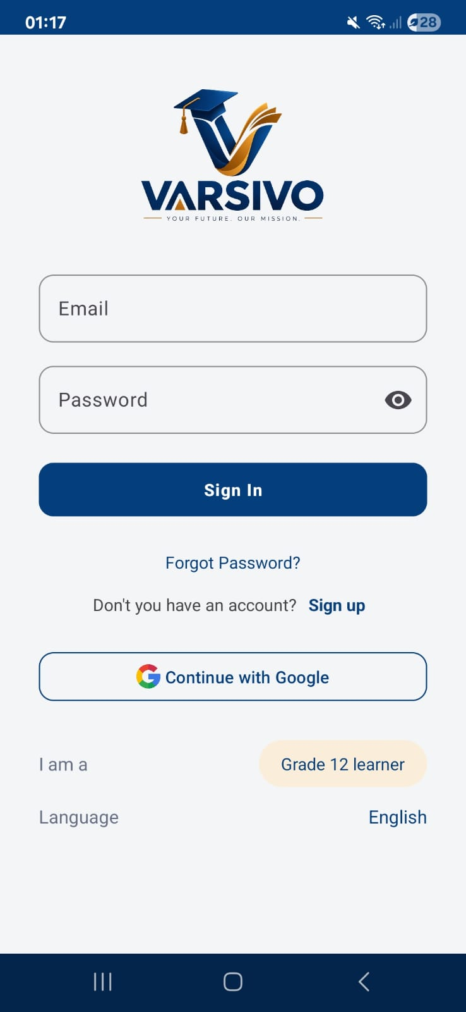

- Home. png
The Home dashboard after logging in
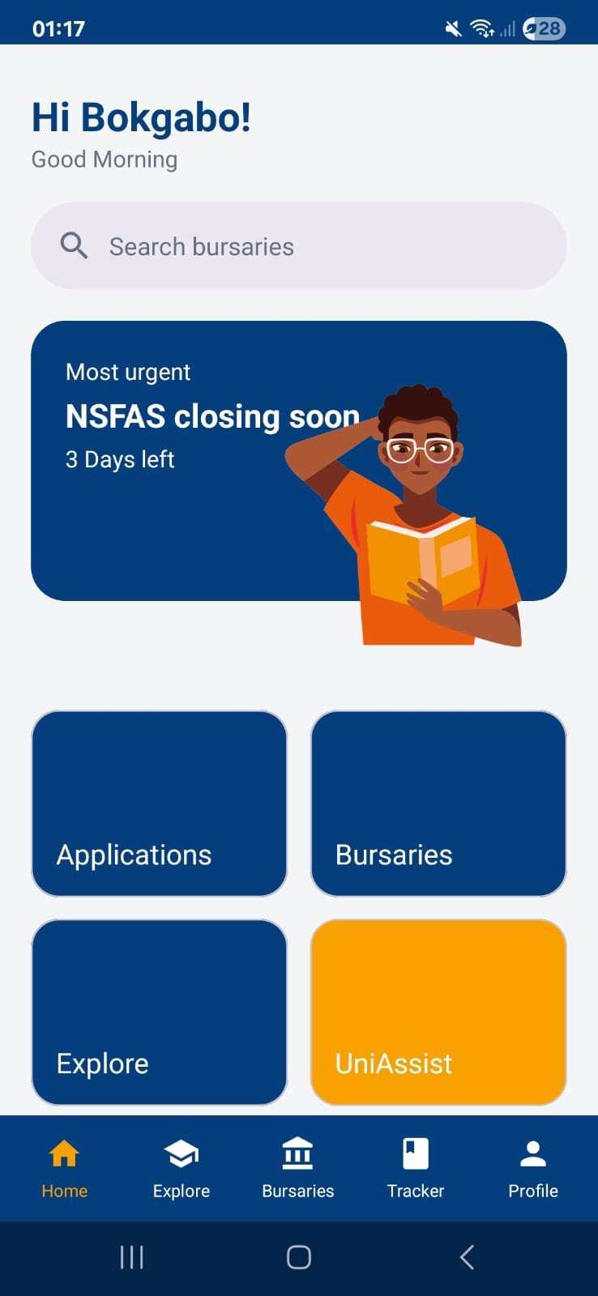

- Bursaries. png
Bursaries list, with the " Live from the Varsivo bursary API" label showing
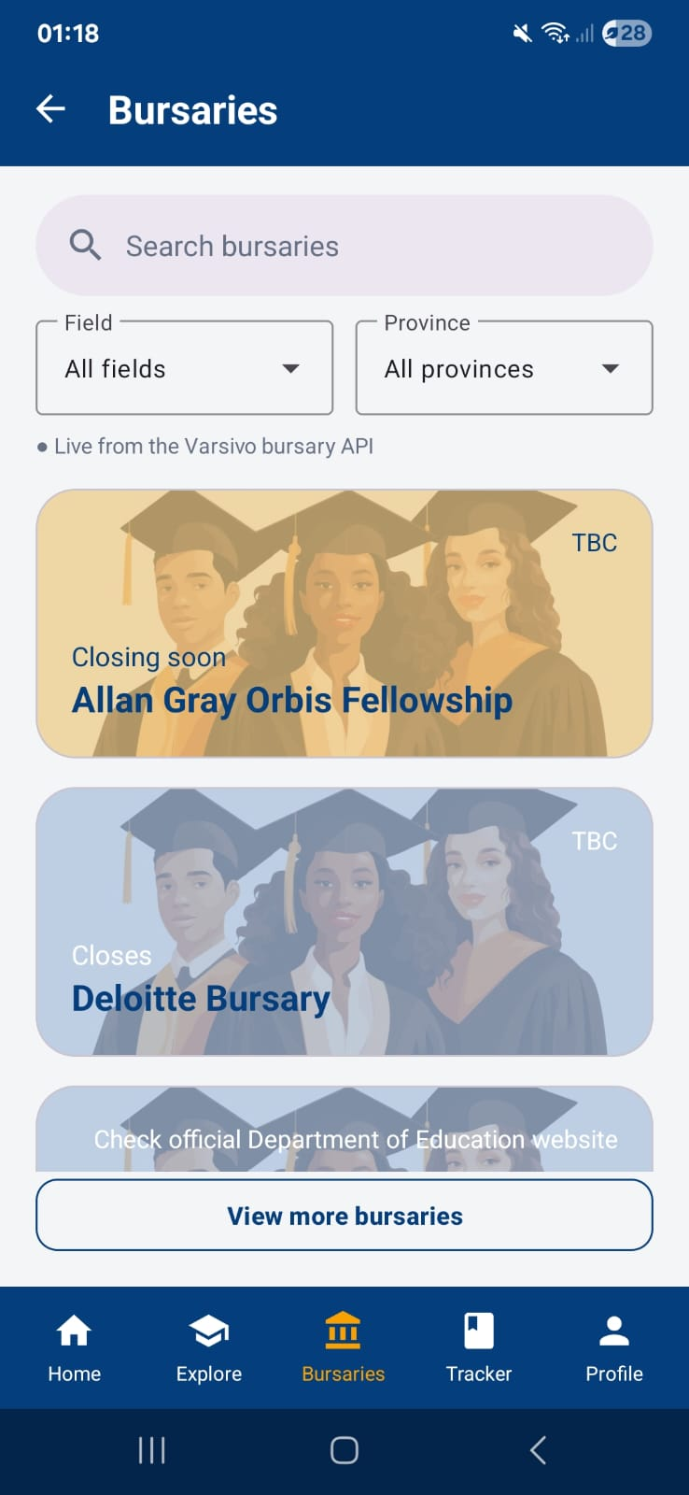

- Tracker. png
The Application tracker with at least one application in it
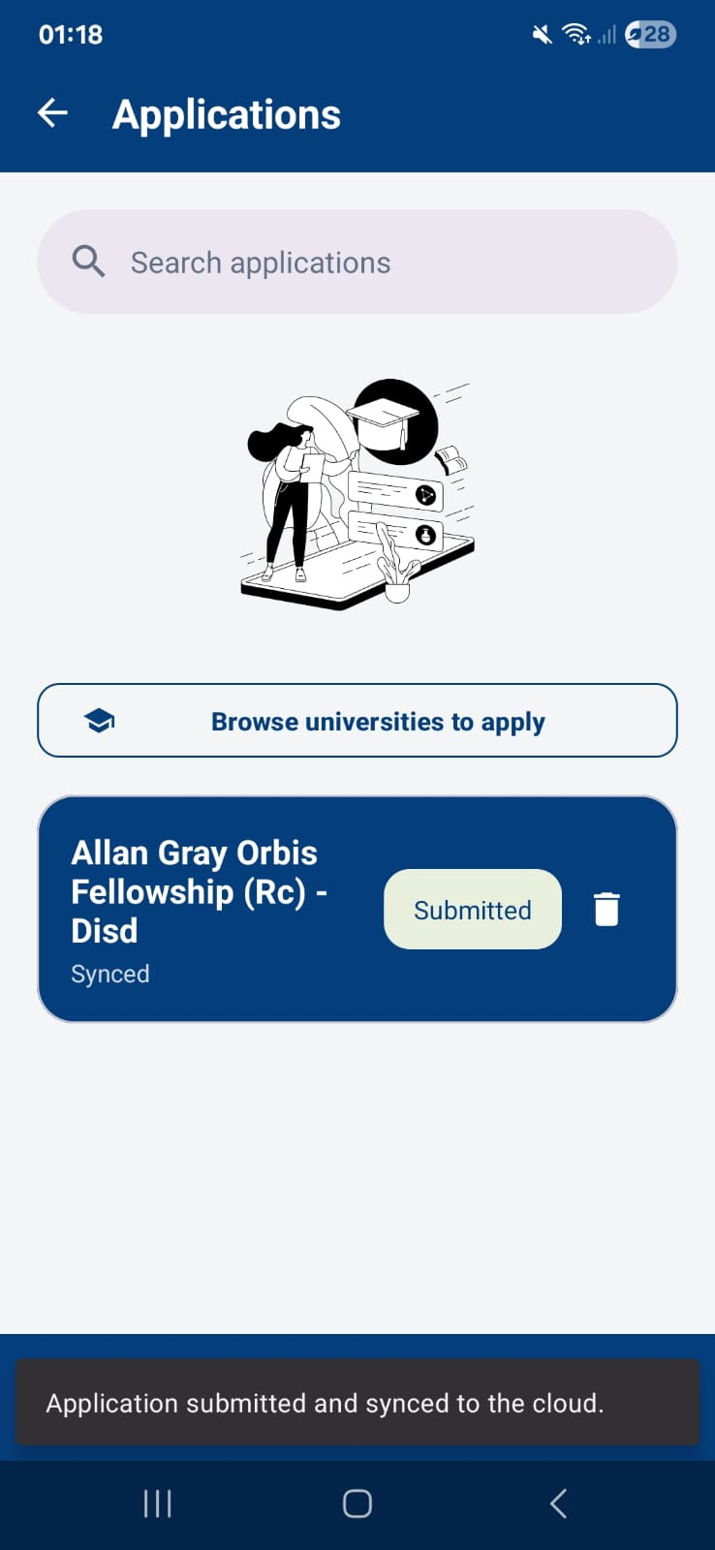

- APS. png
Explore after calculating the APS, showing "Careers for your APS (32)" with the career list
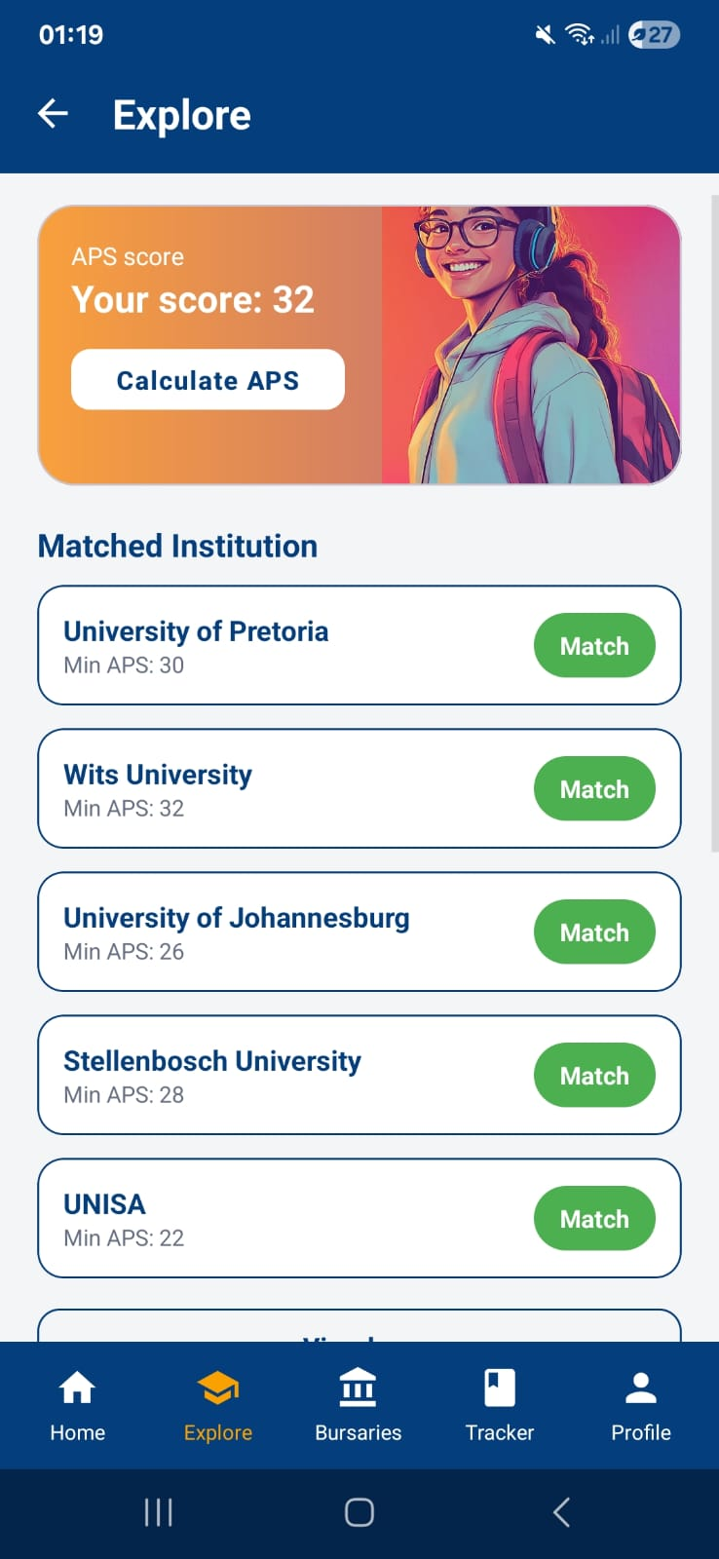

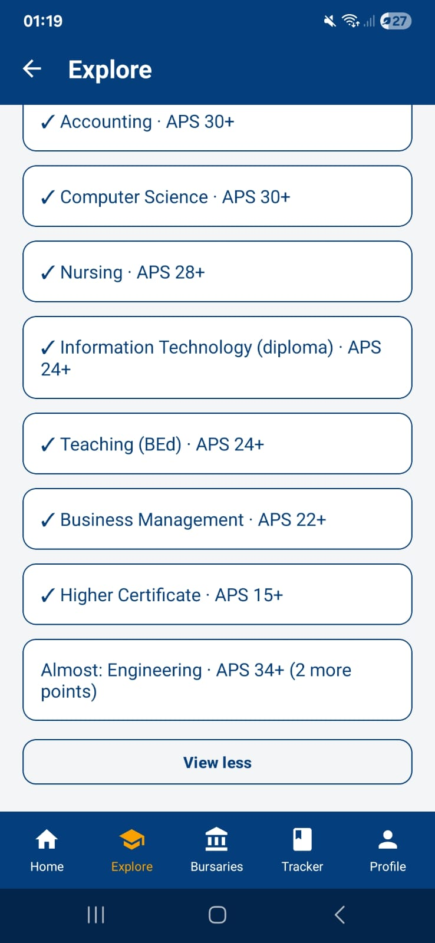
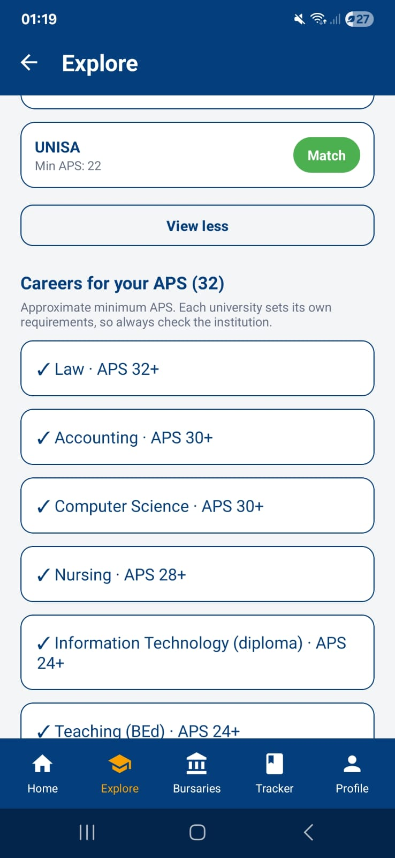

- Uniassist.png
UniAssist unlocked, with the timetable and deadlines
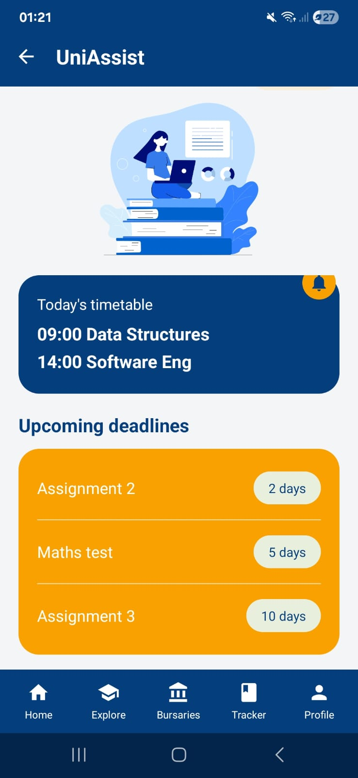

- Settings.png
Settings with a profile photo showing
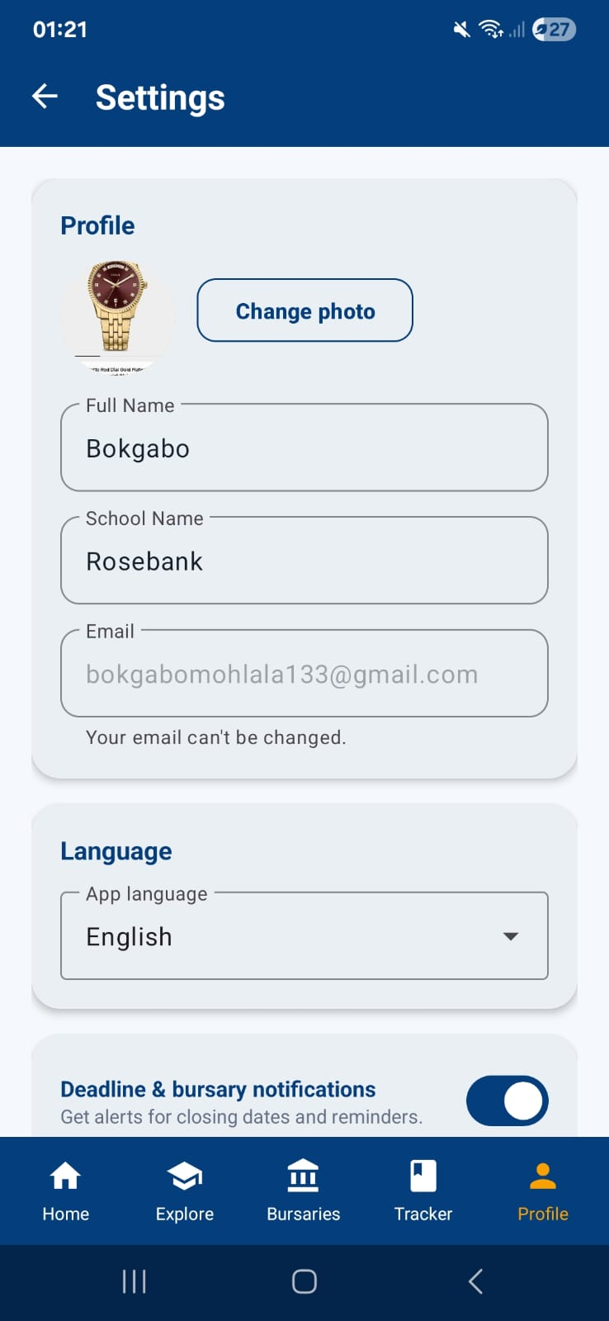

- Isizulu.png
Any screen with the language set to isiZulu
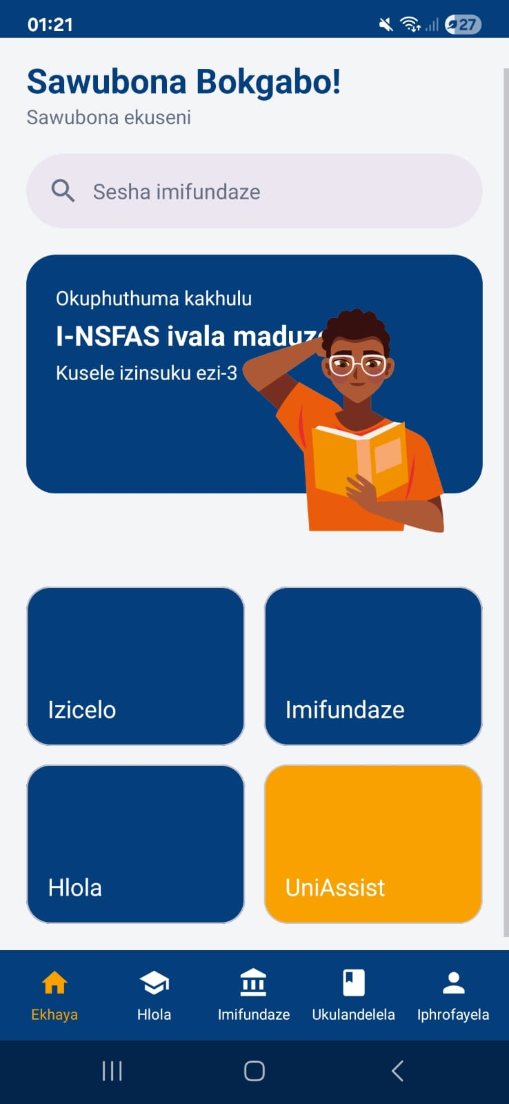

- Actions. png
The green "All checks have passed" page.


