VARSIVO
Tertiary Applications, Bursaries & Career Guidance App
OPSC6312 – Part 1: Research, Planning and Design
Research Report
Work-Integrated Learning (WIL) Project

SECTION A - Research

1. Introduction

1.1 Background
Every year, thousands of Grades 12 learners across South Africa reach the end of matric with limited, fragmented support for one of the biggest decisions of their lives: what to study, where to study it, and how to fund it. Career guidance at school level is often under-resourced, bursary information is scattered across dozens of separate websites and social media pages, and university application deadlines, requirements and APS scores differ from institution to institution. This leaves many capable learners applying too late, to the wrong qualifications, or missing funding opportunities entirely simply because they did not know these opportunities existed.
That gap does not close once a learner is accepted. Once enrolled, students take on day-to-day academic planning – timetables, deadlines, exam revision – with no single tool that carried them there from their subject and university choices in the first place. Varsivo is designed to close both gaps in one continuous experience: from choosing subjects and universities in high school, through daily academic planning, to final-year and career preparation, with a premium UniAssist tier unlocked once a learner is verified as an enrolled tertiary student.
Varsivo is being developed as a Work-Integrated Learning (WIL) academic project by a four-member student group, comprising a website prototype, a mobile app prototype, and a connected database, built using free and open-source tools (React, Android Studio, Firebase, Figma, VS Code and GitHub). Once Part 1 (Research, Plan and Design), Part 2 (Build) and any further evaluation stages are complete, the long-term goal is to deploy Varsivo as a live mobile application on the Google Play Store.

1.2 Problem statement
Grade 12 learners in South Africa lack a single, reliable, and continuously supported digital platform that guides them through career discovery, tertiary applications and bursary funding before enrolment – and existing tools stop supporting them the moment they are accepted, leaving a second, unaddressed gap once they actually reach tertiary level.

1.3 Aim and objectives
The aim of the Varsivo project is to design and build a mobile-first system that supports learners from career exploration through matric applications and bursary funding and then continues supporting them into tertiary study through a dedicated premium tier.
- To research existing tertiary-guidance and academic-planning platforms and identify gaps Varsivo can address.
- To design a system that helps Grade 12 learners match their grades to careers, qualifications, and institutions.
- To provide a centralised, filterable bursary and funding database, free of charge, for all high-school users.
- To design UniAssist, a premium, student-email-verified feature tier for learners who have enrolled at a tertiary institution, including day-to-day academic planning.
- To plan a system architecture and database design that can realistically be built with free, open-source tools and later deployed to the Google Play Store.

1.4 Scope
This Part 1 submission covers research into five comparable existing platforms, a problem and objective definition, and the planning and design groundwork (system architecture, database structure, and user flows) for Varsivo. It does not yet cover implementation, which forms the build phase of the project.

1.5 Target audience
Varsivo has two primary user groups. The first is Grade 12 (and, to a lesser extent, Grade 11) learners preparing for tertiary applications, who receive full access to career guidance, the APS calculator, the bursary database, and application tracking at no cost. The second is enrolled tertiary students, who gain access to UniAssist – a premium tier unlocked once a valid student email address is verified, extending Varsivo's support into day-to-day academic planning rather than ending at enrolment.

1.6 Research approach
Because no single existing app covers Varsivo's entire intended journey, four apps were researched across two categories that together map onto that journey. The first category – GradesMatch and BridgeApp – covers pre-enrolment career guidance and application execution. The second category – My Study Life and Reslocate – covers the wider academic journey, including the day-to-day planning and APS/course-matching functionality most relevant to the free tier and to informing UniAssist's premium, post-enrolment features. Reviewing all four together provides a realistic picture of what already exists, what students currently must piece together themselves, and where Varsivo can add genuine value.

2. Pre-Enrolment Guidance & Application Apps

2.1 GradesMatch

Overview
GradesMatch is positioned as Africa's leading career guidance platform, offering personalised career planning, university application support, bursary management, and student success services for high school students in South Africa and across Africa. It is designed to enhance how learners, teachers and parents interact with careers, higher learning institutions, and bursaries.

Core features
- Careers – search for a career of interest
- Match – match current school grades to opportunities in higher learning institutions and academic funding.
- Spotlight – hear from industry experts about their career journeys and the challenges they faced.
- Institutions – view higher learning institutions across South Africa and the qualifications they offer.

Applications support.
GradesMatch runs an early applications service that helps matriculants secure conditional offers, get approved for bursaries or scholarships, and even secure conditional residence offers, easing the transition from school to tertiary study. Learners are taught to apply using mock applications while still in Grade 11 and are advised on the documents they will need (Grade 11/12 report cards, ID documents, proof of residence). For the Health Sciences faculty specifically, the platform's community page has an “Available Bursaries” section where learners can browse and apply for funding opportunities and see what each one covers. Learners are also encouraged to look beyond NSFAS, since 350 funding opportunities are listed on the system.

Strengths
- Backed by real-world impact stories and partnerships (e.g. Trevor Noah Foundation collaboration), suggesting credibility and NGO/corporate trust.
- Large bursary database (~350 opportunities) rather than an NSFAS-only focus.
- Early-intervention model that engages learners from Grade 11, not only in matric year.
- Serves multiple user types (learners, teachers, parents), not a single-user product.

Weaknesses
- The Android app itself appears dated and low-traction – third-party mirrors show old version numbers and very low download counts, suggesting most value is delivered through the website and human facilitators rather than a polished native app.
- Heavy reliance on manual document submission (certified IDs, proof of residence), resembling a workflow that bridges into human-processed applications rather than a fully self-service digital tool.
- Some public-facing content is dated (still referencing 2019 application cycles in places), suggesting inconsistent content upkeep.

How it was implemented
GradesMatch operates primarily as a web platform plus a companion Android app, supported by a facilitator/community-based service model rather than a purely self-service app experience. Its bursary and institution data is manually curated and updated by a GradesMatch team, which explains both its depth (350+ bursaries) and its upkeep challenges.

2.2 BridgeApp

Overview
An important research finding is that BridgeApp is not an independent competitor – it is GradesMatch's own premium, execution-focused product. BridgeApp positions itself as the “ultimate guide to navigating university applications, tracking progress, and applying for funding – all in one place,” aimed at helping students and parents make better decisions about tertiary study.

Core features
- Explore career opportunities, salary expectations, and job market demand data for a selected qualification.
- Find scholarships, bursaries and financial aid matching the student's academic profile.
- Create an application plan tailored to marks, career interests, and location preference.
- An APS calculator that quickly verifies whether a student meets entry requirements for chosen qualifications.
- Filtering by entry requirements, tuition fees, related careers and more, across multiple universities
- Indicates which qualifications a student is most likely to be accepted into, based on academic results and required APS scores.
- A Digital Application Assistant, powered by AI, which helps organise the applications journey, so nothing is missed.
- Application Services – BridgeApp can process applications on the student's behalf were requested.
- Intelligent Notifications via SMS/WhatsApp that guide the student on what to do as institutions respond.
- Bridge Learn – e-learning courses with video-guided tutorials on how to apply and how to respond to institution replies.

Traction and pricing
BridgeApp reports strong quantifiable traction: 43,000 completed applications, 86,000 qualifications applied for, and 4,500 early provisional offers secured in 2023. Its premium packages start from R99, giving access to tools and support for the student's application journey.

Strengths
- Strong quantifiable traction (tens of thousands of completed applications/offers) demonstrates proven product-market fit.
- AI-assisted application tracking combined with a human-in-the-loop “we apply for you” service is a genuine differentiator most free tools lack.
- WhatsApp/SMS notifications match how South African youth communicate (low-data, high-reach channels).
- A clear, low-cost premium tier (from R99) makes monetisation approachable for the target market.
- The APS calculator and filtering directly address a real, practical matric pain point.

Weaknesses
- Because it is owned by GradesMatch, it is not a true alternative – its weaknesses mirror GradesMatch's own (dated native app footprint, reliance on manual/certified documents, facilitator-dependent processes).
- Cost from R99 upward is a barrier for the most under-resourced learners it claims to serve unless proven fee-waiver pathways exist.
- No visible continuity into tertiary life once a student enrols – the product stops at “getting in,” not “staying in and succeeding.”

How it was implemented
BridgeApp layers an AI-assisted tracking and notification system on top of GradesMatch's existing data (institutions, bursaries, careers), then adds a paid, higher-touch service tier (human application processing) on top. This is effectively a freemium-to-service upsell model rather than a separate technical product.

2.3 Comparison GradesMatch vs BridgeApp
Since BridgeApp is GradesMatch's own premium arm, the most useful framing is not “two competitors” but “one ecosystem with two tiers” – a free guidance layer and a paid execution layer.
Aspect | GradesMatch | BridgeApp
Relationship | Parent platform / brand | Product built by GradesMatch (premium arm)
Primary focus | Career guidance across learners, teachers, parents | Application execution: APS calculator, tracking, AI assistant
Cost | Free core platform | Paid packages from R99
Standout feature | Large bursary database (~350 listings) | AI-driven application tracking + apply-on-your-behalf service
Communication | Not clearly defined publicly | SMS / WhatsApp intelligent notifications
Post-enrolment support | Nonevident | Nonevident
Native app polish | Appears low traction / dated | No distinct standalone listing; tied to GradesMatch
Table 1: GradesMatch vs BridgeApp comparison

3. Academic Planning & Journey Apps
The second research category widens the lens beyond the matric application moment, covering apps relevant to the ongoing academic planning that Varsivo's free tier and UniAssist premium tier both need to support.

3.1 My Study Life – School Planner

Overview
My Study Life is a free, cross-platform academic planner used by millions of students internationally. It focuses on class schedules, homework tracking, exam revision planning, and a life-organiser feature (“Xtra”) for extracurricular activities. It syncs across devices and works offline, saving changes locally and syncing once a connection is available.

Strengths
- Purpose-built for academic life rather than a generic calendar, which students and reviewers highlight as its main advantage.
- Supports weekly and rotating timetables, exam tracking with grade breakdowns, a Pomodoro focus timer, and reliable offline access with automatic sync – directly comparable to a requirement Varsivo must also meet.

Weaknesses
- No South African context at all – no APS calculation, no local university or bursary information, and no guidance for choosing a subject or degree path.
- Several premium features sit behind a paywall, and it is entirely English language, with no support for South African official languages.

How it was implemented
Given its cross-platform availability (web, iOS, Android) and real-time sync across devices, it likely uses a central REST or GraphQL API connected to a cloud database (tasks, timetables and exams stored server-side), with local on-device storage (e.g. SQLite/Room equivalents) for offline access, synced back to the server once connectivity returns – the same offline-first pattern Varsivo needs to implement.

3.2 Reslocate

Overview
Reslocate describes itself as an AI-powered career guidance ecosystem built specifically for South African high school learners and their parents. It matches learners to institutions and courses based on their APS score, offers an AI tutor for homework help, surfaces scholarships, and provides past exam papers.

Strengths
- The closest existing match to Varsivo's “choosing a path” function; covers a large number of local institutions and courses, keeps a live scholarship database, and adds safety features such as verifying private colleges and accommodation providers.
- A parent-facing view is a distinctive addition not seen in the other apps researched.

Weaknesses
- Focused entirely on the pre-university decision stage. Once a learner has enrolled, the app offers little ongoing support for day-to-day academic planning, deadline tracking, or final-year/career transition – exactly the gap Varsivo is designed to fill.

How it was implemented
Matching thousands of courses against a user's APS score suggests a structured relational database (institutions, courses, requirements) queried through a REST API, with a separate AI service (a hosted LLM API) powering the tutor and recommendation features. Scholarship and housing data described as “updated daily” suggests server-side data feeds rather than static in-app content.

3.4 Comparison - My Study Life vs Reslocate

Feature | My Study Life | Reslocate
Covers subject/university choice | No | Yes – core focus
Covers day-to-day academic planning | Yes – core focus | No
Offline access | Yes | Not specified / likely limited
South African context (APS, NSFAS, local unis) | No | Yes
Multi-language (SA languages) | No | Not specified
Push notifications for deadlines | Yes (reminders) | Not specified
Covers final year/career transition | No | Partial (career articles)

4. Combined Comparison Across All Four Apps
Viewed together, the four apps split cleanly into two clusters: pre-enrolment decision support (GradesMatch, BridgeApp, Reslocate) and academic-life planning (My Study Life). None currently spans both. Table 3 summarises each app's category, primary value, and main gap briefly.
App | Category | Primary value | Main gap
GradesMatch | Pre-enrolment guidance | Career guidance + large bursary database | Dated app, manual document workflow
BridgeApp | Pre-enrolment execution | APS calculator + AI-assisted application tracking | Paid tier, stops at enrolment
My Study Life | Academic planning | Offline-first timetable, homework, and exam tracking | No South African context at all
Reslocate | Pre-enrolment guidance | AI matching + parent-facing view + verified housing | No support once enrolled

The pattern that emerges is consistent across all four apps: strong, often free tools exist for the pre-enrolment decision, and at least one strong tool exists for general academic planning, but no researched app carries a South African student continuously from subject choice through to graduation and career entry – and none offer local-language support throughout.

5. Best Features to Bring into Varsivo
Based on the strengths and gaps identified across both research categories, the following features are recommended for Varsivo, organised by source app, with a final set of features that no existing app offers and that Varsivo should introduce as genuine differentiators.

5.1 From the pre-enrolment guidance apps
- APS calculator and qualification-matching (from BridgeApp) – a near-mandatory feature for South African matriculants; inexpensive to build and high perceived value.
- A bursary/funding database with filtering (from GradesMatch and Reslocate) – kept free at the high-school tier, since pay walling funding information would be ethically risky for Varsivo's target users.
- An AI-assisted application tracker with reminders (from BridgeApp) – timelines, task checklists and deadline nudges delivered via push notifications and/or WhatsApp-style alerts.
- Career-to-salary-to-demand mapping (from BridgeApp) – helps learners choose paths, not only qualify for them.
- A parent-facing view and verification of institutions/housing (from Reslocate) – builds trust with both learners and parents.
- A lightweight mock/practice application mode (from GradesMatch's Early-Grade-11 approach) so users build familiarity with the process before the real admissions window opens.

5.2 From the academic planning apps
- Reliable offline-first design with automatic sync once connectivity returns (from My Study Life) – essential given inconsistent data access for many South African students.
- A clean reminders/dashboard system for upcoming deadlines and exams (from My Study Life), extended into UniAssist for tertiary-level timetables and coursework.

5.3 Where Varsivo can differentiate.
No researched app – across either category – offers meaningful support once a learner is accepted into a tertiary institution, and none offer South African multi-language support. These are the two clearest opportunities for Varsivo to lead rather than follow.
- UniAssist premium tier: student-email-verified features for enrolled tertiary students, extending Varsivo's academic planning (timetables, deadlines, exam tracking) beyond enrolment – something none of the five researched apps provide.
- Tiered access model: full free access for still-in-high-school users (career guidance, APS calculator, bursary search, application tracking), with UniAssist unlocked only once tertiary enrolment is verified – avoiding the outright paywall that limits BridgeApp's reach.
- One continuous student profile carrying a learner from subject/university choice, through daily academic planning, to final-year and career preparation – a feature no single existing app offers.
- South African multi-language support throughout the app, which none of the five researched apps provide.
- A modern, well-maintained native mobile experience – several researched competitors show signs of a dated or low-traction native app; a clean, actively maintained Android app (built for Google Play) is itself a differentiator.

6. Conclusion
The research shows a clear gap in the market. GradesMatch, BridgeApp and Reslocate each support parts of the pre-university decision, while My Study Life supports day-to-day academic planning once a student is already studying – but no single app connects both halves of the journey, and none offer multi-language support for South African users. Because BridgeApp is GradesMatch's own premium arm, the pre-enrolment cluster is best understood as one ecosystem with two tiers rather than several independent competitors, which sharpens rather than weakens the opportunity for Varsivo: a genuinely distinct, continuous alternative. Varsivo is positioned to combine the strongest features of all four apps – offline-first planning, APS-based matching, bursary/deadline awareness, and AI-assisted tracking – into a single app that follows a student across their entire academic journey, from matric to graduation, through its free tier and the UniAssist premium tier.

7. References
APKPure. (n.d.) GradesMatch. Available at: https://apkpure.com (Accessed: 22 July 2026).
BridgeApp by GradesMatch. (n.d.) BridgeApp. Available at: https://bridgeapp.co.za (Accessed: 22 July 2026).
CareersPortal. (n.d.) How GradesMatch Can Benefit You as a Matriculant. Available at: https://www.careersportal.co.za (Accessed: 22 July 2026).

Educational App Store. (2023) My Study Life Review – Features, Pricing, Pros & Cons. Available at: https://www.educationalappstore.com/app/my-study-life-school-planner (Accessed: 20 July 2026).
GradesMatch. (n.d.) GradesMatch. Available at: https://gradesmatch.co.za (Accessed: 22 July 2026).
GradesMatch Sandton. (n.d.) Facebook page. Available at: https://www.facebook.com (Accessed: 22 July 2026).
My Study Life, Ltd. (2026) My Study Life – School Planner. Google Play. Available at: https://play.google.com/store/apps/details?id=com.virblue.mystudylife (Accessed: 20 July 2026).
Reslocate. (2026) Reslocate: AI-powered career guidance ecosystem. Apple App Store. Available at: https://apps.apple.com/py/app/reslocate/id6737713352 (Accessed: 20 July 2026).
Siyavula. (n.d.) My Future: GradesMatch. Available at: https://www.siyavula.com (Accessed: 22 July 2026).
Soft112. (n.d.) GradesMatch. Available at: https://www.soft112.com (Accessed: 22 July 2026).
Trevor Noah Foundation. (n.d.) Impacting Career Pathways with GradesMatch. Available at: https://trevornoahfoundation.org (Accessed: 22 July 2026).

SECTION B - Plan

8. Introduction
This section sets out the full planning and design for Varsivo, building directly on the findings of the Research Report above. It covers the app overview, a detailed list of requirements (including every minimum requirement from the assignment brief), user interface design with mockups and a navigation diagram, the API and database design, a UML class diagram, the data the app will capture and store, and the Part 1 project plan.

9. App Overview

9.1 Name and icon
Name: Varsivo — a coined name (echoing "varsity") chosen because it does not clash with any existing app, organisation, or government programme, unlike alternatives considered and rejected during planning (e.g. "Khetha" and "Vulindlela", both already in use by South African government and education initiatives).
Icon concept: a simple upward path/compass motif inside a rounded square, in the app's primary navy-blue (#2E5B8A), symbolising forward progress and direction through a student's academic journey.

9.2 Innovative features
Building on the gaps identified in the Research Report, Varsivo introduces the following features that no single researched app currently offers together:
• One continuous student profile carrying a learner from subject/university choice, through matric applications and bursary funding, to enrolment and eventually final-year/career preparation.
• UniAssist: a premium, student-email-verified tier unlocked once a learner is confirmed as an enrolled tertiary student, extending Varsivo into day-to-day academic planning (timetables, deadlines, exam tracking) rather than stopping at acceptance.
• A tiered access model — full free access to career guidance, the APS calculator, the bursary database, and application tracking for all high-school users, with UniAssist unlocked only once verified, avoiding the outright paywall that limits BridgeApp's reach.
• South African multi-language support (English, isiZulu, and Afrikaans), which none of the four researched apps provide.
• Offline-first design for both the free tier and UniAssist, inspired by My Study Life but extended with South African-specific content.

10. Detailed List of Requirements
The table below includes every minimum requirement from the assignment brief, elaborated for Varsivo specifically, plus the additional features that make the app innovative and directly address the gaps identified in the Research Report.
Requirement | How Varsivo Implements It | Category
Register & log in (encrypted password) | Users register with email/password (hashed with bcrypt server-side) or via Google SSO. First-time users complete a short profile: grade/year of study, subjects, and preferred language. | Brief minimum
Single sign-on (SSO) | Google Sign-In is offered alongside standard email/password registration to reduce friction for first-time high-school users. | PoE only
Change settings | Users can update their language, notification preferences, grade/year of study, and subjects at any time from the Profile screen. | Brief minimum
Connect to a REST API + database | A REST API manages users, academic profiles, institutions/courses, bursaries, and application tracker entries, backed by a structured database (see Section 12). | Brief minimum
Offline mode with sync | Application tracker entries and reminders created without connectivity are stored locally on-device and automatically synced once a connection is available, following the same offline-first pattern identified in My Study Life. | PoE only
Real-time push notifications | Push notifications alert users to upcoming application deadlines, bursary closing dates, and (for UniAssist users) academic deadlines and exam reminders. | PoE only
Multi-language support (2+ SA languages) | The interface supports English, isiZulu, and Afrikaans, selectable at onboarding and changeable anytime in Settings — a gap identified in every researched app. | PoE only
APS calculator & course matching | Users enter subject marks; the app calculates their APS score and matches it against institution/course entry requirements, inspired by BridgeApp and Reslocate. | Innovative feature
Bursary & funding database | A filterable, regularly-updated list of bursaries and scholarships, free for all high-school users, inspired by GradesMatch's ~350-listing database. | Innovative feature
Application tracker | Tracks the status of each university/college application (submitted, in progress, offer received), inspired by BridgeApp's tracking feature. | Innovative feature
UniAssist premium tier | Unlocked once a student email address is verified; extends the app into day-to-day academic planning (timetable, deadlines, exam tracking) for enrolled tertiary students. | Innovative feature

11. User Interface Design
Below are wireframe mockups for each core screen, followed by a diagram showing how a user navigates between them. These are wireframe-level mockups intended to guide Part 2 development — refine the visual styling in Figma or Android Studio's layout editor before building.

11.1 Screen 1: Login / Onboarding
Purpose: allows a new or returning user to authenticate before accessing the app. Offers email/password login, registration, Google SSO, a role indicator (Grade 11/12 learner), and a language selector so the app can display in the user's preferred language from the very first screen.
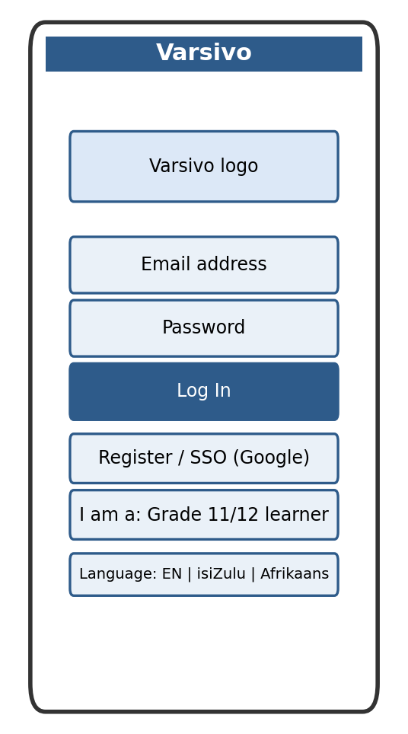
Figure 1: Login / Onboarding screen mockup

11.2 Screen 2: Home Dashboard
Purpose: the user's landing screen after logging in. Surfaces the single most urgent deadline at the top, then provides quick access to the Career & Course Explorer, Bursary Database, and Application Tracker, plus a prompt to unlock UniAssist once the user is ready to verify tertiary enrolment.
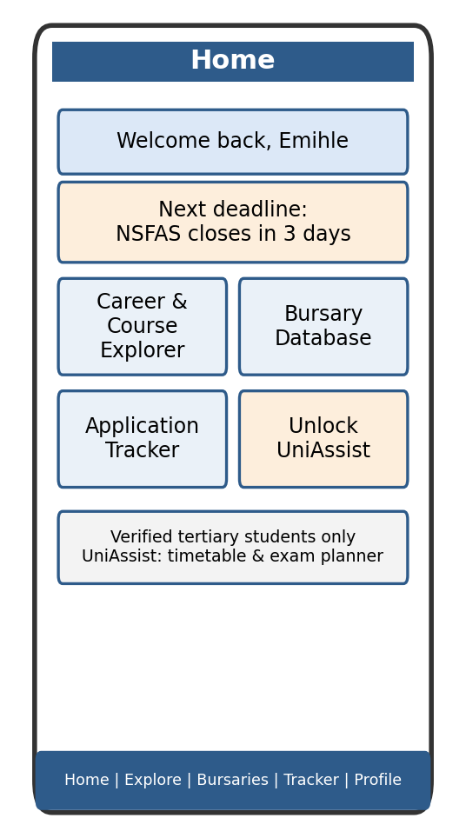
Figure 2: Home Dashboard screen mockup

11.3 Screen 3: Career & Course Explorer
Purpose: lets users calculate their APS score and browse institutions/courses and careers they qualify for, directly addressing the pre-enrolment decision-making gap identified in the Research Report (inspired by BridgeApp and Reslocate).
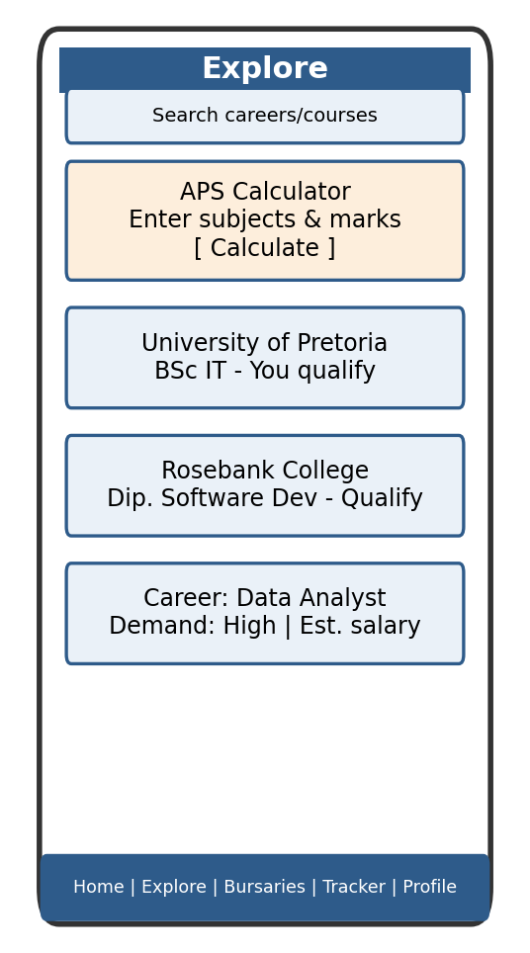
Figure 3: Career & Course Explorer screen mockup

11.4 Screen 4: Bursary Database
Purpose: a filterable, free list of bursaries and scholarships (by field of study and province), inspired by the depth of GradesMatch's bursary listings but presented in a cleaner, self-service interface.
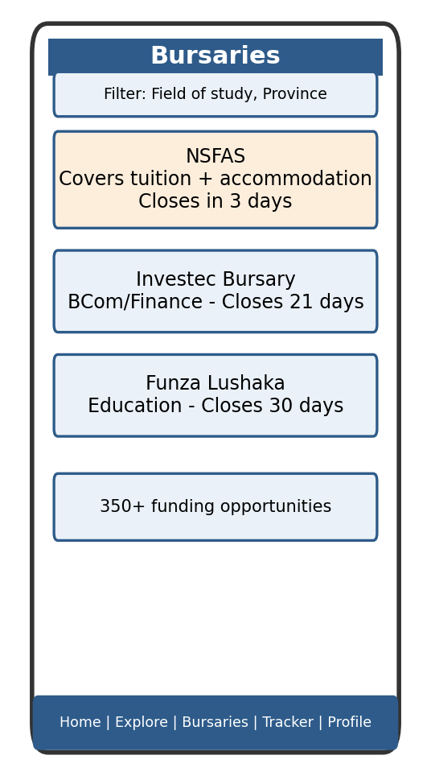
Figure 4: Bursary Database screen mockup

11.5 Screen 5: Application Tracker
Purpose: tracks the status of each application a learner has submitted, and allows new entries to be added even while offline, syncing automatically once reconnected.
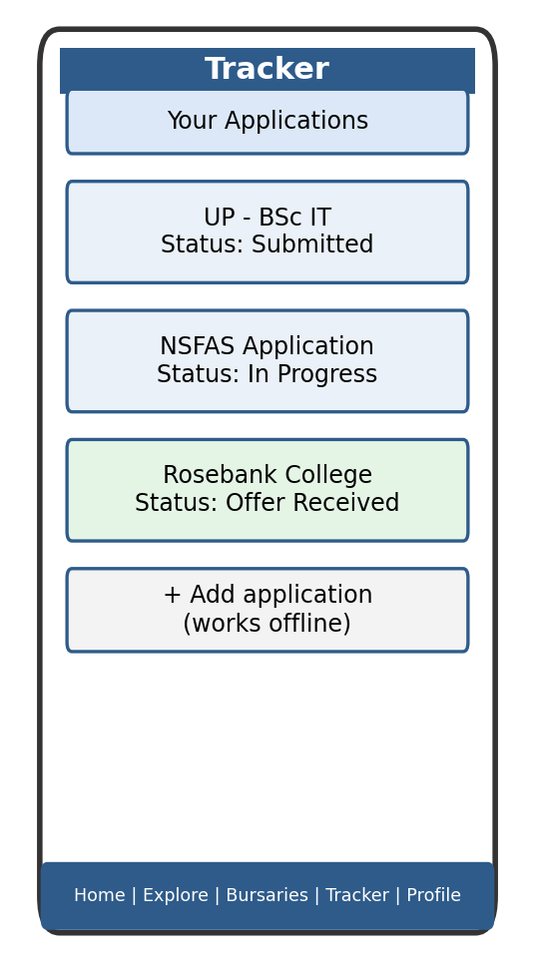
Figure 5: Application Tracker screen mockup

11.6 Screen 6: UniAssist Dashboard (premium, unlocked)
Purpose: available only once a student email address has been verified. Extends Varsivo into day-to-day academic planning — timetable, assignment deadlines, and exam countdowns — directly addressing the post-enrolment gap identified in every researched app.
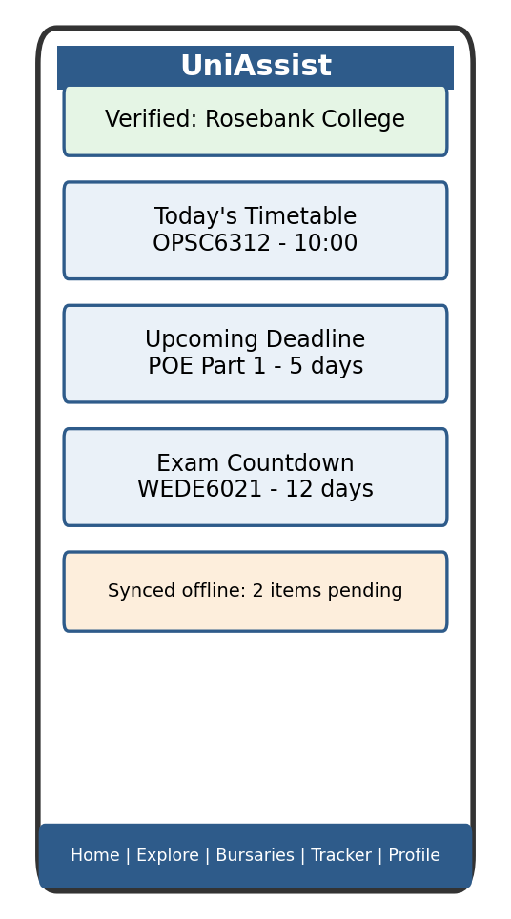
Figure 6: UniAssist Dashboard (premium, unlocked) screen mockup

11.7 Navigation Diagram
The diagram below shows how a user moves between Varsivo's core screens. UniAssist screens are only reachable once a student email has been verified, keeping the free and premium tiers clearly separated while still reachable from the same Home Dashboard.
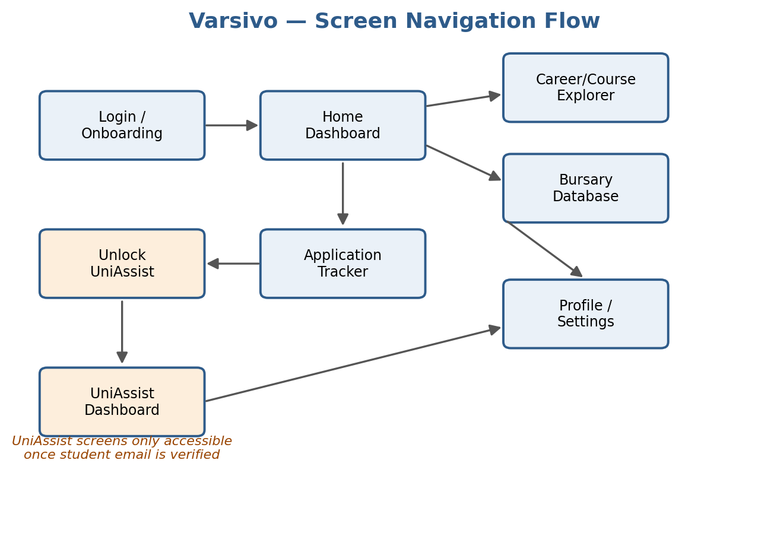
Figure 7: Screen navigation flow diagram

12. API and Database Design
Varsivo will use a REST API connected to a structured database. The API will expose endpoints for user authentication, profile management, institution/course lookup, APS calculation, bursary listings, application tracker CRUD operations, and UniAssist verification.
Hosting and database: Firebase is proposed as the primary backend, since Firestore provides offline persistence out of the box (supporting the offline-mode-with-sync requirement), Firebase Authentication handles secure login/SSO, and Firebase Cloud Messaging directly satisfies the push notification requirement — covering three separate requirements through one vendor with minimal custom backend code. Where a fully custom REST endpoint is required (e.g. APS matching logic or UniAssist email verification), a small Node.js API layer will be hosted on Railway and will read/write to Firestore. This hybrid approach should be confirmed with the module lecturer to ensure it satisfies the "REST API you create" requirement.
Key endpoints planned:
• POST /auth/register, POST /auth/login — user authentication
• GET /institutions?aps={score} — returns institutions/courses matching a given APS score
• GET /bursaries?field={field}&province={province} — returns filtered bursary listings
• GET /applications, POST /applications, PUT /applications/{id} — application tracker CRUD, supporting offline queuing and sync
• POST /uniassist/verify — verifies a student email address and unlocks the premium tier
• PATCH /users/{id}/settings — updates language, notification, and profile settings

13. UML Diagram
The simplified class diagram below shows the core entities in Varsivo and how they relate: a User has an AcademicProfile, which is matched against Institutions and Bursaries; an ApplicationTracker entry and UniAssistSubscription both belong to a User; and all entities communicate with the backend through a shared RestApiClient that also manages offline synchronisation and triggers the NotificationService.
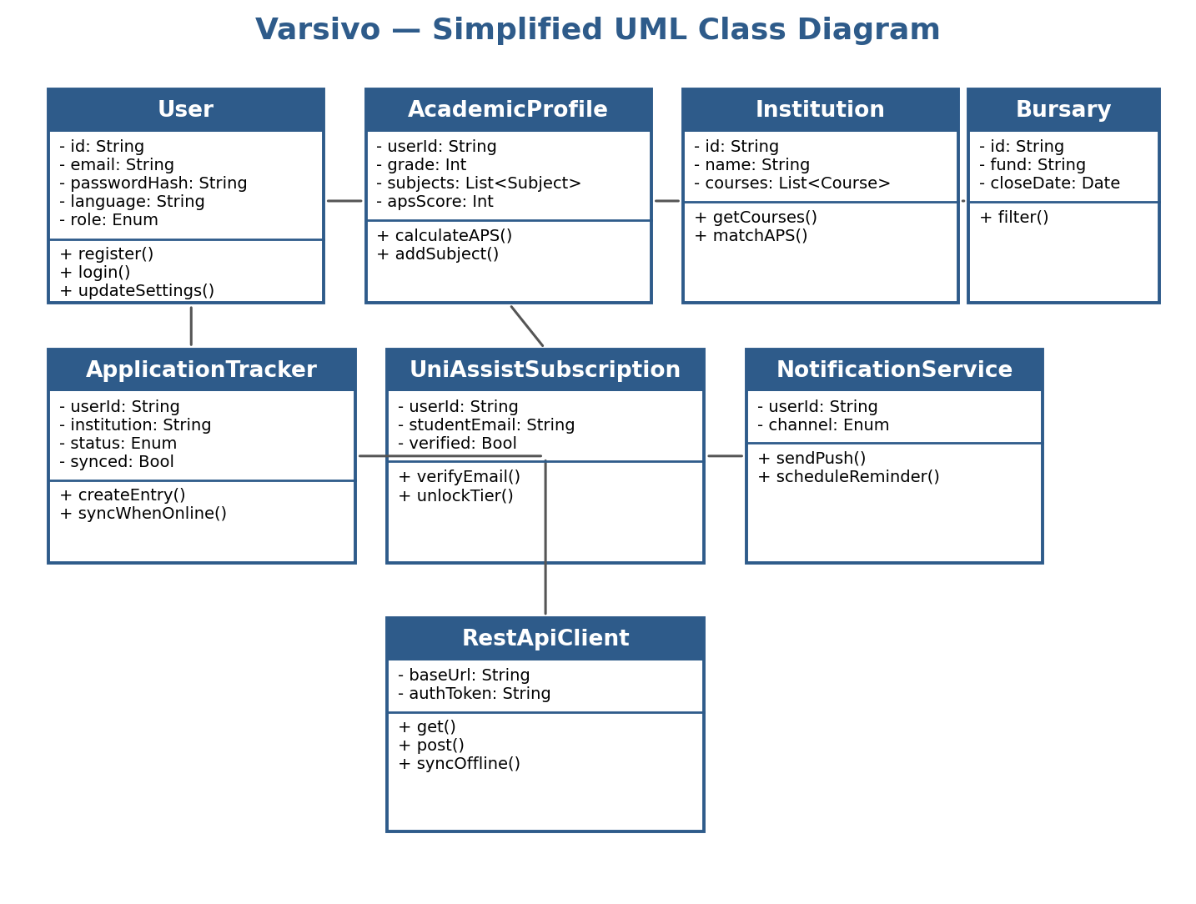
Figure 8: Simplified UML class diagram

14. Data Captured and Stored
Field | Data Type | Entity | Notes
email | String | User | Unique, used for login
passwordHash | String | User | Hashed, never stored in plaintext
preferredLanguage | String (enum) | User | EN / isiZulu / Afrikaans
role | String (enum) | User | High-school learner / verified tertiary student
grade / yearOfStudy | Integer | AcademicProfile | e.g. Grade 11, or 1st year
subjects | List<Subject> | AcademicProfile | Each with a subject name + mark
apsScore | Integer | AcademicProfile | Calculated from subjects
institutionName | String | Institution | e.g. "University of Pretoria"
courseRequirements | List<Integer> | Institution | Minimum APS per course
bursaryName / closeDate | String / Date | Bursary | Used for filtering and reminders
applicationStatus | String (enum) | ApplicationTracker | Submitted / In Progress / Offer Received
synced | Boolean | ApplicationTracker | False until synced from offline storage
studentEmail / verified | String / Boolean | UniAssistSubscription | Used to unlock the premium tier
notificationType | String (enum) | NotificationService | Deadline / Bursary / Academic / General

15. Project Plan (Gantt Chart)
The chart below breaks the remainder of Part 1 into specific, manageable tasks — including trimming the Research Report to the required word count and taking real screenshots — rather than a single "finish the document" block, with buffer time included before the deadline.
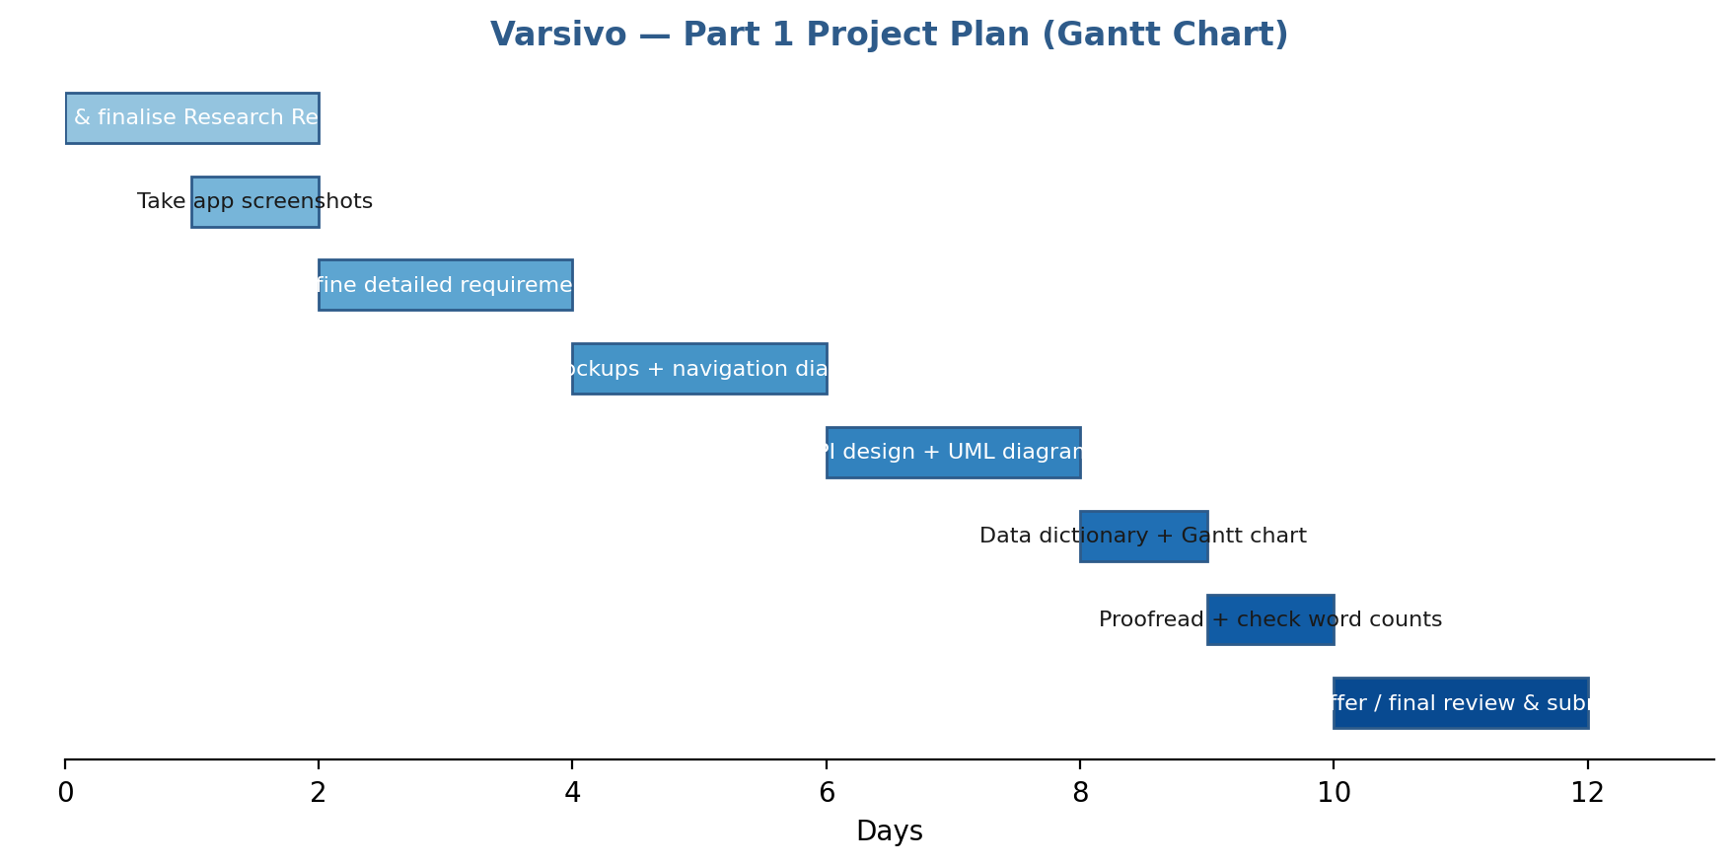
Figure 9: Part 1 project plan / Gantt chart

16. Conclusion
This section has detailed Varsivo's complete design for Part 1: its overview and innovative features, a full requirements list covering every minimum brief requirement plus Varsivo's differentiators, a six-screen user interface with a clear navigation flow separating the free and UniAssist tiers, an API and database approach using Firebase, a UML model of the core data entities, a full data dictionary, and a realistic project plan. Together with the Research Report, this provides enough detail for another developer to understand and begin building the Part 2 prototype, while leaving room to confirm the exact backend approach with the module lecturer and to refine the visual design in Figma or Android Studio.

17. References
Firebase (2026) Firebase Cloud Messaging Documentation. Available at: https://firebase.google.com/docs/cloud-messaging (Accessed: 26 July 2026).
Firebase (2026) Firestore Offline Data Documentation. Available at: https://firebase.google.com/docs/firestore/manage-data/enable-offline (Accessed: 26 July 2026).
Railway (2026) Railway Documentation. Available at: https://docs.railway.app (Accessed: 26 July 2026).

