REAKTZIA · ROADMAP AT A GLANCE
From today to live product
Phase 0 is already shipped. Three paths to a fully-working product.
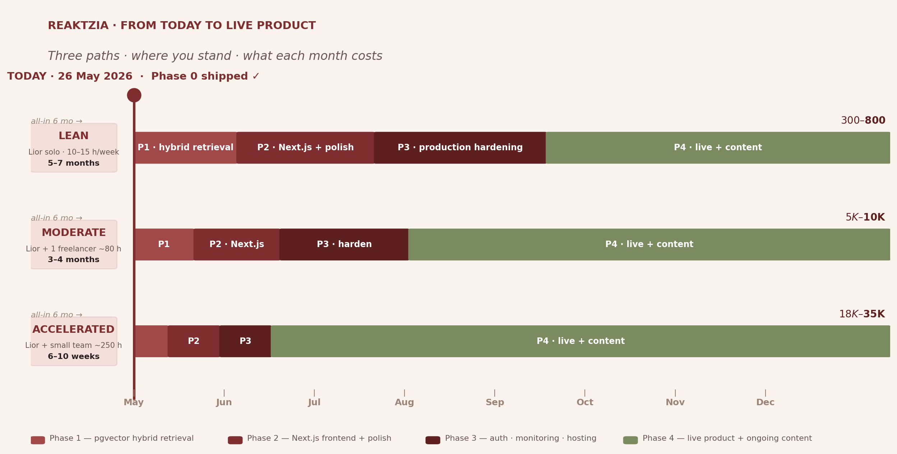
Read the bar for your chosen path. Each segment = one phase. The rightmost number = all-in 6-month cost.

HOW TO READ THE CHART · 3 TAKEAWAYS
What the picture tells you
- Phase 0 is done. You can demo the working Oracle to GFI today — no waiting on any of the three paths below.
- The Moderate path is the smart-money option. ~$5K–$10K + 3–4 months gets a polished public product. The freelance hours unblock the boring infrastructure work that would otherwise eat 5–7 months of Lior's time.
- Pick by deadline, not by cost. If GFI commits funding and wants something live in 2 months, Accelerated. If the GFI presentation next week is the only fixed point, Lean is fine.
Daniel's decision in one line
Lean = Lior's time + ~$800. Moderate = ~$8K. Accelerated = ~$25K. All three reach the same destination — the difference is who absorbs the boring infrastructure work.
Next action
- Decide the path with Daniel after the GFI presentation. No need to pick before.
- If Moderate: start posting a freelance brief on Toptal / Upwork for a senior full-stack dev (~80h over 8 weeks).
- Phase 1 (hybrid retrieval) can start whenever — it's the next concrete step on every path.
— reaktzia · May 2026 —

