Data Analysis

## Statistical Analysis

We present descriptive summaries of key sample statistics. We compared baseline sample characteristics between those children found to be at risk of OSA and those not at risk. We used the Fisher’s exact test or chi-square tests for categorical variables. The Wilcoxon rank sum test or Kruskal–Wallis test was used for continuous variables. We considered p-values of <0.05 to be statistically significant.

## Descriptive Analysis

Overall, a total of 79 children with a mean age of 4.6 (2, 10) were recruited. Of these, 47 (59%) were male. Comparing baseline characteristics between children with possible diagnosis of SDB 58 (73.42) and those without revealed a significant difference in suspected allergic rhinitis (p=0.017) and those with suspected OSA (p < 0.000). There were however no significant differences in other population characteristics as shown in table 1.

Table 1: Baseline characteristics of all participants with and without SDB

| **Characteristics** | **All participants n=79** | **PSQ > 0.33 n=58** | **PSQ < 0.33 n=21** | **p-value** |
| --- | --- | --- | --- | --- |
| Age | 4.57±1.96 | 4.33±1.75 | 5.22±2.4 | 0.153 |
| 2-5 yrs | 57(72) | 44(76) | 13(62) |  |
| 6-10 yrs | 22(28) | 14(24) | 8(38) |  |
| Gender, n(%) |  |  |  | 0.606 |
| Male | 47(59) | 36(62) | 11(52) |  |
| Female | 32(41) | 22(38) | 10(48) |  |
| Asthma, n(%) | 49(62) | 37(64) | 12(57) | 0.973 |
| Allergic rhinitis, n(%) | 42(53) | 36(62) | 6(29) | 0.017 |
| BMI(kg/m^2) | 14.43±2.22 | 14.36±2.41 | 14.62±1.6 |  |
| Birth weight category, n(%) |  |  |  | 0.101 |
| <2.5 kgs | 8(10) | 8(14) | 0(0) |  |
| >=2.5 kgs | 71(90) | 50(86) | 21(100) |  |
| Hospital category, n(%) |  |  |  | 0.181 |
| Private | 14(18) | 8(14) | 6(29) |  |
| Public | 65(82) | 50(86) | 15(71) |  |
| BMI category, n(%) |  |  |  | 0.646 |
| Underweigh | 4(5) | 3(5) | 1(5) |  |
| Normal | 63(80) | 44(76) | 19(90) |  |
| Overweight | 8(10) | 7(12) | 1(5) |  |
| Obese | 4(5) | 4(7) | 0(0) |  |
| Height | 109.99±17.55 | 109.14±18.07 | 112.36±16.23 |  |
| SDB,n(%) | 58(73) | 58(100) | 0(0) |  |
| OSA,n(%) | 44(56) | 40(69) | 4(19) | 0 |

A total of 14 (18) childen and caregivers interviewed after treatment of SDB related symptoms showed signs of SDB (PSQ score >0.33). There were however no significant inter group differences in overal characteristics between chilldren with scores over 0.33 and those with scores lower than 0.33. More descriptive results are as presented in the table 2.

Table 2: Characteristics of participants with and without SDB at 6-8 weeks post operation

| **Characteristics** | **All participants n=79** | **PSQ > 0.33 n=14** | **PSQ < 0.33 n=65** | **p-value** |
| --- | --- | --- | --- | --- |
| Age | 4.57±1.96 | 4.83±1.57 | 4.51±2.05 | 0.301 |
| 2-5 yrs | 57(72) | 8(57) | 49(75) |  |
| 6-10 yrs | 22(28) | 6(43) | 16(25) |  |
| Gender, n(%) |  |  |  | 0.606 |
| Male | 47(59) | 10(71) | 37(57) |  |
| Female | 32(41) | 4(29) | 28(43) |  |
| Asthma, n(%) | 49(62) | 8(57) | 41(63) | 0.857 |
| Allergic rhinitis, n(%) | 42(53) | 9(64) | 33(51) | 0.533 |
| BMI(kg/m^2) | 14.43±2.22 | 14.14±1.44 | 14.49±2.36 |  |
| Birth weight category, n(%) |  |  |  | 1 |
| <2.5 kgs | 8(10) | 1(7) | 7(11) |  |
| >=2.5 kgs | 71(90) | 13(93) | 58(89) |  |
| Hospital category, n(%) |  |  |  |  |
| Private | 14(18) | 0(0) | 14(22) |  |
| Public | 65(82) | 14(100) | 51(78) |  |
| BMI category, n(%) |  |  |  |  |
| Underweigh | 4(5) | 0(0) | 4(6) |  |
| Normal | 63(80) | 12(86) | 51(78) |  |
| Overweight | 8(10) | 2(14) | 6(9) |  |
| Obese | 4(5) | 0(0) | 4(6) |  |
| Height | 109.99±17.55 | 111.25±12.95 | 109.72±18.47 |  |
| SDB,n(%) | 58(73) | 14(100) | 44(68) |  |
| OSA,n(%) | 44(56) | 7(50) | 37(57) | 0.86 |

To better understand class separation between the two PSQ score levels, we plotted bar graphs of age category, asthma, allergic rhinitis, birth weight, hospital status and of the PSQ score levels. Notably, there were some trend across the PSQ score levels; with age, asthma, allergic rhinitis, gender and hospital type categories having more numbers for scores of PSQ > 0. 33, when compared to a score of PSQ < 0.33. This observation indicates the possibility of these independent categorical explaining variability in PSQ scores. 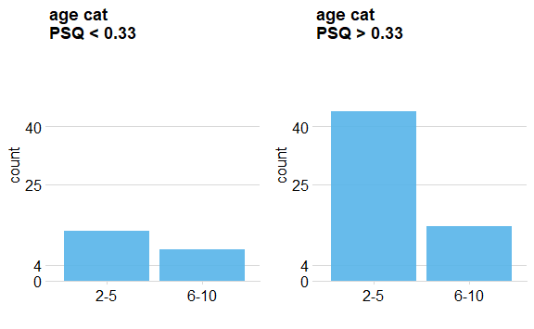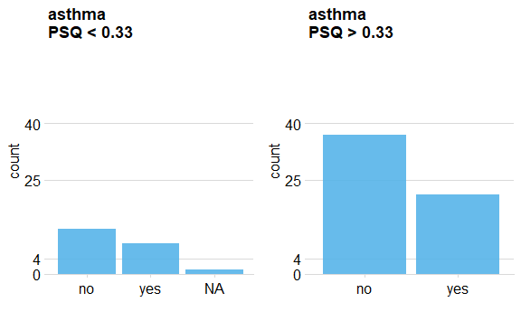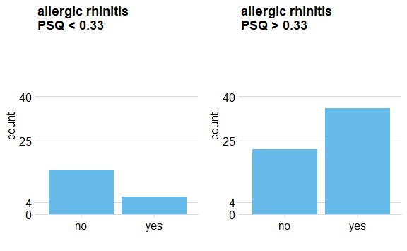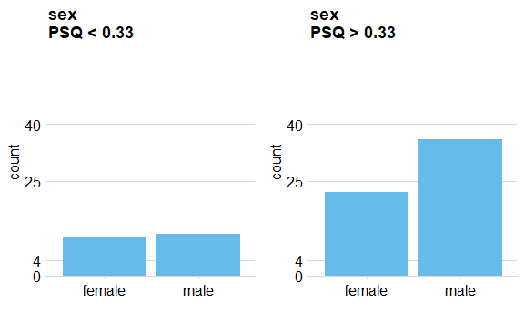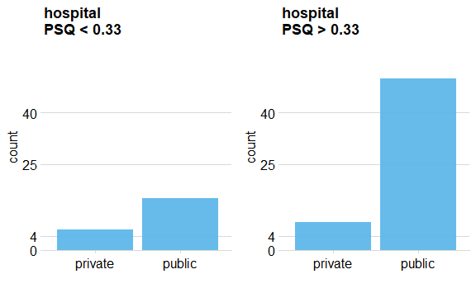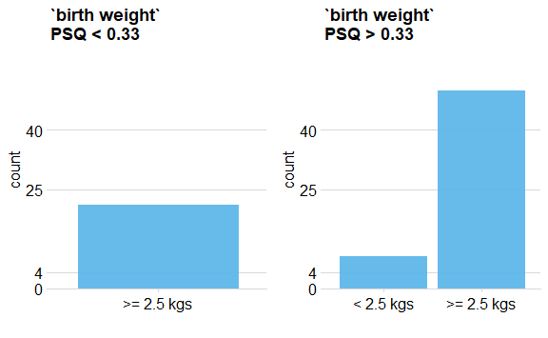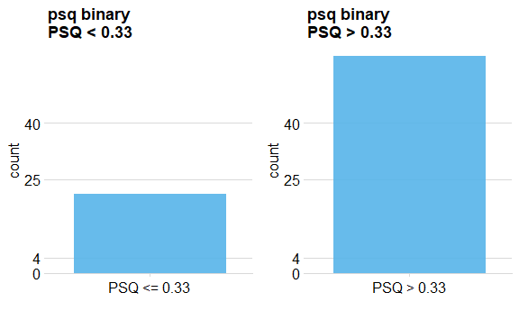

We also visualized this class separation across numeric independent variables. There was clear class separation in the distribution of height across the two PSQ score levels. No trend was observed for bmi and wealth quantile as shown in Figure 8.

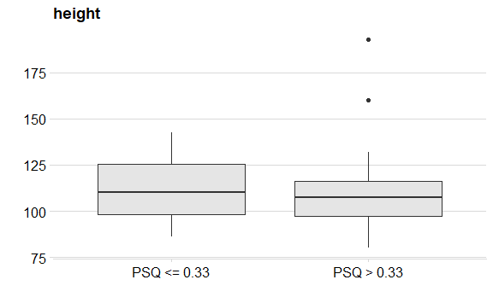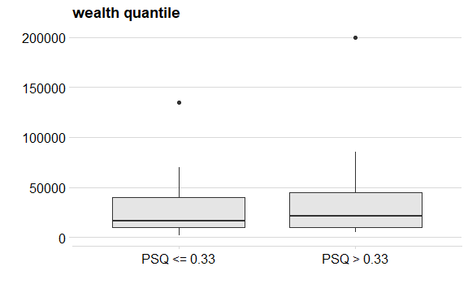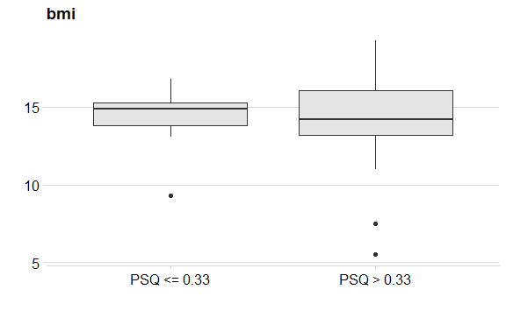

A pie chart diagram of bmi category shows a missing class obese for PSQ scores > 0.33. This in a way limits modelling when some classes have cell counts of zero across variable of interest.

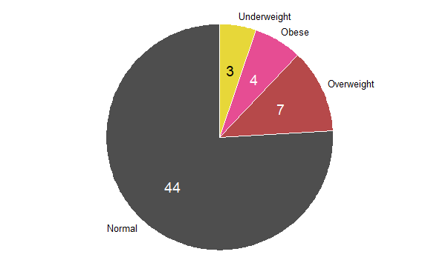

Figure 11: variation of bmi categories for PSQ score > 0.33

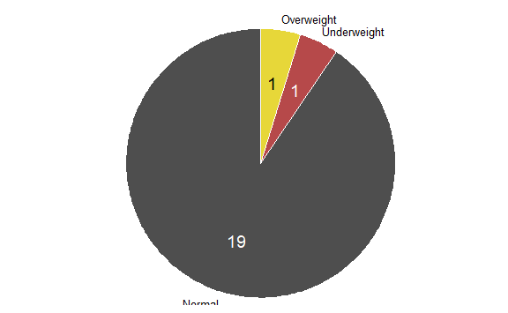

Figure 12: variation of bmi categories for PSQ score <= 0.33

## Logistic regression results

We further performed a logistic regression to explore predictors of SDB scores > 0.33. Overall, having allergic rhinitis contributed a significant change in log odds of SDB by (0.2322±0.10244), p-value = 0.0266. Accessing treatment of SDB in a public hospital also had an effect of 0.3032 on log odds of having SDB when compared to going to a private hospital. Inter group difference in other categorical factors like bmi category, age, birth weight category, gender was not significant. This was a very simple logistic regression model with minimal parametric tuning, but which can be improved if more data indicative of SDB were available.

|  |  |  |  |  |  |  |
| --- | --- | --- | --- | --- | --- | --- |
| term | estimate | std.error | statistic | p.value | 2.5 % | 97.5 % |
| (Intercept) | 0.5039 | 0.5175 | 0.9736 | 0.3337 | -0.5104 | 1.5182 |
| allergic_rhinitis_diagyes | 0.2322 | 0.1024 | 2.2668 | 0.0266 | 0.0314 | 0.4330 |
| asthma_diagyes | 0.0106 | 0.1061 | 0.0999 | 0.9207 | -0.1973 | 0.2185 |
| height | -0.0008 | 0.0045 | -0.1829 | 0.8554 | -0.0096 | 0.0079 |
| birth weight>= 2.5 kgs | -0.0883 | 0.1837 | -0.4808 | 0.6323 | -0.4483 | 0.2717 |
| age_cat6-10 | -0.0648 | 0.1621 | -0.3996 | 0.6907 | -0.3824 | 0.2529 |
| sexmale | 0.0233 | 0.1052 | 0.2212 | 0.8256 | -0.1828 | 0.2294 |
| hospitalpublic | 0.3032 | 0.1393 | 2.1775 | 0.0330 | 0.0303 | 0.5762 |
| bmi_catObese | 0.3377 | 0.2423 | 1.3936 | 0.1681 | -0.1372 | 0.8125 |
| bmi_catOverweight | 0.1753 | 0.1696 | 1.0334 | 0.3051 | -0.1572 | 0.5078 |
| bmi_catUnderweight | 0.0065 | 0.2603 | 0.0249 | 0.9802 | -0.5037 | 0.5167 |

We tested for the overall effect of bmi category and it wasn’t statistically significant (p = 0.4322). One explanation for this is the existence of null cells across PSQ score levels. We also estimated odds ratios from the regression.

|  |  |  |  |
| --- | --- | --- | --- |
| term | OR | 2.5 % | 97.5 % |
| (Intercept) | 1.6551 | 0.6002 | 4.564 |
| allergic_rhinitis_diagyes | 1.2614 | 1.0319 | 1.542 |
| asthma_diagyes | 1.0107 | 0.8209 | 1.244 |
| height | 0.9992 | 0.9905 | 1.008 |
| birth weight>= 2.5 kgs | 0.9155 | 0.6387 | 1.312 |
| age_cat6-10 | 0.9373 | 0.6822 | 1.288 |
| sexmale | 1.0235 | 0.8329 | 1.258 |
| hospitalpublic | 1.3542 | 1.0308 | 1.779 |
| bmi_catObese | 1.4017 | 0.8718 | 2.254 |
| bmi_catOverweight | 1.1916 | 0.8546 | 1.662 |
| bmi_catUnderweight | 1.0065 | 0.6043 | 1.677 |

An interpretation of the odds indicates that having allergic rhinitis increased the odds of a having PSQ score > 0.33 by a factor of 1.26. An admission into a public hospital was also associated by an increase in the odds of having SDB by a factor of 1.35. A similar infrence can be drawn for remainder of the factors.