1. Introduction

The key point of this program is to embody LuxuryItem interface. LuxuryItem interface’s function is to add luxury tax to yacht and caviar, so we should add function which adds luxury tax when calculating prices in yacht and caviar. Let’s look at Luxury item interface first. Inheritance will be like this picture below.

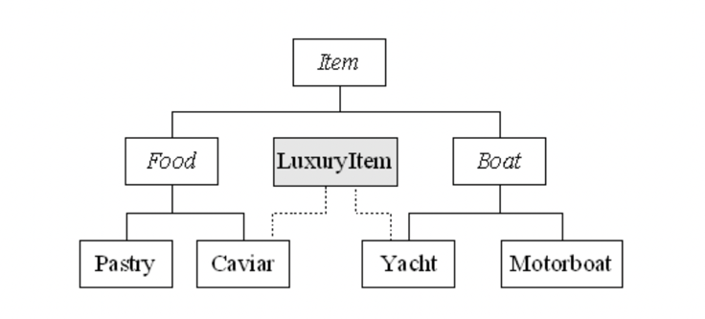

1. Function description

-LuxuryItem Interface

This interface has one function. Named ‘calculateLuxuryTax’, this function calculates Luxury tax which occurred in Caviar and Yacht.

-Item Class

Item class has several methods. Most important methods is getDescription() methods. This methods will be overrided in inherited classes. Inherited classes are below.

-Food Class

Food class is inherited by Item class, and have variable named calories. So we should make setter & getter about calories variable. Also override toString() methods that can return super class’s information(item class) and this class’s variable calories information.

-Pastry Class

Pastry class is inherited by Food class. This class has flavor variable, so I made setter & getter about flavor variable. In getDescription() methods, overrides Item class’s getDescription() methods, returns super class(food)’s description and also this pastry’s information. And I formatted currency using NumberFormat.

-Boat Class

Boat class is inherited by Item class, has one variable calls horsepower. So make getter& setter about horsepower and override toString() methods that can return its super class’s information (item class) and this class’s variable horsepower variable.

-Motorboat Class

Motor class is inherited by Boat class. It has one variable seats, so make getter & setter about seats variable. And override getDescription() methods to add description about this class. To make it clear, this Motorboat class is inherited by Boat class, and Boat class is inherited by Item class. So this getDescription() method has information about Item, Boat, and Motorboat.

-Yacht Class

Yacht class is inherited by Boat class. And Most important, this is luxury item, so we should implement calculateLuxuryTax() to add taxes when we calculate price. (LuxuryItem interface is interface and only has methods declaration, so we should implement detail in class which uses LuxuryItem interface).

This class’s getDescription() has information about Item, Boat, Yacht information and prices are calculated adding luxury taxes.

-Caviar Class

Caviar class is same with Yacht. This is also luxury item, so we should implement calculateLuxuryTax() method detail. Same as Yacht, this class’s getDescription() method has information about Item, Food, Caviar.

1. Final Statement

This problem’s most important thing is interface(LuxuryItem). This interface only has method declaration. So if we want to use this interface, we should declare this interface’s methods clearly and detail.

And I used NumberFormat to print currency simply and plainly. This helps to calculate currency and can change currency easily. I used US dollar $.

1. Execution

We could see Yacht and Caviar classes are added luxury tax. So we can conclude we implemented interface correctly.