, Picture

## CERIA CHECK IN & PAYMENT SYSTEM

Campus Event Check-In System

Company Name: TT1L_G5

| NAME | STUDENT ID |
| --- | --- |
| MUHAMMAD AQIL BIN RAHMAT | 1211107976 |
| AHMAD FAIZ BIN ANUAR | 1211109154 |
| WAN MUHAMMAD ILHAN BIN WAN ZIL AZHAR | 1211102908 |
| MUHAMAD AIMAN BIN MOHD EHWAL | 1211103064 |

## 

## **Task 1**

**System Overview**

The CERIA Check & Vendor System is an all in one software that aims to streamline the systems that are used during campus events. By integrating the existing student database, we eliminate the manual registration so the students simply have to log in using their existing student account. We also integrate the payment processing system into our software so vendors can also use the app to track purchases made by the students.

**Key Features**

1. **Student Authentication & Check In**

* Fully Integrated University Student Database
* Students can login using their existing student account

1. **Event Management**

* Admins can create new events
* Admins can register vendor and assign them to an event

1. **Vendor System**

* Vendors have their own dashboard where they can track purchases made by the students
* Vendors can see each payment made by students

**Vision**

This project entails the development of a digital check-in system for campus events, designed to integrate seamlessly with the university’s student identification database and payment processing infrastructure. The platform enhances event management by streamlining attendance tracking, ticket validation, and on-site transaction capabilities, providing a cohesive and efficient solution for both organizers and attendees.

**Scope**

The system would allow participants and vendors to check in for an event via QR for a seamless, user-friendly experience. Features include real-time notifications, on-the-spot payment integration, and a rating system for the event. It will not include mapping integration, third-party map systems, or outdoor navigation.

**Goals & Objectives**

Our goal for this event check-in system is:

* To ensure users can easily check in to the event.
* Provide an easy-to-use payment structure.
* Act as an alternative to manual check-in.
* Ensure the system is scalable for big and small events.

## **Task 2**

**Context Object**

Based on the requirements of the project, the context object (entities) that would be involved in the system are:

| **Context Object** | **Description** |
| --- | --- |
| Device | The main point of interaction between the users. |
| Internet | Required for real-time check-ins, database access, payment processing, and syncing. |
| System | The campus check-in system is being developed, which manages check-ins, ticketing, and integration with other services. |
| Admin | University staff who oversee event approvals, monitor attendance, and manage system settings. |
| Students | University Students who will use the system to check-in to the events or pay for items |
| Vendor | Sellers registered to sell items during the event |
| Payment Gateway | To handle on-the-spot payment methods. |
| QR Code | Used for check-ins by scanning the QR code. |
| Database | Storing data such as Users, check-ins and payments data. |

**Sources of Requirements**

We gathered requirements from multiple sources, including stakeholders like students, staff, and university administrators, as well as technical systems such as the payment gateway API and the student ID database. We also reviewed existing check-in systems such as CLiC, to gather inspiration and best practices for user experience and functionality.

| **Source** | **Type** | **Information** |
| --- | --- | --- |
| Student | Stakeholder | Their needs for an easy check-in process, preferred credentials, and feedback on usability. |
| Vendor | Stakeholder | Their needs for transaction tracking, product registration, and check-in verification for vendors. |
| Admin | Stakeholder | Defined operational and policy needs for monitoring attendance, event approval, event information, and user management. |
| Payment Gateway API | System | Defined technical specifications for integrating real-time payments and secure transactions. |
| Student ID System (CLiC) | System | Data structure and access methods for student verification. |

## **Task 3**

**Requirements Elicitation Plan Using Kano Model**

We designed a survey based on the Kano model to gather information from potential users and stakeholders on the features they would like to be included in the system. The survey is made using Google Forms and shared to the students of MMU. Using the data we gathered from the survey, we can classify potential stakeholders into dissatisfiers, satisfiers, and delighters.

The survey consists of two types of questions, **functional** and **dysfunctional**, which allows us to analyze user responses and determine whether a feature is a basic need, performance attribute, or excitement factor. Using this structured approach, we can ensure that we prioritize development efforts based on what users expect.

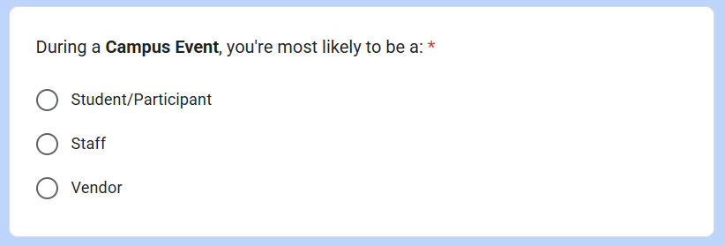

The survey will start with the user clarifying their roles during a campus event.

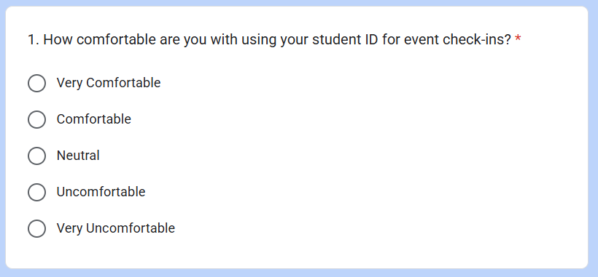

Question 1 is a **functional** question which ask the user whether they would like to use their student ID for event check-ins. The answer ranges from Very Comfortable to Very Uncomfortable, with other expressions in between. This allows us to validate whether a feature is worth developing for the system.

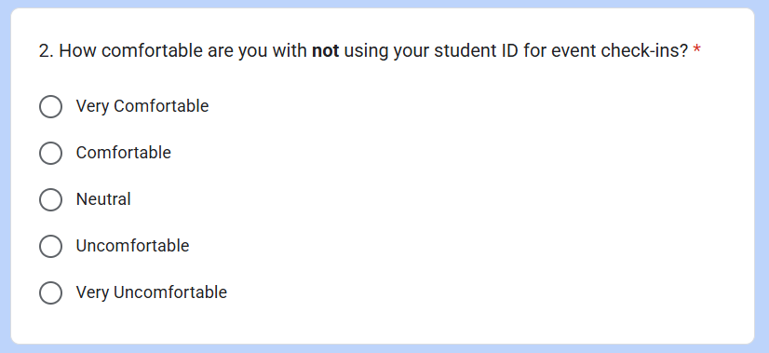

Question 2 is a **dysfunctional** question that ask the users if they are not comfortable with using their student ID for event check-ins. This question is a direct opposite of Question 1. The answer ranges from Very Comfortable to Very Uncomfortable, with other expressions in between. This allows us to validate if a feature is not worth developing for the system.

**Potential Requirements For Dissatisfiers, Satisfiers and Delighters**

To classify features, we analyzed survey responses and set percentages threshold based on user expectations:

| **Classification** | **Threshold** | **Definition** |
| --- | --- | --- |
| Dissatisfiers | 60% of users are very comfortable/comfortable, and 30% are very uncomfortable/uncomfortable if it’s missing. | Features that user expects by default. Absence of the feature would cause user dissatisfaction. |
| Satisfiers | 35% of users are very comfortable/comfortable, and 15% are very uncomfortable/uncomfortable if it’s missing. | Features that increase satisfaction if works well and is not generally expected by the user. |
| Delighters | Atleast 30% of users are neutral if it’s available, and 30% of users are neutral if it’s missing. | Unexpected features that impress users. |

Based on the responses from the survey, we can classify if a feature is considered a dissatisfier, satisfier, or delighter.

## **Task 4**

**Elicitation Execution**

## **Task 5**

**Software Requirements Specifications (SRS)**

## 