NAME:KASSIM BOLAJI

MATRIC:171001

DEPT:CIVIL ENGINEERING

LECTURER-IN-CHARGE:

DR. CHUKS DIJJI

ARTHUR PETER MOLLER

TERMINALS,APAPA

**WHAT DO APM TERMINAL DO?**

APM Terminal is a container handling terminal that employs hydraulic power to the utilization of cranes to load and transport containers at the sea port.

APM Terminals offers the global shipping community a geographically balanced, integrated Global Port, Terminal and Inland Services Network which includes interests in 61 ports and terminals in 33 countries with 16 new terminal development or expansion projects underway, along with 132 Inland Services locations in 48 countries.

These services would require the most advanced terminal technology,equipment and state-of- the-art operations .All these equipments are needed to be maintained by Engineers.

**HISTORY OF APM TERMINALS**

APM Terminals, Apapa is the largest container terminal operator in West Africa commissioned on the 19th of June 2008. The modernized Apapa Container Terminal was handed over to APM Terminals Apapa Ltd through privatization.

APM Terminals invested a large sum of money to Apapa terminal modernization and expansion,including the delivery of four reconditioned Panamax gantry cranes, doubling the facility’s terminal handling capacity which lead to the growth of vessel calls and monthly container traffic.

Improved productivity after the hand over has enabled APM Terminals Apapa to eliminate container vessel waiting times, resulting in shipping lines ending congestion surcharges.

Apapa Terminal is one of the most modern and efficient terminals in Africa. It handles 45%

of Nigeria’s total container traffic and 50% of all imports to the country. APM Terminals is at

the vanguard of the industry, providing the essential port infrastructure required for the

handling of all seaborne cargoes and ongoing global economic development

**DEPARTMENTS AND ENGINEERS WORKING THERE.**

There are 3 departments working in APM Terminals.They are:

1) Maintenance Department

2) Maintenance Planning Department

3) Facility Management Department

**MAINTENANACE DEPARTMENT**

They carry out preventive and corrective repair and maintenance on equipments.Equipments

Such as Cranes,Trucks,Generators,Crane Spreader etc

The department is further sub-divided into three

a)Workshop Dept b)Crane Dept c)Power Dept

**A)WORKSHOP DEPT**

They deal with diesel engine of trucks and reach stackers

**B)CRANE DEPT**

They deal with crane spreaders and mobile harbor cranes,rubber tyred gantry cranes etc

**C)POWER DEPT**

They repair and service all generators on the plant site and also flood lightning.

**ENGINEERS IN MAINTEANCE DEPARTMENTS.**

**1)MECHANICAL ENGINEERS**

They determine the faults of equipments such as the trucks,reach stackers,generators etc .They suggest the remedy and instruct the technicians on how to repair it.They also supervise preventive maintenance that is being carried out by technicians

**2)ELECTRICAL ENGINEERS**

They determine the cause of electrical faults on warehouse buildings,generators,trucks,reach stackers etc and suggest and show the technicians on how to repair them.

**3)AUTOMOTIVE ENGINEERS**

These are the engineers that come from the manufacturer of the equipments. They specialize on repair of auto-motives.

Specialized repairs that cannot be handled by mechanical engineers are referred to them.

**MAINTENANCE PLANNING DEPARTMENTS**

They layout plans to carry out periodic and preventive maintenance on all the equipments.They also monitor the number of breakdowns and determine the key performance Indicator(KPI) operators on all equipment.

**ENGINEERS IN MAINTENANCE PLANNING DEPARTMENTS**

**1)PLANNING ENGINEERS**

Take care of the above functions.They can be Mechanical,Civil Engineers etc.They are trained

Personnel.They make use of Microsoft Excel to carry out their plans

**2)SOFTWARE ENGINEERS/CONTROL ENGINEERS**

They handle any malfunctions of the crane control system .They make use of Programmable

Logic Controllers(PLC)

**3)ENGINEER ANALYST**

They are electrical engineers with special training on PLC or control systems.This position performs special responsibility for planning, co -coordinating and monitoring maintenance activities to achieve maximum availability of equipment and a reduction in maintenance assignment , project and department optimization,and support the

engineering department on need basis

**FACILITY MANAGEMENT DEPARTMENT**

They maintain all the factor facilities like air conditioning,Road constructions and grading of

Roads on the plant site.

They also deal with acquisition of intra plant vehicles.Its headed by faculty manager who is

usually a CIVIL ENGINEER.

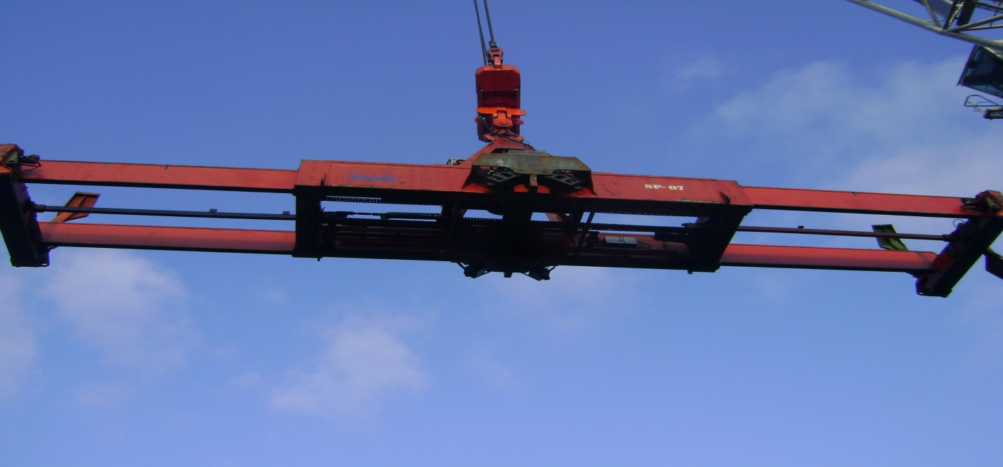

**CRANE SPREADER**

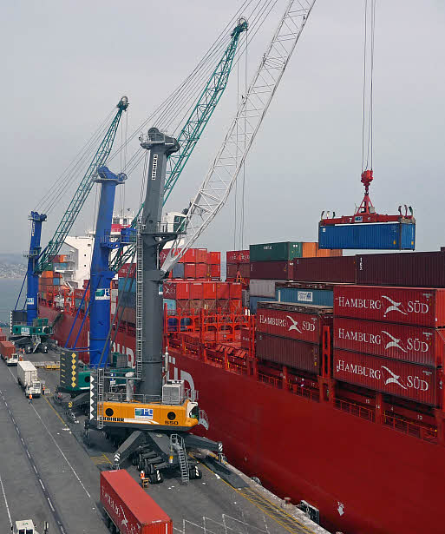 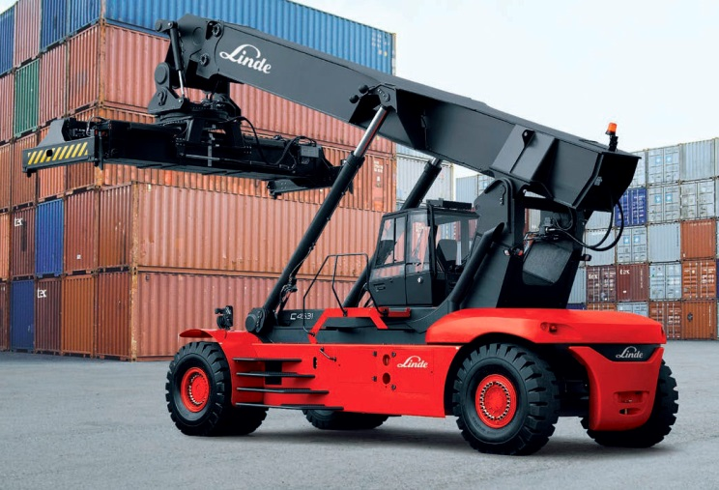

**MOBILE ABHOR CRANES REACH STAKERS**

**FACTORY RULES**

1)No Pedestrian movement.

2)Use of safety helmet is compulsory.

3)All individuals are to use safety belt and cover all in the workshop.

4)Individuals must not enter a blind spot(a place where crane/truck driver cant see).

**SAFETY**

**INDIVIDUAL SAFETY**

i. The number of injuries/fatalities: 1 major injury, 1 major fatality.

ii. The loss time injury reduced to 0.41 per 1 million man hours.

iii. Health care was provided for all staff alongside life insurance.

iv. The company also trains its staff from time to time both in safety and in their field of

operation

**ENVIROMENTAL SAFETY**

i. For the above stated period the total green house emission was managed at 19,982

tonnes even with the limited availability of electricity.

ii. The company plans for a 15% CO2 reduction by the year 2012.

iii. The company also plans to carry out green investments such as; Surface water

treatment system and water treatment plant

**SOURCE OF POWER**

DIESEL is the main source of power that run equipments such as the mobile harbor crane,rubber tyred gantry and other mechanical devices.

The flood lights and Street Lights are run by Solar energy.

APM Terminals,APAPA also depend on Power Holding Company of Nigeria for electricity.

**CHALLENGES**

1)Unfavorable Government Policy: APM Terminal is a multi-national company and some policies induced by lawmakers in a country might reduce productivity of the factory.

2)Source of Power: Interrupted Power Supply implies regular purchase of fuel with money that should have been channeled to other means.

3)Sea Pirates:Ships are sometimes hijacked by Pirates.This leads to loss on the company’s finance.

4)Working Hours:Because of the intensity of the job,staffs are subjected to 12 working hours per day(7 a.m- 8 a.m)

**MY PROFESSION?**

I would like to be a Structural Engineer.

**WHY?**

As the world grows,structural innovation grows because it is guided basically by just one simple and logical principle,that is “Build anything you like,but take care of the foundation first’.

This implies there is actually no limitation to structures but your own imaginations.I like to innovate and think outside the box.There are still a whole lot of undiscovered stuffs in structural engineering.Due to this fact I believe that I can apply my own ingenuity for the benefit of man and the profession thereby making this world a better place for all to live.