10:30 AM Build Sensory Device

12 * 8 * 6 = 576

24 * 24 = 576

[Haptic Skin: A virtual sense of touch - YouTube](https://www.youtube.com/watch?v=OYVU9Ha_rHs)

11:15 AM Build Logo

12:15 PM Build OCR

1:35 PM Build Voice Communication

3:00 PM Finish Chess

[100% blind player shows fantastic bit of speed! - YouTube](https://www.youtube.com/watch?v=KO0EMvh7Y3w)

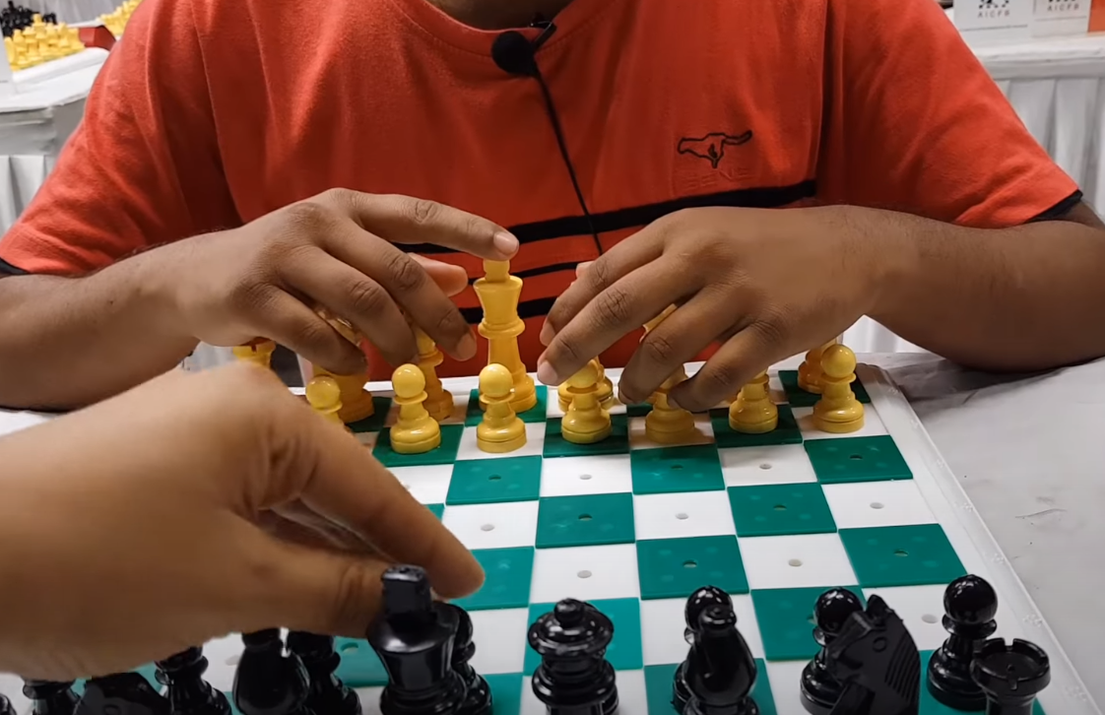

4:00 PM Finish PacMan

5:00 PM Finish BlackJack

6:00 PM Finish Board Game 2D

9:00 PM Finish MineCraft

12:00 AM Finish BattleField3

3:00 AM Finish BattleFront II

5 AM Start Presentation

7 AM Finish Presentation