***How to export DataTable to Excel file in MVC ASP.Net core***

1. **Install the Required Package**

Install ‘EPPlus’ package from NuGet package manager.

1. **Create the Controller Action Method**

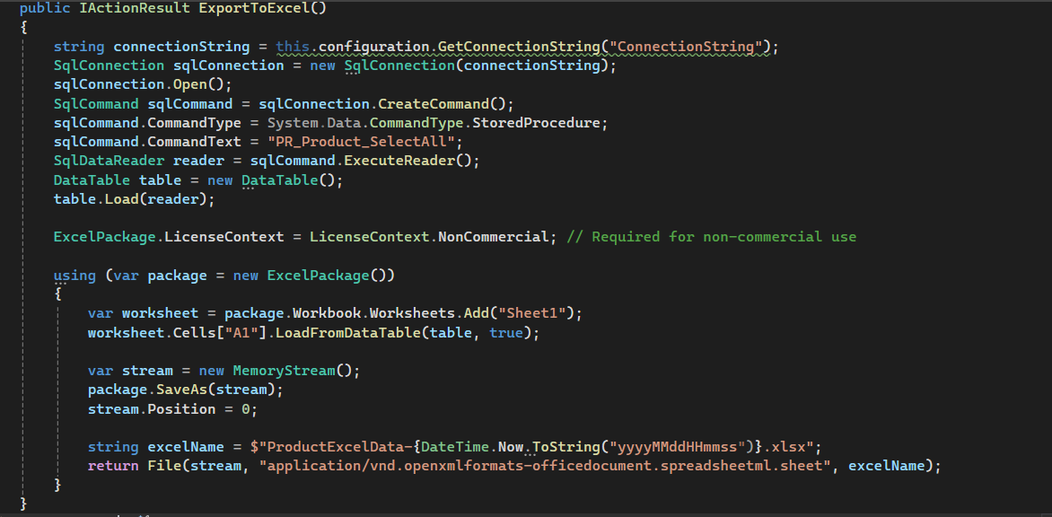

1. **Run the application**

When the URL is "http:4050/Home/ExportToExcel" the browser will download the Excel file generated by the controller action.