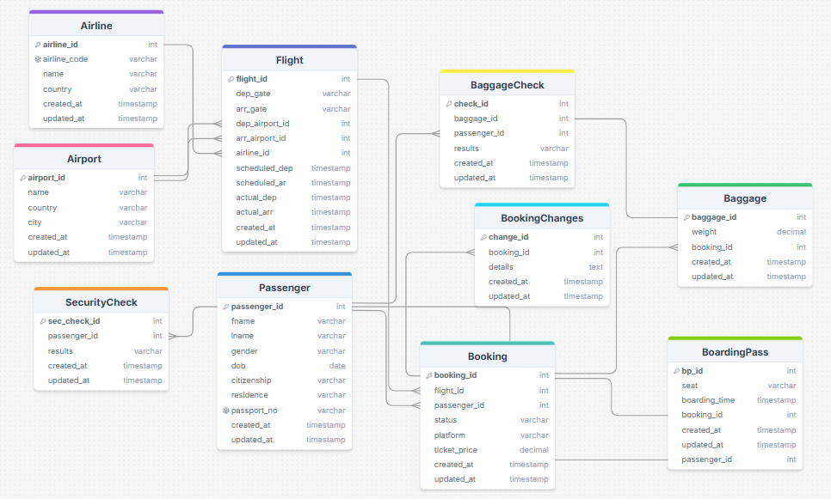

**Entities (Tables and their purpose)**

**Airline** – stores information about airlines.  
**Airport** – stores information about airports.  
**Flight** – contains flight schedules (departure, arrival, time, airline).  
**Passenger** – personal information of passengers.  
**Booking** – records reservations made by passengers for flights.  
**BoardingPass** – information about boarding passes issued to passengers.  
**Baggage** – information about passengers’ luggage.  
**BaggageCheck** – results of baggage inspection.  
**SecurityCheck** – results of passenger security checks.  
**BookingChanges** – information about modifications of bookings.

**Attributes (Important columns)**

Each table has a **Primary Key (PK)**.

**Foreign Keys (FK):**

Flight → Airline (airline_id)  
Flight → Airport (dep_airport_id, arr_airport_id)  
Booking → Passenger (passenger_id), Flight (flight_id)  
BoardingPass → Booking (booking_id)  
Baggage → Booking (booking_id)  
SecurityCheck → Passenger (passenger_id)  
BookingChanges → Booking (booking_id)

**Relationships**

**Airline – Flight**: One airline can have many flights (1:N).  
**Airport – Flight**: One airport can handle many departures/arrivals (1:N).  
**Passenger – Booking**: One passenger can make many bookings (1:N).  
**Booking – BoardingPass**: Each booking generates one boarding pass (1:1).  
**Booking – Baggage**: One booking can include many pieces of baggage (1:N).  
**Passenger – SecurityCheck**: One passenger can undergo multiple security checks (1:N).  
**Passenger – BaggageCheck**: One passenger can have multiple baggage checks (1:N).  
**Booking – BookingChanges**: One booking can have multiple changes (1:N).