Extrapolating Capacity Estimates to a Linear Stream Network

Kevin See

May 25, 2021

Table of Contents

1 Biomark, Inc.

# Introduction

The quantile random forest (QRF) capacity model we have developed uses paired fish abundance and detailed habitat data from selected sites around the Columbia River Basin to estimate the carrying capacity at the 200-500 meter reach scale, where such detailed habitat data is available. Initially, and to date, the sites where such data was collected were monitored by CHaMP ([Columbia Habitat Monitoring Program](https://www.champmonitoring.org/)). This aspect of the QRF model is useful for examining empirical fish/habitat relationships, determining what habitat factors may be limiting capacity at a particular location, and examining the improvement to capacity after rehabilitation actions. However, there is also a need to generate capacity estimates on larger spatial scales (e.g. tributary, watershed, population, etc.).

To date, inference to areas without detailed habitat data and at larger spatial scales has relied on master sample points and attributes associated with them (Larsen et al. 2016). This method was developed because that dataset was available at the time, and covered the entire Columbia River Basin. However, each master sample point does not actually represent a stretch of river, rather they are a single location (latitude/longitude coordinates) that is meant to be representative of about a kilometer of stream. Some points are closer together than a kilometer though, due to tributary junctions or other issues. Because of how they’re constructed and what they actually represent, the interpretation of capacity estimates at master sample points is slightly more complicated than we desire.

Recently, a group of NOAA researchers has developed a line layer that breaks down the Columbia River Basin into 200 meter reaches, with various attributes assigned to each reach. It covers the same area as the master sample point dataset, but provides better interpretation and visualization properties than the master sample point layer. In this document, we present details about how we have used both the master sample points and the line network as extrapolation tools, and include some comparisons of the results between them.

# Methods

## QRF Models

We examined results from a total of six different QRF models, three each for spring/summer Chinook and steelhead. These consisted of a model for redds, and two versions of a QRF model for summer juveniles. The first of these used what we considered the best choice of metrics from the entire CHaMP dataset. The second focused on metrics that are collected by DASH (Drone Assisted Stream Habitat protocol) that can be calculated from CHaMP data as well. This version allows direct QRF estimates to be made for areas sampled by DASH, since the CHaMP protocol is no longer in use.

## Master Sample Points

The master sample points were generated in the design phase of CHaMP. These 551,046 sites were selected from the NHD Plus 1:100,000 stream layer covering WA, OR and ID at an average density of one site per kilometer (Larsen et al. 2016). Each CHaMP site where direct QRF capacity estimates were made corresponds to one of these master sample points, identified and selected using a generalized randomized tessellation stratification (GRTS) design (Olsen et al. 2012, Stevens Jr and Olsen 2004). CHaMP generated a number of attributes for each master sample point, referred to here as globally available attributes (GAAs) because they are associated with every master sample point across all watersheds. We chose 11 to include in the extrapolation model (Table 1).

Table 1: Attributes available at every master sample point, used as covariates in extrapolation model.

ShortName

Name

Description

TRange

Temeprature Range

Mean Temperature Range from PRISM data

Elev_M

Elevation

Elevation of site as extracted from the 10 m Digital Elevation Model

CHaMPsheds

CHaMP Watershed

CHaMP Watershed site falls in if appropriate

NatPrin1

Natural Class PCA 1

Natural Classification PCA 1 Score

DistPrin1

Disturbance Class PCA 1

Disturbance Classification PCA 1 Score

SrtCumDrn

Drainage Area (sqrt)

Square root of the cumulative drainage

StrmPwr

Stream Power

Stream Power

Slp_NHD_v1

Slope

Slope of Flowline (m/m) from the NHD Plus file

Channel_Type

Channel Type

Geomorphic Channel Type from Beechie Layer

WIDE_BF

Bankfull Width - modeled

Modeled bankfull width of stream, (m)

S2_02_11

Average August Temperature

NorWeST 10 year average August mean stream temperatures for 2002-2011

The original extrapolation model used the log of capacity estimates at each CHaMP site (fish / m) as the response, and selected GAAs as covariates. The model was fit using the *svyglm* function in the *survey* (Lumley 2004) package with R software (R Core Team 2019), accounting for the various survey design weights within each CHaMP watershed. We then used that model to predict capacity at every master sample point that was not a CHaMP site. In other words, we fit a linear regression to establish associations between estimated habitat capacity, from QRF, at CHaMP sites and globally available attributes from those sites and then used those associations at locations where CHaMP habitat data was not available to predict capacity at those master sample points.

The design weights were based on the particular stratification used in each CHaMP watershed to select monitoring sites. The most common stratification used three categories of valley segment type (source, transport and depositional) and selected a fixed number of sites from each strata. Because the strata are not equally distributed across the watershed, the design weights account for that unequal distribution. There are potential consequences to ignoring those weights when analyzing data from these sites (Nahorniak et al. 2015).

To roll up capacity estimates to larger spatial scales, the average predicted capacity of master sample points along a stream was multiplied by the length of that stream, and then combinations of streams could be added together to generate overall capacity estimates for a watershed.

## Line Network

We adapted this method to using a [stream layer](https://www.nwfsc.noaa.gov/research/datatech/data/col_basin_hist_project/index.cfm) created by Morgan Bond and Tyler Nodine at the Northwest Fisheries Science Center. This layer consisted of a line file divided into 200m reaches with various attributes attached to each reach. The line file is based on the [National Hydrography Dataset High Resolution](https://www.usgs.gov/core-science-systems/ngp/national-hydrography/nhdplus-high-resolution) (NHDPlus HR) dataset, which has a higher resolution, 1:24,000, compared to the older layer that the master sample points were chosen from.

Table 2: Attributes available at every 200m reach, used as covariates in extrapolation model.

ShortName

Description

slope

Stream gradient

rel_slope

Relative slope. Reach slope minus upstream slope

Sinuosity

Reach sinuosity. 1=Straight, 1< sinuous

regime

Flow regime. 1= mixed, 2=snow dominated, 3=rain dominated.

alp_accum

Number of upstream cells in alpine terrain

fines_accu

Number of upstream cells in fine grain lithologies

flow_accum

Number of upstream DEM cells flowing into reach

grav_accum

Number of upstream cells in gravel producing lithologies

p_accum

Number of upstream cells weighted by average annual precipitation.

fp_cur

Current unmodified floodplain width

S2_02_11

NorWeST 10 year average August mean stream temperatures for 2002-2011

DistPrin1

Disturbance Classification PCA 1 Score

NatPrin1

Natural Classification PCA 1 Score

NatPrin2

Natural Classification PCA 2 Score

We determined which reach was closest to each CHaMP site, and used the predicted QRF capacity density of those CHaMP reaches as the response with the attributes attached to each 200m reach as covariates (Table 2). We also took this opportunity to move to a random forest modeling framework. This accommodates possible non-linear or saturating effects of some of these covariates on capacity predictions, and prevents the extrapolation model from predicting capacity values well above or well below the range of predictions at CHaMP sites.

## Range of Covariates

We examined the range of the covariates used in each method, for wadeable streams, and compared it to the range of values found at CHaMP sites or reaches. This exercise provides some context about how representative the suite of CHaMP sites are compared to the rest of the Columbia River Basin. These figures are found at the end of this document.

# Capacity Comparisons

We computed the total capacity of each species in each population using both methods, for summer juveniles (using both CHaMP and DASH habitat metrics) and redds, and compared them. The correlations between the two estimates are shown in Table 3.

Table 3: Correlation coefficient between capacity estimates at the population scale using each method.

Species

Model

r

Chinook

CHaMP

0.937

Chinook

DASH

0.910

Chinook

Redds

0.883

Steelhead

CHaMP

0.859

Steelhead

DASH

0.987

Steelhead

Redds

0.984

We plotted one estimate against the other in Figure 1, and showed the relative difference in Figure 2.

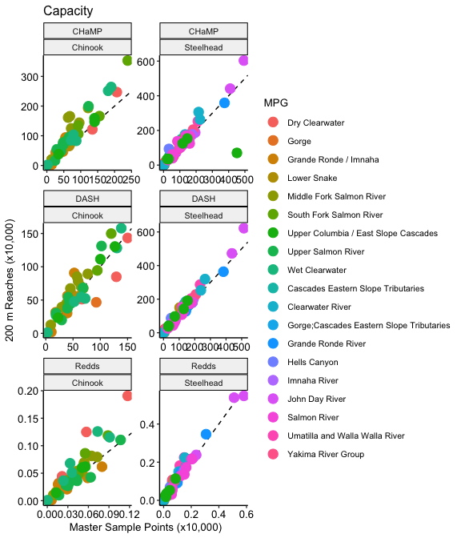

Figure 1: Capacity estimates for each population, calculated with the master sample points method on the x-axis and the line network on the y-axis.

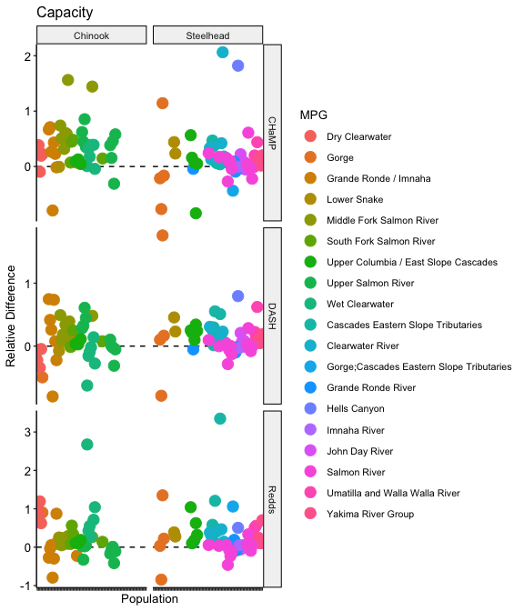

Figure 2: Relative difference between the capacity estimates for each population, using the master sample points method as the reference.

# Maps

This shows the difference in how the results can be visualized.

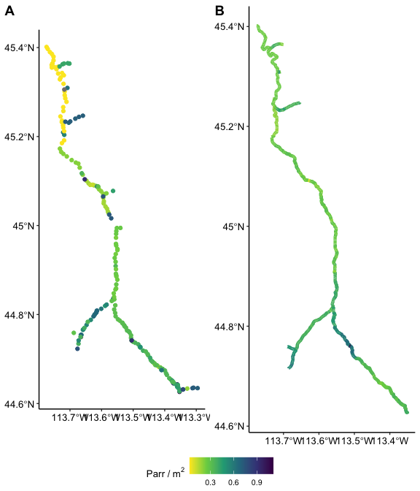

Figure 3: Plots of Chinook parr capacity in the Lemhi, using the master sample points method (A) and the 200 m reach method (B).

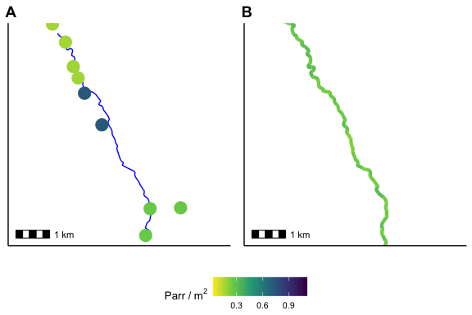

Figure 4: Plots of Chinook parr capacity in an approximately 8km stretch of the Lemhi, using the master sample points method (A) and the 200 m reach method (B). The NHDPlus layer has been added in (A).

# Discussion

Extrapolations of QRF predictions are useful for higher-level spatial analyses or comparisons, such as at the watershed level. Examining predictions at individual master sample points or 200m reaches should be discouraged. For that scale, detailed habitat data should be collected, by using a protocol like DASH, and direct estimates of capacity can be made using a QRF model. On the other hand, extrapolation summaries of capacity at the watershed scale, for various species and life-stages, can be useful in broad prioritization discussions, to determine what life-stages and watersheds to target for rehabilitation.

For most of the GAAs, the range of values represented at CHaMP sites or reaches overlapped with the range of values in other places, with a few exceptions. The most notable is modeled precipitation (Precip) in the Clearwater basin (Figure 6). We did not use Precip as a covariate in the master sample points extrapolation model, but it does indicate that something about the conditions in the Clearwater may be different from other places with the interior Columbia River Basin, and therefore extrapolations to that area should be scrutinized carefully. The 2nd PCA of the natural classification (NatPrin2) also shows some deviation from the CHaMP dataset in the Willamette, Lower Columbia and Salmon watersheds. It could be worth investigating what part of that PCA (or combination of parts) are driving that deviation.

For both species, across all three QRF models, the two extrapolation models resulted in estimates of total capacity at the population scale that are very highly correlated (Table 3). The linear network estimates were often greater than the master sample point estimates, to a greater or lesser degree, but not always (Figure 1).

Changing the modeling framework from linear regression to a random forest has several benefits. Primarily, it provides a method to constrain extrapolation predictions naturally, even when the extrapolation covariates are beyond the range found at CHaMP sites. In addition, random forests accommodate potential non-linear associations between capacity predictions and GAAs while handling correlations among GAAs. The sample size of CHaMP sites with QRF predictions of capacity is sufficient to fit a random forest model, so we have no concerns about the “data-hungry” nature of this framework for this situation.

Although the master sample point method has been used for several years, there is no reason to believe estimates from that method are inherently superior to using a line network, so even in the cases when the two models result in different estimates of capacity, it is difficult to say which is “better”. On the other hand, there are several reasons to support using the line network method, apart from the actual results, primarily based on the ease of interpretation. Extrapolation to a line network involves capacity predictions at actual 200 m reaches along a stream network, while the master sample point method provides estimates at instantaneous “points” on the landscape. The summation of capacity to larger spatial scales is more straightforward when using a line network, and the maps that can be created are easier to interpret (Figure 3).

Therefore, we conclude that the extrapolation to a linear network method presented here is superior to the master sample point method, and should be adopted moving forward for examining QRF outputs at large spatial scales.

# References

Larsen, D. P., C. J. Volk, D. L. Stevens Jr, A. R. Olsen, and C. E. Jordan. 2016. An overview of the Columbia Habitat Monitoring Program’s (CHaMP) spatial-temporal design framework. South Fork Research.

Lumley, T. 2004. Analysis of complex survey samples. Journal of Statistical Software 9(1):1–19.

Nahorniak, M., D. P. Larsen, C. Volk, and C. E. Jordan. 2015. Using inverse probability bootstrap sampling to eliminate sample induced bias in model based analysis of unequal probability samples. Plos one 10(6):e0131765.

Olsen, A., T. Kincaid, and Q. Payton. 2012. Design and analysis of long-term ecological monitoring studies. Pages 126–150 *in* R. Gitzen, J. Millspaugh, A. Cooper, and D. Licht, editors. Cambridge University Press England, UK.

R Core Team. 2019. R: A language and environment for statistical computing. R Foundation for Statistical Computing, Vienna, Austria.

Stevens Jr, D. L., and A. R. Olsen. 2004. Spatially balanced sampling of natural resources. Journal of the American Statistical Association 99(465):262–278.

# Covariate Range Figures

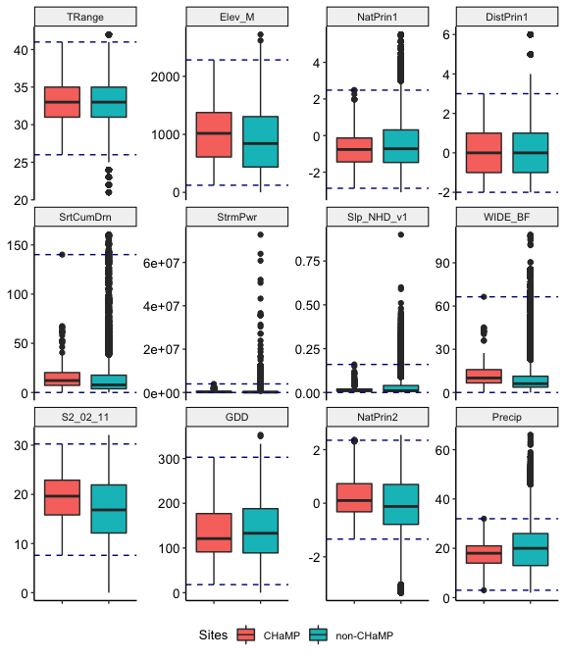

Figure 5: Boxplots of GAA values at CHaMP sites and non-CHaMP master sample points. Horizontal lines represent range of values at CHaMP sites.

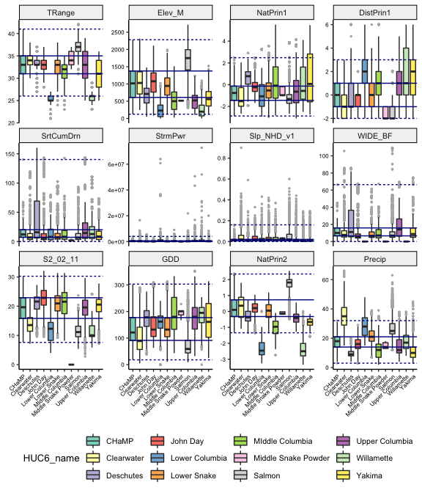

Figure 6: Boxplots of GAA values at CHaMP sites and non-CHaMP master sample points, colored by HUC6. Horizontal lines represent range of values at CHaMP sites (dashed) and the 25th and 75th quantiles of the CHamP sites (solid).

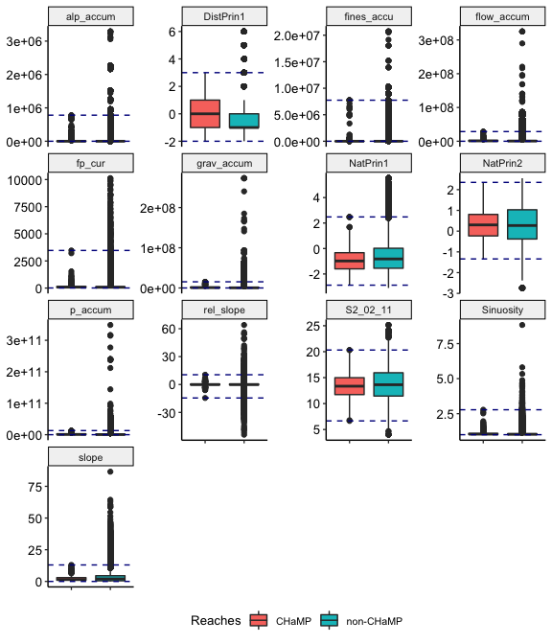

Figure 7: Boxplots of GAA values at CHaMP reaches and non-CHaMP 200 m reaches. Horizontal lines represent range of values at CHaMP sites.

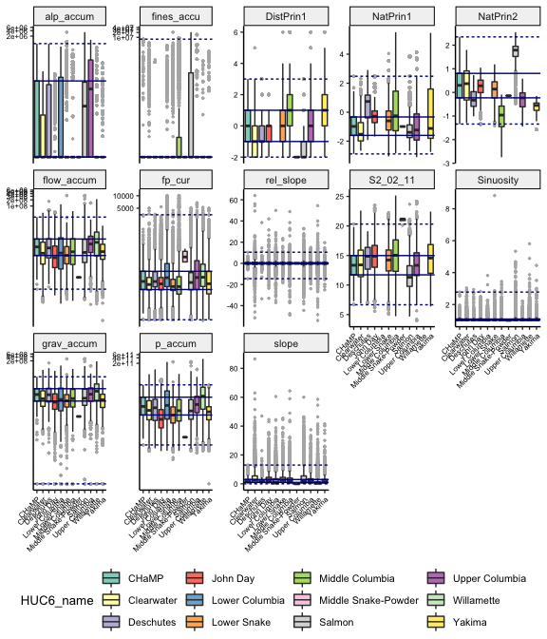

Figure 8: Boxplots of GAA values at CHaMP reaches and non-CHaMP 200 m reaches, colored by HUC6. Horizontal lines represent range of values at CHaMP sites (dashed) and the 25th and 75th quantiles of the CHamP sites (solid).