**Assignment 1 Mail Client (10points)**

I used python 3 to implement the mail client, relying heavily on the smtplib library to handle the creation of the smtp ports and uses TCP. Calling the SMTP_SSL method from smtplib will create a smtp socket with the smtp server being contacted and its port. Since the gmail smtp server needs some form of encryption and for the port I chose to connect through, I needed to use SSL encryption. For this I imported the ssl library and using the create_default_context method creates an object to handle the SSL encryption. Passing this object into the socket creation will encrypt the data passing through the socket automatically. Using the “with” statement to create the socket, the socket will automatically be closed after the “with” statement completes.

For simplicity’s sake the email’s and the body text is hardcoded and running the client displays the to email, from email, and the body before sending the message.

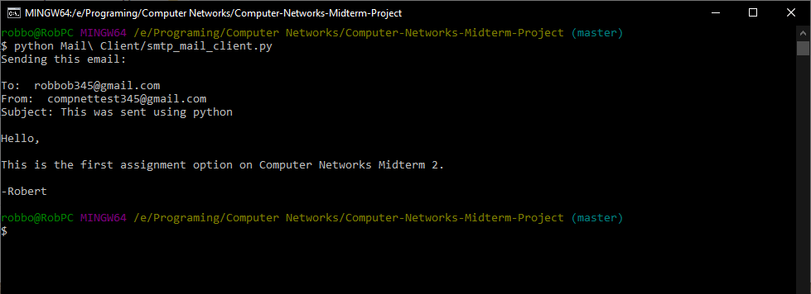

Sent email:

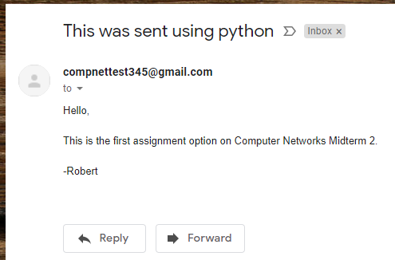

**Assignment 3: ICMP Ping(10points)**

Again, I used python 3 to implement the ICMP ping tool, which utilized the pythonping library’s ping method. The ping method handles sending the ICMP packets and receives the responses and stores the data in a return object. Using the return object, I track the maximum RTT, minimum RTT, and number of missed packets, as well as calculating the percentage packet loss, average RTT, and the standard deviation of the RTTs. I imported the statistics library to use the stdev method to calculate the standard deviation, as well as importing the time library to space out the time between sending the ICMP packets.

The tool asks for the user to input an IP address to ping and the number of packets to send. Then returns each response and after all responses, displays the stats.

Output of the ping tool:

