Scam Trainer

Application to aid the detection of false advertisements and phishing

1. Background
   1. From infants to the elderly, everyone is using the internet and email, and that includes criminals as well. All demographics have to worry about false advertisements and phishing when they are on the computer or their phones and the consequences can range from a scam that spreads to their friends to matters of national security. This is an issue that is solved by becoming familiar with these fake ads and emails, so I want to make an app that helps people distinguish between real and criminal when they are on their devices.
   2. I will primarily focus on helping the older generation with identifying scams because the younger generation is more familiar with the devices and may not be literate enough to understand the minute differences. Also, in my experience, older people seem to have some anxiety when dealing with computers and phones because of such dangers, so I want to help them overcome their fear.
   3. These scams are getting harder to distinguish what is real and what is fake, but there always tends to be some tells that can be noticed to identify the scams.
2. Objectives

The objective is to increase online security and safety, inform the public of such dangers, and contribute to removing the scams by making them ineffective because nobody is falling for them.

1. Scope of the general problem

There is a lot of information on these scams and how people are fooled by them so it is fairly easy to describe to someone, but the issue is trying to portray the information in a simple and memorable manner so that people that do not interact with computers very often are able to avoid the dangers of the internet.

1. Specific problem statement

Develop an application to expose older folks to trends in false ads and phishing emails in order to improve their online security.

1. Typical use cases
   1. Change account settings
      1. Change name
      2. Change password
      3. Reset progress
   2. Browse random example
   3. Browse categories
   4. Play quiz game
2. Proposed solutions
   1. Create a mobile app
      1. Accessible to most people because mobile devices are widely used
   2. Create a web app
      1. More accessible to target demographic, older generations are less likely to have or know how to utilize smart phones
3. List of functionalities
   1. Create account (user)
      1. Save credentials (system)
   2. View example (user)
      1. Display images and text (designer)
      2. Save to account that particular example was viewed (system)
   3. Browse example categories (user)
      1. Display examples thumbnails (designer)
      2. Save to account that category was completely viewed (system)
   4. Play game/quiz (user)
      1. Per category
      2. Available after browsing all examples in category
      3. Save score to account (system)
4. Design
   1. General guidelines
      1. Large Text for easier legibility for older eyes
      2. Clear, contrasting colors when necessary
      3. Use icons when possible to convey general ideas
      4. Give feedback for important actions (correct, incorrect, completed, wrong password)
      5. Keep user in control/don’t lock user into anything
      6. Following many of the guidelines provided in <https://uxplanet.org/accessible-design-designing-for-the-elderly-41704a375b5d>
   2. Sketches
      1. Preliminary Sketches

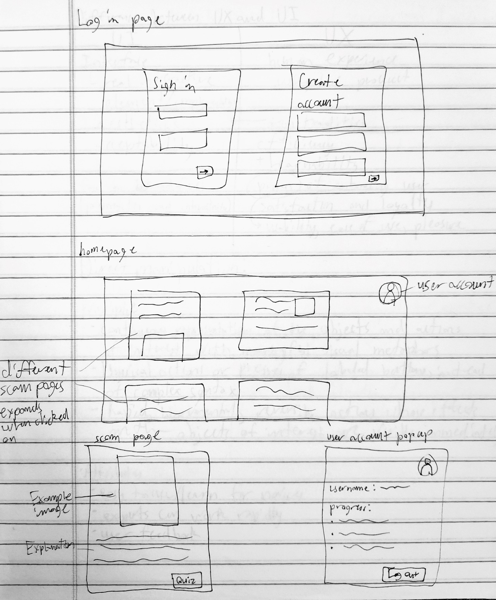

1. Implementation
   1. 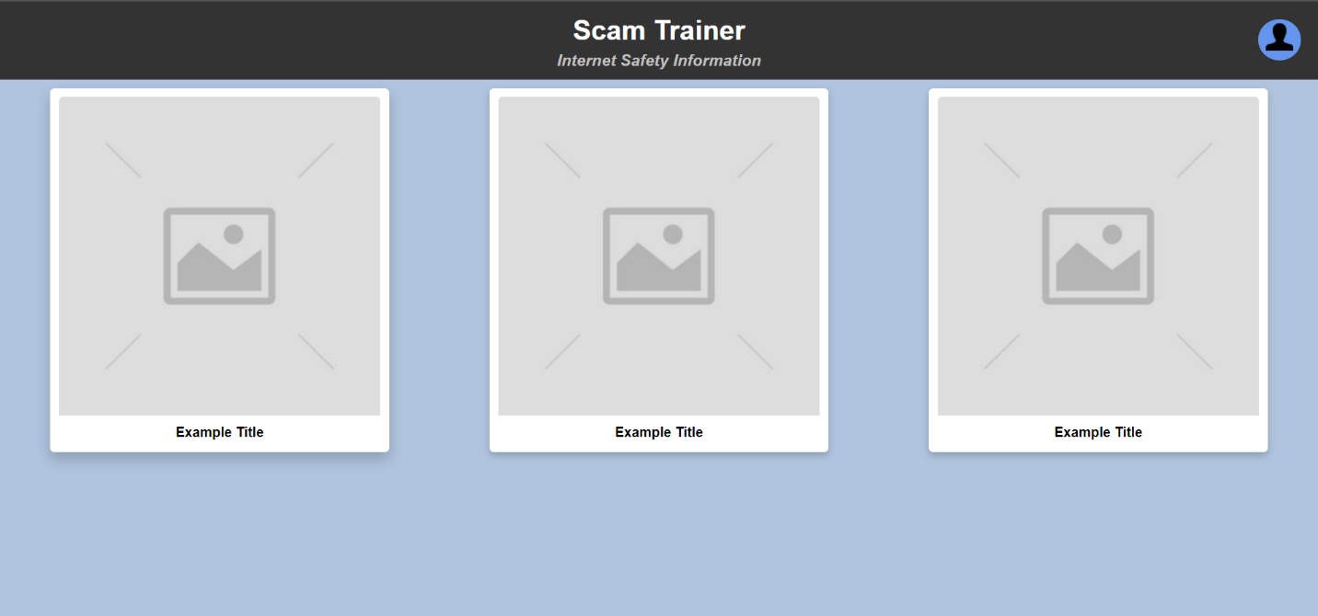Early Layout
      1. Sidebar menu for user information and start or example popups. The header bar will stay on top of all other elements on page while scrolling. Improved the color scheme slightly to increase contrast.

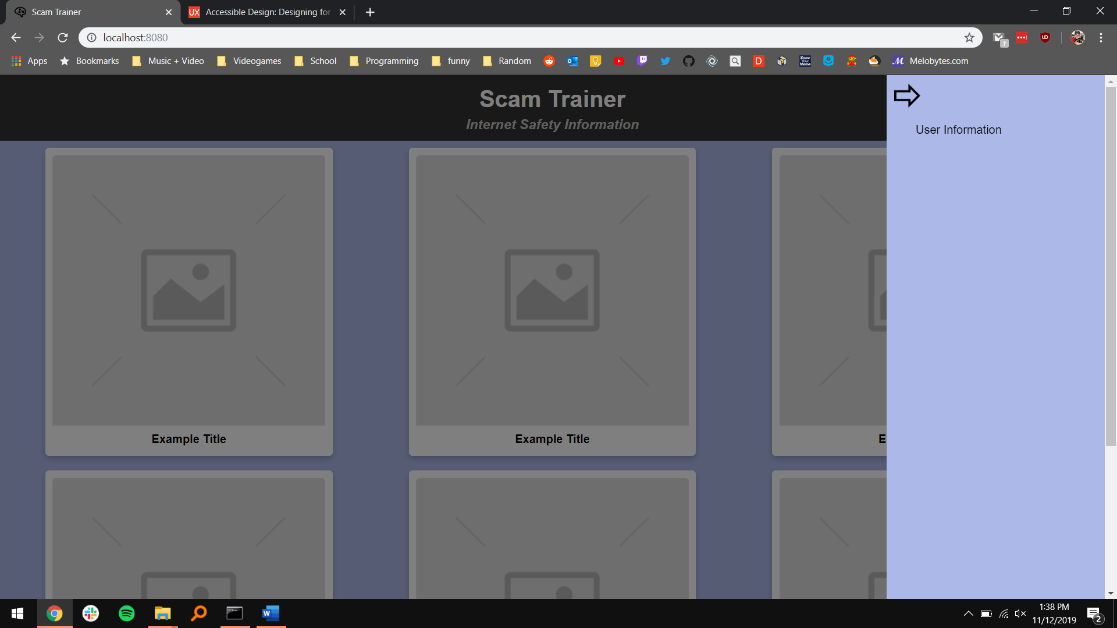

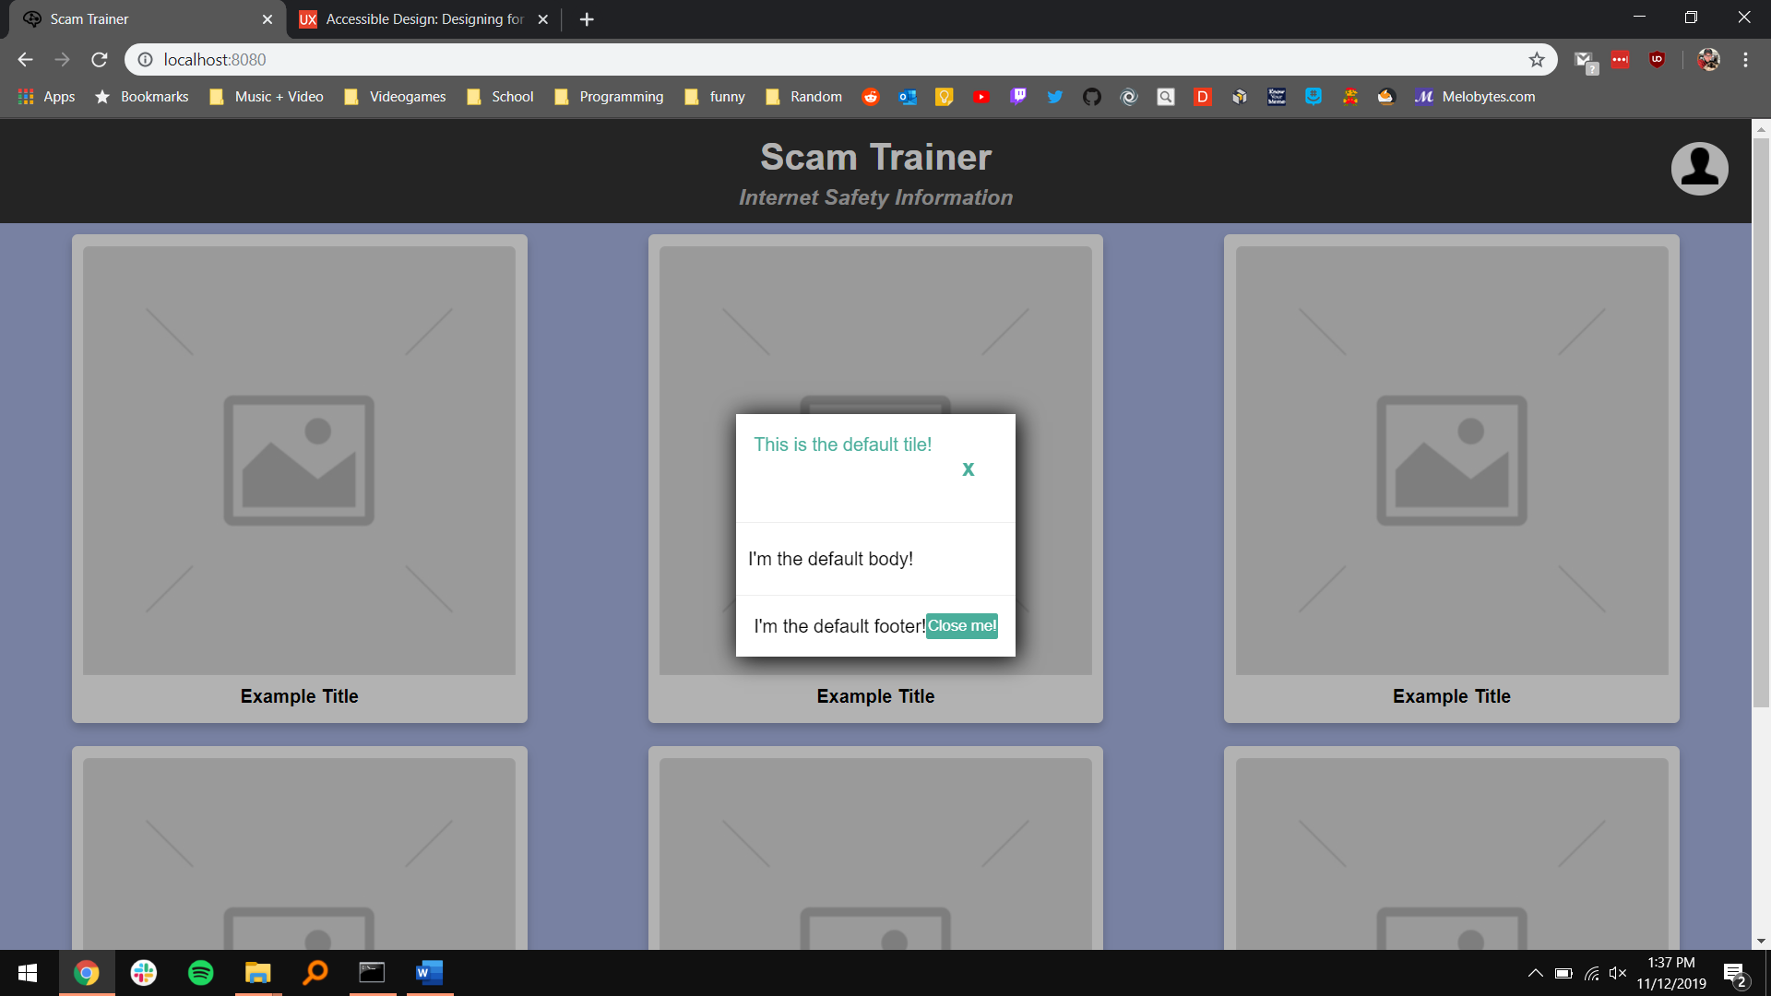

* 1. Final Design
     1. The background color changed to a soft red-pink to enhance readability for colorblind users.

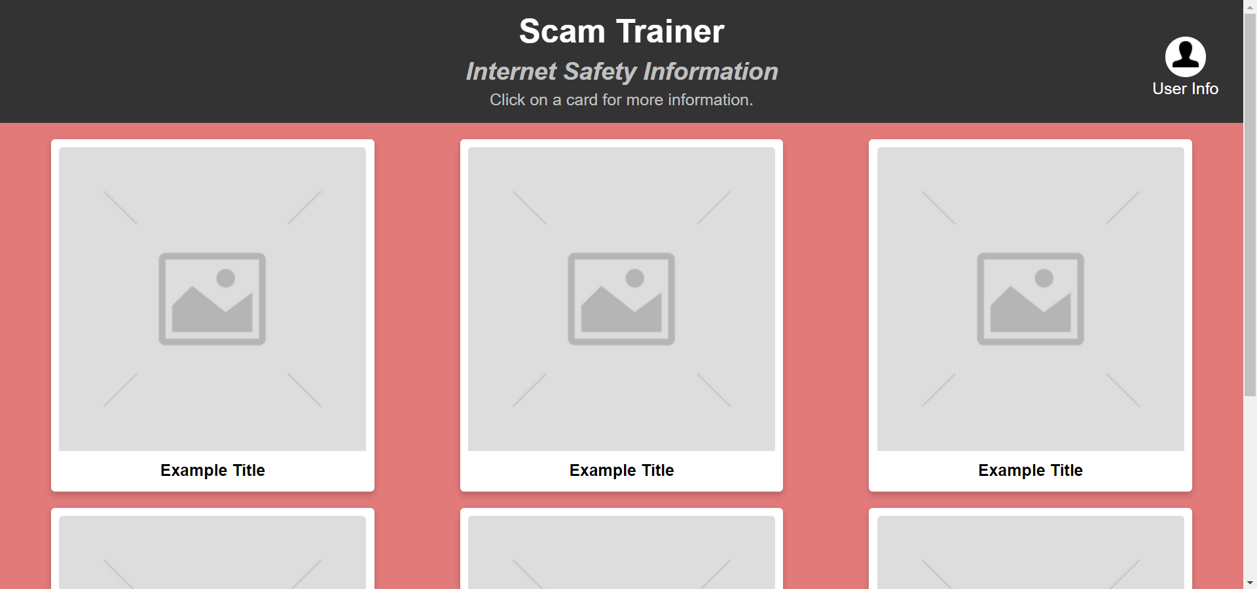

* + 1. Clicking on the “User Info” button displays the current user’s progress through the different examples and allows them to reset their progress or sign out with the respective buttons at the bottom of the page.

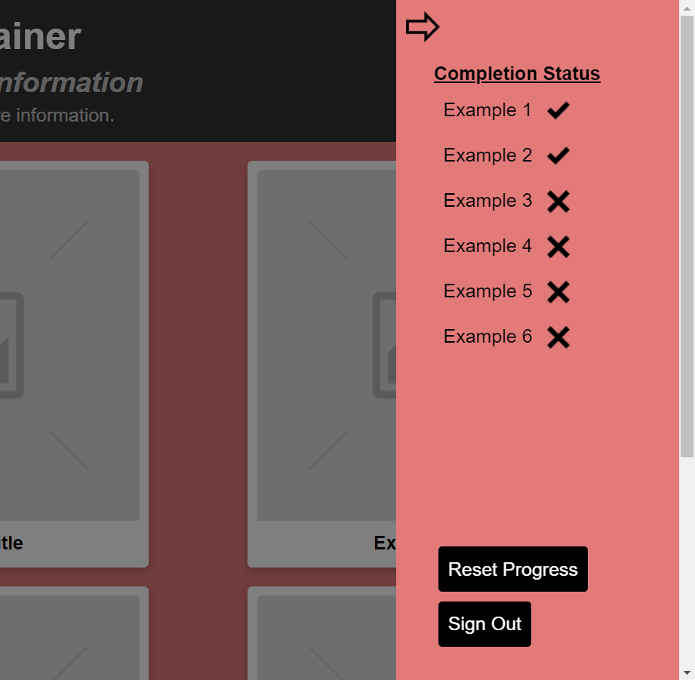

* + 1. Clicking on any of the example cards on the homepage will cause a pop-up window to appear with information relating to the selected example.

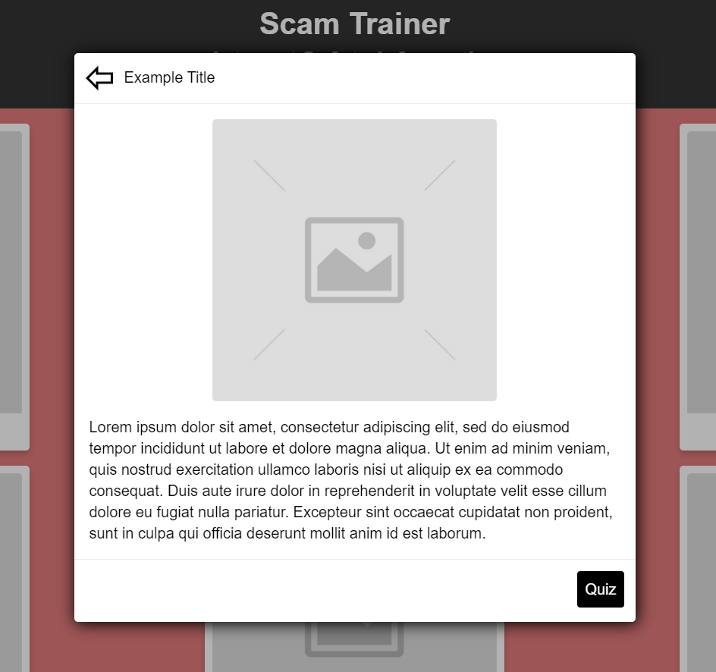

* + 1. Users can test their knowledge of whichever example they chose by clicking on the “Quiz” button at the bottom of the example window. Completing the quiz successfully will show a medal or checkmark to show that the example was completed on the card itself and will display as completed on the side menu.

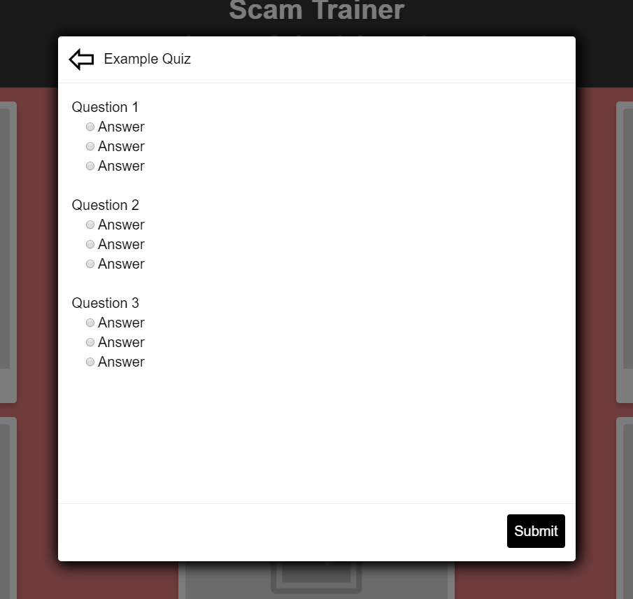

* + 1. Once the user navigates to the side menu, an example card, or example quiz, they are locked-in to that view until clicking the back arrow or one of the options that navigates to another page. This was done to prevent misclicks taking the user away from the desired page since older users are generally less comfortable using a mouse.
    2. An example of the content in each page would be the below image and a description of how the email can be determined to be false. In this case I would point out the return address at the top of the email and discuss how if it was a real email, the address wouldn’t be a string of random characters.

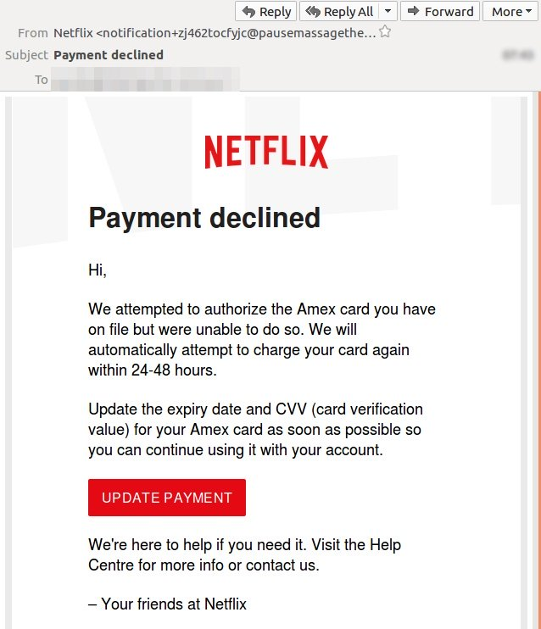

1. Implementation Tools

Vue.js – Using vue.js was very useful because it allows for modularization of different aspects of the webpage, which made it very simple for all the example cards and pop-up windows to be the same layout and design without needing to copy and paste the same HTML elements over and over again.

In order to view the website on your localhost, npm must be installed on your machine and from the directory with the README.md, run “npm run serve” and the site will be locally hosted on localhost:8080. There may be dependencies that need to be installed in order for the site to load correctly.

1. Testing

Not much testing was done on the application because I would need many older people to use and report on their experiences using it and I did not have time to contact many people to test for me and since the application is made for the specific use by seniors, using people outside of that user group did not make much sense. If I did have time, I would test for the general usability, the ease of navigation through the app, and for the retainability of both how to use the app and the information gained from the app.

1. Enhancements

Some changes I would like to make to the application that were not completed in the timeframe would be the user creation/login page, adding a tutorial/walkthrough the site for first time visitors, and usage logging features. The user creation and login page would be necessary for the functionality of the app so that each individual user’s progress would be saved and could be accessed from any device the app is being accessed from. The tutorial/walkthrough would be very beneficial to help the users less familiar with using the internet get an understanding of what they need to do to fully utilize the application. The usage logging features would be used to collect usage data and after analyzing the data, future additions or improvements would be made to ensure that the app is being used to its full potential.

If I were to do this project over, I would utilize user centered design or participatory design principles in order to make the application as user friendly as possible because It is difficult to completely understand the issues faced by your userbase when you are not in that group yourself. Having older people using the app as it is being built and providing feedback would be very beneficial in ensuring that the application is as senior-friendly as possible. Along with this, I would incorporate more testing throughout the design process to make sure that my desired userbase likes the design along with the implementation.