HW #3 - Breadcrumb Implementation

**Description**

I created a breadcrumb trail for a simple website with 7 pages. This simple web app starts on a homepage, then the user decides whether they want to change the styling of the header or body of the site, each of which is directs to its own page. The user is then asked if they want to change the font style or the color of the previously selected element, again directing to different pages depending on the selection.

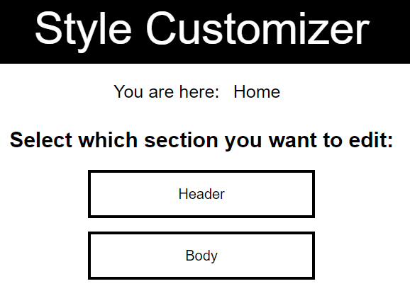

At the top of each subpage, there is a breadcrumb trail informing the user of what page they currently are on and how they got to that specific page. Each previously accessed page in this navigation bar are links leading back to the previous page for easy access to earlier steps in the process. The images on the next page show how navigating through the pages adds onto the breadcrumb trail based on whatever was selected. The flow looks like this:

Header

Color

Font

Color

Font

Body

Home

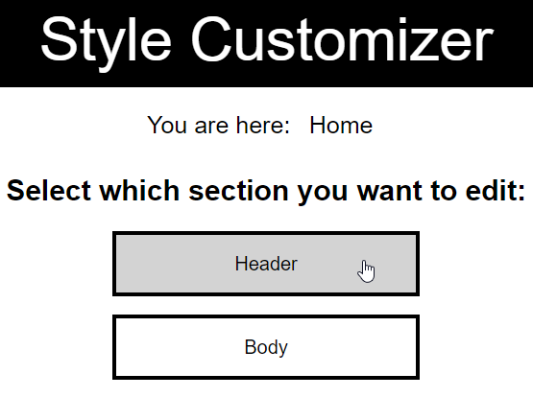

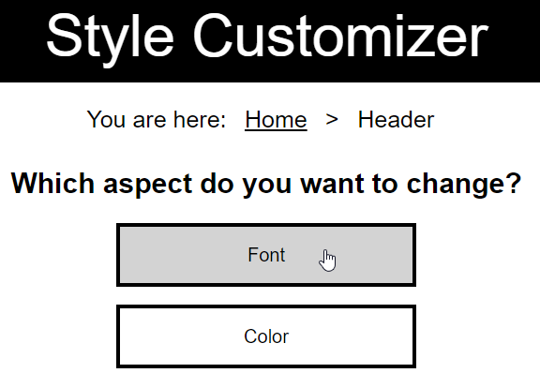

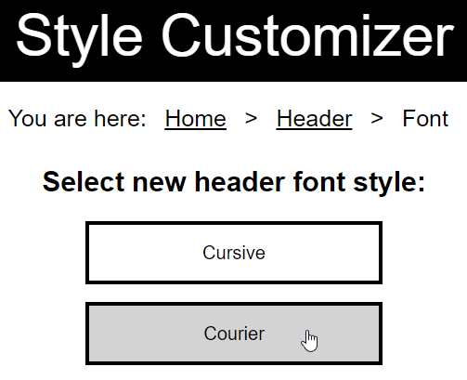

**Code**

Since these are all separate pages and they appear in a specific order, an html list is used which adds the current page on the end of the previously visited pages. The following code snippets show how the trail is created as the user navigates from the homepage, to the body page, to the body color page:

Home:

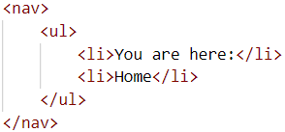

Body:

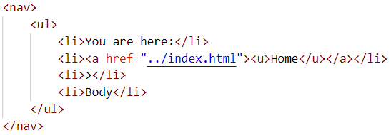

Body Color:

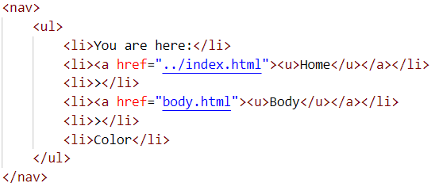

CSS (to make it a horizontal list):

