**Collection:**

After created the work space clicking the create option.

Now we need to create the collection for that as given below,without creating the collection we cant proceed with requests.

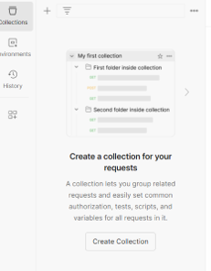

Now click on create collection and opens a page and give the collection name as given below

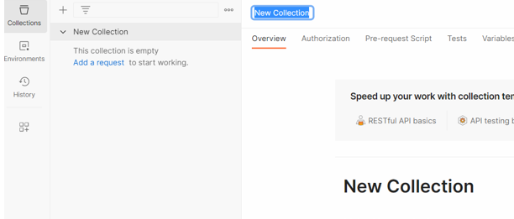

Give name of collection and we can see that as above we can see that option add request ,we can add the request.

And start with the requests,we can give the name to requests and can proceed.

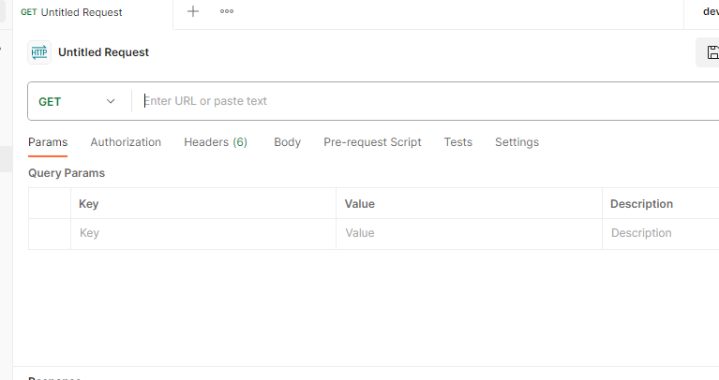

By giving name and we can proceed with the request.