Fantasy league legend

[文档副标题]

215959

# Abstract

Table of content

Table of content

Abstract 1

1 introduction 3

2.background research 5

3.professional considerations 8

4.requirement analysis 10

5.system design 11

5.1 learning objectives 11

Modules 11

The function of combine all the rating together with team chemistry value 11

The function of calculate the team chemistry. 11

Tkinter library 12

UI design 12

6.implementation 12

7.testing 13

7.evaluation 14

8.conclusion 16

9.appendix 17

# 1 introduction

As more and more sports move towards professionalism, sports analytics is gaining more and more attention, especially after the great success of baseball and basketball, and now terms such as "magic ball theory" and "penalty kicks" have gained considerable fame in both fan and AI circles. At the same time, "fantasy leagues" have become very common. A fantasy league tournament is a model in which players create their own teams as professional basketball managers.

The goal of this report is to create a card game based on the fantasy league model. Two players will choose their respective players as professional basketball managers and the system will score the players individually and by the bonds between them, with the team with the highest score winning. Another objective is to clarify the difference between the scoring system and other scoring systems. The main difference is that the scoring system takes into account the overall relationship between the players and the impact of the level of understanding on the overall team score. This will be achieved through memization. This report will demonstrate in more detail the program requirements, practices, implementation and evaluation of this project.

Team chemistry in NBA

Most teams have great surface strengths, but when they don't produce results, the team says 'wait, give me time, all we're missing is chemistry. It could be conclude as two main part:

A sense of community - when every player on the team finds their place, plays to their strengths and is willing to contribute to their teammates.

The level of understanding - players understand each other's strengths and weaknesses and are able to work well together e.g. when one player could free to shot, his teammate pass the ball to him in time.

In this project, the team chemistry will be considered as an index，and the team rating system will calculate the actual value of this index. Also the value will be taken into account in the final team score.

This article will show the process of making the game in 8 steps and the key points：

Part 2details the preliminary research carried out before starting to design the solution. This includes an outline for some of the scoring systems already in place.

Part 3 deals with professional considerations, including how the project will take into account the public interest, professional competence and integrity, and accountability to relevant authorities.

Part 4 outlines the requirements of the project to determine the size and focus of the anticipated final project. This includes the functional and non-functional requirements of the final system.

Part 5 describes the overall game and the design process for the rating system. The learning objectives of the project are discussed, as well as the functionality that the rating system will have. Furthermore, the selection and comparison of models for player data structures will also be discussed in this section. Finally, the creation of the user interface and the explanation of the rules of the game are explained in detail.

Part 6 describes all the problems encountered during the implementation of the project. It outlines the general order in which the problems occurred and how they were dealt with.

part7 describes the evaluation and testing of the system. It includes a comparison of this scoring system with other scoring systems and an assessment of the accuracy of the project using R-values. It also includes a self-reflection on the overall results of the project and highlights any other outstanding issues with the system.

Part8 is the conclusion, which summarizes all the elements covered in this report. And discusses further work that could be done on this project in the future, reflecting on the outstanding requirements and explaining how they could be implemented.

# 2.background research

The team Elo rating system

Elo is a simple measure of strength based on game-by-game results; in details it is method used to calculate the relative skill level of players in a zero-sum game. A player's Elo score is expressed as a number, which may vary depending on the outcome of the rated game played. At the end of each game, the winning player receives points from the number of points lost. The difference between the ratings of the winners and losers determines the total number of points gained or lost after the game. If the player with the higher rating wins, the player with the lower rating will only gain some rating points. However, if the lower rated player gets a losing victory, many rating points will be transferred. In the case of a tie, the lower rated player will also gain some points from the higher rated player. This means that the rating system is self-correcting. In the long run, players who are rated too low or too high should accordingly perform better or worse than the rating system expects and thus gain or lose rating points before the rating reflects their true strength.

So, in this program, Elo ratings depend only on the final score of each game and the location of the game (home field advantage). They include both regular season and playoff games.

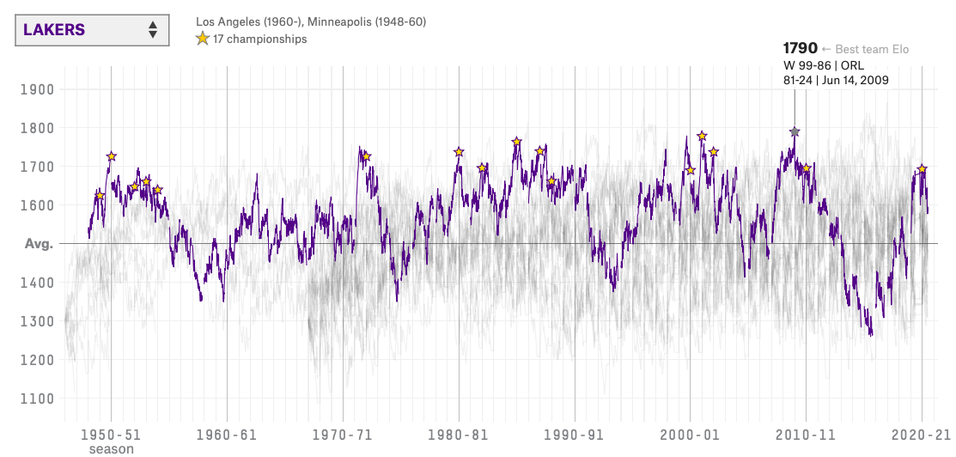

-Figure1. the graph about Los Angeles Lakers team Elo

This graph shows the change in Elo scores for the Los Angeles Lakers team from 1950 to the present day, with the scores at each stage and the slope giving a good indication of the overall strength of the team at that time. To work out who would win and who would lose between the two teams, you first have to calculate the difference in points between them. In order to map this difference into probabilities, Elo is often statistically and research by the sigmoid function (logistic) Specifically, it is a function that maps (−∞,+∞)→[0,1], where σ(0)=0.5. Elo rating is often used by the sigmoid function (logistic) for statistics and research specifically, it is a function that maps the difference between Elo rating. The sigmoid function is used here to get a better look at the data comparison of a zero-sum game.

.

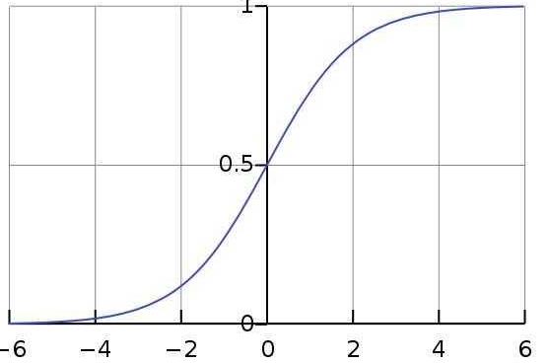

**-** Figure **2. sigmoid function digram**

Fibonacci sequence

Fibonacci sequence is a sequence in which each number is the sum of the first two numbers. The number at a specific position in the Fibonacci sequence can be obtained using recursive methods.

The pseudocode for fib can be conclude as:

Define Fib(n)

If n = 0

Return 0

Else

Return Fib(n-1)+Fib(n-2)

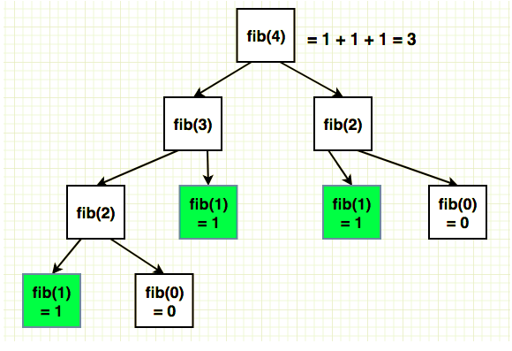

**-** Figure **3.the fib diagram**

**Memorization**

**In computing, memorization is an optimization technique that focuses on speeding up computer programs by storing the results of expensive function calls and returning the cached results when the same input occurs again.** **memoization is an optimization of the recursion function. Unlike the fib function, it sets up an object called a cache, which stores all the return values we have obtained, and when the function is executed it will check whether the cache has the required data, and if it does, it can be called directly, if not, the next calculation will be done, which can effectively reduce the number of recursions.**

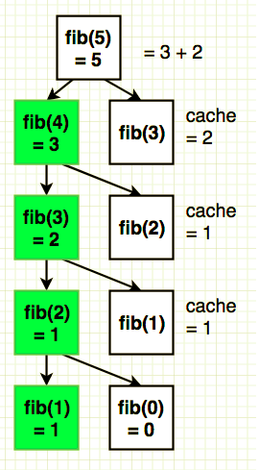

# 3.professional considerations

3.1. BCS Code of Conduct

This is the BCS Code]of Conduct[4] which relate to my project:

1.1 have due regard for public health, privacy, security and wellbeing of others and the environment;

The game is a team rating game, it will store the data about the name for the team, the member of the player’s ‘fantasy team’ and the final rating for their team when they finished their selection. Also the statistical data for the NBA players could be found through the internet.

1.2have due regard for the legitimate rights of third parties;  
Due to the free charge of this game , there will have fewer obligation for the third part.

1.3  conduct your professional activities without discrimination on the grounds of sex, sexual orientation, marital status, nationality, color, race, ethnic origin, religion, age or disability, or of any other condition or requirement;

The game designed for all age group without any discrimination, the older and the children all will be able to enjoy this game, In the process of game the children should be supported by their teacher or parents, which could help them expand their team manager ability to create their own team.

1.4  promote equal access to the benefits of IT and seek to promote the inclusion of all sectors in society wherever opportunities arise.  
This game is a free charge game which means the it will promote the benefit of IT equally. It will not consider anything about economic background.

2.5. respect and value alternative viewpoints and seek, accept and offer honest criticisms of work;

I will show my biggest respect of all of the feedbacks from the user, rather than ignoring these.

4.6 encourage and support fellow members in their professional development.  
If any of my fellows get any question in their professional development, I will do my best to help and support them.

2.2. Ethical Issues[5]

This project is a specific type of game, so it is necessary to consider the ethical approval in order to make sure it will not damage social healthy. This project is only a rating game do not include any feature about risk, for the participants will have a try on this rating game and could provide the feedback for this project if they want. Due to this game do not have age limitation, this game will make sure there is nothing harmful to the health of minors . The

6 basic rule of the game and the rating of user’s fantasy team will be show in the interface, and the information about their fantasy team only be used after the participants sign the consent form. All of the feedback from the participant will be stored in personal laptop which protected by the password

# 4.requirement analysis

The main use of the scoring system is to allow users to choose as well as match their 'fantasy league' and get feedback. This part will consider an rational rating system, which the functional requirement and non-functional requirement will be outline.

Functional requirements

Here are the List for Functional requirements:

* The project shall be playable by two player on one computer
* The user will be able to input their team name
* The system should provide the user the order of pick
* Users will be able to choose the player from the random set
* Users will be able to see the information and image of the player
* The system should rate the team fairly

Non-functional requirements

Here are the List of Non-Functional Requirements

* The project will be developed using Python and Python Graphical User Interface
* The User could go through the user interface easily
* The project will compatible on desktop device

# 5.system design

## 5.1 learning objectives

* Explore and figure out the most suitable model for players data structure
* Strength python knowledge
* Learn to build the User Interface by Python Tkinter library
* Explore the how to calculate the value of relationship and how the player relation will impact on the final rating
* Come up with a reasonable function to rate the player group

The main learning objectives of this project were to learn and find the most suitable model for the player data structure and to build a team scoring system by finding the core of the relational ability values between players. As the final form of the project will be a game, it was necessary to find a suitable framework library. The last and most important part of the project is to find a suitable scoring method for the players. I found that memoization is the easiest and most efficient way to Implement and integrate results rating of each team, so understanding how to use memoization became another learning objective. The last learning objective was to learn more about the use of the python library and to increase proficiency in python. The choice of programming language for this project was simple as python is simple and easy to understand with many libraries for data analysis and statistics.

### Modules

#### Modelling team chemistry

In this project, the team chemistry are design separate into three type.

Type 1; basic level, in the first level will only consider the relationship between each other

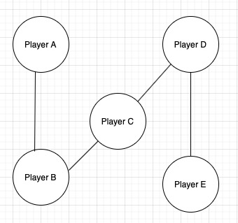

- Figure4. the player chemistry relation display

As shown in the picture, the lines between each player represent their relationship and the value on each line represents the level of chemistry between the players, the higher the value the higher the chemistry between the players, in other words the higher the value the better the relationship between the players, which makes it easier for the players to produce good results. And this is where the main focus of this project will be.

Type 2:middle level, this level will consider the relationship between individual and a group set.

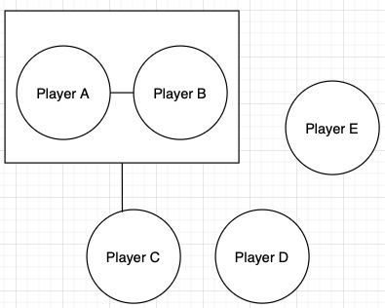

- Figure5. the graph show the relation

Unlike the first type, the second type is an evolution of the first type, which describe the relationship between groups and individuals, as expressed in the diagram, where player A and player B are a combination, and player C is associated with this combination in some way, and the addition of player C will potentially make the combination stronger

Type 3:high level, this level will consider the relationship between group set and group set

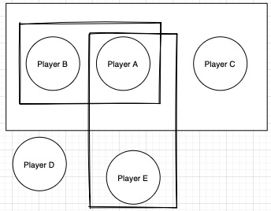

- Figure6. the graph show the final type

The final team chemistry design will show the relationship between groups. As the diagram above shows, player A is a group with player B, and player A is a group with player E. When group AB is combined with group AE, what effect does this have on this new combination.

### The function of combine all the rating together with team chemistry value

The first method to solve this condition is attempted to use the Fibonacci. Which is mentioned in the background research, it is a kind of naïve recursion. According to the fib function, the project could result the team rating as a Fibonacci number:

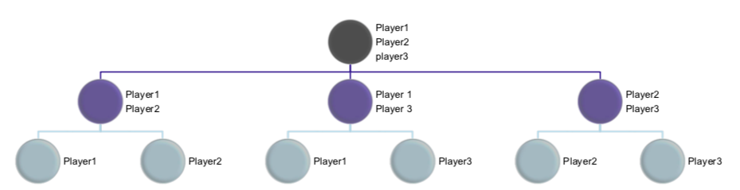

Figure7. The player rating implement by fib method

As the diagram above shows, the objective is to try to obtain the rating of a team of three players (Player1,2,3). In order to calculate the rating of this team, firstly we need to obtain the individual values of each player, and secondly we need to take into account the possibility that each two of the three players will be combined together, as shown in the second row of the diagram above. In simple terms, the strength of the second row is the strength of the third row plus k, e.g. (player 1,2) = strength (player 1) + strength (player 2) + k, and so on. The formula given in formula 1 is the recursion made by this method, so that the final team rating can be derived.

Here the Strength function is used to describe the rating of a player or team, S is the total number of the player and t is the player which is a number of T.

$Strength\left(S\right)=\left(\sum{Strength\left(T\right)/st.T∈Powerset\left(Players\right)∧Cardinality\left(T\right)=Cardinality\left(S\right)-1∧T⊂S}\right)/Cardinality\left(S\right)$ formula 1 $$S∈Powerset\left(Players\right)$$

$$Strength\left(S\right)=\frac{\sum_{\left|T\right|=\left|S\right|-1}{Strength\left(T\right)}}{\left|S\right|}where S⊆Players T⊆S$$

The pseudocode code for this function by using fib recursion is shown below, As it is rely on the way of recursion, it is necessary to set up the base case, so for this project’s pure recursion is if the number of set one, it will straight return that player’s rating.

Define Strength(set)

If num == 1

Return Rating(set[0])

Else

strength = 0;

For each subset in itertools.combination(set, len(set)-1)

Strength += Strength(subset)

Strength / (len(set))

Return Strength()

However, it will cause stack overflow condition, which is the program uses more memory space than is available on the call stack, for example like the graph to calculate the overall rating of (player1,player2,player3). The algorithm will calculate the rating of (player1,player2) and (player1,player3) and (player2,player3) then combine their rating to get the rating of three player, if there are request to rating a player of 4 group it will do a recursion until find all factor it need to calculate, In this case, the recursion will do a lot of redundant work and have a low efficiency. So I try to find the more efficient way to solve the calculation (improve the fib recursion), which is the Memoization, the basic idea for memoization, is attempt to save all of the result that obtain from the recursion. And take out the result directly when we use it to calculate further information. Therefore, an array is defined to store the calculated data, and then query from the array when needed, which will save unnecessary calculations and improve the efficiency of the program.

Here is the pseudocode for Memoization:

Define Strength(set)

Memo = keys:powerset5 -> values: zeros(len(powerset5(players)))

If num == 1

Memo[set] = Rating(set[0])

Return Rating(set[0])

Else

If (Memo[set] == 0)

strength = 0;

For each subset in itertools.combination(set, len(set)-1)

strength += Strength(subset)

strength / (len(set))

Memo[set] = strength

Return Memo[set]

In the pseudocode, the function will always check the Set and do the recursion which will always check all of the powerset of len(set), until it find the personal rating, however, as the method mentioned before, the formula to calculate a group rating is Strength(player1,2)= Strength(player1)+Strength(player2)+K, K is the major factor influence the total rating of a group combine. ,it is a process in which new players and previous players go from strange to familiar, as well as the formation of team play and mutual cooperation. So if the two player have a good relationship their combine K will be a large number, vice versa.

### The function of calculate the team chemistry.

In the background research, we found out the Elo rating could be a good way to represent the strength of each team. I searched the Elo ratings of the 14 teams and selected the highest Elo rating at that point in time as an important figure in calculating the team chemistry value, due to the fact that 14 outstanding teams were selected for this project.

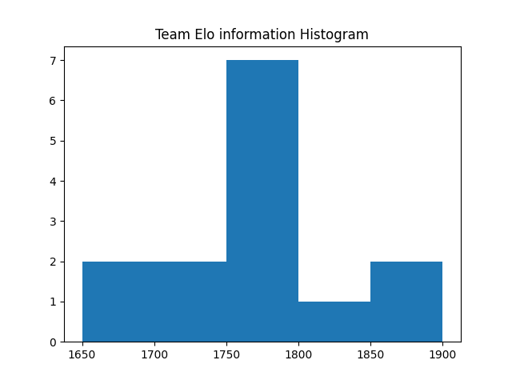

-team Elo histogram

As the graph shows, most of the teams have an Elo score between 1736 and 1796, which ensures that these teams are very strong, as the initial Elo score is 1500. For the purpose of this project, we need to find the team chemistry values of the best combinations from these 14 teams. Each of the 14 teams will have several role players in addition to the famous combinations. The chart below summarizes the information on all players, including the famous combinations, which will be used to calculate the relationship value K..

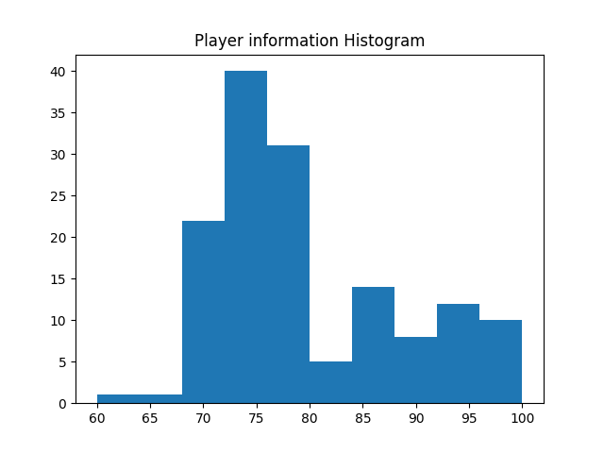

-the player rating information histogram

The mean for player rating is 79.188.

According to the background research, Elo rating is often used by the sigmoid function (logistic) for statistics and research, so we can conclude that Elo ratings are a logistic distribution. However, it is hard to find a distribution that fits the player's rating. For simplicity and ease in computations, I assume that both player ratings and ELO ratings can be normally distributed.

Here is the formula to calculate the team chemistry value:

$$α=\frac{\sum_{i=1}^{m}{TeamElo\left(t_{i}\right)}}{\sum_{i=1}^{n}{PlayerElo\left(p_{i}\right)}}×\frac{n}{m}$$

$$T\left(t,p_{1},…,p_{n}\right)=\frac{\left(\frac{TeamElo\left(t\right)}{α}×NumberOfPlayers(t)-\sum_{p=t-p_{1},…,p_{n}}{PlayerElo\left(p\right)}\right)}{n}$$

$$Chemistry\left(p_{1},…,p_{n}\right)=Strength\left(p_{1}…p_{n}\right)×n-\sum_{i=1}^{n}{PlayerElo(p_{i})}$$

In this project both of player rating and Team Elo are considered as normal distribution, so we could find a specific ratio by the mean of team Elo/ the mean of player rating. This formula uses this ratio value and all the information about the team at the time to calculate the team chemistry value of the best combination within that team.

### Tkinter library

### UI design

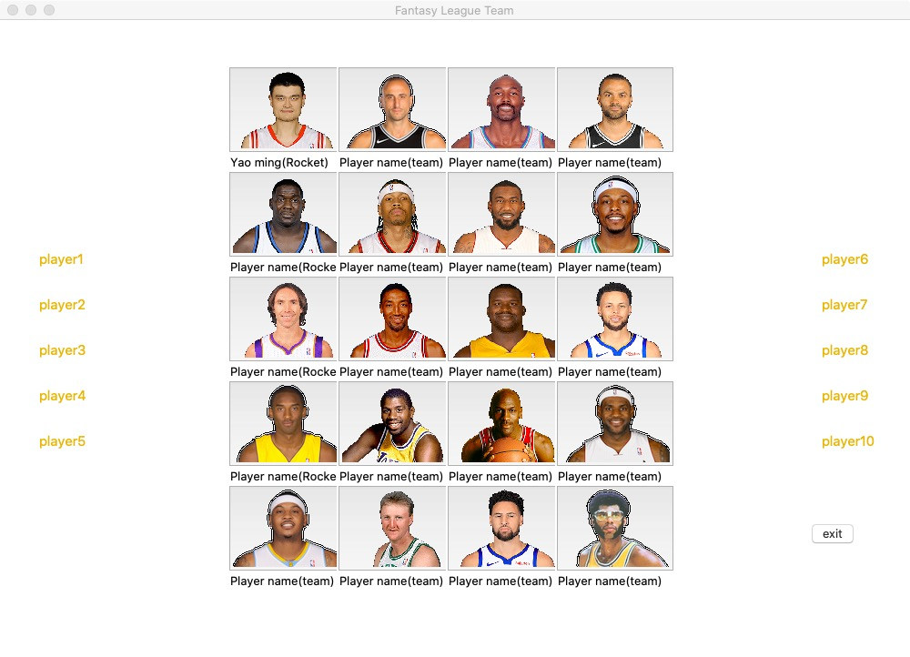

-UI diagram

# 6.implementation

#### Explore the suitable model for data structure

For the basic setting of the data, the main objective of this project was to explore and calculate the tacit values of the relationships between players (team chemistry). Based on the background research, I selected 14 famous combinations and compiled their team and teammate data as database for this project.

The initial stage of the model is based on the graph by adjacency list, in other words, each player has a certain relationship with each other.



-The adjacency list model

This image shows how the relationships between players can be represented by the adjacency list.

the adjacency list is a chain structure of the graph it will have the vector, states, and a line connect the state. In this diagram, Player A connect to Player B, that means Player A have a relationship with Player B. And the result for adjacency list is easy to represent Here are the graph to show the relation result:

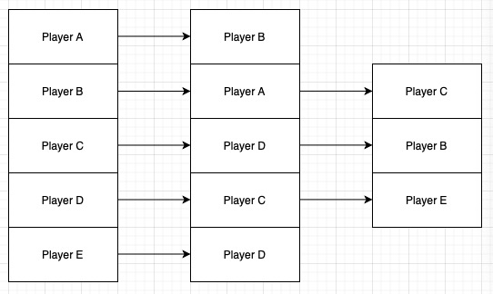

However there are another way to represent the result of Adjacency list.

Adjacency list can also be represented as arrays:

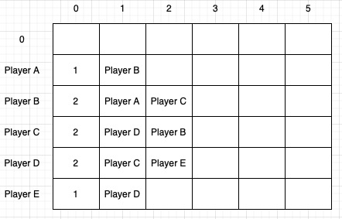

-The Adjacency list result

In this table the horizontal rows represent the number of connections of that point and the vertical columns represent each unit, with column 0 indicating how many connections there are.

The second stage is to use the Graph represent by adjacency matrix as a basis to upgrade the relationships from the previous stage and to find the relationships between individual players and different sets. As the initial data structure model, Although the Adjacency List gives a clear represent of the relationship between players, this project takes into account the relationship between players as a value. Therefore, in the second stage I chose to use the adjacency matrix to express the relationships between players. The graph is used to be design as the model to show the relationship combine between each player. A Graph is a non-linear data structure consisting of nodes and edges. The nodes are sometimes also referred to as vertices and the edges are lines or arcs that connect any two nodes in the graph. And it is consists of a finite set of vertices(or nodes) and set of Edges which connect a pair of nodes .The Adjacency Matrix is the main factor which give us a way to represent our player relation graph in an efficient and structured procedure. It is easy to represent nodes and edges by creating a matrix table as the graph show below:

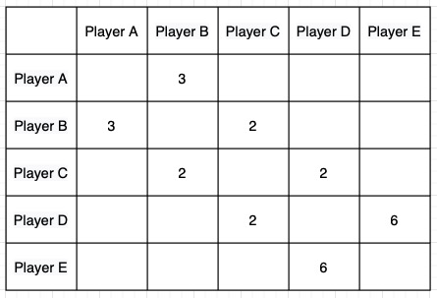

-adjacency matrix graph show the value

Unlike the adjacency matrix graph above, it is possible to express not only the relationship between players, but also the value of the relationship between players. If there are two players have a relation value, the adjacency matrix will consider the value as the weigh and conclude in the table.

Finally, the power set model is set up, which not only identifies relationships between individuals and groups, but also between groups and groups

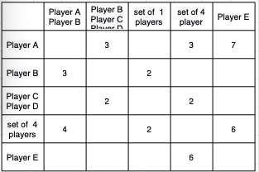

-adjacency matrix graph show the value between power set and power set

In the final stage, both horizontal and vertical nodes will be power sets, which represent the possibility of all player combinations and the function represented can be shown as P(p) * P(p) = Graph. And edges are used in this project to show the relationship between each power group, if there is no relationship between the groups then the edge will be entered as null, otherwise the actual value will be entered and saved in the table to show that a relationship does exist between the selected power groups.

# 7.testing

#### Unit test

|  |  |  |  |  |  |  |
| --- | --- | --- | --- | --- | --- | --- |
| Module | Normal Value | | Extreme Value | | Anomalous Value | |
| Value | Test result | Value | Test result | Value | Test result |
| Team elo | ‘Utah Jazz’ | 1800 | - | - | ‘Hello’ | 0 |
| Strength | ‘A’,’B’ | 108 | ‘A…Z’ | Stack overflow | ‘Nobody’ | Error |
|  |  |  |  |  |  |  |

#### Integration test

Stregmth - Memo

#### System test

|  |
| --- |
| Case |
|
| Player select teams normally | A wins as expected |  |  |  |  |  |
| Player does nothing | ‘A’,’B’ | 108 | ‘A…Z’ | Stack overflow | ‘Nobody’ | Error |
|  |  |  |  |  |  |  |

# 7.evaluation

This section will contain self-reflection and some quantitative analysis of the calculated scores to assess the accuracy of the scores. In addition to this, there will be a comparison of this scoring system with other scoring systems that exist. These were chosen over user testing because the project is more focused on the back-end functionality of the system rather than the end-user experience.



-confusion matrix graph

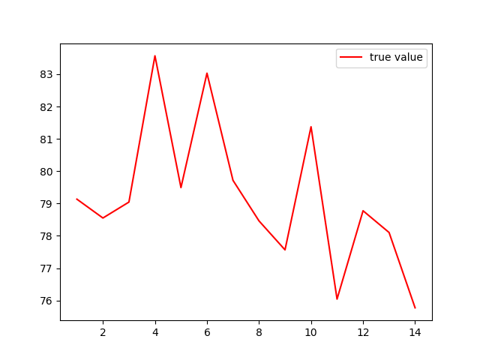 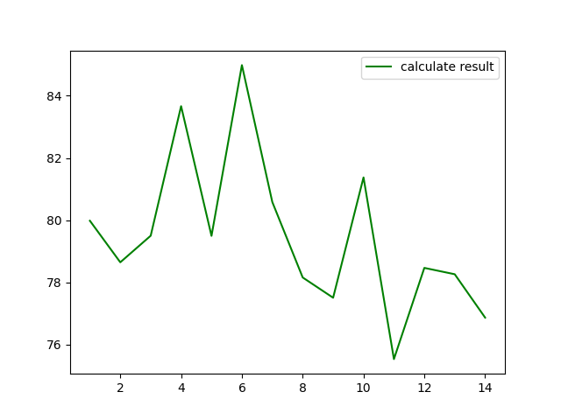

-True value -calculate value

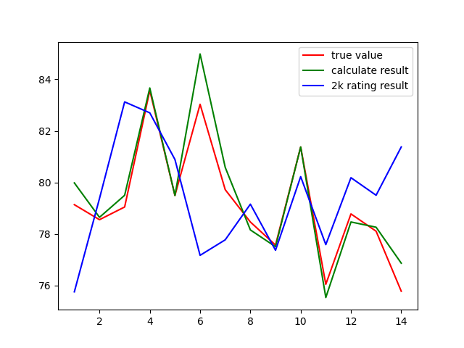

-conclude graph

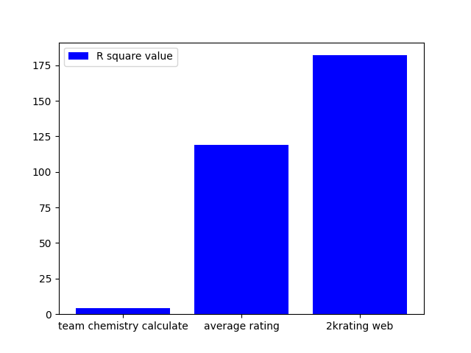

-r square value bar chart

# 8.conclusion

# 9.appendix