* **Use case**

**Seller**



**Account Payable Block**

**Web Server**

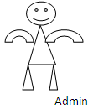 

**Buyer**

