1.)

First of all, we know use ‘size’ to know how many data we have, then use ‘sort’ to sort data from low to high. Then use totally number of data divide 3 to split them two three groups, which are low, medium and high MPG .

Low from 9 to 18.5

Medium from 19 to 26.8

High from 26.8 to 46.6

2

Use gplotmatrix function to plot them, since we want to all the feature compare with MPG, so each plot have to has MPG, then pair from all pairs feature combinations, so that we have 49 plots. Acceleration and weight most informative regarding MPG.

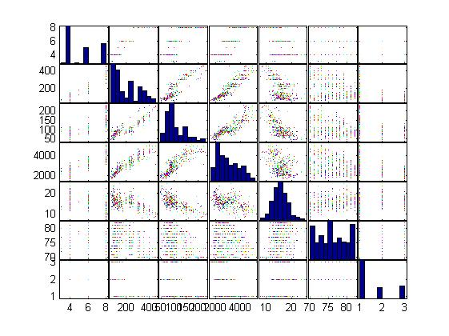

Q3

function w = LRS3(Y,X,n)

if n==0,

X=ones(length(X),1);

elseif n==1,

X=[ones(length(X),1),X];

elseif n>1,

single=X;

indices=1:(n-1);

for i = indices,

X=[X,single.^(i+1)];

end

X=[ones(length(X),1),X];

end

w=pinv((X'\*X))\*X'\*Y;

Q4

Use the slover (q3) to calculated 0th to 4th order polynomial

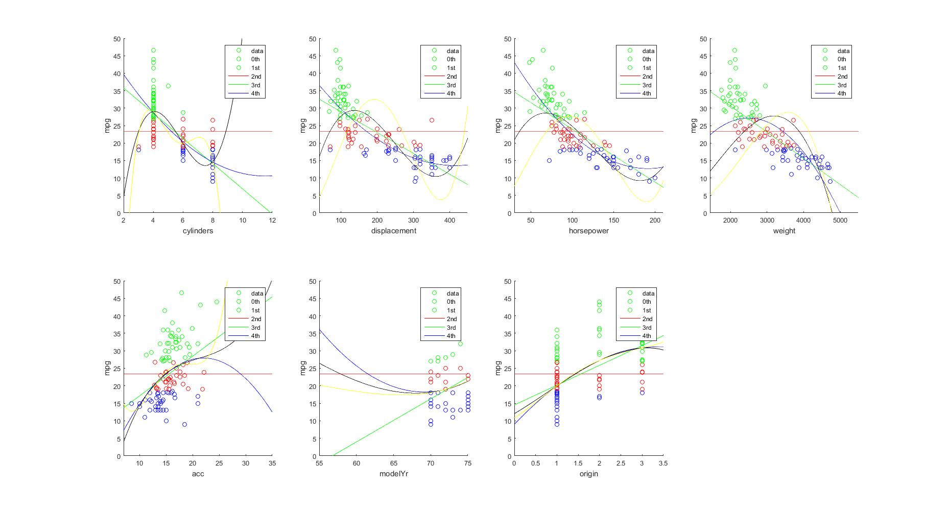

cylinders-mpg: training errors for five functions are

127.26

81.48

81.40

78.25

78.25.

cylinders-mpg: test errors for five functions are

80.72

98.29

98.18

98.43

98.42.

disp-mpg: training errors for five functions are

127.26

76.05

72.26

93.97

176.00.

disp-mpg: test errors for five functions are

80.72

103.11

102.36

105.57

128.10.

horsepower-mpg: training errors for five functions are

127.26

79.39

71.28

84.88

129.20.

horsepower-mpg: test errors for five functions are

80.72

110.23

106.28

105.30

114.38.

weight-mpg: training errors for five functions are

127.26

71.38

98.43

153.83

217.67.

weight-mpg: test errors for five functions are

80.72

102.37

104.12

116.15

139.81.

acc-mpg: training errors for five functions are

127.26

117.82

116.58

115.76

113.38.

acc-mpg: test errors for five functions are

80.72

88.31

90.41

91.56

90.97.

modelYr-mpg: training errors for five functions are

127.26

103.72

101.70

101.73

101.75.

modelYr-mpg: test errors for five functions are

80.72

98.11

98.53

98.59

98.63.

origin-mpg: training errors for five functions are

127.26

106.20

105.46

105.46

105.46.

disp-mpg: test errors for five functions are

80.72

89.04

88.90

88.90

88.90.

cylinders-mpg: training errors for five functions are

126.30

81.57

81.32

78.58

78.39.

cylinders-mpg: test errors for five functions are

81.62

102.59

102.57

104.75

104.91.

disp-mpg: training errors for five functions are

126.30

76.46

72.09

95.91

177.15.

disp-mpg: test errors for five functions are

81.62

105.01

105.97

109.43

125.52.

horsepower-mpg: training errors for five functions are

126.30

81.15

71.48

87.17

131.58.

horsepower-mpg: test errors for five functions are

81.62

102.31

106.19

106.09

112.07.

weight-mpg: training errors for five functions are

126.30

71.35

100.01

156.01

218.57.

weight-mpg: test errors for five functions are

81.62

105.60

102.34

106.20

124.91.

acc-mpg: training errors for five functions are

126.30

113.50

112.94

112.94

112.52.

acc-mpg: test errors for five functions are

81.62

88.08

87.82

87.84

88.38.

modelYr-mpg: training errors for five functions are

126.30

103.65

101.48

101.48

101.49.

modelYr-mpg: test errors for five functions are

81.62

92.36

91.94

91.90

91.88.

origin-mpg: training errors for five functions are

126.30

103.55

102.35

102.35

102.35.

disp-mpg: test errors for five functions are

81.62

85.92

88.14

88.14

88.14.

cylinders-mpg: training errors for five functions are

128.04

78.01

77.48

75.80

75.63.

cylinders-mpg: test errors for five functions are

79.78

103.52

103.73

103.21

103.06.

disp-mpg: training errors for five functions are

128.04

73.34

68.51

93.20

177.37.

disp-mpg: test errors for five functions are

79.78

101.54

104.10

105.24

115.92.

horsepower-mpg: training errors for five functions are

128.04

80.99

72.33

86.52

132.28.

horsepower-mpg: test errors for five functions are

79.78

103.93

107.09

107.99

109.66.

weight-mpg: training errors for five functions are

128.04

70.06

100.55

159.15

224.29.

weight-mpg: test errors for five functions are

79.78

104.75

101.90

103.63

117.07.

acc-mpg: training errors for five functions are

128.04

116.73

115.39

115.26

114.54.

acc-mpg: test errors for five functions are

79.78

86.00

86.98

86.88

86.73.

modelYr-mpg: training errors for five functions are

128.04

104.11

102.57

102.64

102.70.

modelYr-mpg: test errors for five functions are

79.78

94.50

94.95

95.03

95.10.

origin-mpg: training errors for five functions are

128.04

104.17

103.51

103.51

103.51.

disp-mpg: test errors for five functions are

79.78

95.88

95.55

95.55

95.55.

M=3 polynomial order performs the best in the test set

Which feature is the most informative regarding mpg consumption in that case? Horsepower

5.

Training and testing mean squared errors are :

84.75

51.46

51.53

6.

I spited this question to 3 parts. Low medium and high MPG.

I used training data to compute cost and gradient, then optimizing to [1 0] range

I make all low mpg data equal to 0, otherwise equal to 1. Then use incorrectly predict value divide to totally case.

testing low MPG our predict data MSE is : 0.009524 = 0.95%

traning low MPG our predict data MSE is : 0.025478=2.5%

testing medium MPG our predict data MSE is : 0.318182=31%

traning low MPG our predict data MSE is : 0.114943=11%

testing High MPG our predict data MSE is : 0.054422=5.4%

training High MPG our predict data MSE is : 0.004367=4%

7.

I make the cylinders displacement horsepower wight acceleration data as training data as X, and Mpg data as Y . X and Y are training data, then use them to predict the specific data. This question I used feature normalization, since feature normalization could make leaning fast, make the plot convert fast. First of all I calculated sigma/mu for each row feature , then normalization scale , after that we have x’ = (x-\mu)/\sigma. ，then we have the function of feature normalization .then use multiple variable linear regression

Predicted 6 cylinders, 300 cc displacement, 170 horsepower, 3600 lb weight,9 m/sec2 acceleration, (using gradient descent) mpg :16.254682

According to Q1, this car belong to low mpg rate category.

8.

First of all, observe the model of car, usually the big car cost more gas which MPG get low. Secondly, observe the wheel. More big wheel cost more gas.