Two Phase Merge Sort Analysis

**System Configuration:**

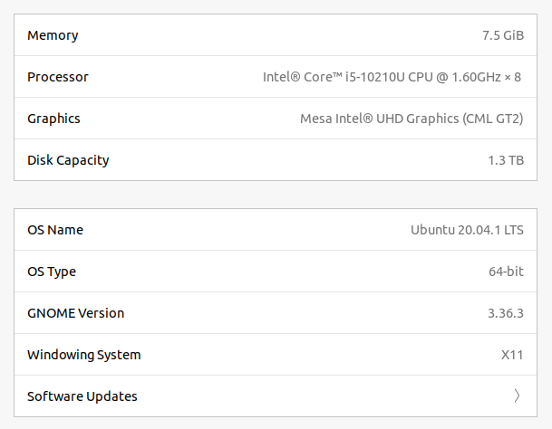

**Observations:**

**Observation #1: Sort Merge Join**

|  |  |
| --- | --- |
| **Memory Block (M)** | **Execution time with (seconds)** |
| 50 | 4.62 |
| 60 | 4.28 |
| 70 | 4.13 |
| 80 | 4.16 |
| 90 | 4.049 |
| 100 | 4.048 |

* Relations: R(X,Y) S(Y,Z)
* Join on : Y

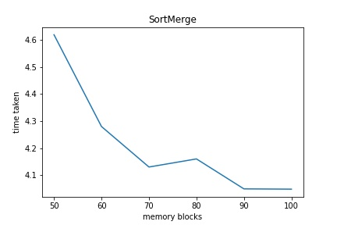

**Inference**

From above graph we infer that:

* When 50 memory blocks were used then execution time was more. As the number of memory blocks increases, the execution time decreases
* Reason - as the number of memory blocks increases, more tuples can be brought in memory thus, reducing the file I/O. Hence, the execution time decreases.

**Observation 2: Hash Join**

|  |  |
| --- | --- |
| **Memory Block (M)** | **Execution time with threads (seconds)** |
| 50 | 0.0354 |
| 60 | 0.028 |
| 70 | 0.025 |
| 80 | 0.0239 |
| 90 | 0.0205 |
| 100 | 0.021 |

* Relations: R(X,Y) S(Y,Z)
* Join on : Y

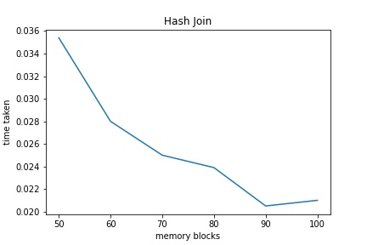

**Inference**

From above graph we infer that:

* As the number of memory blocks increases, the execution time decreases.