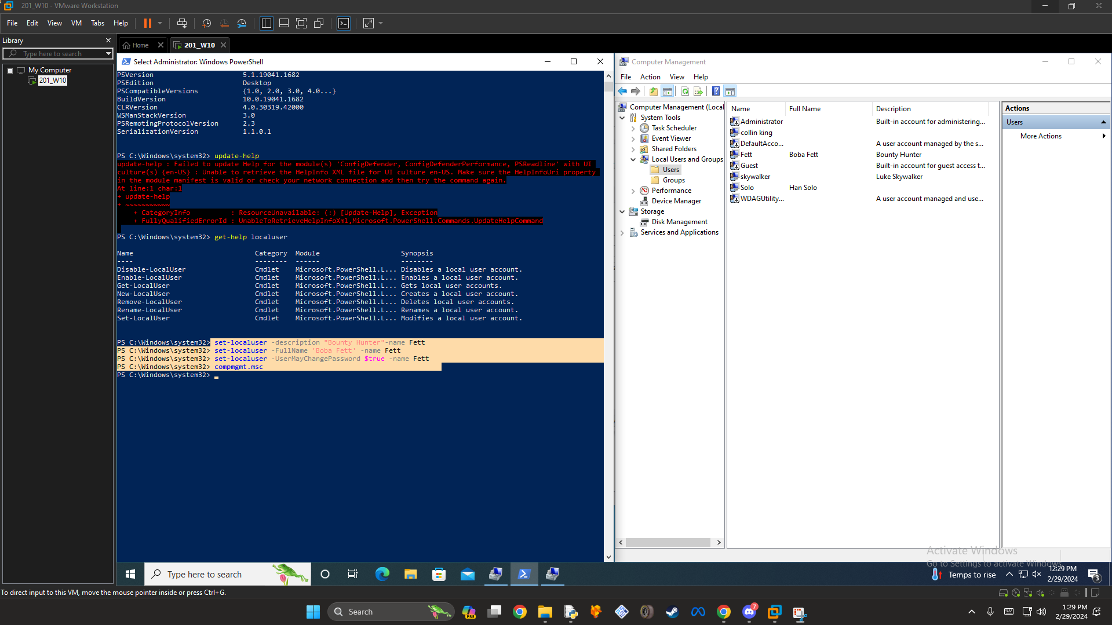
Part 1: Modify Users

Using update-help and correcting boba frets information

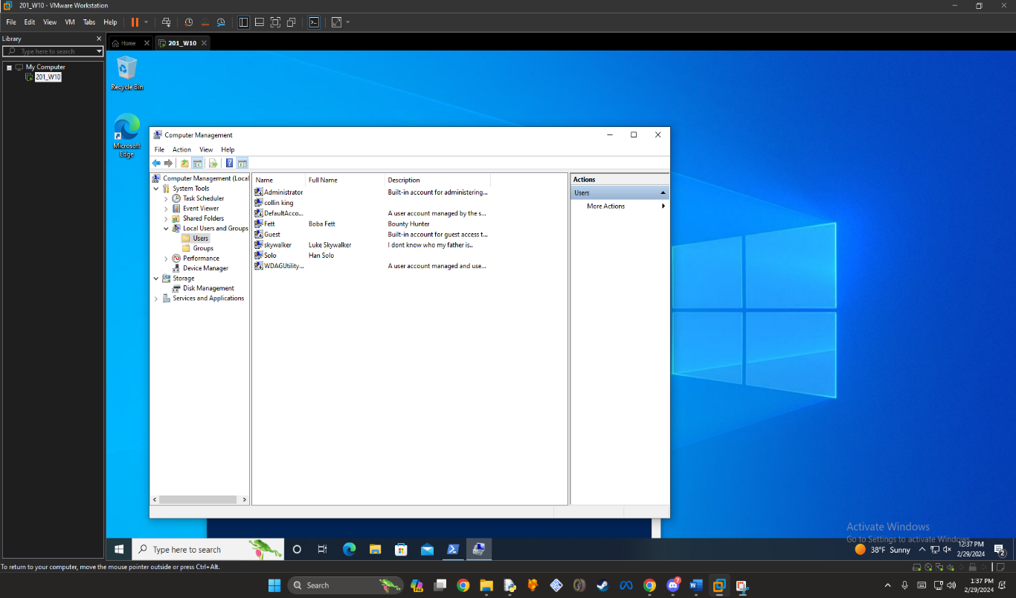

Changing Luke Skywalkers information

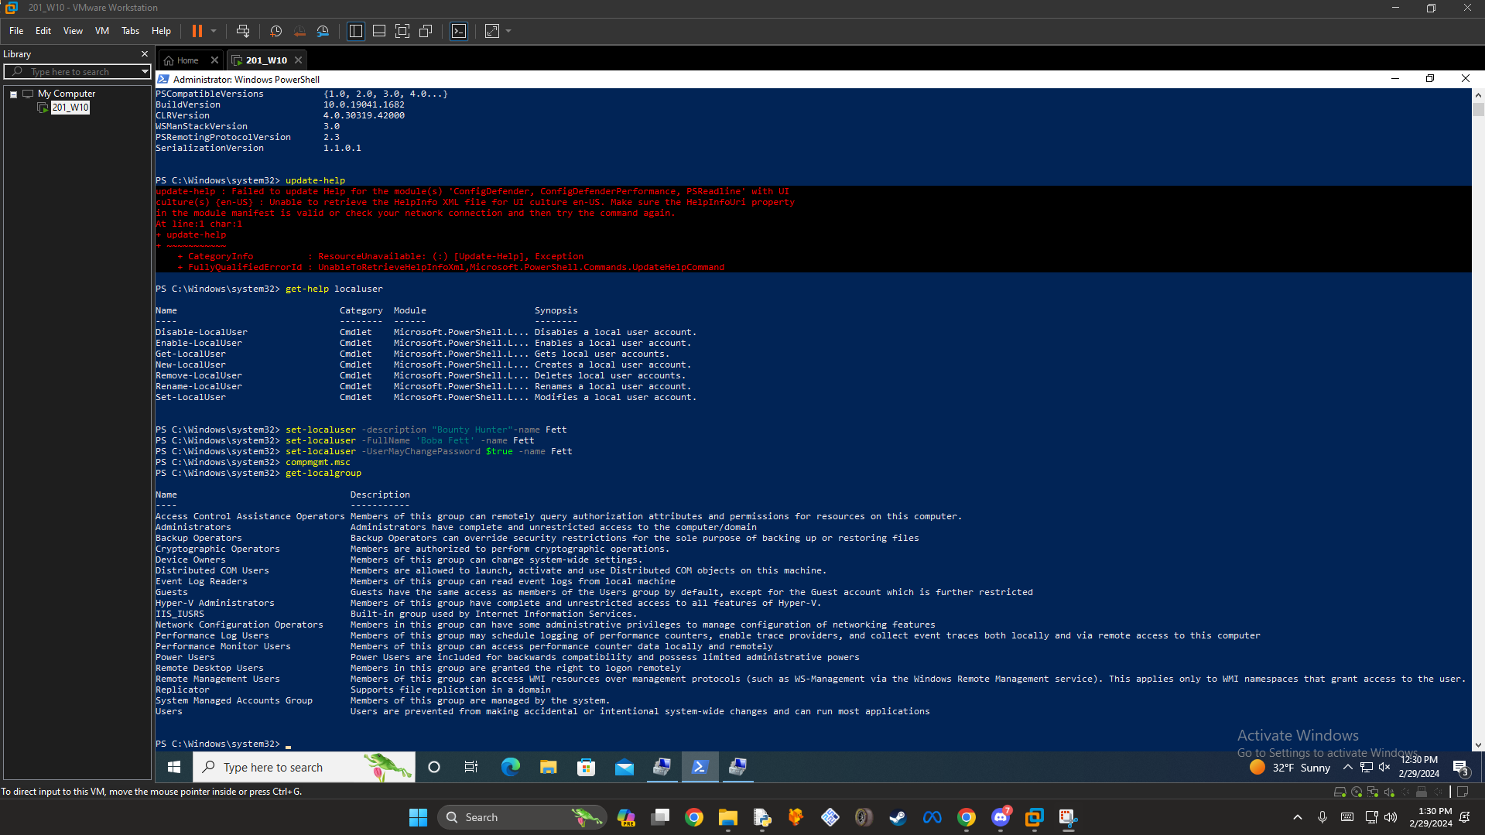
Using the get-localgroup command

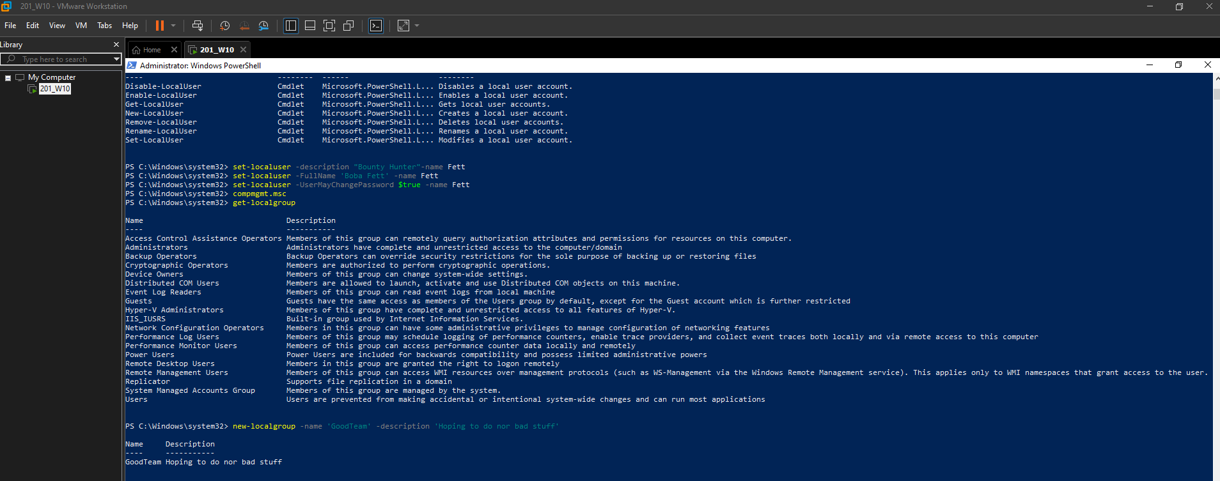

Creating a local group called ‘goodteam’
Typo’d ‘not’ in the description

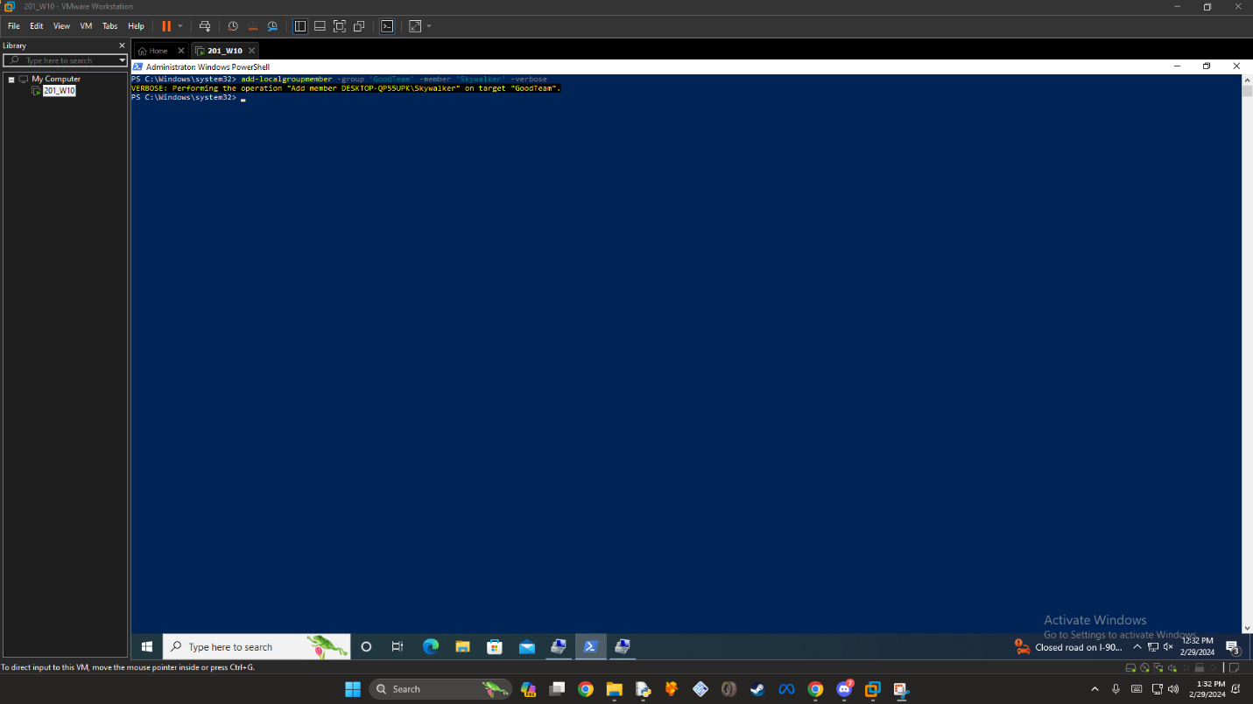
Adding skywalker to the goodteam

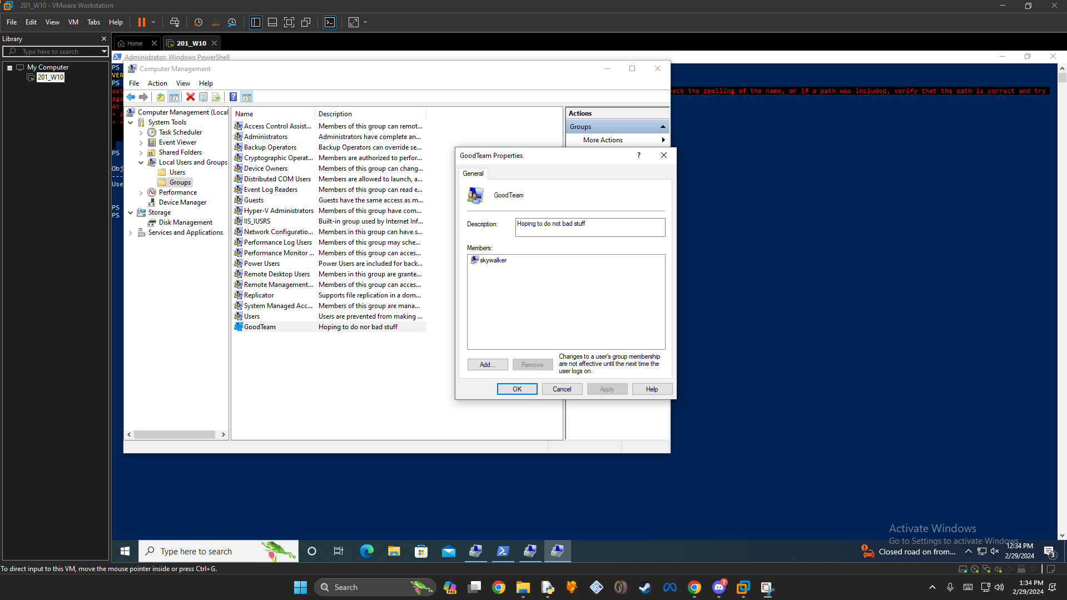

All members are displaying, also fixed the typo in the description

