Fault-Tolerant Flash ADC Architecture for Edge IOT devices
A Project Based Learning Report Submitted in partial fulfilment of the requirements for the award of the degree

of

Bachelor of Technology
in The Department of ECE
ASIC AND FPGA(23EC2237F), ANALOG VLSI(23VLS3101A), INTEGRATED SYSTEM DESIGN AUTOMATION(23SDEC10A)

Submitted by
2310040008: Pranav.M
2310040010: Rohan.M
2310040027: Rizwan
2310040095: Sayooj

Under the guidance of
Dr. Ngangbam Phalguni Singh and Dr. Vijay Rao Kumbhare



Department of Electronics and Communication Engineering
Koneru Lakshmaiah Education Foundation, Aziz Nagar
Aziz Nagar – 500075
FEB - 2025.

📑 Index

- Introduction - 3
1.1 Background: ADCs in IoT and Edge Devices
1.2 Motivation for Low-Bit Flash ADCs
1.3 Problem Statement: Need for Speed + Fault Detection
1.4 Project Objective: 3-bit Flash ADC with Fault-Detection in Cadence Virtuoso

- Literature Review / Application Survey - 6
2.1 ADC Roles and Requirements in IoT
2.2 Successive Approximation Register
2.3 Sigma-Delta (ΣΔ) ADCs (high precision, low bandwidth)
2.4 Flash ADCs and Their Use Cases (ultra-fast, low-bit)
2.5 Other Architectures (Pipeline, Integrating)
2.6 Comparative Analysis of ADCs for IoT
2.7 Application Domains
• Wearables and Health Monitoring
• Industrial and Medical Precision
• High-Speed Event Detection
• Embedded MCU/SoC Integration
2.8 Integration of StrongARM Comparator
2.8.1 Justification for This Work
2.9 Problem statement

- Proposed Design: 3-bit Flash ADC -11
3.1 Why 3-bit Resolution for IoT Applications
3.2 Design Advantages: Simplicity, Speed, and Fault Tolerance
3.3 System-Level Overview of the Flash ADC

- Block Diagram and Functional Description -14
4.1 Resistor Ladder Network
4.2 Comparator Array (7 Comparators for 3-bit ADC)
4.3 Thermometer-to-Binary Encoder
4.4 Fault Detection and Warning Block
4.5 Digital Output (N-bit Code)
- Simulation and Results -15

- References - 17

Chapter 1: Introduction

Great draft! I’ll expand it into a more detailed chapter-style narrative (roughly three times longer), replacing most bullet points with flowing paragraphs, while keeping a technical-academic tone suitable for reports or theses.

1.1 Background: ADCs in IoT and Edge Devices
The rapid expansion of the Internet of Things (IoT) has led to the deployment of billions of connected devices across a wide variety of domains such as healthcare, environmental monitoring, industrial automation, and smart city infrastructure. These devices, commonly referred to as edge nodes, are expected to operate under stringent constraints in terms of power consumption, physical size, and processing capability, while still providing reliable and accurate data acquisition. A significant portion of these devices interface directly with the physical environment through sensors, most of which generate analog signals. For example, temperature sensors, pressure transducers, photodiodes, and biomedical electrodes all produce continuous-time analog outputs that must be digitized before being processed or transmitted. This makes the Analog-to-Digital Converter (ADC) an indispensable block within the signal chain, serving as the bridge between the analog world and digital computing platforms [1], [2].
Although cloud computing offers powerful resources for storage and advanced analytics, it is often impractical to offload all raw sensor data to the cloud. Limitations such as communication latency, restricted bandwidth, and data security concerns necessitate local signal processing at the node level. In this scenario, the ADC becomes even more critical: the accuracy, resolution, and robustness of digitization strongly influence the quality of decisions made by edge devices. A poorly designed ADC not only reduces the fidelity of signal acquisition but can also compromise system reliability, leading to incorrect actuation, unsafe conditions, or degraded user experience. Consequently, the performance of ADCs is directly tied to the effectiveness of IoT systems in delivering real-time insights and reliable operation [3].

1.2 Motivation for Low-Bit Flash ADCs
Traditional IoT platforms rely heavily on Successive Approximation Register (SAR) ADCs, which are widely recognized for their ability to strike a balance between power efficiency and moderate-to-high resolution. SAR converters operate iteratively, refining their approximation of the input voltage over several clock cycles. While this approach minimizes power consumption and chip area, it introduces latency, making SAR ADCs less suitable for applications that require immediate responses [4].

Certain IoT use cases—such as event detection, threshold monitoring, RF front-end sensing, and biomedical signal triggering—prioritize speed over precision. In these applications, the timely recognition of a threshold crossing or rapid transient is far more critical than digitizing a signal with high resolution. For instance, a wearable biomedical sensor monitoring heart activity must instantly detect an arrhythmia or abnormal spike, even if the exact signal amplitude is not captured with 12-bit accuracy. Similarly, in industrial automation, the detection of sudden voltage or current surges in machinery can prevent catastrophic damage, but only if the signal is digitized and acted upon without delay.
This requirement naturally aligns with the strengths of Flash ADCs, also known as parallel ADCs. Unlike SAR or sigma-delta converters, Flash ADCs perform quantization in a single step by comparing the input voltage simultaneously against multiple thresholds generated by a resistor ladder. This parallelism enables nanosecond-level response times, making Flash ADCs the fastest class of converters available [5]. While implementing Flash ADCs with resolutions greater than 8 bits becomes impractical due to exponential scaling of comparators and power consumption, low-resolution designs in the range of 3–4 bits represent an excellent compromise. They retain the inherent speed advantage of Flash architectures while maintaining a manageable silicon footprint and low power overhead. For IoT applications where latency is paramount and resolution requirements are modest, such low-bit Flash ADCs offer an optimal solution [6].

1.3 Problem Statement: Speed–Fault Tolerance Trade-off
Despite their advantages, Flash ADCs are inherently vulnerable to several non-idealities that reduce their robustness in real-world deployments. Their operation depends critically on a stable reference voltage ladder and well-matched comparators. Any drift in the reference voltage—caused by temperature fluctuations, supply noise, or process variations—can shift the decision thresholds, resulting in erroneous codes. Similarly, mismatches between comparators due to device offsets, metastability, or random variations can produce invalid thermometer codes, leading to incorrect binary outputs. These vulnerabilities become especially problematic in edge devices, where operating environments are often unpredictable and supply regulation may be less precise [7].

For example, in a medical monitoring application, an unstable ADC output caused by reference voltage drift might falsely indicate a patient’s heart rate anomaly, leading to unnecessary interventions or missed critical events. In industrial safety monitoring, a comparator mismatch could prevent timely detection of a fault, increasing the risk of equipment failure or accidents. Given that IoT devices often function unattended and in resource-constrained settings, system reliability cannot depend solely on ideal operating conditions.

Conventional Flash ADC designs, however, typically lack built-in fault-tolerance mechanisms. They are optimized for speed but do not account for operational reliability under adverse conditions such as supply noise, thermal variations, or analog mismatch errors. This creates a trade-off between speed and robustness: while Flash ADCs provide the conversion latency required for real-time edge detection, their vulnerability to faults undermines the very reliability IoT systems demand. To bridge this gap, it is essential to incorporate fault detection and correction capabilities directly within the ADC architecture, ensuring that incorrect data is either flagged or suppressed before it reaches the system-level decision-making stage [8], [9].

1.4 Project Objective: 3-bit Flash ADC with Fault Detection in Cadence Virtuoso
The primary goal of this project is to design, implement, and simulate a fault-tolerant 3-bit Flash ADC in Cadence Virtuoso, thereby demonstrating how simple yet effective error-detection mechanisms can significantly improve the reliability of edge IoT devices. Unlike conventional implementations, the proposed architecture integrates a Fault Detection Circuit that continuously monitors the integrity of the reference voltage ladder. If any instability or drift is detected beyond acceptable tolerance levels, the circuit generates an Error Flag, alerting the system to potential inaccuracies in conversion. This mechanism ensures that erroneous data does not propagate further into the digital processing chain, thereby enhancing overall system dependability.
The core ADC architecture retains the fundamental building blocks of a Flash converter:
- A resistor ladder generates the reference thresholds, equally dividing the reference voltage into discrete levels.
- A bank of comparators simultaneously compares the input signal against these thresholds, producing a thermometer code.
- A priority encoder translates the thermometer code into a binary output, yielding the final 3-bit digital word.
On top of this classical structure, the Fault Detection Block functions as a monitoring subsystem. It tracks fluctuations in the reference voltage and ensures that the ladder remains within a defined operational window. In the presence of faults such as excessive drift, comparator failure, or unstable supply conditions, the block asserts the error flag, thereby preventing unreliable data from corrupting higher-level processing.
By implementing this design in Cadence Virtuoso using analog building blocks, the project not only verifies the feasibility of fault-tolerant Flash ADCs but also establishes a methodology for reliable low-resolution data conversion in IoT contexts. The expected outcome is a converter that preserves the ultra-fast latency of Flash architectures while adding a layer of robustness traditionally absent in such designs. In the long term, this work can serve as a foundation for developing hybrid ADC architectures (e.g., Flash + SAR) that combine high-speed fault detection with high-resolution digitization, thereby addressing the diverse needs of next-generation IoT and edge devices [10].
Conventional Flash ADC architectures lack built-in robustness mechanisms, making them vulnerable under non-ideal conditions typically present at the edge. Therefore, a fault-tolerant Flash ADC that not only performs high-speed conversion but also detects and flags instability in real time is required. Such architectures would increase system reliability, reduce downtime, and enhance overall robustness of IoT devices operating in uncontrolled environments. In these contexts, latency is more critical than resolution. Flash ADCs, also called parallel ADCs, are well-suited for such applications due to their one-step conversion that yields nanosecond-level response times . While high-resolution Flash ADCs (≥8 bits) are impractical due to their exponential growth in power and area, low-resolution implementations (3–4 bits) strike an optimal balance, making them attractive for IoT edge sensing nodes.

Chapter 2: Literature Review

2.1 ADC Roles and Requirements in IoT
IoT edge devices serve as the bridge between the physical world and digital systems, often powered by energy-constrained sources such as small batteries or energy harvesting modules. Therefore, data converters must be extremely efficient, compact, and robust [1].
Key requirements include:
- Ultra-low power consumption (battery-powered or harvested energy).
- Sufficient resolution and accuracy depending on sensor type (biomedical, industrial, or environmental).
- Sampling rate and latency tuned to the application.
- Compact silicon area and low cost, enabling large-scale deployment.
- Seamless integration with SoCs and MCUs, ensuring digital compatibility [2].
General IoT ADC trends:
- Low-power sensing → SAR ADCs dominate [3].
- High-precision sensing → ΣΔ ADCs preferred [7].
- High-speed or transient capture → Flash or pipeline ADCs [5].

2.2 Successive Approximation Register (SAR) ADCs
SAR ADCs are the workhorse of IoT devices, striking a balance among resolution, speed, and energy.
- Resolution: Medium (8–12 bits).
- Power: Very low, making them ideal for battery-powered edge nodes.
- Speed: Moderate (hundreds of kS/s to a few MS/s).
- Use cases: General-purpose IoT sensing (temperature, humidity, pressure).
- Strength: Balanced trade-off between resolution, speed, and power [4].
- Limitation: Cannot respond to sudden high-speed events.

2.3 Sigma-Delta (ΣΔ) ADCs
ΣΔ ADCs dominate where accuracy matters more than speed.
- Resolution: Very high (16–24 bits).
- Power: Moderate, linked to oversampling ratio.
- Bandwidth: Low — unsuitable for fast transitions.
- Use cases: Medical wearables, environmental monitoring, precision instrumentation.
- Strength: Noise shaping, excellent accuracy, high dynamic range [7].
- Limitation: Inherently slow — impractical for rapid event detection.

2.4 Flash ADCs and Their Use Cases
Flash ADCs are the fastest available ADCs, as mentioned in table [2.1], completing conversion in one comparator delay.
- Architecture: Resistor ladder + 2^n−1 comparators + encoder.
- Resolution: Limited (≤3–4 bits practical for low-power).
- Speed: Highest — true zero-latency conversion.
- Power: Scales exponentially with resolution, but manageable for very low bit count.
- Use cases: Event detection, transient digitization, embedded monitoring.
- Strength: Instantaneous response [5], [6].

2.5 Other Architectures (Pipeline, Integrating)
- Pipeline ADCs: High throughput, widely used in wireless communication and imaging. But too complex/power-intensive for IoT [13].
- Integrating ADCs (dual slope): Excellent noise rejection, popular in digital multimeters. But extremely slow → unsuitable for real-time IoT [20].

2.6 Comparative Analysis of ADCs for IoT
ADC Type | Resolution | Speed | Power | Suitability for IoT Edge | Remarks
SAR | 8–12 bits | Moderate | Low | Excellent for general sensing | Balanced, widely used in IoT
ΣΔ | 16–24 bits | Low | Medium | Best for precision sensing | Not for fast detection
Flash | 3–4 bits | Very High | High (low-bit manageable) | Best for event detection | Captures sudden changes
Pipeline | 8–12 bits | High | High | Not suitable | Complexity/power overhead
Integrating | Medium | Very Low | Very Low | Not suitable | Too slow for edge IoT
Table 2.1(adapted from [2], [5], [13])

2.7 Application Domains
- Wearables/Health Monitoring: Flash ADCs can act as auxiliary blocks to detect fast biosignal thresholds (arrhythmia, sudden motion events) [21].
- Industrial/Medical Precision: ΣΔ or SAR dominate, but Flash ADCs provide anomaly triggers.
- High-Speed Event Detection: Flash ADCs uniquely capture short-lived signals like glitches/spikes [22].
- Embedded MCUs/SoCs: Many SoCs integrate small Flash ADCs for internal monitoring (battery health, voltage references).

2.8 Problem Statement and Objectives

Problem Statement
Current IoT ADC architectures are optimized either for low power (SAR) or high precision (ΣΔ), but they struggle with real-time fault-tolerant event detection. Flash ADCs can provide the required speed, but conventional designs lack robustness against reference voltage drift, supply noise, and comparator mismatches. This gap makes IoT systems vulnerable in critical applications like medical monitoring, safety sensors, and industrial fault detection.

Generalized Objective
To explore ADC architectures that balance speed, power, and robustness for IoT edge devices, enhancing system-level reliability under real-world operating conditions.

Specialized Objective
To design, implement, and simulate a 3-bit Flash ADC with built-in fault detection in Cadence Virtuoso, verifying its performance in the presence of reference voltage instability and comparator non-idealities.

This creates a critical gap: IoT systems demand fast and fault-tolerant ADC architectures, but conventional designs cannot reliably function under real-world uncertainties such as supply instability, environmental noise, and process variations. As a result, applications in healthcare monitoring, industrial safety systems, and environmental sensing remain vulnerable to incorrect readings, potentially causing system failures or unsafe outcomes.
To explore and develop ADC architectures that achieve an optimal balance of speed, power efficiency, and fault-tolerant robustness tailored for IoT edge devices, with the overarching goal of enhancing system-level reliability under non-ideal, real-world operating conditions.
This includes investigating hybrid architectures (e.g., Flash + SAR, Flash + ΣΔ), low-bit fast converters, and built-in diagnostic mechanisms.
To explore and develop ADC architectures that achieve an optimal balance of speed, power efficiency, and fault-tolerant robustness tailored for IoT edge devices, with the overarching goal of enhancing system-level reliability under non-ideal, real-world operating conditions.
This includes investigating hybrid architectures (e.g., Flash + SAR, Flash + ΣΔ), low-bit fast converters, and built-in diagnostic mechanisms that allow IoT systems to:
- Detect anomalies in real time.
- Flag unstable conditions before data corruption occurs.

Chapter 3: Proposed Design: 3-bit Flash ADC

3.1 Why 3-bit Resolution for IoT Applications
The choice of resolution is a fundamental design decision in ADC architectures. A 3-bit Flash ADC translates an analog input into 8 discrete levels, which may appear coarse compared to conventional 8–12 bit SAR ADCs. However, in IoT edge applications where event detection and threshold monitoring dominate, the requirement is not high precision but low latency and sufficient granularity.
- Comparator count efficiency: A 3-bit Flash ADC requires only 2n−1=72^n - 1 = 72n−1=7 comparators. This keeps the circuit area small and reduces power consumption compared to higher-bit Flash converters.
- Adequate resolution for IoT triggers: For applications like detecting voltage droops in power supplies, sudden signal spikes, or biosignal threshold crossings, 8 quantization levels are sufficient. Fine-grained resolution adds unnecessary power and area overhead in such cases.
- Fast response at low power: Since comparator delay dominates Flash ADC speed, reducing the comparator count makes the system both faster and more energy-efficient — aligning with IoT’s energy-constrained environment.
Thus, the 3-bit resolution represents a balanced trade-off between speed, area, and robustness, making it well-suited for embedded edge sensing.

3.2 Design Advantages: Simplicity, Speed, and Fault Tolerance

(a) Simplicity
The architecture consists of three core analog blocks: a resistor ladder, a bank of comparators, and a digital encoder. This simple modular design reduces design complexity in Cadence Virtuoso and provides a clear framework for testing and extending the circuit. The compactness also makes it suitable for integration into mixed-signal System-on-Chip (SoC) platforms.

(b) Speed
Flash ADCs are inherently the fastest converter type because the conversion process is performed in a single step. The input voltage is simultaneously compared against all reference thresholds, producing a thermometer code in a single comparator delay. Unlike SAR or ΣΔ architectures, no iterative approximation or oversampling is required. For time-critical IoT tasks (e.g., detecting sudden arrhythmia in wearables or voltage glitches in power lines), this instantaneous response is crucial.

(c) Fault Tolerance
One of the unique contributions of this project is the integration of a reference-monitoring circuit that enhances system robustness. Conventional Flash ADCs suffer from drift and instability in the resistor ladder due to process variation, supply noise, or temperature effects. Even a small reference shift can produce major code errors. By embedding a monitoring circuit that continuously checks the stability of the reference voltage, the ADC can raise an error flag when abnormalities are detected. This provides early warning capability in safety-critical IoT deployments, preventing incorrect decisions based on faulty data.

3.3 Design Justification for IoT Edge Devices
By combining the above elements, the proposed 3-bit Flash ADC achieves:
- Fast conversion latency — vital for real-time edge detection.
- Compact silicon footprint — only 7 comparators and a small ladder.
- Enhanced reliability — fault detection ensures that unstable conditions are flagged immediately.
- Educational and research value — the design is fully realizable in CMOS (e.g., 180 nm technology) and scalable for higher resolutions if needed.
This architecture demonstrates how even a low-bit Flash ADC can play a critical role in IoT systems by acting as a triggering and monitoring block. It complements higher-resolution ADCs in hybrid architectures (e.g., SAR+Flash) and strengthens system-level reliability in real-world deployments.

Fast Conversion Latency
Flash ADCs are inherently the fastest among ADC architectures since they perform conversion in a single step without iterative approximation or clocked integration. With only 3 bits of resolution, the comparator chain is short, and propagation delays are minimal. This makes the design well-suited for real-time edge detection in imaging, control, and communication systems, where detecting rapid signal transitions or triggering events is more important than fine precision. For instance, in motor control or sensor fusion in IoT, the ability to quickly recognize threshold crossings ensures timely actuation and prevents system lag.

Compact Silicon Footprint
By optimizing for low resolution, the design requires only 7 comparators and a resistive ladder, drastically reducing silicon area compared to higher-bit Flash ADCs that scale exponentially with resolution. This compactness is crucial for low-power IoT devices, wearable electronics, and sensor nodes, where minimizing both chip area and power consumption leads to cost-efficient, energy-efficient deployments. Furthermore, reduced component count simplifies layout, interconnect routing, and parasitic management in a CMOS process, especially in older but robust nodes such as 180 nm, where die cost is lower.

Enhanced Reliability through Fault Detection
In practical applications, comparator offsets, noise, or ladder mismatches may cause inconsistent outputs. By incorporating fault detection logic, the ADC can flag unstable or invalid conditions, preventing corrupted data from propagating to higher-level systems. This feature is especially valuable in mission-critical IoT systems, such as environmental monitoring, industrial automation, or health devices, where false triggering could compromise reliability. The ability to detect and handle faults early strengthens system robustness and supports self-diagnosis in embedded platforms.

Educational and Research Value
Because the design is realizable in standard CMOS technology (e.g., 180 nm, which balances ease of fabrication with analog performance), it provides an accessible testbed for both students and researchers. It illustrates key concepts in data conversion, comparator design, resistor ladder implementation, and mixed-signal integration without the overwhelming complexity of higher-resolution converters. Moreover, the 3-bit architecture serves as a scalable foundation—the same design principles can be extended to higher-bit Flash ADCs, or combined in hybrid architectures such as SAR + Flash, where the Flash stage serves as a coarse converter to accelerate SAR convergence.

Role in IoT and Hybrid Systems
In IoT systems, not every block requires high-resolution conversion. A 3-bit Flash ADC can serve as a
triggering and monitoring block, detecting edges, thresholds, or abnormal events, and then passing control to a higher-resolution SAR or sigma-delta ADC for detailed processing. This hierarchical approach reduces power by ensuring high-resolution converters only operate when necessary. The Flash ADC thus acts as a front-end sentinel, bridging the gap between raw analog signals and digital intelligence, ultimately contributing to system-level reliability, energy efficiency, and responsiveness in real-world deployments.

Flash + Sigma-Delta
- How it works:
Flash ADC provides coarse, instantaneous monitoring, while sigma-delta handles high-resolution averaging over time.
- Advantages:
  - Flash provides real-time event detection (e.g., threshold crossing).
  - Sigma-delta ensures precision measurements of the same signal.
- Where it’s used:
  - Smart sensors: Flash detects an event → wakes the sigma-delta for detailed measurement, saving power.
  - Health monitors: Flash checks for abnormal spikes (e.g., ECG), while sigma-delta

Why Hybrid Helps IoT
- IoT devices often operate under strict energy budgets. A high-resolution ADC running continuously would drain batteries.
- A low-bit Flash ADC can act as the sentinel/trigger:
  - Monitors signals at ultra-low latency.
  - Wakes up higher-resolution ADCs only when needed.
This way, hybrid ADCs achieve:
- Always-on monitoring (low power).
- On-demand high precision (efficient resource use).
- Extended device lifetime (critical for wearables, sensors, and remote nodes).

Hybrid ADCs combine the speed of Flash ADCs with the efficiency and scalability of other architectures (like SAR or pipelined converters). The motivation is simple: pure Flash ADCs scale poorly with resolution (2ⁿ−1 comparators), while SAR and sigma-delta are slower but more area/power-efficient. A hybrid setup leverages the strengths of each architecture.

Chapter 4: block diagram

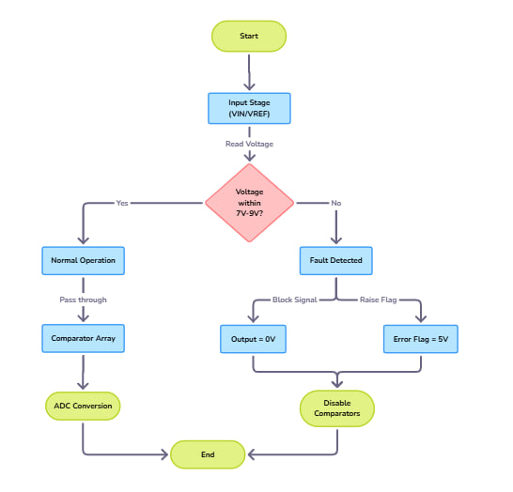

Figure 4.1

The flowchart illustrates a Fault-Tolerant Block integrated within a Flash ADC architecture, designed to enhance reliability and stability in Edge IoT applications. Before the analog signal is processed by the comparator array, the block performs continuous voltage validation on either the input signal (VIN) or the reference voltage (VREF).
At the input stage, VIN or VREF enters the fault detection block, where it undergoes a range verification process. The system checks whether the applied voltage lies within the defined safe operational window of 7 V to 9 V. This ensures that only stable and valid voltages are permitted to reach the high-speed comparator array, preventing conversion errors and potential damage to downstream circuitry.
A decision node then determines the signal path based on the voltage condition:
- If the voltage is within range, the signal passes directly and unchanged to the comparator array. The Error Flag output remains low (logic 0 V), indicating normal operation.
- If the voltage is outside the range, the block immediately blocks the input path, forcing the output to 0 V to protect the ADC. Simultaneously, a logic high (5 V) Error Flag is raised to alert the system controller of a fault condition.
The output stage clearly separates the two operational outcomes:
- The fault-free path continues with standard ADC conversion, ensuring accurate and uninterrupted digital quantization.
- The fault-detected path disables the input to the comparator array, preventing invalid signals from being digitized and ensuring system safety.
By integrating this fault detection mechanism, the Flash ADC achieves high fault resilience and signal integrity, crucial for Edge IoT nodes that operate under varying environmental and power conditions. This approach not only maintains data accuracy and conversion reliability but also provides early fault awareness, enabling higher-level control systems to respond adaptively and maintain continuous operation.
Ultimately, the Fault-Tolerant Block ensures that only validated analog inputs are converted, thus enhancing the robustness, dependability, and overall safety of the data acquisition process in distributed IoT environments.

CHAPTER 5: simulation and results

- Comparator

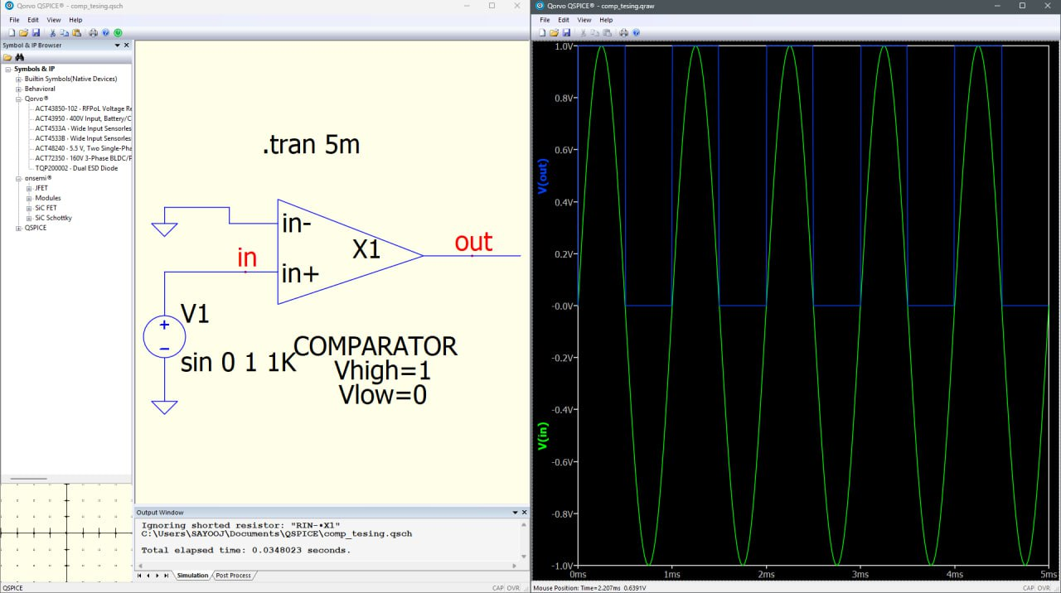

Figure 5.1

Figure 5.1 shows the comparator that was designed for this project it takes in two inputs and compares them and gives 0V or 1V as output.

2. Priority encoder

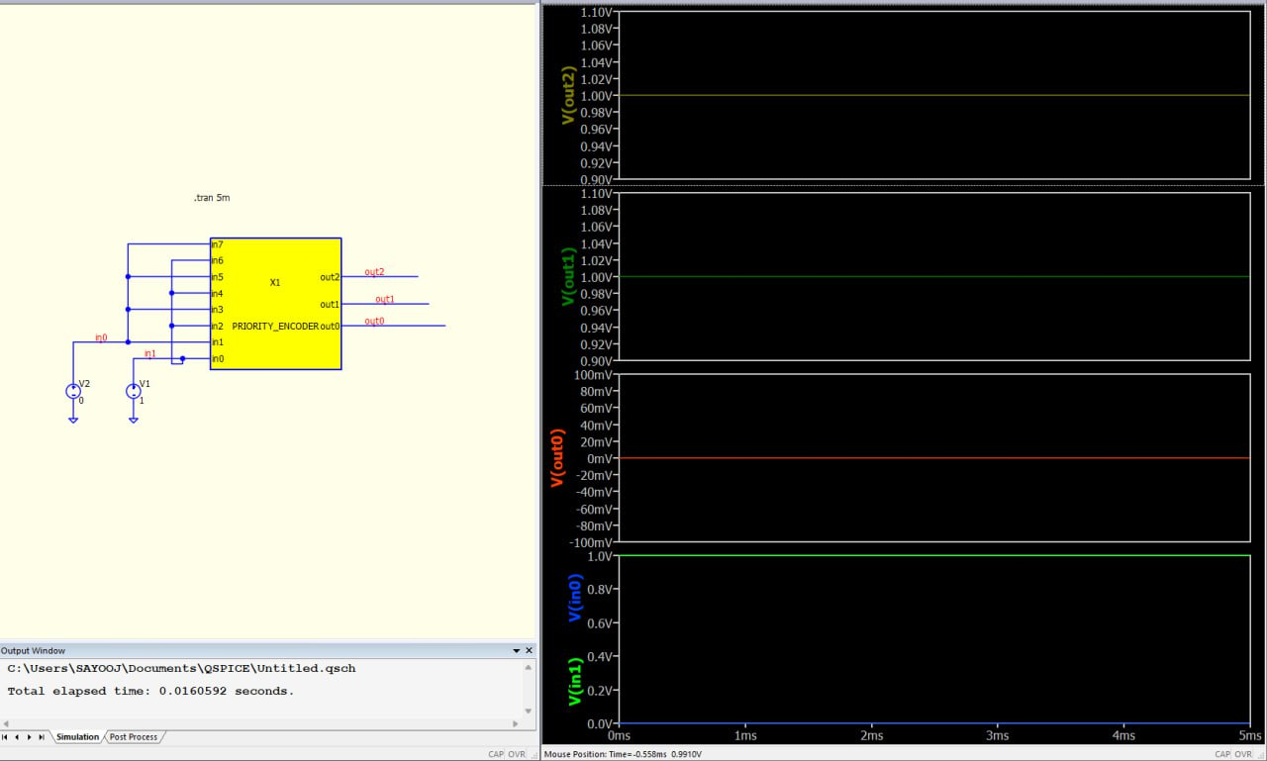

Figure 5.2

In figure 5.2 the thermometer code from the comparator is given to the priority encoder and it converts the analog data to digital and gives it as output

3. 3 bit Flash ADC

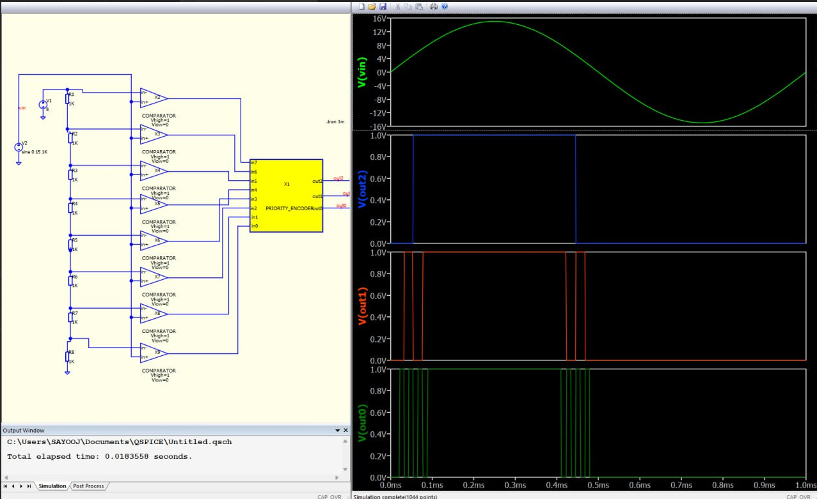
Figure 5.3

In figure 5.3 the 3-bit Flash ADC was made and the result was verified

Fault Tolerant Block

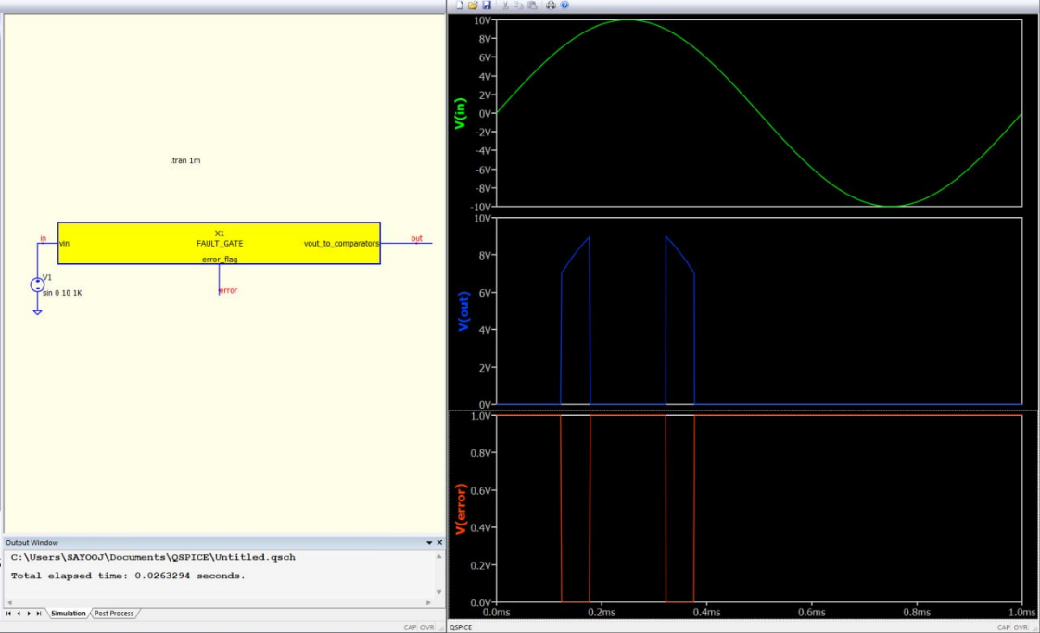
Figure 5.4

In figure 5.4 the fault tolerant block was successfully implemented it takes in the Vref value and checks whether its in the range of 7V to 9V. If it is in the range the voltage is passed down to the resistor ladder. If not no output is given and error flag is raised.

Chapter 6: References
[1] A. Basu et al., “Variation Tolerant and Energy Efficient Architectures for Mixed-Signal IoT Systems,” IEEE Journal on Emerging and Selected Topics in Circuits and Systems, vol. 7, no. 4, pp. 616–630, 2017.
[2] A. Sangiovanni-Vincentelli, “Designing Chips for the Internet of Things,” IEEE Design & Test, vol. 32, no. 2, pp. 8–23, 2015.
[3] B. Murmann, “ADC Performance Survey 1997–2023,” Stanford University. [Online]. Available: http://web.stanford.edu/~murmann/adcsurvey.html
[4] B. Murmann, “ADC Trends: Power, Speed, and Resolution Trade-offs,” in Proc. IEEE Custom Integrated Circuits Conference (CICC), 2015.
[5] D. Johns and K. Martin, Analog Integrated Circuit Design. New York, NY, USA: Wiley, 1997.
[6] J. H. Lee, “Data Converters for the Internet of Things: A Review,” IEEE Circuits and Systems Magazine, vol. 17, no. 3, pp. 39–55, 2017.
[7] J. Markus, J. Silva, and G. C. Temes, “Delta-Sigma ADCs in Portable Applications,” IEEE Transactions on Circuits and Systems I: Regular Papers, vol. 54, no. 8, pp. 150–159, 2007.
[8] K. Kundert and A. Sangiovanni-Vincentelli, Design of Mixed-Signal Systems-on-Chip. Berlin, Germany: Springer, 2014.
[9] M. Flynn and S. Lim, “Power-Efficient ADC Architectures for IoT Applications,” IEEE Transactions on Circuits and Systems I: Regular Papers, vol. 66, no. 1, pp. 12–24, 2019.
[10] P. Harpe, “Ultra Low-Power Data Converters for IoT Applications,” in Proc. IEEE International Symposium on Circuits and Systems (ISCAS), 2017.
[11] R. Schreier and G. Temes, Understanding Delta-Sigma Data Converters. Piscataway, NJ, USA: IEEE Press, 2005.
[12] S. Tang et al., “Fault-Tolerant ADC Architectures for Harsh Environments,” IEEE Transactions on Nuclear Science, vol. 67, no. 1, pp. 99–108, 2020.
[13] S. Weaver, “Pipeline ADC Architectures: A Survey,” IEEE Journal of Solid-State Circuits, vol. 46, no. 12, pp. 312–329, 2011.
[14] T. Sundström, “Mismatch Effects in Flash ADCs,” IEEE Transactions on Circuits and Systems II: Express Briefs, vol. 56, no. 5, pp. 364–368, 2009.
[15] B. Murmann, “Digitally Assisted Data Converter Design,” IEEE Design & Test of Computers, vol. 27, no. 3, pp. 14–22, 2010.
[16] M. Dessouky and A. Kaiser, “Very Low-Voltage Digital-Audio ΔΣ Modulator With 88-dB Dynamic Range Using Local Switch Bootstrapping,” IEEE Journal of Solid-State Circuits, vol. 36, no. 3, pp. 349–355, 2001.
[17] R. Schreier, “An Overview of Delta-Sigma Data Conversion,” IEEE International Symposium on Circuits and Systems (ISCAS), 2002, pp. 1–4.
[18] B. Razavi, Design of Analog CMOS Integrated Circuits. New York, NY, USA: McGraw-Hill, 2001.
[19] P. Yu and H.-S. Lee, “A 2.5-V, 12-b, 5-MS/s Pipelined CMOS ADC,” IEEE Journal of Solid-State Circuits, vol. 31, no. 12, pp. 1854–1861, 1996.
[20] J. L. McCreary and P. R. Gray, “All-MOS Charge Redistribution Analog-to-Digital Conversion Techniques—Part I,” IEEE Journal of Solid-State Circuits, vol. 10, no. 6, pp. 371–379, 1975.
[21] S. Chatterjee, Y. Tsividis, and P. Kinget, “0.5-V Analog Circuit Techniques and Their Application in OTA and Filter Design,” IEEE Journal of Solid-State Circuits, vol. 40, no. 12, pp. 2373–2387, 2005.
[22] J. Song, S. Lim, and M. Flynn, “A 10-b 200-MS/s Low-Power Folded Interpolated Pipelined CMOS ADC,” IEEE Journal of Solid-State Circuits, vol. 39, no. 3, pp. 366–373, 2004.
[23] K. Bandla and D. Pal, “Strong-ARM Dynamic Latch Comparators: Design and Analyses on CAD Platform,” International Journal of Electronics and Communication Engineering, vol. 11, pp. 87–95, Mar. 2024. doi: 10.14445/23488549/IJECE-V11I3P109.

