Project 2 - README – Brad Peterson

**Required Functionality**

This project uses a dataset of animals to create a database, implement basic CRUD operations for that database, and finally build out a dashboard to display it. This dashboard must display each animal’s data in a table, use preset filters to find dogs that fit various specified criteria, and display a graph of the results as well as show where that animal is located when selected. Additionally, you’ll notice that the results are limited to 10 per page and pagination is used to navigate the remaining dataset.

Criteria given for filters: 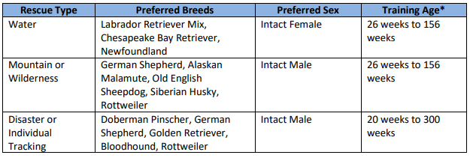

1. Query of all dogs in the database as default.

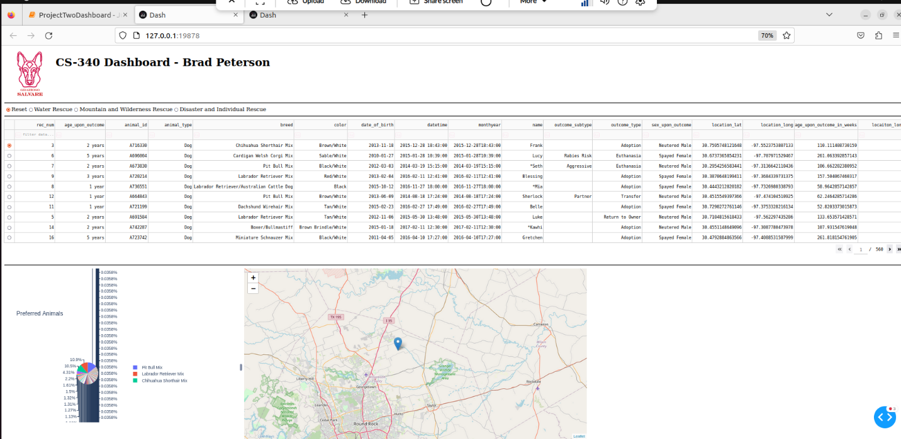

1. Query of dogs fit for Water Rescue.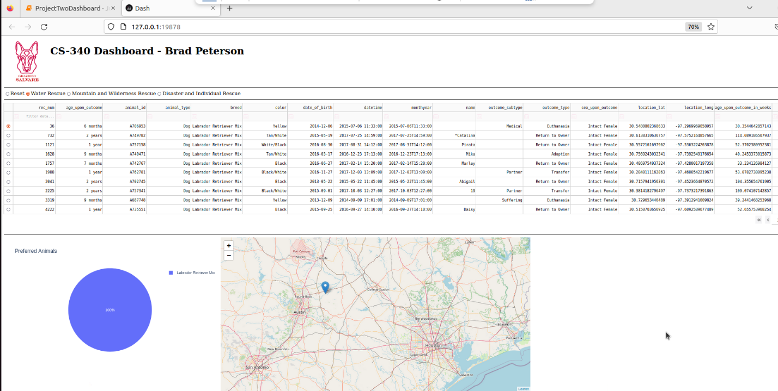
2. Query of dogs fit for Mountain/Wilderness Rescue.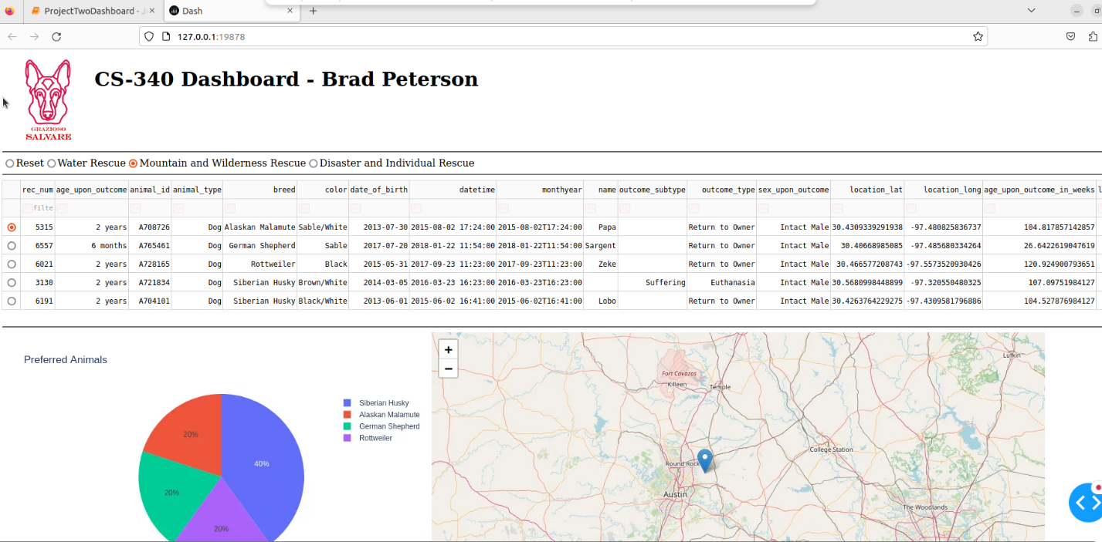
3. Query of dogs fit for Disaster/Individual Tracking.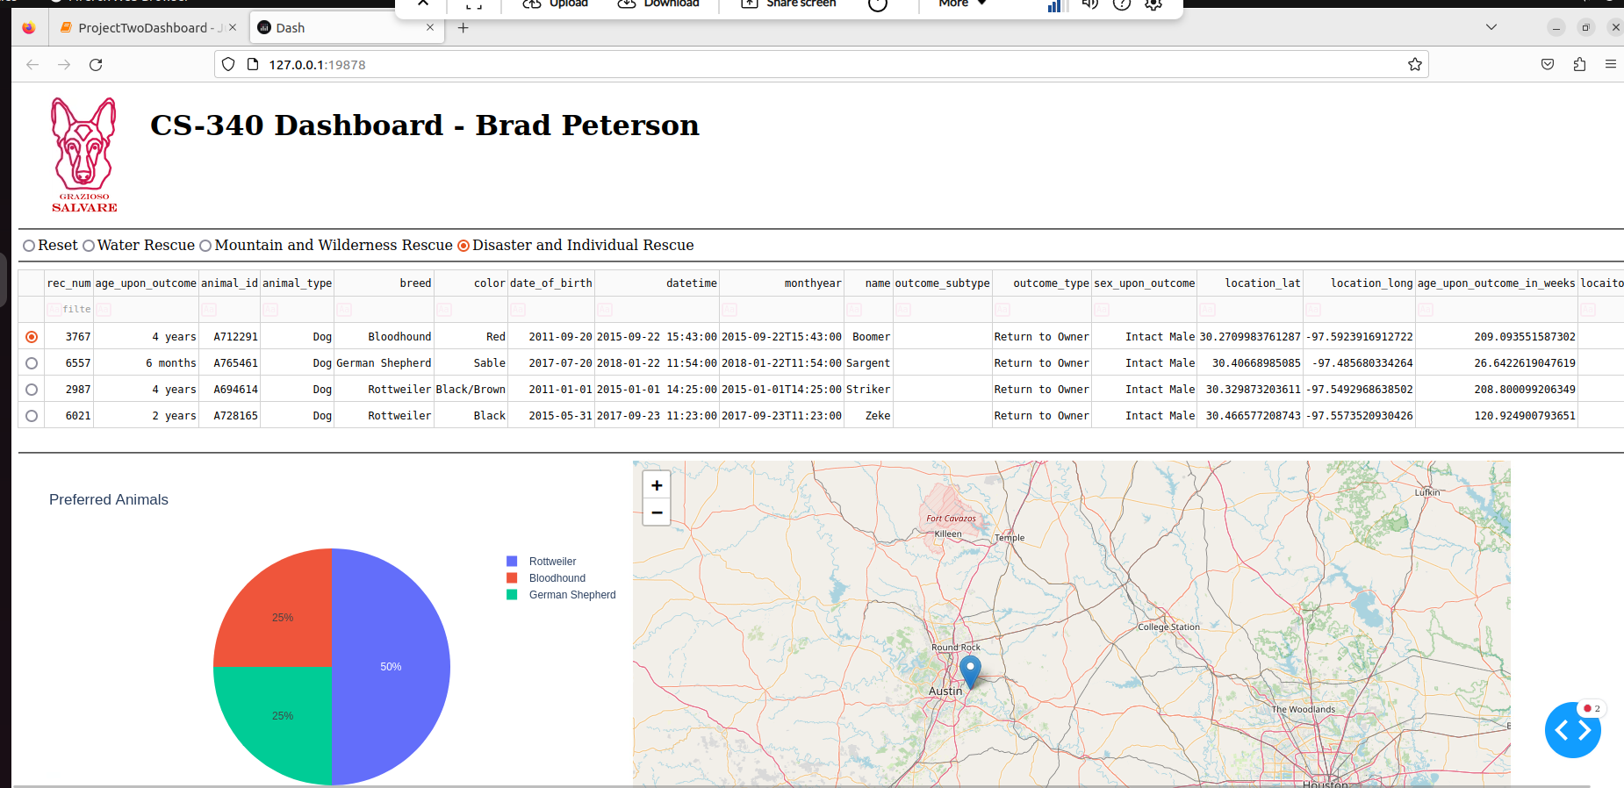

**Tools Used**

1. MongoDB – Used for the database itself and chosen for it’s ease of use with Python and document-based storage that was an ideal fit for this data set.
2. Dash – Used to create the dashboard with minimal front end programming knowledge required.
3. Plotly – Used to visualize the data in graphical form.
4. Pandas – Used to store data after being queried from the database to be used in other components.
5. Python – Used to create CRUD operations to add functionality to the database as well as producing the dashboard.

**Instructions to reproduce**

1. Import data set into “animals” database. A screenshot of a computer

   AI-generated content may be incorrect.
2. Set up user account with read/write accessA screenshot of a computer program

   AI-generated content may be incorrect.
3. Ensure ‘aacCrud.py’ is in the same folder as ‘ProjectTwoDashboard_BradPeterson.ipynb’ and Run ‘ProjectTwoDashboard_BradPeterson.ipynb’ file.
4. Click the localhost link that appears in the Python notebook.
5. Select either a radio button you’d like to filter to or select an individual dog to see their location.

**Challenges Faced**

I think the most difficulty I faced was understanding the different tools used in the creation of this project. I found that when I could just sit down and practice queries on the database I was well prepared for that aspect. I did find the documentation for Dash to be quite useful. I tried initially to make the “Reset” option a button and the other filters radio buttons but couldn’t quite find the right way to do this with Dash.

Additionally, I think it was challenging to wrap my head around what form the data was taking throughout and my last breakthrough came after using the print statements to view the dataframe to identify why I was struggling with IDs.

I also know that this data set wasn’t perfectly clean and my queries hardcoded the type of dog I was looking for but may have missed some. I had tried to find a way to perform a partial string search in the query. I think I would need a different endpoint to pull this off besides the simple read() function. I also read a little bit about Regex but didn’t get deep into this option.