“GMAT® questions are the property of the Graduate Management Admission Council® and are reprinted with their permission.”

GMAT Mini-Test Questions and Answers

Sentence Correction
INSTRUCTIONS
This question presents a sentence, part of which or all of which is underlined. Beneath the sentence you will find five ways of phrasing the underlined part. The first of these repeats the original; the other four are different. If you think the original is best, choose the first answer; otherwise choose one of the others.
This question tests correctness and effectiveness of expression. In choosing your answer, follow the requirements of standard written English; that is, pay attention to grammar, choice of words, and sentence construction. Choose the answer that produces the most effective sentence; this answer should be clear and exact, without awkwardness, ambiguity, redundancy, or grammatical error.
Sentence Correction Question 1
Carbon-14 dating reveals that the megalithic monuments in Brittany are nearly 2,000 years as old as any of their supposed Mediterranean predecessors.

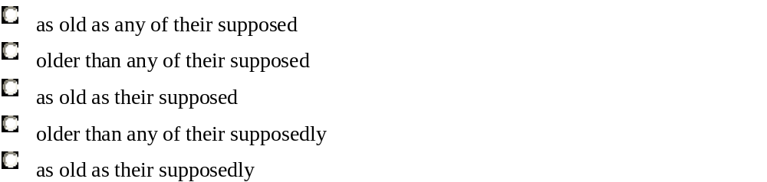

EXPLANATION

The first, third and last choice do not state the comparison logically. The expression as old as indicates equality of age, but the sentence indicates that the Brittany monuments predate the Mediterranean monuments by 2,000 years. In the second choice, the best answer, older than makes the point of comparison clear. This choice also correctly uses the adjective supposed, rather than the adverb supposedly used in the fourth and last choices, to modify the noun phrase Mediterranean predecessors.
Sentence Correction Question 2
Each of Hemingway's wives - Hadley Richardson, Pauline Pfeiffer, Martha Gelhorn, and Mary Welsh - were strong and interesting women, very different from the often pallid women who populate his novels.

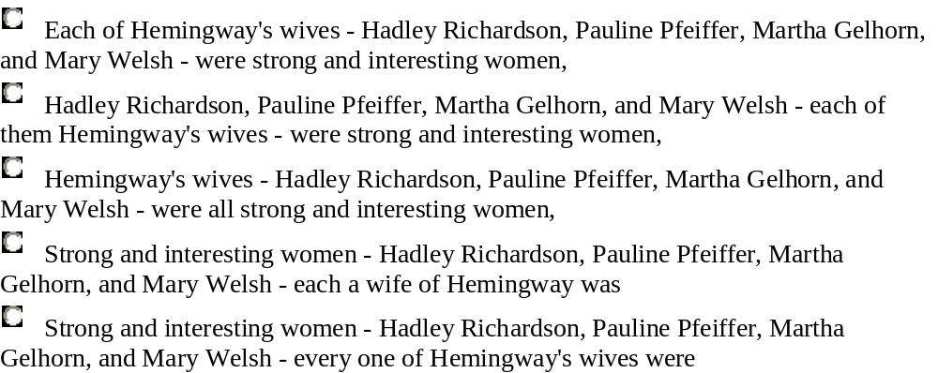

EXPLANATION

Each choice except the third contains errors of agreement. In both the first and last choice, the singular subject (each in the first choice, every one in the last choice) does not agree with the plural verb were, while in the fourth choice, the plural subject women is mismatched with the singular verb was.

In the second choice the subject and verb agree, but the descriptive phrase placed between them creates an illogical statement because each cannot be wives; each can be one of the wives, or a wife.

The pronoun constructions in the first, second, fourth and last choice are wordy; also, the second, fourth and last choices are very awkwardly structured and do not convey the point about Hemingway's wives clearly.

The third choice correctly links wives with were, eliminates the unnecessary pronouns, and provides a clearer structure.

Sentence Correction Question 3
The end of the eighteenth century saw the emergence of prize-stock breeding, with individual bulls and cows receiving awards, fetching unprecedented prices, and excited enormous interest whenever they were put on show.



EXPLANATION

The third choice is the best. The third verb phrase in the series describing bulls and cows should have the same grammatical form as the first two. Only the third choice has a present participle (or "-ing" form) that is parallel with the two preceding verbs, receiving and fetching.

Instead of the present participle, the first and second choices use the past tense (excited), the fourth choice uses an auxiliary verb (would excite), and the last choice uses the past perfect tense (had excited). Additionally, the incorrect verb tenses in the second and last choice are introduced by a pronoun, it, that lacks a logical noun referent.

Sentence Correction Question 4
While Jackie Robinson was a Brooklyn Dodger, his courage in the face of physical threats and verbal attacks was not unlike that of Rosa Parks, who refused to move to the back of a bus in Montgomery, Alabama.

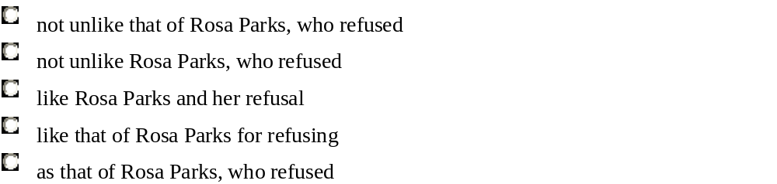

EXPLANATION

The second and third choice present faulty comparisons: in the second choice, Jackie Robinson's courage is compared to Rosa Parks herself, not to her courage, and in the third choice it is compared to both Rosa Parks and her refusal.
The fourth choice does not make it clear whether it was Jackie Robinson or Rosa Parks who showed courage in refusing to move to the back of the bus; in fact, saying for refusing rather than refused makes it sound as if courage moved to the back of the bus. The last choice incorrectly uses as rather than like to compare two noun phrases. The first choice is the best.

Sentence Correction Question 5
In astronomy the term "red shift" denotes the extent to which light from a distant galaxy has been shifted toward the red, or long-wave, end of the light spectrum by the rapid motion of the galaxy away from the Earth.

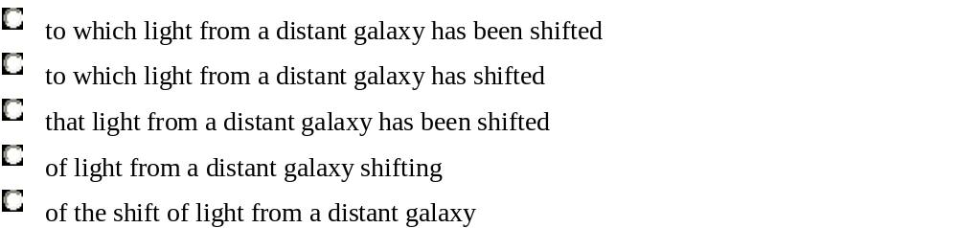

EXPLANATION

The first choice is best because it is idiomatic and because its passive verb construction, has been shifted, clearly indicates that the light has been acted upon by the rapid motion.
In the second choice, the active verb has shifted suggests that the light, not the motion, is the agency of action, but such a construction leaves the phrase by the rapid motion of the galaxy away from the Earth without any logical or grammatical function.
In the third choice, the construction the extent that light is ungrammatical; denotes the extent must be completed by to which. The fourth choice incorrectly employs an active verb, shifting, and extent of light is imprecise and awkward.
The last choice is faulty because it contains no verb to express the action performed by the rapid motion.
Reading Comprehension

INSTRUCTIONS

The questions in this group are based on the content of a passage. After reading the passage, choose the best answer to each question. Answer all questions following the passage on the basis of what is stated or implied in the passage.

Reading Comprehension Question 1
A meteor stream is composed of dust particles that have been ejected from a parent comet at a variety of velocities. These particles follow the same orbit as the parent comet, but due to their differing velocities they slowly gain on or fall behind the disintegrating comet until a shroud of dust surrounds the entire cometary orbit. Astronomers have hypothesized that a meteor stream should broaden with time as the dust particles' individual orbits are perturbed by planetary gravitational fields. A recent computer-modeling experiment tested this hypothesis by tracking the influence of planetary gravitation over a projected 5,000-year period on the positions of a group of hypothetical dust particles. In the model, the particles were randomly distributed throughout a computer simulation of the orbit of an actual meteor stream, the Geminid. The researcher found, as expected, that the computer-model stream broadened with time. Conventional theories, however predicted that the distribution of particles would be increasingly dense toward the center of a meteor stream. Surprisingly, the computer-model meteor stream gradually came to resemble a thick-walled, hollow pipe.
Whenever the Earth passes through a meteor stream, a meteor shower occurs. Moving at a little over 1,500,000 miles per day around its orbit, the Earth would take, on average, just over a day to cross the hollow, computer-model Geminid stream if the stream were 5,000 years old. Two brief periods of peak meteor activity during the shower would be observed, one as the Earth entered the thick-walled "pipe" and one as it exited. There is no reason why the Earth should always pass through the stream's exact center, so the time interval between the two bursts of activity would vary from one year to the next.
Has the predicted twin-peaked activity been observed for the actual yearly Geminid meteor shower? The Geminid data between 1970 and 1979 show just such a bifurcation, a secondary burst of meteor activity being clearly visible at an average of 19 hours (1,200,000 miles) after the first burst. The time intervals between the bursts suggest the actual Geminid stream is about 3,000 years old.
The primary focus of the passage is on which of the following?
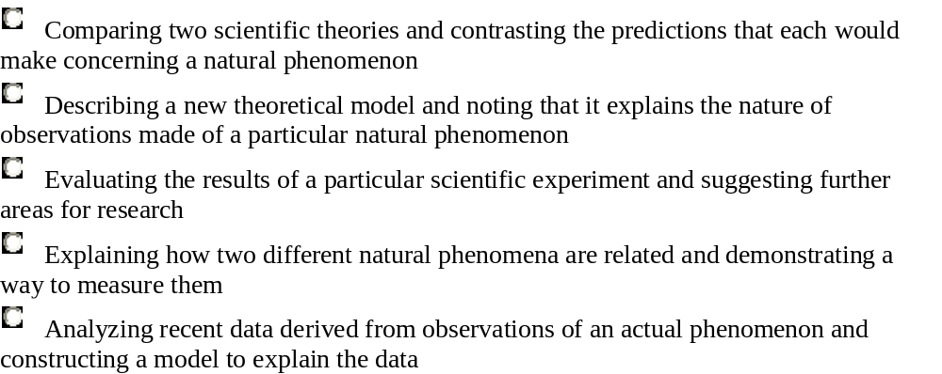

EXPLANATION
This question asks you to identify the primary focus of the passage. The best answer is the second choice. The author describes the new theoretical model in the first paragraph; in the final paragraph the author states that the data obtained from actual observations which are discussed in the second and third paragraphs, is consistent with the new theoretical model.
The first choice is not correct; the computer model confirmed the astronomers' hypothesis that meteor streams broaden with time, and although the model yielded an unexpected result, the passage makes no reference to further areas for research, and only a single phenomenon is described in the passage. And, the last choice is not correct because it reverses the order of events. The model yielded a prediction that was subsequently confirmed by observational data; the model was not constructed to explain the data.

Reading Comprehension Question 2
Traditionally, the first firm to commercialize a new technology has benefited from the unique opportunity to shape product definitions, forcing followers to adapt to a standard or invest in an unproven alternative. Today, however, the largest payoffs may go to companies that lead in developing integrated approaches for successful mass production and distribution.
Producers of the Beta format for videocassette recorders (VCR's), for example, were first to develop the VCR commercially in 1975, but producers of the rival VHS (Video Home System) format proved to be more successful at forming strategic alliances with other producers and distributors to manufacture and market their VCR format. Seeking to maintain exclusive control over VCR distribution, Beta producers were reluctant to form such alliances and eventually lost ground to VHS in the competition for the global VCR market.
Despite Beta's substantial technological head start and the fact that VHS was neither technically better nor cheaper than Beta, developers of VHS quickly turned a slight early lead in sales into a dominant position. Strategic alignments with producers of prerecorded tapes reinforced the VHS advantage. The perception among consumers that prerecorded tapes were more available in VHS format further expanded VHS's share of the market. By the end of the 1980's, Beta was no longer in production
According to the passage, consumers began to develop a preference for VCR's in the VHS format because they believed which one of the following?
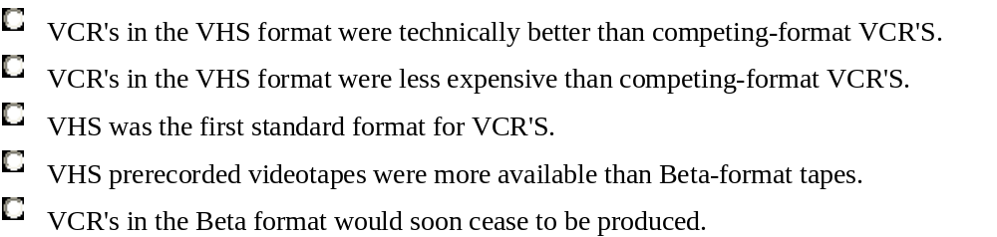

EXPLANATION
The best answer is the fourth choice. The passage states that the "perception among consumers that prerecorded tapes were more available in VHS format further expanded VHS's share of the market." None of the information given in the passage suggests that consumers thought the VHS-format was technically better (the first choice) or less expansive than Beta (the second choice). Nor does the passage indicate that consumers believed that VHS-format VCR's were the first on the market (the third choice) or that VHS-format VCR's would eventually drive Beta VCR's out of production entirely (the last choice).
Reading Comprehension Question 3

All of the cells in a particular plant start out with the same complement of genes. How then can these cells differentiate and form structures as different as roots, stems, leaves, and fruits? The answer is that only a small subset of the genes in a particular kind of cell are expressed, or turned on, at a given time. This is accomplished by a complex system of chemical messengers that in plants include hormones and other regulatory molecules. Five major hormones have been identified: auxin, abscisic acid, cytokinin, ethylene, and gibberellin. Studies of plants have now identified a new class of regulatory molecules called oligosaccharins.
Unlike the oligosaccharins, the five well-known plant hormones are pleiotropic rather than specific; that is, each has more than one effect on the growth and development of plants. The five have so many simultaneous effects that they are not very useful in artificially controlling the growth of crops. Auxin, for instance, stimulates the rate of cell elongation, causes shoots to grow up and roots to grow down, and inhibits the growth of lateral shoots. Auxin also causes the plant to develop a vascular system, to form lateral roots, and to produce ethylene.
The pleiotropy of the five well-studied plant hormones is somewhat analogous to that of certain hormones in animals. For example, hormones from the hypothalamus in the brain stimulate the anterior lobe of the pituitary gland to synthesize and release many different hormones, one of which stimulates the release of hormones from the adrenal cortex. These hormones have specific effects on target organs all over the body. One hormone stimulates the thyroid gland, for example, another the ovarian follicle cells, and so forth. In other words, there is a hierarchy of hormones.
Such a hierarchy may also exist in plants. Oligosaccharins are fragments of the cell wall released by enzymes: different enzymes release different oligosaccharins. There are indications that pleiotropic plant hormones may actually function by activating the enzymes that release these other, more specific chemical messengers from the cell wall.
The passage suggests that which of the following is a function likely to be performed by an oligosaccharin?
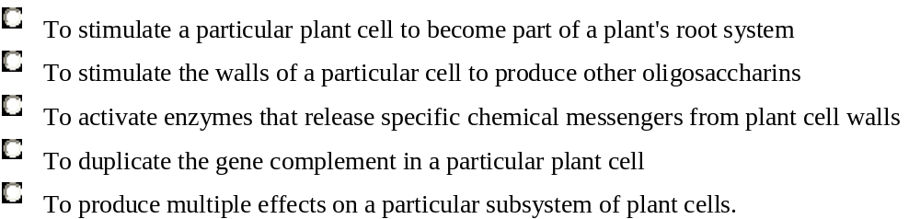

EXPLANATION

The best choice is the first. The last paragraph characterizes oligosaccharisn as "specific chemical messengers". The passage indicates that these chemical messengers are "specific" in that, unlike the pleiotropic hormones, they are likely to have particular effects on particular plant cells. The first choice is correct because it is the only choice that describes an effect on a specific aspect of plant growth and development: stimulating a particular plant cell to become a part of a plant's root system. The second and third choices are incorrect because the last paragraph indicates that enzymes activate the release of oligosaccharins. The fourth choice is incorrect because although oligosaccharins do affect the activity of the gene complement of a particular cell, they do not duplicate that complement. The last choice is incorrect because the second paragraph indicates that an oligosaccharin has a specific effect rather than multiple effects on plant cells.

Reading Comprehension Question 4

Most large corporations in the United States were once run by individual capitalists who owned enough stock to dominate the board of directors and dictate company policy. Because putting such large amounts of stock on the market would only depress its value, they could not sell out for a quick profit and instead had to concentrate on improving the long-term productivity of their companies. Today, with few exceptions, the stock of large United States corporations is held by large institutions-pension funds, for example-and because these institutions are prohibited by antitrust laws from owning a majority of a company's stock and from actively influencing a company's decision-making, they can enhance their wealth only by buying and selling stock in anticipation of fluctuations in its value. A minority shareholder is necessarily a short-term trader. As a result, United States productivity is unlikely to improve unless shareholders and the managers of the companies in which they invest are encouraged to enhance long-term productivity (and hence long-term profitability), rather than simply to maximize short-term profits.
Since the return of the old-style capitalist is unlikely, today's short-term traders must be remade into tomorrow's long-term capitalistic investors. The legal limits that now prevent financial institutions from acquiring a dominant shareholding position in a corporation should be removed, and such institutions encouraged to take a more active role in the operations of the companies in which they invest. In addition, any institution that holds twenty percent or more of a company's stock should be forced to give the public one day's notice of the intent to sell those shares. Unless the announced sale could be explained to the public on grounds other than anticipated future losses, the value of the stock would plummet and, like the old-time capitalists, major investors could cut their losses only by helping to restore their companies' productivity. Such measures would force financial institutions to become capitalists whose success depends not on trading shares at the propitious moment, but on increasing the productivity of the companies in which they invest.
The passage supports which of the following statements?
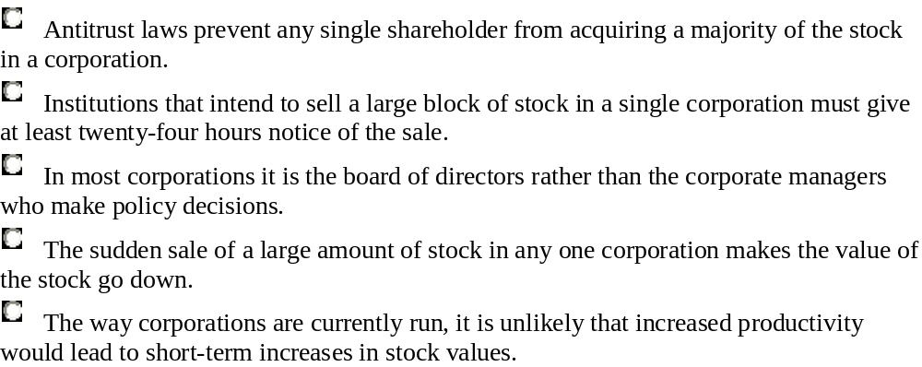
EXPLANATION
This question asks you to identify a statement for which evidence is presented in the passage. The best answer is shown.
…In addition, any institution that holds twenty percent or more of a company's stock should be forced to give the public one day's notice of the intent to sell those shares. Unless the announced sale could be explained to the public on grounds other than anticipated future losses, the value of the stock would plummet… | The passage states that the sudden sale of a large amount of a corporation's stock twenty percent or more - causes the value of that stock to decline.
Antitrust laws prevent any single shareholder from acquiring a majority of the stock in a corporation. | The first choice is incorrect. The author states that "large institutions" are prohibited from owning a majority of the stock in any one corporation. However, the author does not say whether or not other parties are similarly prohibited.
Institutions that intend to sell a large block of stock in a single corporation must give at least twenty-four hours notice of the sale. | The second choice is not correct. The author proposes that institutions that intend to sell a large block of a corporation's stock should be required to give a day's notice: the author does not say that such institutions are already required to do so
In most corporations it is the board of directors rather than the corporate managers who make policy decisions. | The third choice is not correct. The only mention of boards of directors, in the first sentence of the passage, refers to a historical past in which individual capitalists could control boards of directors and dictate company policy. However, the passage does not say anything about what role boards of directors currently play in making policy decisions.
The way corporations are currently run, it is unlikely that increased productivity would lead to short-term increases in stock values. | The last choice is not the correct answer. The passage only discusses the relationship between increased long-term productivity and long-term profitability; is does not say anything about the relationship between increased productivity and short-term stock values.

Reading Comprehension Question 4

Many United States companies have, unfortunately, made the search for legal protection from import competition into a major line of work. Since 1980 the United States International Trade Commission (ITC) has received about 280 complaints alleging damage from imports that benefit from subsidies by foreign governments. Another 340 charge that foreign companies "dumped" their products in the United States at "less than fair value." Even when no unfair practices are alleged, the simple claim that an industry has been injured by imports is sufficient grounds to seek relief.
Contrary to the general impression, this quest for import relief has hurt more companies than it has helped. As corporations begin to function globally, they develop an intricate web of marketing, production, and research relationships. The complexity of these relationships makes it unlikely that a system of import relief laws will meet the strategic needs of all the units under the same parent company.
Internationalization increases the danger that foreign companies will use import relief laws against the very companies the laws were designed to protect. Suppose a United States-owned company establishes an overseas plant to manufacture a product while its competitor makes the same product in the United States. If competitor can prove injury from the imports-and that the United States company received a subsidy from a foreign government to build its plant abroad- United States company's products will be uncompetitive in the United States, since they would be subject to duties.
Perhaps the most brazen case occurred when the ITC investigated allegations that Canadian companies injuring the United States salt industry by dumping rock salt, used to de-ice roads. The bizarre aspect of the complaint was that a foreign conglomerate with United States operations was crying for help against a United States company with foreign operations. The "United States" company claiming injury was a subsidiary of a Dutch conglomerate, while the "Canadian" companies included a subsidiary of a Chicago firm that was the second-largest domestic producer of rock salt.

The passage warns of which of the following dangers?
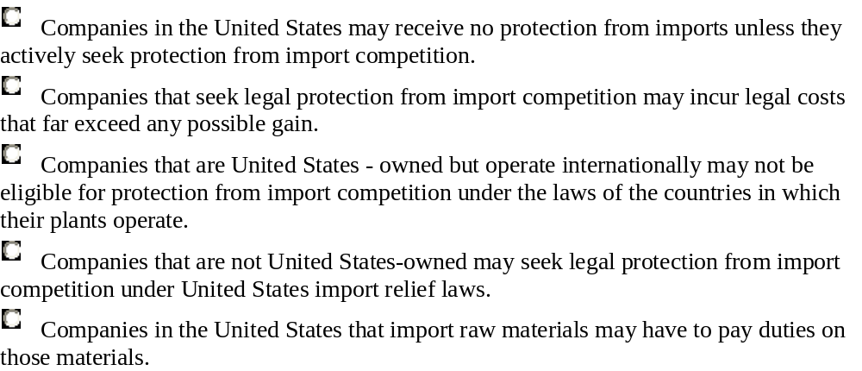
EXPLANATION
This is the best answer.
Internationalization increases the danger that foreign companies will use import relief laws against the very companies the laws were designed to protect. | The "danger" of import relief laws is stated. Import relief laws are the legal protection referred to in the correct choice. The passage does not mention the situations described in the other choices.
Critical Reasoning

INSTRUCTIONS

For this question, select the best of the answer choices given.

Critical Reasoning Question 1

Which of the following best completes the passage below?
In a survey of job applicants, two-fifths admitted to being at least a little dishonest. However, the survey may underestimate the proportion of job applicants who are dishonest, because _____.

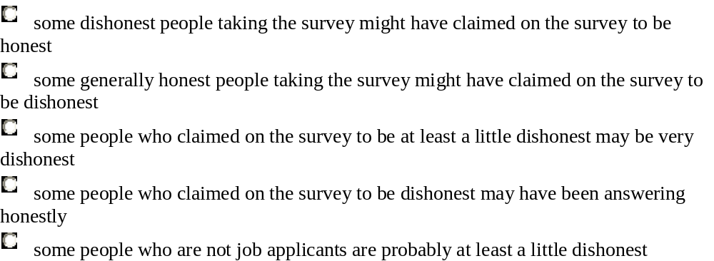

EXPLANATION

If applicants who are in fact dishonest claimed to be honest, the survey results would show a smaller proportion of dishonest applicants than actually exists. Therefore, the first choice is best.
The second choice is inappropriate because generally honest applicants who claimed to be dishonest could contribute to the overestimation, but not to the underestimation, of dishonest applicants.
The fourth choice is inappropriate because applicants who admitted their dishonesty would not contribute to an underestimation of the proportion of dishonest applicants.
The third and last choices are not appropriate because the argument is concerned neither with degrees of dishonesty nor with the honesty of nonapplicants.

Critical Reasoning Question 2
A program instituted in a particular state allows parents to prepay their children's future college tuition at current rates. The program then pays the tuition annually for the child at any of the state's public colleges in which the child enrolls. Parents should participate in the program as a means of decreasing the cost of their children's college education.
Which of the following, if true, is the most appropriate reason for parents not to participate in the program?
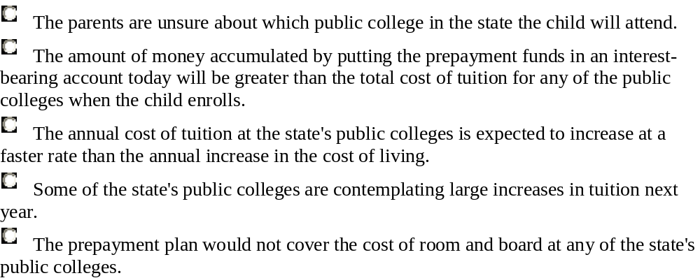

EXPLANATION

The passage recommends that parents participate in a tuition prepayment program as a means of decreasing the cost of their children's college education. If this choice were true, placing the funds in an interest-bearing account would be more cost-effective than participating in the prepayment program. Therefore, this choice would be a reason for not participating and is the best answer.
Neither the first nor the last choice is clearly relevant to deciding whether to participate. Since the program applies to whatever public college the child might choose to attend, the contingency described in the first choice is covered in the plan. Regardless of whether the parents participate, the expenses mentioned in the last choice would not be included in the cost of tuition. The third and fourth choices, by stating that tuition will increase, provide support for participating in the program.
Critical Reasoning Question 3
Fact 1: Television advertising is becoming less effective: the proportion of brand names promoted on television that viewers of the advertising can recall is slowly decreasing.
Fact 2: Television viewers recall commercials aired first or last in a cluster of consecutive commercials far better than they recall commercials aired somewhere in the middle.
Fact 2 would be most likely to contribute to an explanation of fact 1 if which of the following were also true?

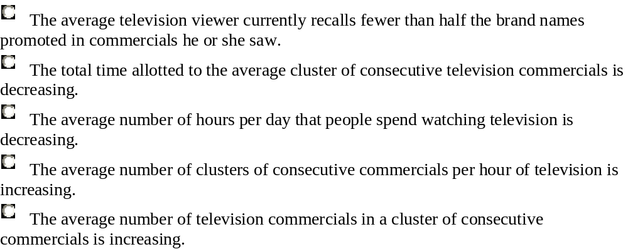

EXPLANATION

The last choice indicates that the number of commercials in a cluster is increasing, so it entails that proportionally more commercials are aired in intermediate positions. Hence, the last choice helps fact 2 explain fact 1 by showing that increasingly more commercials are aired in positions in which viewers find them difficult to recall. This is the best answer.
The first choice testifies to the ineffectiveness of television advertising but does not help fact 2 explain fact 1.
The second choice indicates that fact 2 contradicts rather than explains fact 1, since it suggests that the number of commercials per cluster is decreasing.
The third and fourth choice help explain fact 1 - the third choice by describing a change in viewing habits and the fourth choice by describing a change in programming - but neither relates fact 2 to fact 1.

Critical Reasoning Question 4

The average normal infant born in the United States weighs between twelve and fourteen pounds at the age of three months. Therefore, if a three-month-old child weighs only ten pounds, its weight gain has been below the United States average.

Which of the following indicates a flaw in the reasoning above?
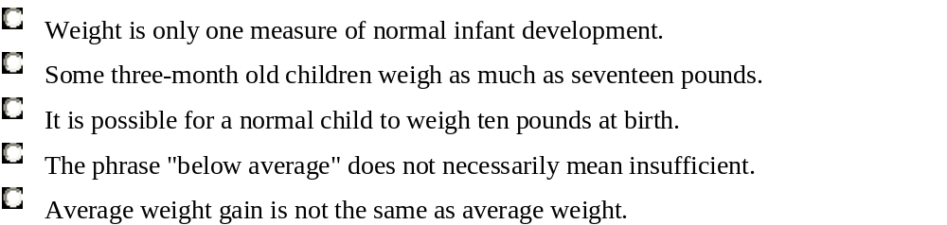
EXPLANATION

The evidence on which the conclusion is based concerns only average weight, but the conclusion concerns average weight gain. Because there is not necessarily a connection between an absolute measurement - such as weight - and a rate of increase - such as weight gain - this argument is flawed. The relevant reasoning error is described in the last choice, which is the best answer.
Neither the first or fourth choice identifies a reasoning error in the passage, since the passage makes no claim that weight is the only relevant measure of infant development in general (the first choice), and no claim about sufficiency (the fourth choice). Both the second and third choice are consistent with the claims in the passage, and neither identifies a flaw in the argument.

Critical Reasoning Question 5

Which of the following best completes the passage below?
People buy prestige when they buy a premium product. They want to be associated with something special. Mass-marketing techniques and price-reduction strategies should not be used because ___________ .
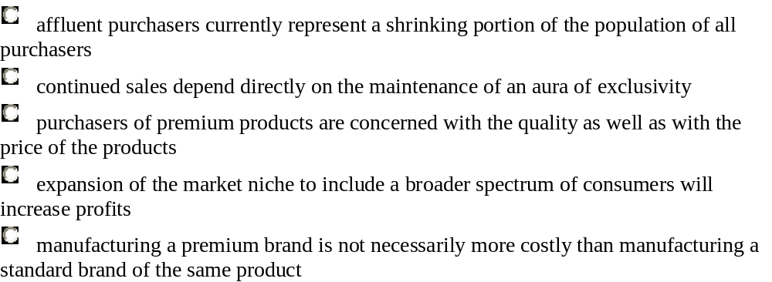

EXPLANATION

The incomplete passage calls for an explanation of why price-reduction and mass-marketing methods should not be used for premium products. The second choice, which states that sales of these products require that they appear special, provides such an explanation. This is the best answer.
No other choice offers an appropriate explanation. The third choice suggests that purchasers of premium products find reduced prices attractive, and it has not been established that the methods affect quality or perception of quality.
The diminishing proportion of affluent buyers cited in the first choice argues for using price reductions to attract buyers of lesser means, while the fourth choice argues for, rather than against, using mass marketing.
The last choice is inappropriate, since there is no indication that manufacturing costs are relevant.
Problem Solving
INSTRUCTIONS
Solve the problem and indicate the best of the answer choices given.
Numbers: All numbers used are real numbers.
Figures: A figure accompanying a problem solving a question is intended to provide information useful in solving the problem. Figures are drawn as accurately as possible EXCEPT when it is stated in a specific problem that its figure is not drawn to scale. Straight lines may sometimes appear jagged. All figures lie in a plane unless otherwise indicated.

Problem Solving Question 1
Harriet wants to put up fencing around three sides of her rectangular yard and leave a side of 20 feet unfenced. If the yard has an area of 680 square feet, how many feet of fencing does she need?
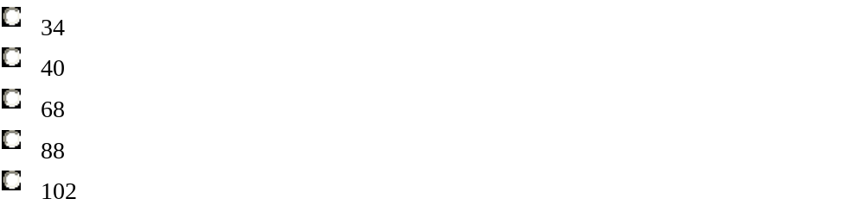
EXPLANATION
W
20 |  | 20
W
The diagram shows the rectangular yard with the known dimension, 20 feet, and the unknown dimension, w feet. The area of the yard is 20w= 680 square feet, so w = 680/ 20 = 34 feet. The length of the fencing needed is 34+20+34=88 feet.

Problem Solving Question 2
A toy store regularly sells all stock at a discount of 20 percent to 40 percent. If an additional 25 percent were deducted from the discount price during a special sale, what would be the lowest possible price of a toy costing $16 before any discount?

EXPLANATION

The lowest possible price is paid when the maximum discount is received, so the lowest possible regular price is $16 - 0.40($16) = $9.60. With an additional 25 percent discount, the lowest possible price is $9.60 - 0.25($9.60) = $7.20. The best answer is the second one.
Alternatively, the lowest possible price to be paid for the item can be calculated by realizing that if you are being given a discount of 40 percent you are paying 60 percent of the listed price of the item. If an additional 25 percent discount is offered on the item, the price of the item becomes (0.75)(0.60)($16) = $7.20.

Problem Solving Question 3
Which of the following equations has a root in common with x2 - 6x + 5 = 0?
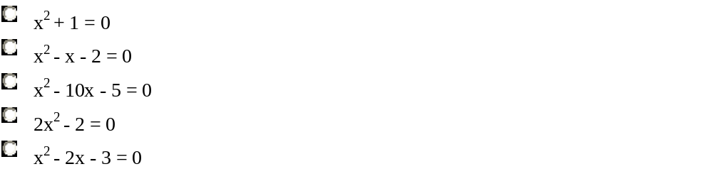
EXPLANATION
Since x² - 6x + 5 = (x - 5)(x - 1), the roots of x² - 6x + 5 = 0 are 1 and 5. When these two values are substituted in each of the five choices to determine whether or not they satisfy the equation, only in the fourth choice does a value satisfy the equation, namely, 2(1)² - 2 = 0. Thus the best answer is 2x² - 2 = 0.

Problem Solving Question 4
If "basis points" are defined so that 1 percent is equal to 100 basis points, then 82.5 percent is how many basis points greater than 62.5 percent?
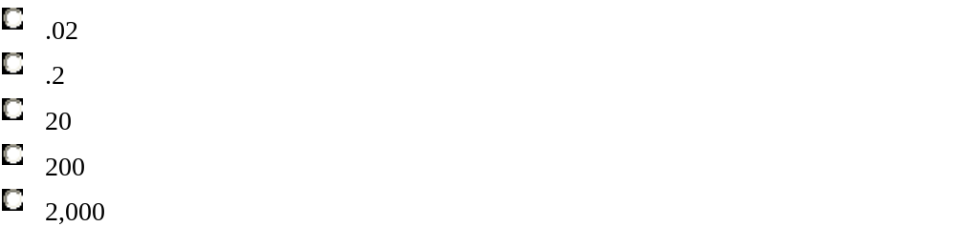
EXPLANATION
There is a difference of 20 percent between 82.5 percent and 62.5 percent. If 1 percent equals 100 basis points, then 20 percent equals 20(100) or 2,000 basis points.

Problem Solving Question 5
If x + 5y = 16 and x = -3y, then y =
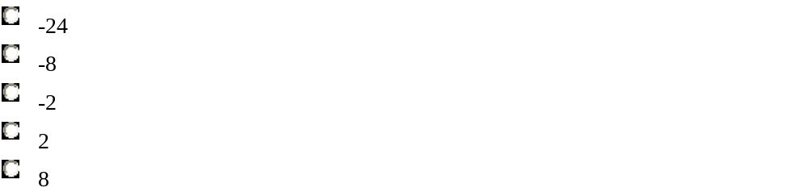
EXPLANATION
Substitution of the second equation into the first equation yields
(-3y) + 5y | = | 16
2y | = | 16
y | = | 8

Data Sufficiency

INSTRUCTIONS

This data sufficiency problem consists of a question and two statements labeled (1) and (2), in which certain data are given. You have to decide whether the data given in the statements are sufficient for answering the question. Using the data given in the statements plus your knowledge of mathematics and everyday facts (such as the number of days in July or the meaning of counterclockwise), you must indicate whether
- statement (1) ALONE is sufficient, but statement (2) alone is not sufficient to answer the question asked;
- statement (2) ALONE is sufficient, but statement (1) alone is not sufficient to answer the question asked;
- BOTH statements (1) and (2) TOGETHER are sufficient to answer the question asked, but NEITHER statement ALONE is sufficient;
- EACH statement ALONE is sufficient to answer the question asked;
- statements (1) and (2) TOGETHER are NOT sufficient to answer the question asked, and additional data specific to the problem are needed.
Numbers: All numbers used are real numbers.
Figures: A figure accompanying a data sufficiency problem will conform to the information given in the question, but will not necessarily conform to the additional information given in statements (1) and (2).
Lines shown as straight can be assumed to be straight and lines that appear jagged can also be assumed to be straight.
You may assume that the positions of points, angles, regions, etc., exist in the order shown and that angle measures are greater than zero.
All figures lie in a plane unless otherwise indicated.
Note: In data sufficiency problems that ask for the value of a quantity, the data given in the statements are sufficient only when it is possible to determine exactly one numerical value for the quantity.
Example
In triangle PQR, what is the value of x ?  (1) PQ = PR  (2) y = 40 | 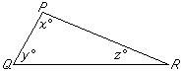
Explanation: According to statement (1), PQ=PR; therefore, (PQR is isosceles and y = z. Since x + y + z = 180, it follows that x + 2y = 180. Since statement (1) does not give a value for y, you cannot answer the question using statement (1) alone. According to statement (2), y = 40; therefore, x + z = 140. Since statement (2) does not give a value for z, you cannot answer the question using statement (2) alone. Using both statements together, since x + 2y = 180 and the value of y is given, you can find the value of x. Therefore, BOTH statements (1) and (2) TOGETHER are sufficient to answer the question, but NEITHER statement ALONE is sufficient.
Data Sufficiency Question 1
If a real estate agent received a commission of 6 percent of the selling price of a certain house, what was the selling price of the house?
(1) The selling price minus the real estate agent's commission was $84,600.
(2) The selling price was 250 percent of the original purchase price of $36,000.
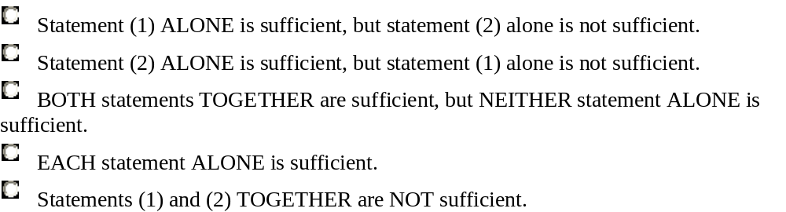
EXPLANATION
From (1) it follows that $84,600 is 94% (100% − 6%) of the selling price, and thus the selling price, $84,600 / 0.94, can be determined. Therefore (1) alone is sufficient.
From (2) it follows that the selling price is 2.5($36,000). Thus, (2) alone is sufficient.
The best answer is the fourth choice.

Data Sufficiency Question 2
John and David each received a salary increase. Which one received the greater dollar increase?
(1) John's salary increased 8 percent.
(2) David's salary increased 5 percent.
EXPLANATION
In (1) there is no information about David's salary and in (2) there is no information about John's salary; thus neither statement alone is sufficient, and the answer must the third or fifth choice. Since (1) and (2) together give only the percentage increases in salary, it cannot be determined which person received the greater dollar increase. Therefore, (1) and (2) together are not sufficient, and the best answer is the last choice.
Data Sufficiency Question 3
Carlotta can drive from her home to her office by one of two possible routes. If she must also return by one of these routes, what is the distance of the shorter route?
(1) When she drives from her home to her office by the shorter route and returns by the longer route, she drives a total of 42 kilometers.
(2) When she drives both ways, from her home to her office and back, by the longer route, she drives a total of 46 kilometers.
EXPLANATION

Statement (1) alone is not sufficient because only the sum of the distances of the two routes is given and there are infinitely many pairs of numbers with a given sum.
From (2) the distance of the longer route can be found, but there is no information about the distance of the shorter route. Statement (2) alone is therefore not sufficient.
From (1) and (2) together, the distance of the shorter route can be determined (42 − 46/2), and the third choice is the best.

Data Sufficiency Question 4
The symbol ∇ represents one of the following operations: addition, subtraction, multiplication, or division. What is the value of 3 ∇ 2?
(1) 0 ∇ 1 = 1
(2) 1 ∇ 0 = 1
EXPLANATION
Since 0 + 1 = 1, 0 - 1 = -1, 0 × 1 = 0, and 0 ÷ 1 = 0, it follows from (1) that ∇ represents addition, so the value of 3 ∇ 2 can be determined. Hence, (1) alone is sufficient.
Since 1 + 0 = 1, 1 - 0 = 1, 1 × 0 = 0, and 1 ÷ 0 is undefined, it follows from (2) that ∇ could represent either addition or subtraction, so that 3 ∇ 2 could equal 5 or 1. Thus, (2) alone is not sufficient.
The best answer is the first choice.
Data Sufficiency Question 5
Is the prime number p equal to 37?
(1) p = n² + 1, where n is an integer.
(2) p² is greater than 200.
EXPLANATION
In (1) the expression n² + 1 can represent a prime number less than 37, equal to 37, or greater than 37, depending on the value of n. For example if n = 4, then 4² + 1 = 17; if n = 6, then 6² + 1 = 37; and if n = 10, then 10² + 1 = 101; and 17, 37 and 101 are all prime numbers. Thus (1) alone is not sufficient.
Since 14² = 196 and 15² = 225, it follows from (2) that p > 14, so that p might or might not equal 37. Thus (2) alone is not sufficient.
The values of p for n = 4 and n = 6 given above show that (1) and (2) together are not sufficient, and the last choice is the best answer.

Analysis of an Issue
In this section, you will need to analyze the issue presented and explain your views on it. There is no "correct" answer. Instead, you should consider various perspectives as you develop your own position on the issue.
WRITING YOUR RESPONSE: Take a few minutes to think about the issue and plan a response before you begin writing. Be sure to organize your ideas and develop them fully, but leave time to reread your response and make any revisions that you think are necessary.
EVALUATION OF YOUR RESPONSE: College and university faculty members from various subject-matter areas, including management education, will evaluate the overall quality of your thinking and writing. They will consider how well you
- organize, develop, and express your ideas about the issue presented
- provide relevant supporting reasons and examples
- control the elements of standard written English

GMAT SCORING GUIDE
A score of 6 - Outstanding
A 6 paper presents a cogent, well-articulated analysis of the complexities of the issue and demonstrates mastery of the elements of effective writing.
A typical paper in this category
- explores ideas and develops a position on the issue with insightful reasons and/or persuasive examples
- is clearly well organized
- demonstrates superior control of language, including diction and syntactic variety
- demonstrates superior facility with the conventions (grammar, usage, and mechanics) of standard written English but may have minor flaws
A score of 5 - Strong
A 5 paper presents a well-developed analysis of the complexities of the issue and demonstrates a strong control of the elements of effective writing.
A typical paper in this category
- develops a position on the issue with well-chosen reasons and/or examples
- is generally well organized
- demonstrates clear control of language, including diction and syntactic variety
- demonstrates facility with the conventions of standard written English but may have minor flaws
A score of 4 - Adequate
A 4 paper presents a competent analysis of the issue and demonstrates adequate control of the elements of writing.
A typical paper in this category
- develops a position on the issue with relevant reasons and/or examples
- is adequately organized
- demonstrates adequate control of language, including diction and syntax, but may lack syntactic variety
- displays control of the conventions of standard written English but may have some flaws
A score of 3 - Limited
A 3 paper demonstrates some competence in its analysis of the issue and in its control of the elements of writing but is clearly flawed.
A typical paper in this category exhibits one or more of the following characteristics:
- is vague or limited in developing a position on the issue
- is poorly organized
- is weak in the use of relevant reasons or examples
- uses language imprecisely and/or lacks sentence variety
- contains occasional major errors or frequent minor errors in grammar, usage, and mechanics
A score of 2 - Seriously Flawed
A 2 paper demonstrates serious weaknesses in analytical writing skills.
A typical paper in this category exhibits one or more of the following characteristics:
- is unclear or seriously limited in presenting or developing a position on the issue
- is disorganized
- provides few, if any, relevant reasons or examples
- has serious and frequent problems in the use of language and sentence structure
- contains numerous errors in grammar, usage, or mechanics that interfere with meaning
A score of 1 - Fundamentally Deficient
A 1 paper demonstrates fundamental deficiencies in analytical writing skills.
A typical paper in this category exhibits one or more of the following characteristics:
- provides little evidence of the ability to develop or organize a coherent response to the topic
- has severe and persistent errors in language and sentence structure
- contains a pervasive pattern of errors in grammar, usage, and mechanics that severely interferes with meaning
- off-topic, in a foreign language, merely attempts to copy the topic, or consists of keystroke characters.

Analysis of an Issue Question 1
In some countries, television and radio programs are carefully censored for offensive language and behavior. In other countries, there is little or no censorship.
In your view, to what extent should government or any other group be able to censor television or radio programs? Explain, giving relevant reasons and/or examples to support your position.

Analysis of an Issue Question 2
"Schools should be responsible only for teaching academic skills and not for teaching ethical and social values."
Discuss the extent to which you agree or disagree with the opinion expressed above. Support your point of view with reasons and/or examples from your own experience, observations, or reading.

Analysis of an Issue Question 3
In matching job candidates with job openings, managers must consider not only such variables as previous work experience and educational background but also personality traits and work habits, which are more difficult to judge.
What do you consider essential in an employee or colleague? Explain, using reasons and/or examples from your work or worklike experiences or from your observations of others.

Analysis of an Issue Question 4
"Organizations should be structured in a clear hierarchy in which the people at each level, from top to bottom, are held accountable for completing a particular component of the work. Any other organizational structure goes against human nature and will ultimately prove fruitless."
Discuss the extent to which you agree or disagree with the opinion expressed above. Support your point of view with reasons and/or examples from your own experience, observations, or reading.

Analysis of an Issue Question 5
"Nations should cooperate to develop regulations that limit children's access to adult material on the Internet."*
* The Internet is a worldwide computer network.
Discuss the extent to which you agree or disagree with the opinion stated above. Support your views with reasons and/or examples, from your own experience, observations, or reading
Analysis of an Argument
In this section, you will be asked to write a critique of the argument presented. You are NOT being asked to present your own views on the subject.
WRITING YOUR RESPONSE: Take a few minutes to evaluate the argument and plan a response before you begin writing. Be sure to organize your ideas and develop them fully, but leave time to reread your response and make any revisions that you think are necessary.
EVALUATION OF YOUR RESPONSE: College and university faculty members from various subject-matter areas, including management education, will evaluate the overall quality of your thinking and writing. They will consider how well you
- organize, develop, and express your ideas about the argument presented
- provide relevant supporting reasons and examples
- control the elements of standard written English
Analysis of an Argument Question 1
The following appeared as part of an annual report sent to stockholders by Olympic Foods, a processor of frozen foods.
"Over time, the costs of processing go down because as organizations learn how to do things better, they become more efficient. In color film processing, for example, the cost of a 3-by-5-inch print fell from 50 cents for five-day service in 1970 to 20 cents for one-day service in 1984. The same principle applies to the processing of food. And since Olympic Foods will soon celebrate its twenty-fifth birthday, we can expect that our long experience will enable us to minimize costs and thus maximize profits."

Analysis of an Argument Question 2
The following appeared as part of the business plan of an investment and financial consulting firm.
"Studies suggest that an average coffee drinker's consumption of coffee increases with age, from age 10 through age 60. Even after age 60, coffee consumption remains high. The average cola drinker's consumption of cola, however, declines with increasing age. Both of these trends have remained stable for the past 40 years. Given that the number of older adults will significantly increase as the population ages over the next 20 years, it follows that the demand for coffee will increase and the demand for cola will decrease during this period. We should, therefore, consider transferring our investments from Cola Loca to Early Bird Coffee."
Discuss how well reasoned you find this argument. In your discussion be sure to analyze the line of reasoning and the use of evidence in the argument. For example, you may need to consider what questionable assumptions underlie the thinking and what alternative explanations or counterexamples might weaken the conclusion. You can also discuss what sort of evidence would strengthen or refute the argument, what changes in the argument would make it more logically sound, and what, if anything, would help you better evaluate its conclusion.
Analysis of an Argument Question 3

The following appeared in an article in a photography magazine.
"When choosing whether to work in color or in black-and-white, the photographer who wishes to be successful should keep in mind that because color photographs are more true-to-life, magazines use more color photographs than black-and-white ones, and many newspapers are also starting to use color photographs. The realism of color also accounts for the fact that most portrait studios use more color film than black-and-white film. Furthermore, there are more types of color film than black-and-white film available today. Clearly, photographers who work in color have an advantage over those who work in black-and-white."
Discuss how well reasoned you find this argument. In your discussion be sure to analyze the line of reasoning and the use of evidence in the argument. For example, you may need to consider what questionable assumptions underlie the thinking and what alternative explanations or counterexamples might weaken the conclusion. You can also discuss what sort of evidence would strengthen or refute the argument, what changes in the argument would make it more logically sound, and what, if anything, would help you better evaluate its conclusion.

Analysis of an Argument Question 4
The following appeared as part of a business plan recommended by the new manager of a musical rock group called Zapped.
"To succeed financially, Zapped needs greater name recognition. It should therefore diversify its commercial enterprises. The rock group Zonked plays the same type of music that Zapped plays, but it is much better known than Zapped because in addition to its concert tours and four albums, Zonked has a series of posters, a line of clothing and accessories, and a contract with a major advertising agency to endorse a number of different products."
Discuss how well reasoned you find this argument. In your discussion be sure to analyze the line of reasoning and the use of evidence in the argument. For example, you may need to consider what questionable assumptions underlie the thinking and what alternative explanations or counterexamples might weaken the conclusion. You can also discuss what sort of evidence would strengthen or refute the argument, what changes in the argument would make it more logically sound, and what, if anything, would help you better evaluate its conclusion.
Analysis of an Argument Question 5
The following appeared in the editorial section of a daily newspaper.
"Although forecasts of presidential elections based on opinion polls measure current voter preference, many voters keep changing their minds about whom they prefer until the last few days before the balloting. Some do not even make a final decision until they enter the voting booth. Forecasts based on opinion polls are therefore little better at predicting election outcomes than a random guess would be."
Discuss how well reasoned you find this argument. In your discussion be sure to analyze the line of reasoning and the use of evidence in the argument. For example, you may need to consider what questionable assumptions underlie the thinking and what alternative explanations or counterexamples might weaken the conclusion. You can also discuss what sort of evidence would strengthen or refute the argument, what changes in the argument would make it more logically sound, and what, if anything, would help you better evaluate its conclusion.

