**Django E-Learning App Summary**

**Overview**:

The Django e-learning app is designed to provide users with a platform for online learning.it offers various features such as course enrollment, chat messaging system for communication between student and lecturers, tutorials (videos and pdfs), User account creation and so much more.

**Roles and responsibilities of respective users**:

# Admin

* Creation of Students and Lecturers.
* Creation of course programs and courses.
* Ability to delete, update users (students, lecturers).
* Ability to add to post news and make announcements.

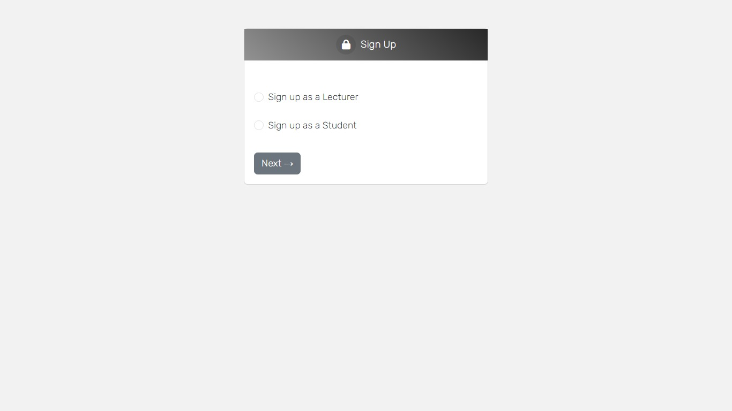

# Lecturer

* Creation of courses related to a particular program
* Communication with students
* Creation of course contents (video, pdf)
* Ability to remove and add students to their courses

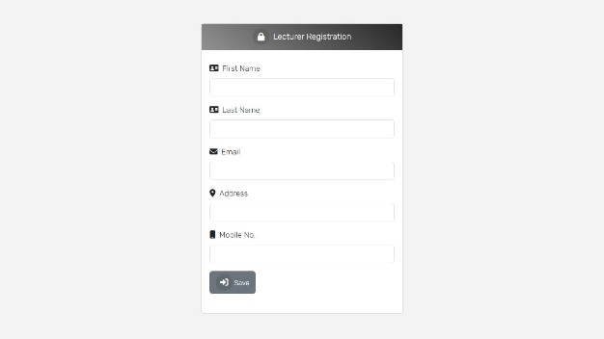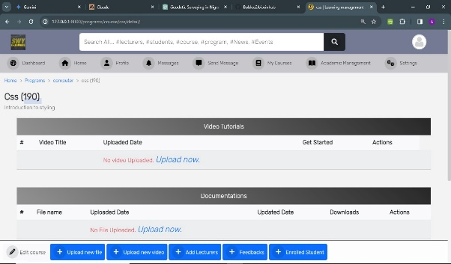

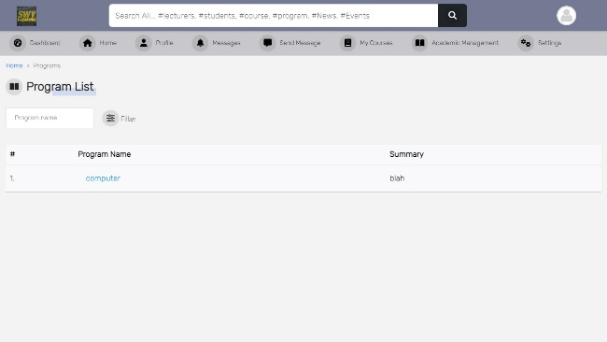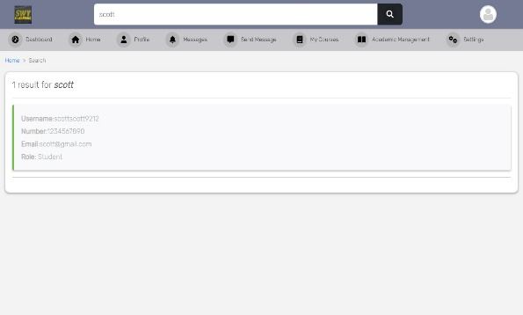

# Students

* Ability to enroll for a course and drop a particular course
* Interact with lecturers
* Give feedbacks on courses

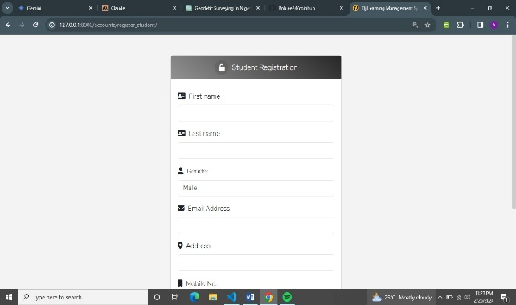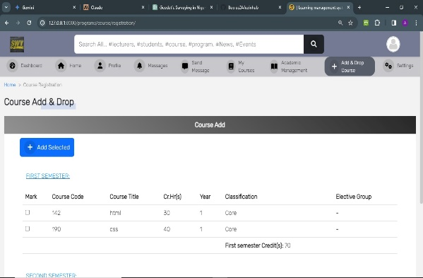

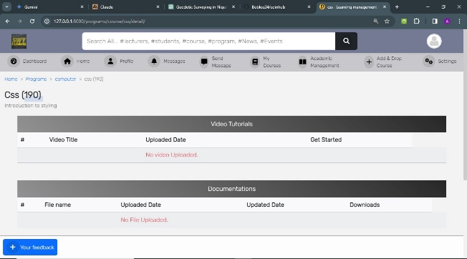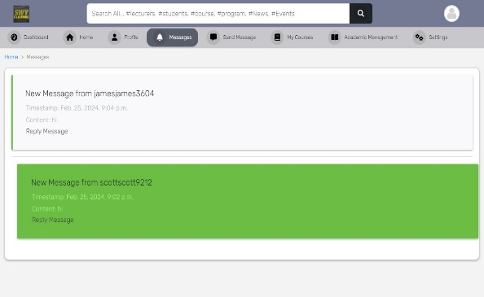

**Noticeable code features**

* Proper writing of views and forms
* Proper url mapping
* Use of redis for messages
* Use of sqlite for storing models in the database
* All python/Django code follows pep8 standard

**System features/personal observations/faq**

* Windows 11
* Although when building and testing the application I ran into some minor errors but after some careful observations, I was able to solve them.